***Screen Shots of Running the Code for Training Machine Learning models on Mislabeled datasets and comparing their accuracy.***

## Resolve Dependencies: Pulls all the dependant libraries to be used.

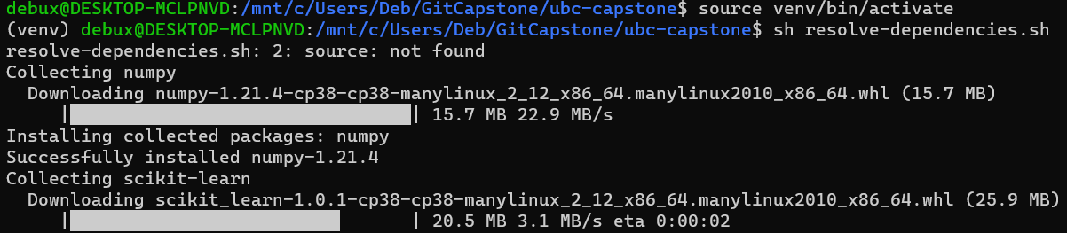

## Running the Experiment#1 on MNIST dataset.

## Running the Experiment#1 for only AdaBoost with WINE dataset:

## Running Experiment#2 on CIFAR10 dataset

Ignore below error.



It will take some time to complete:

Ten Epochs with 740 iterations each. Below Output

