PSTAT 274 Project

Carlos Baez

November 20, 2018

#Generate CSV to Explore with Kepler.GL  
longrides <- filter(Rides_DataA, distance_travelled >= 50000) %>% dplyr::select(start_location_lat, start_location_long, end_location_lat, end_location_long, distance_travelled)  
write.csv(longrides, "longrides.csv")  
  
#Filter out data with more than 100,000 m in distance_travelled  
Trip_Data <-filter(Rides_DataA, distance_travelled <= 100000) %>% dplyr::select(start_location_lat, start_location_long, end_location_lat, end_location_long, distance_travelled, started_on, completed_on)  
rm(Rides_DataA)

#Hourly   
Trip_hourly <- Trip_Data %>% mutate(day = as.numeric(date(started_on)), wday = wday(started_on), hour = hour(started_on)) %>% group_by(day, wday, hour) %>% summarize(count = n())  
  
#Get Hours where count is zero  
full_dates <- cbind(rep(16956:17269,each=24),seq(0,23))  
full_dates <-as.data.frame(full_dates)  
full_dates <- full_dates %>% mutate(wday = wday(as_date(V1)))  
Trip_hourly <- full_join(Trip_hourly,full_dates, by = c("day" = "V1", "wday" ="wday", "hour"= "V2"))  
Trip_hourly <- arrange(Trip_hourly, day, hour) %>% mutate(count = ifelse(is.na(count), 0, count))  
write.csv(Trip_hourly,"trip_hourly.csv")  
rm(full_dates)  
  
#Make time series  
trip_H <- ts(Trip_hourly)[,4]

# Exploring Data

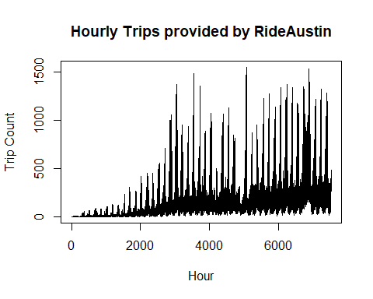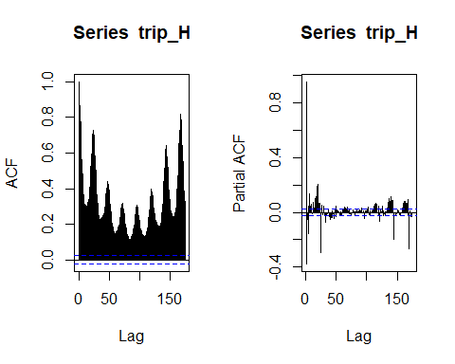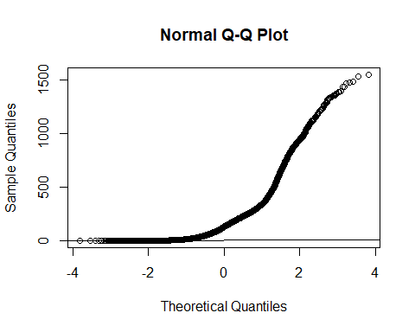

$μ=198.2047505$

$σ^{2}=5.640762×{10}^{4}$

## Differencing

### 24 Hour Differencing

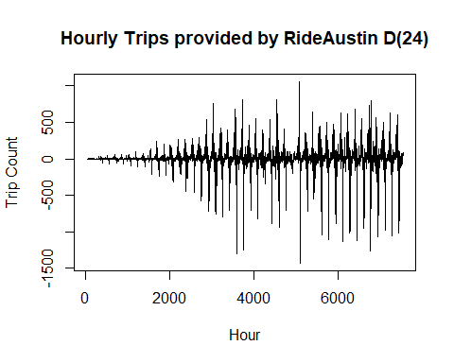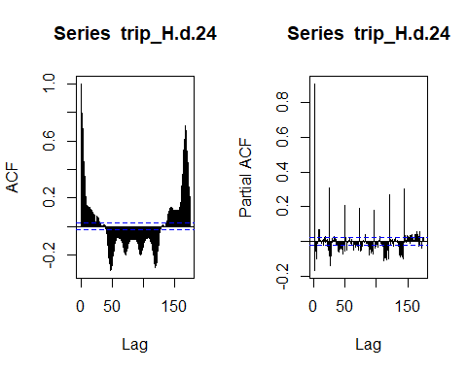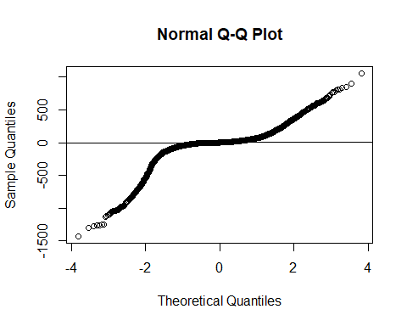

$μ=0.8213525$

$σ^{2}=3.0405066×{10}^{4}$

### 168 Hour Differencing

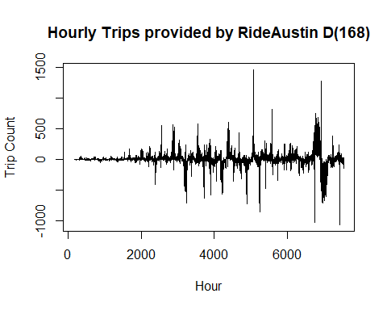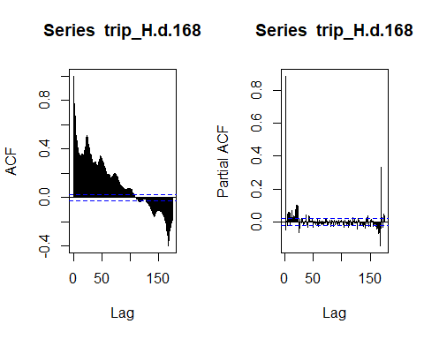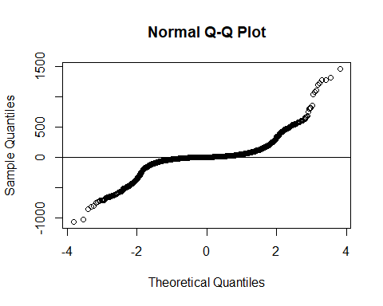

$μ=8.1173996$

$σ^{2}=1.76977×{10}^{4}$

### 24 and 168 hour differencing

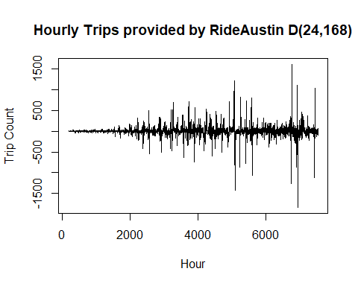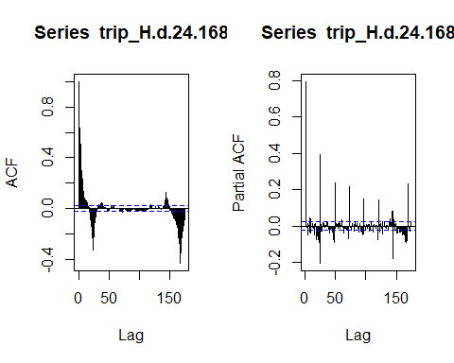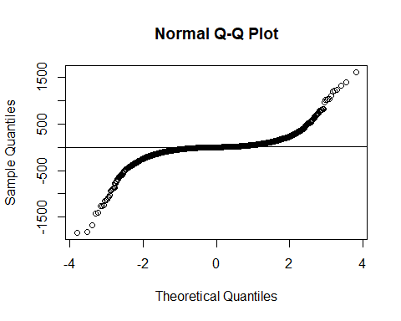

$μ=−0.0618192$

$σ^{2}=1.7215677×{10}^{4}$

## Transformations

### Square Root Transofrmation

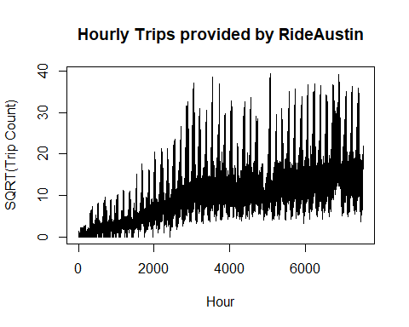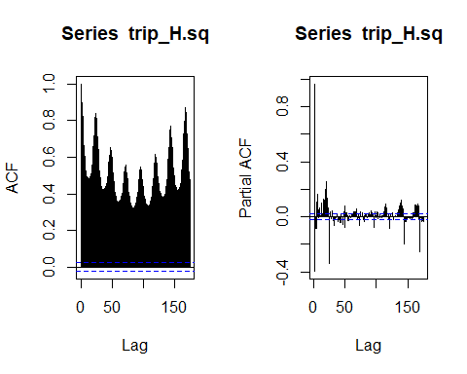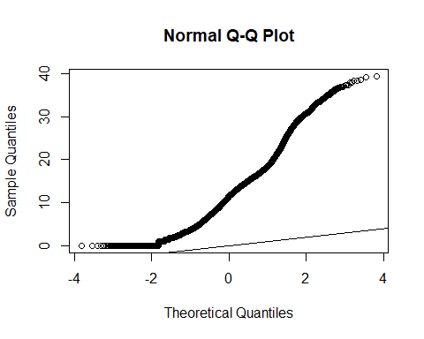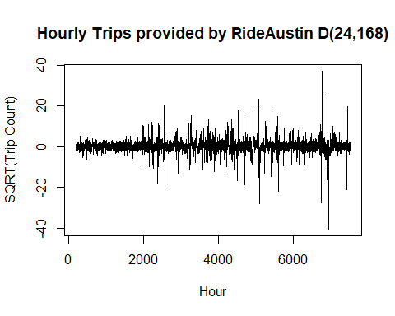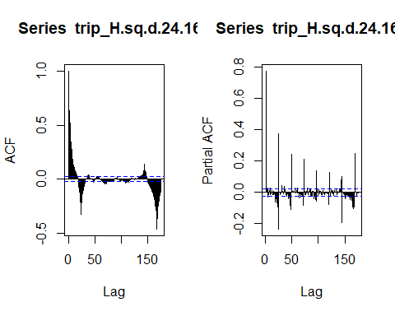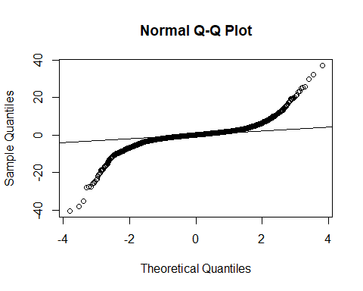

Before differencing:

$μ=11.7821095$

$σ^{2}=59.3945266$

After Differencing:

$μ=−0.0043747$

$σ^{2}=10.7890603$

### Box-Cox Transformation (lambda = 0.23)

## yjPower Transformation to Normality   
## Est Power Rounded Pwr Wald Lwr Bnd Wald Upr Bnd  
## Y1 0.2314 0.23 0.2181 0.2447  
##   
## Likelihood ratio test that transformation parameter is equal to 0  
## LRT df pval  
## LR test, lambda = (0) 1243.934 1 < 2.22e-16

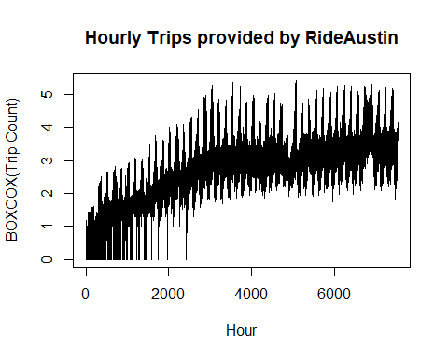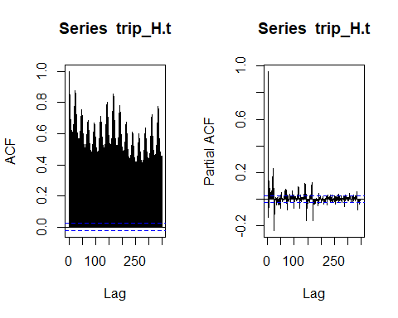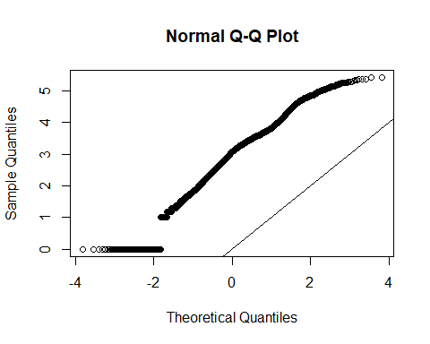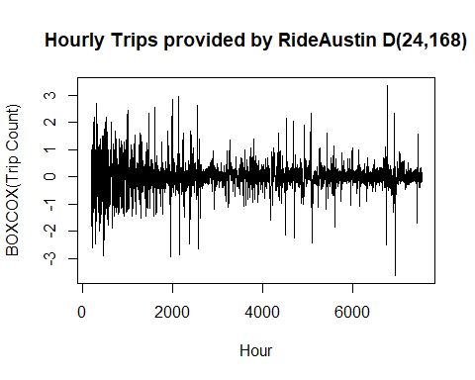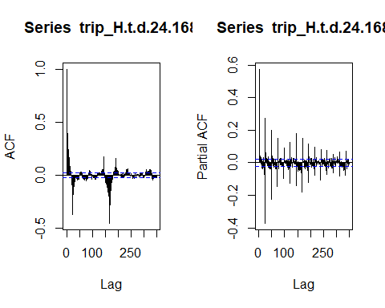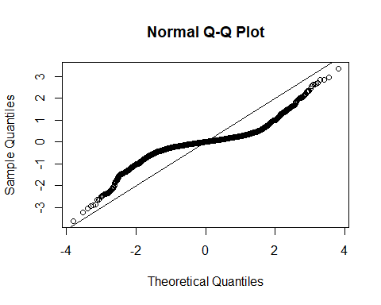

Before Differencing:

$μ=2.8935388$

$σ^{2}=1.1356043$

After Differencing:

$μ=−0.0024903$

$σ^{2}=0.2008531$