|  |  |
| --- | --- |
| **COURSE / UNIT CODE:** ITECH2003 | **TUTOR:** Falih Febrinanto |
| **STUDENT ID:** 30393065 | **STUDENT NAME:** Jiawei Xin |
| **DUE DATE:** 05/12 | **EXTENSION DATE AUTHORISED:** |
| **TITLE OF SUBMISSION:** Brief Report | |

* Indicate the preferred browser and resolution for your website.

There is no doubt that Chrome is still the largest browser in the market, so I worked on Chrome the most, and Google unified the front-end development standards.

According to statistics, 1920*1080 is currently the most popular device resolution, so I design the page base on it, it will preference the best in 1920*1080.

* List in dot point, any changes you made to your design document and the reason you made that change.

I changed the vertical global navigation to the horizontal global navigation because this allows for more content on the web and fits the visitor's browsing habits.

I also reduced the amount of text on the site because I realized I didn't have much to say.

* Provide any updated wireframes.

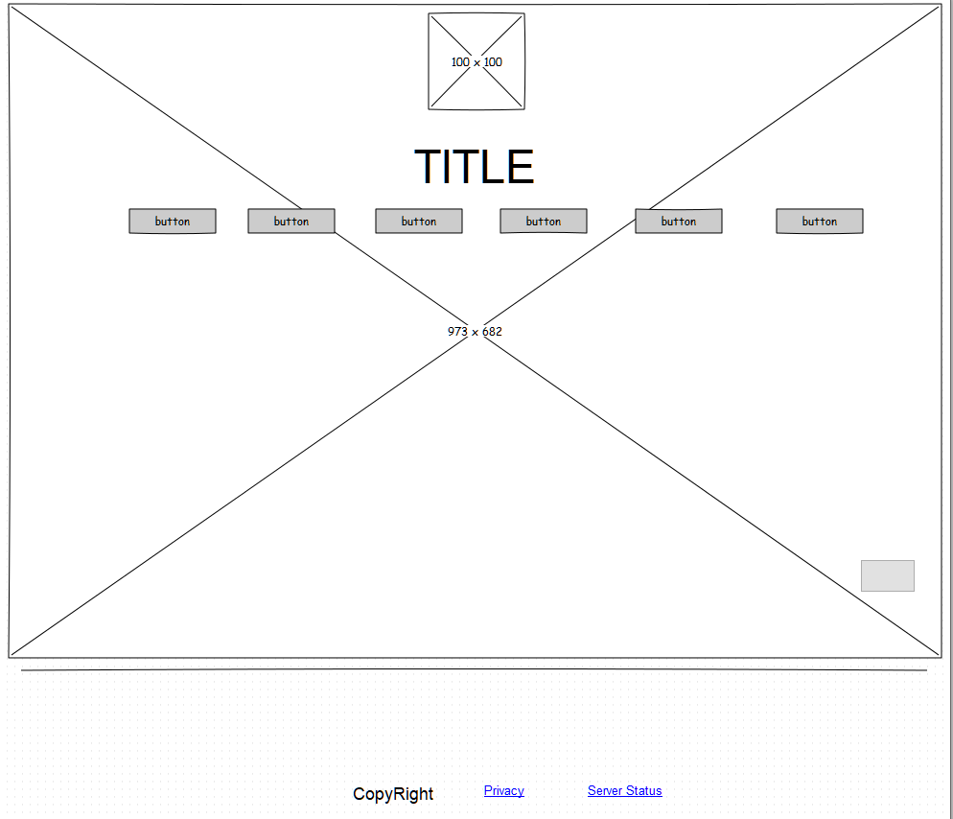

* Indicate exactly where in your website you incorporated the CSS3 requirements. This will make it easier for markers to assess this requirement.
* Contact.html----border-top-left-radius
* Index.html---- .dropdown-content {

box-shadow: 0px 8px 16px 0px rgba(0,0,0,0.2);

border-radius: 10px;

}

* Index.html ---- newsletter----#newsletter .error, #form1 .empty {

-webkit-transition: 0.3s ease-out;

-o-transition: all 0.3s ease-out;

transition: all 0.3s ease-out;

}

* Index.html ----@media
* Include any references in this report.

References

Deutsch, D. (2021). Home | Owl Carousel | 2.3.4. Retrieved 4 December 2021, from https://owlcarousel2.github.io/OwlCarousel2/

GitHub - aFarkas/html5shiv: This script is the defacto way to enable use of HTML5 sectioning elements in legacy Internet Explorer. (2021). Retrieved 4 December 2021, from https://github.com/aFarkas/html5shiv

GitHub - gdsmith/jquery.easing: jQuery Easing Plugin. (2021). Retrieved 4 December 2021, from https://github.com/gdsmith/jquery.easing/

GitHub - sksmatt/UItoTop-jQuery-Plugin: jQuery dynamic UI plugin. (2021). Retrieved 4 December 2021, from https://github.com/sksmatt/UItoTop-jQuery-Plugin

GitHub - status201/jquery-equalheights: Equal heights jQuery Plugin. (2021). Retrieved 4 December 2021, from https://github.com/status201/jquery-equalheights

https://github.com/sargismarkosyan, S. (2021). MobileMenu jQuery plugin. Retrieved 4 December 2021, from https://sargismarkosyan.github.io/MobileMenu/

Index of /group/magiclab/site/js. (2021). Retrieved 4 December 2021, from http://web.stanford.edu/group/magiclab/site/js/

Methvin, D. (2021). jQuery Migrate 1.1.1 Released | Official jQuery Blog. Retrieved 4 December 2021, from https://blog.jquery.com/2013/02/16/jquery-migrate-1-1-1-released/

sform. (2021). Retrieved 4 December 2021, from https://www.npmjs.com/package/sform

Superfish - The jQuery drop-down menu plugin. (2021). Retrieved 4 December 2021, from https://superfish.joelbirch.design/

Anderson, S. (2021, OCTOBER 28TH). What Are The Best Screen Sizes For Responsive Web Design? Retrieved from https://www.hobo-web.co.uk/best-screen-size/