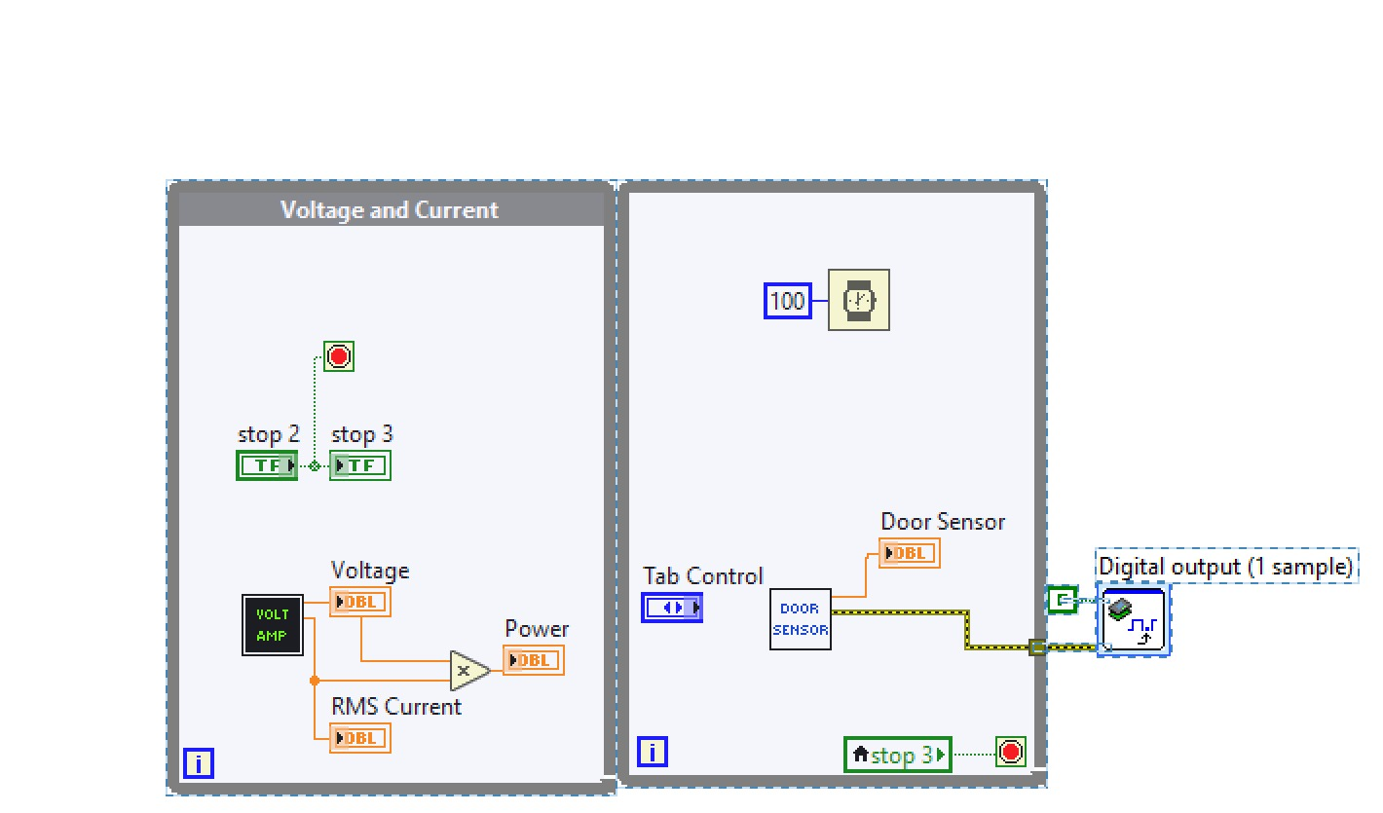

Figure :1

Here in above figure, while loop is used. The function of while loop is to repeats the code within until Boolean “stop 2” button is not pressed. In this while two Boolean are used. One name is “stop 2”, while the other stop 3. When stop 2 control is pressed on front panel, then accordingly voltage and current loop will stop its execution. Stop 3 is just Boolean indicator that is connected to stop 2, so when stop 2 will true, accordingly stop 3 will true and vice versa.

Here one subvi namely VOLT AMP is used, that gives voltage and RMS current value as numeric data. Here numeric indicators namely “Voltage” and “RMS Current” are connected to this subvi. So when this subvi gives numeric data can be displayed here on these indicators. After getting voltage and RMS current data it is multiplied and given the output of it to another numeric indicator namely “Power” to present it on front panel.

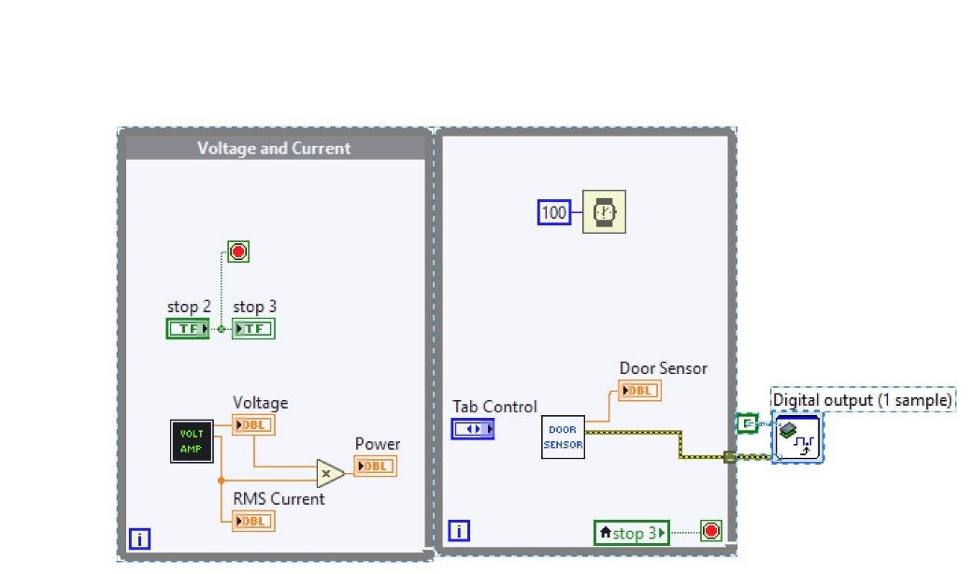

Figure :2

In the above figure, while loop is stopping is controlled from the stop button of voltage and current loop, i.e. from stop 2 button mention in section 1. So when stop 2 of in while loop of figure 1 is pressed it will give true to stop 3, indicator. As in this loop, i.e. figure 2, local variable of stop 3 is used so when stop 3 is true it accordingly will stop this loop also. That simply means from while loop of figure 1 we have controlled another while loop presented in figure 2.

In this loop also timer palette is used, to slow down this loop comparatively to previous one in which no timer is used. This timer Waits the specified number of milliseconds, so here 100 is given as input which means this loop will update its data after each 100 milliseconds. Here one subvi namely DOOR SENSOR is used, that gives sensor value as numeric data. Here numeric indicators namely Door sensor is connected to this subvi so that its numeric data can be displayed here on this indicator.

At the end of while loop Boolean digital output control of myRIO is connected with given “F” as input. So when the while loop will stop then False command will be applied to myRIO digital output pin. Moreover, error line coming from DOOR SENSOR subvi is attached to myRIO palette. So any error occur in subvi will be feed in to myRIO palette and so it will give error message to the user.

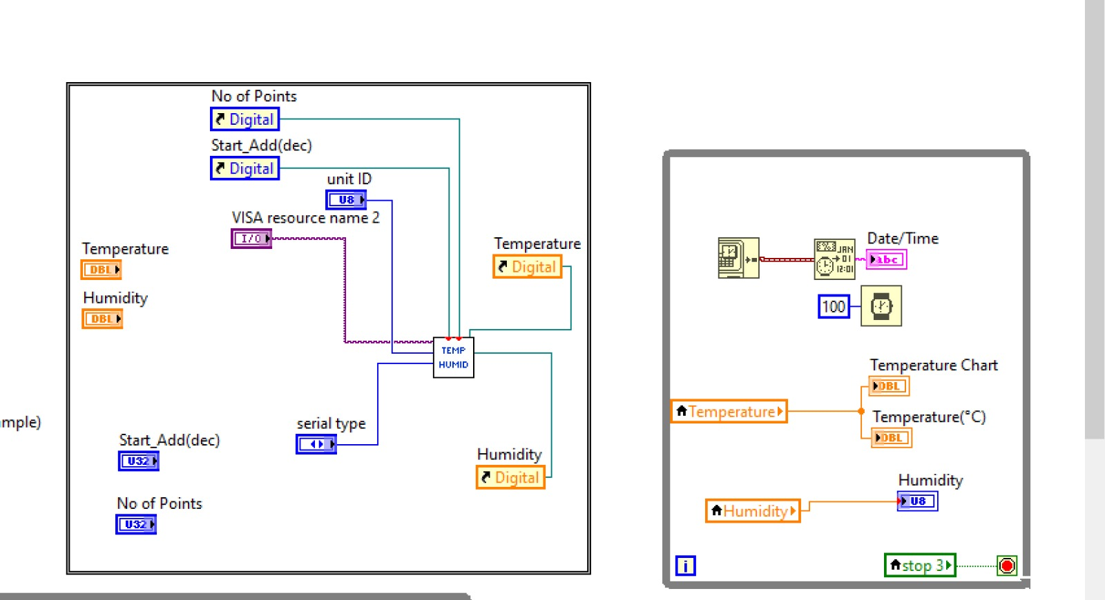

Here one subvi namely TEMP HUMID is placed. This subvi takes some integer inputs like No of Points, star_add(dec), unit ID and serial type. The function of these integer input is that user can input some numeric values into it according to it requirements so that it can be applied to subvi. Moreover, this subvi also takes VISA as input for selecting of COM port. The function of VISA resource is used for connection of hardware on serial/COM port of laptop/computer. The details of VISA will come in section 5. This TEMP HUMID subvi gives temperature and humidity as output in numeric data format that is applied to Temperature and Humidity references. The Temperature and Humidity are double controls in which we can enter real or double data (e.g. 1.1, 2.0001, 5.006 etc.). Moreover, Temperature, Humidity, No of Points and star_add(dec) references are created. The function of references is same as a local variable. Any data placed in these references are also added to its actual control. Here as the requirement of these control was as an indicator. So their references are created and then accordingly connected to subvi namely TEMP HUMID to update the data. These references can be created as below figure.

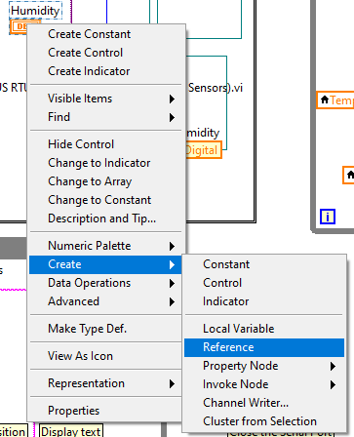



This while loop is controlled from stop 3 button as discussed in previous section. Moreover, this loop is slow down by 100 millisecond delay timer as discussed in previous section. Here temperature local variable put the data into temperature chart and temperature to show it on front panel. Similarly, humidity local variable data is provided to humidity indicator. Here get date/time palette is used to get current date and time of computer in LabVIEW. Than using format date/time string palette this is converted into string format. After getting time and date in string format than it is given to date/time string indicator to present it on front panel.

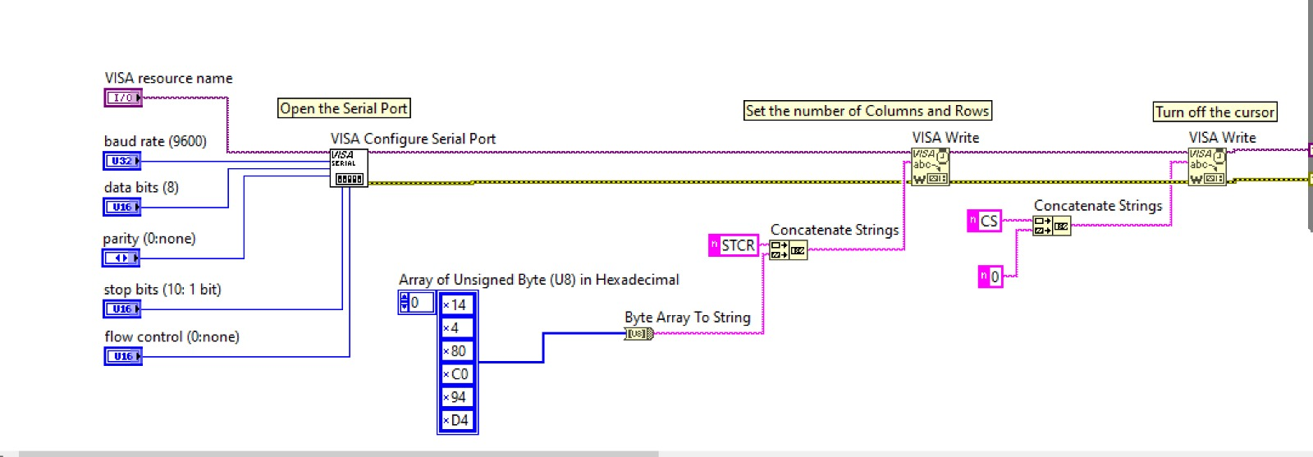

For communication with LCD, VISA resources of LabVIEW is used here. VISA is an NI instrument driver that stand for Virtual Instrument Software Architecture (VISA) I/O standard. VISA is a standard for configuring, and programming systems having serial and other NI systems. Here in VISA resource name control COM port of laptop/computer to which LCD is connected are entered on front panel. Similarly, other parameters of COM port are entered like baud rate, data bits, parity, stop bits and flow control integer controls. After configuring and selecting the COM port it is given to the VISA write palette. This palette write string data to LCD. So for creating string data Array of Unsigned Byte (U8) in Hexadecimal is first created. Then using byte array to string converter it is converted to string format. Now one other string constant is added namely STCR. After having two string these are combine/concatenate, using concatenate string palette. Finally, the output of string concatenate is applied to write palette of VISA. After writing this write function to write to VISA palette, it set the number of columns and rows on LCD screen. Similarly, for turning off the curser of LCD, two string i.e. CS and 0 are concatenated and wrote it to VISA write palette. Moreover, error wire is connected among these palettes so if error came it stop the communication and shows error on front panel of laptop/computer.

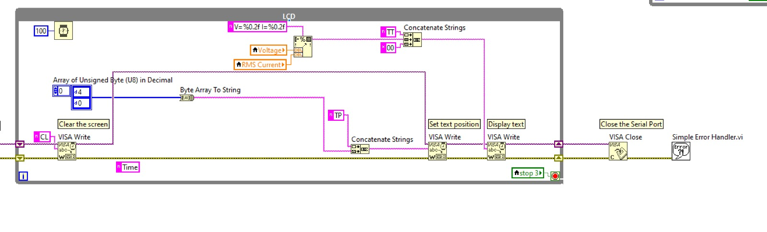

Here same like previous while loops, its stop is controlled by using stop 3 local variable. This while loop is used for writing the voltage and RMS current data to LCD screen. Here first writing CL command to VISA, screen is cleared. In next step byte array of 4 and 0 is created and then converted into string and then concatenated with TP string. This output is applied to VISA Write to set text position on LCD. Using format into string palette numeric data of voltage and RMS current is converted into string. This string is concatenated with TT an 00. Finally, the output of concatenate string is provided to VISA write palette so that voltage and RMS current is displayed on LCD screen. When while loop is stopped, VISA is closed using VISA close palette. If there is any error in reading the serial port, then it is handled using “simple error handler vi”.

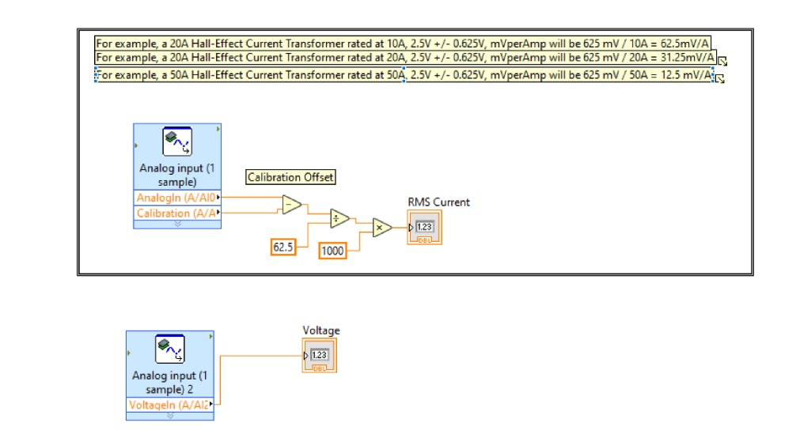

In this part myRIO analoge voltage input is used for finding the RMS current. After getting analog data from sensor on myRIO analog voltage pin AI0 and calibration data, RMS current value is calculated using formula. In this formula calibration offset is found by taking the diffrence of analog voltage pin and calibration data. The output of diffrence is applied is devided by 62.5 according to the formula. Finally it is multplied with 1000 and feeded the numeric data to RMS current indicator for display purpose.



Simalry voltage is messured on another pin of myRIO analoge voltage input (AI2). After getting the voltage it is feeded the numeric indicator namely “Voltage” indicator for display purpose.