Readme – TicketReserve

1. Checkout the project from git by navigating to <https://github.com/xinjteem/ticketReserve>
2. Import the project into eclipse as a Maven project.
3. Build using the goals “clean package” as shown in the screenshot below. 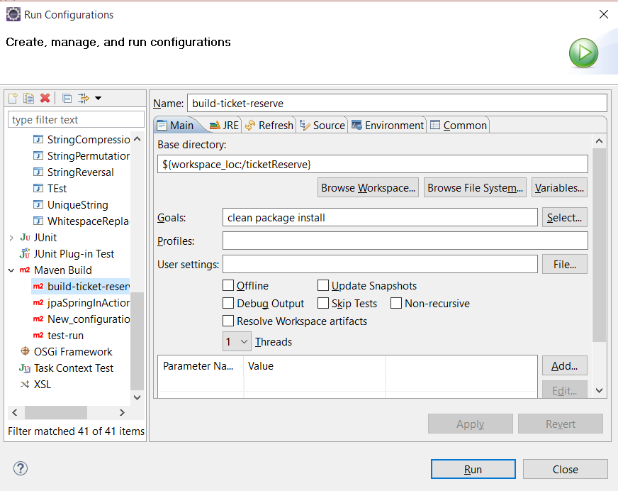
4. This would create a shaded maven jar with all the dependencies packaged within the jar itself. To run the program, simply execute java –jar as shown in the screenshot below. 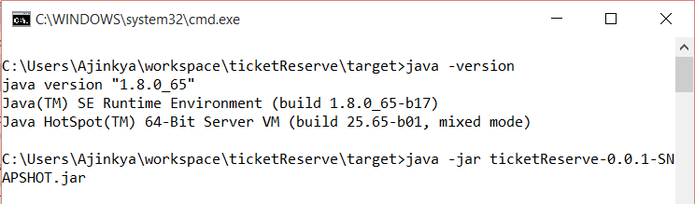

# Running the tests.

1. The functional test case for this project has been created using SoapUI. The same has been adapted to the execution environment using the soapUI maven plugin to automate its execution. The test suite is contained inside the folder functional-test-ticket-reserve.
2. To run the test suite, please add the below plugin repository to your maven settings.xml .

<pluginRepository>

<id>smartbear-sweden-plugin-repository</id>

<url>http://www.soapui.org/repository/maven2/</url>

</pluginRepository>

1. Following that you can import the functional-test-ticket-reserve project in your IDE and run the below goals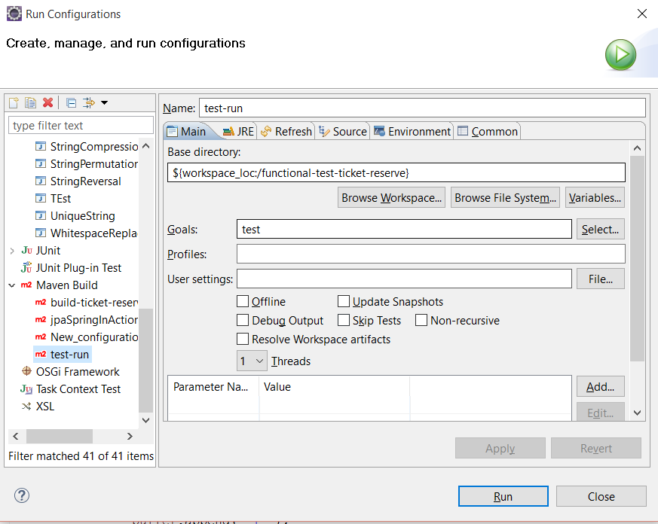
2. Alternatively, you can also run the tests from the command line in the following way. 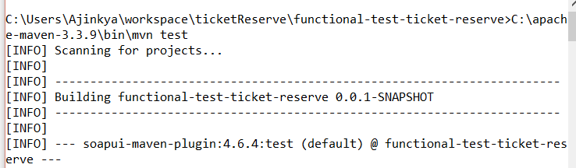
3. In the end you should get a Build Success which indicates that all tests ran and all the associated assertions with the tests passed successfully. 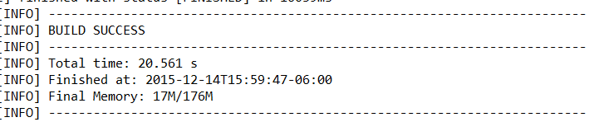
4. To explore the test cases themselves, import the soapui-project.xml file in SoapUI 4.6.4 + .

Note: The test looks for the ticket reserve app to be running and listening on port 8080 on localhost. So please be sure to run the test and the app on the same host and ensure that the app is runnning before running the test. The test also depends on assertions that take into account the number of tickets booked and number of tickets available. Hence once the test run is over, it wont produce similar results in the next run until the ticket reserve app is restarted.