OPENADDRESSES.IO data format/schema

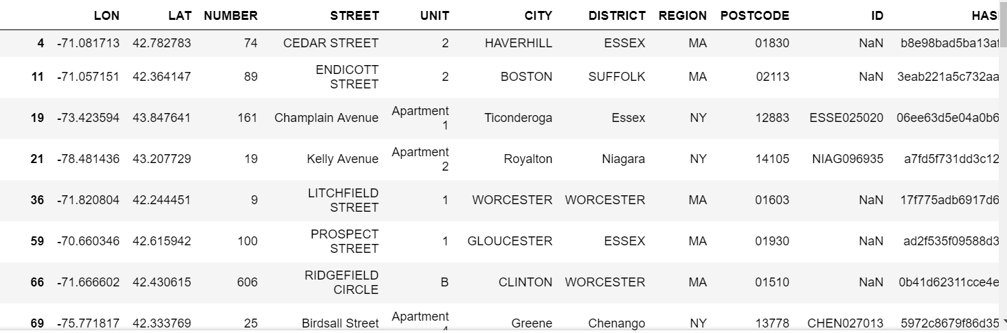

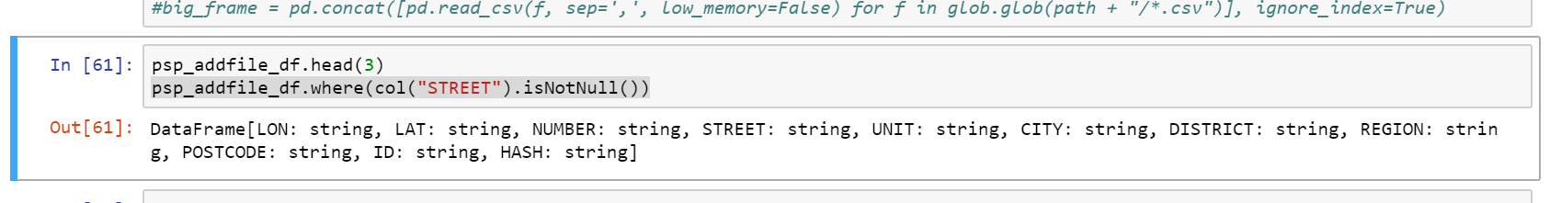

Expected output (see the last column)

