# HBaseXplorer User Guide

Launch HBaseXplorer

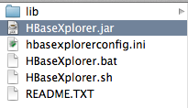

you should download HBaseXplorer.zip from here then unzip

make sure jdk has been installed.

Windows system ,then double click HBaseXplorer.bat

Mac , then double click HBaseXplorer.jar

Linux,double click or run the HBaseXplorer.sh

Features introduction

Click File Menu then add a zookeeper address. HBaseXplorer will connect to HBase when you do that.

Main Form include 3 parts.

Left to right: Table List , Row List, Column Family List, Column Value List

Double click Table list item to load all rows in the table.

Click rows list item to load all column family and column in the row.

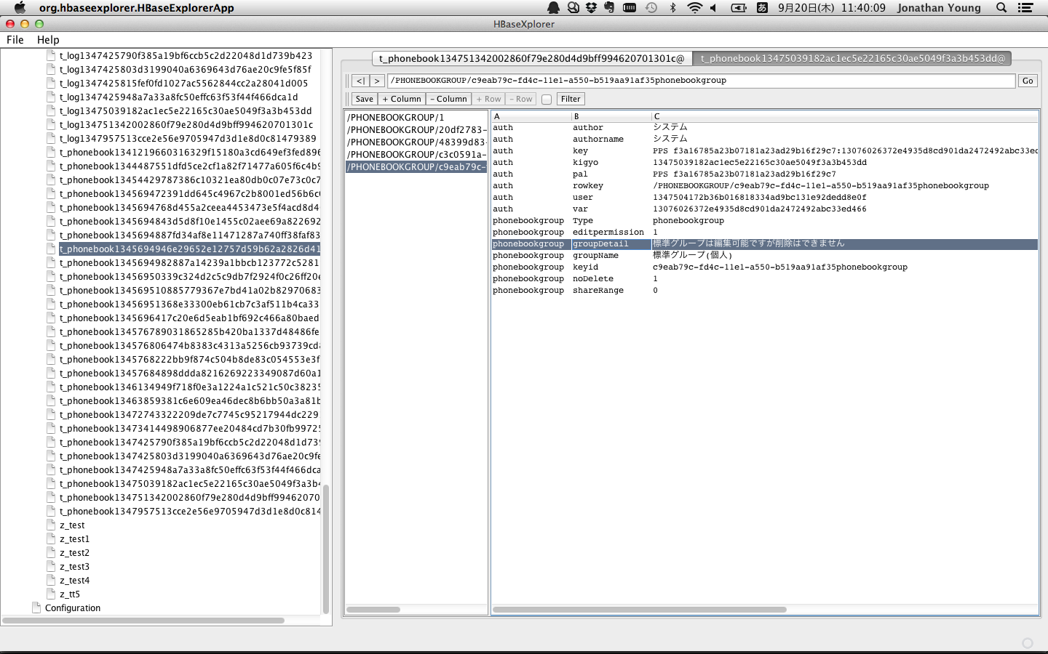

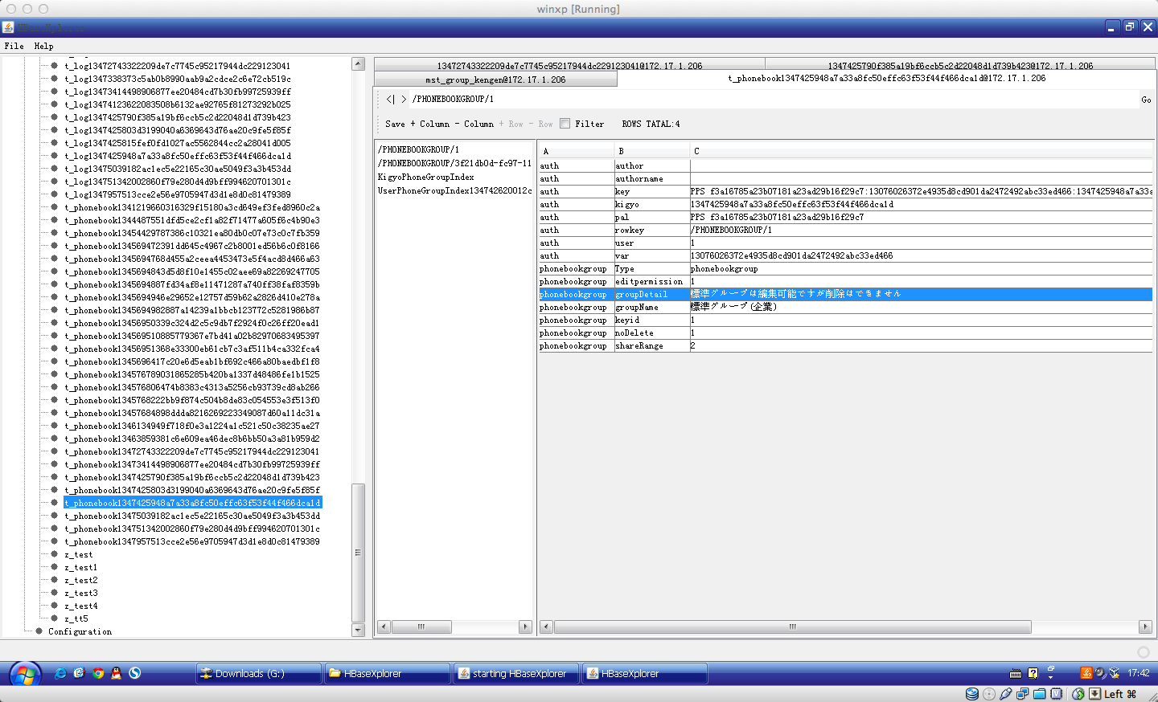

when you want to use filter,then checked the filterbox near filter button.

Select family,input column and value content,select compare operation from combolist. Then filter now.

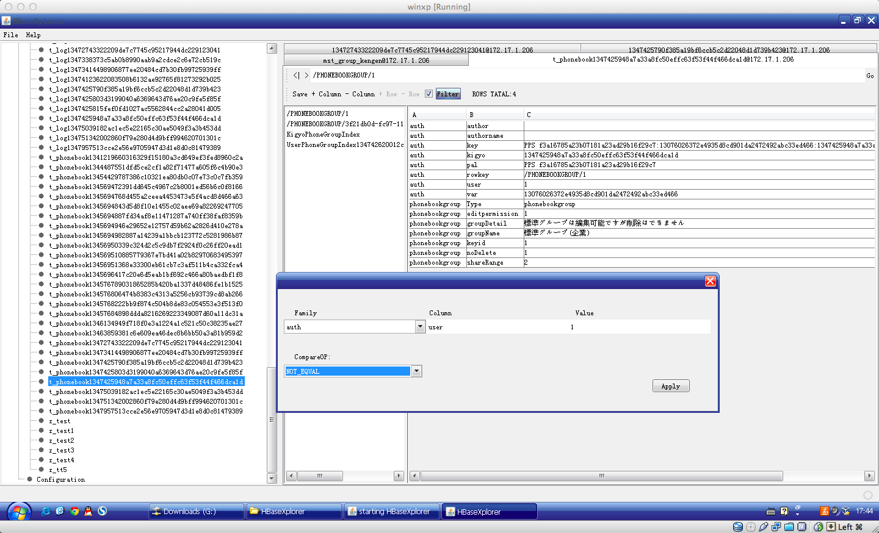

Click +Column to add a column to column family.

Click -Column to remove a column from column family.

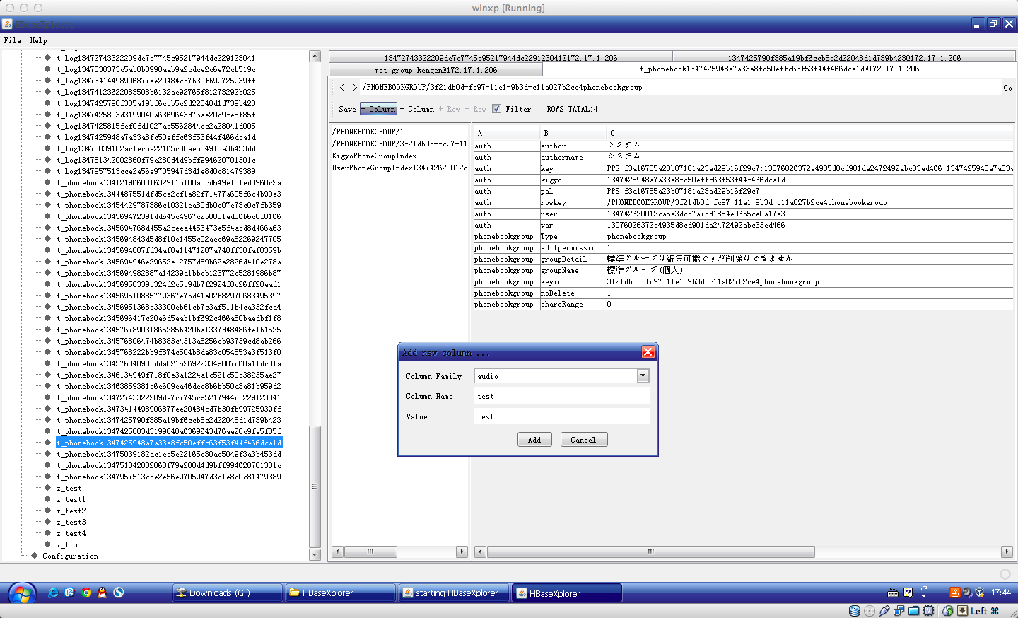

double click value text to edit it , edit ok then click save button to save to hbase.

