This document is a summary of the generalized marginal compatible (GMC) model with a quadratic penalty term ($-λ×ω^{2}$) added to the corresponding log-likelihood function. The EM algorithm has been updated.

Given that the penalty coefficient $λ$ is set to be a small value, i.e., 0.05 (since $λ$ with relatively large magnitude will lead to shrinkage of the exponential tilting parameter $ω$, tried parameter tuning in R already).

We list some combinations of true values for the maximum cluster size univariate marginal probabilities and exponential tilting parameter. The initial values for the marginal probabilities are uniform distributed, and the initial value for the exponential tilting parameter is 0. The following scenarios share the same initial values of parameters.

**(a)** When the maximum cluster size univariate marginal probabilities are subject to binomial distribution ($p=0.5$) and the exponential tilting parameter

> ests = GMC.est(RandomDraws, Rglobal, wTiltInits, qMaxClusInits, penalty = 0.05)

log likelihood before parameter update is: -180.6811

In iteration 1 , the log-likelihood after wTilt but before qMaxClus update is: -180.6798

In iteration 1 , the log-likelihood after both wTilt and qMaxClus updates is: -180.6798

In iteration 2 , the log-likelihood after wTilt but before qMaxClus update is: -180.6798

In iteration 2 , the log-likelihood after both wTilt and qMaxClus updates is: -180.6798

> ests

$qCompleteData

[1] 0.09090909 0.09090909 0.09090909 0.09090909 0.09090909 0.09090909 0.09090909 0.09090909 0.09090909

[10] 0.09090909 0.09090909

$wTiltingParameter

[1] 0.004910825

$Iter

[1] 2

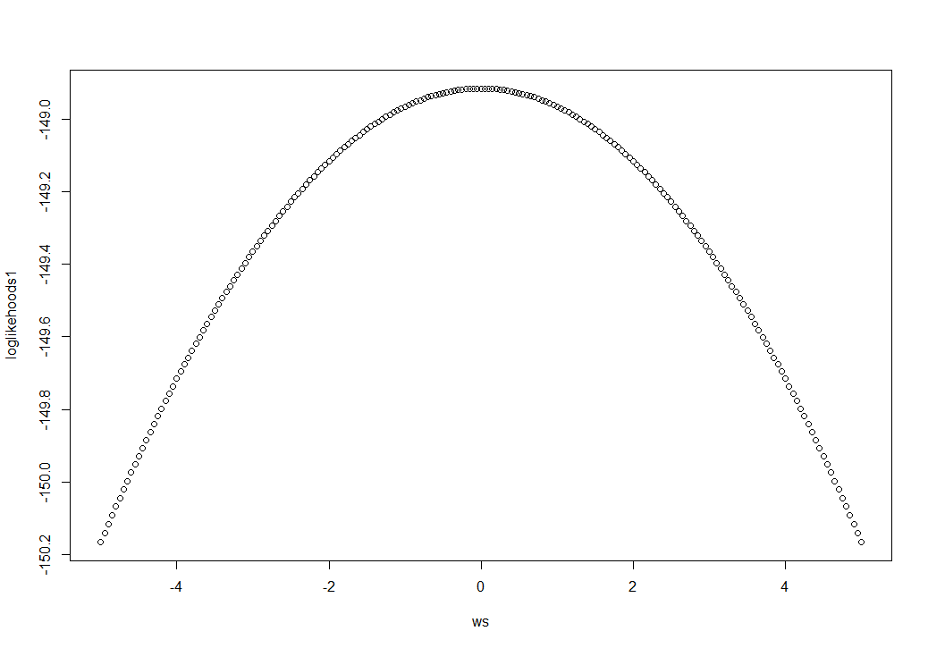

> ws[which.max(loglikehoods1)]

[1] 0

**(b)** When the maximum cluster size univariate marginal probabilities are subject to binomial distribution ($p=0.5$) and the exponential tilting parameter

> ests = GMC.est(RandomDraws, Rglobal, wTiltInits, qMaxClusInits, penalty = 0.05)

log likelihood before parameter update is: -180.6811

In iteration 1 , the log-likelihood after wTilt but before qMaxClus update is: -180.6592

In iteration 1 , the log-likelihood after both wTilt and qMaxClus updates is: -180.6592

In iteration 2 , the log-likelihood after wTilt but before qMaxClus update is: -180.6592

In iteration 2 , the log-likelihood after both wTilt and qMaxClus updates is: -180.6592

> ests

$qCompleteData

[1] 0.09090909 0.09090909 0.09090909 0.09090909 0.09090909 0.09090909

[7] 0.09090909 0.09090909 0.09090909 0.09090909 0.09090909

$wTiltingParameter

[1] -0.02032418

$Iter

[1] 2



> ws[which.max(loglikehoods1)]

[1] 0

**(c)** When the maximum cluster size univariate marginal probabilities are subject to binomial distribution ($p=0.5$) and the exponential tilting parameter

> ests = GMC.est(RandomDraws, Rglobal, wTiltInits, qMaxClusInits, penalty = 0.05)

log likelihood before parameter update is: -180.6811

In iteration 1 , the log-likelihood after wTilt but before qMaxClus update is: -180.5653

In iteration 1 , the log-likelihood after both wTilt and qMaxClus updates is: -180.5653

In iteration 2 , the log-likelihood after wTilt but before qMaxClus update is: -180.5653

In iteration 2 , the log-likelihood after both wTilt and qMaxClus updates is: -180.5653

> ests

$qCompleteData

[1] 0.09090909 0.09090909 0.09090909 0.09090909 0.09090909 0.09090909

[7] 0.09090909 0.09090909 0.09090909 0.09090909 0.09090909

$wTiltingParameter

[1] -0.04675786

$Iter

[1] 2



> ws[which.max(loglikehoods1)]

[1] 0

**(d)** When the maximum cluster size univariate marginal probabilities are subject to binomial distribution ($p=0.5$) and the exponential tilting parameter

> ests = GMC.est(RandomDraws, Rglobal, wTiltInits, qMaxClusInits, penalty = 0.05)

log likelihood before parameter update is: -180.6811

In iteration 1 , the log-likelihood after wTilt but before qMaxClus update is: -180.6592

In iteration 1 , the log-likelihood after both wTilt and qMaxClus updates is: -180.6592

In iteration 2 , the log-likelihood after wTilt but before qMaxClus update is: -180.6592

In iteration 2 , the log-likelihood after both wTilt and qMaxClus updates is: -180.6592

> ests

$qCompleteData

[1] 0.09090909 0.09090909 0.09090909 0.09090909 0.09090909 0.09090909

[7] 0.09090909 0.09090909 0.09090909 0.09090909 0.09090909

$wTiltingParameter

[1] 0.02032418

$Iter

[1] 2



> ws[which.max(loglikehoods1)]

[1] 0

**(e)** When the maximum cluster size univariate marginal probabilities are subject to binomial distribution ($p=0.5$) and the exponential tilting parameter

> ests = GMC.est(RandomDraws, Rglobal, wTiltInits, qMaxClusInits, penalty = 0.05)

log likelihood before parameter update is: -180.6811

In iteration 1 , the log-likelihood after wTilt but before qMaxClus update is: -179.9865

In iteration 1 , the log-likelihood after both wTilt and qMaxClus updates is: -179.9865

In iteration 2 , the log-likelihood after wTilt but before qMaxClus update is: -179.9865

In iteration 2 , the log-likelihood after both wTilt and qMaxClus updates is: -179.9865

> ests

$qCompleteData

[1] 0.09090909 0.09090909 0.09090909 0.09090909 0.09090909 0.09090909

[7] 0.09090909 0.09090909 0.09090909 0.09090909 0.09090909

$wTiltingParameter

[1] 0.1161027

$Iter

[1] 2



> ws[which.max(loglikehoods1)]

[1] 0

**(f)** When the maximum cluster size univariate marginal probabilities are subject to uniform distribution and the exponential tilting parameter

> ests = GMC.est(RandomDraws, Rglobal, wTiltInits, qMaxClusInits, penalty = 0.05)

log likelihood before parameter update is: -180.6811

In iteration 1 , the log-likelihood after wTilt but before qMaxClus update is: -180.1414

In iteration 1 , the log-likelihood after both wTilt and qMaxClus updates is: -180.1414

In iteration 2 , the log-likelihood after wTilt but before qMaxClus update is: -180.1414

In iteration 2 , the log-likelihood after both wTilt and qMaxClus updates is: -180.1414

> ests

$qCompleteData

[1] 0.09090909 0.09090909 0.09090909 0.09090909 0.09090909 0.09090909 0.09090909

[8] 0.09090909 0.09090909 0.09090909 0.09090909

$wTiltingParameter

[1] -0.09519561

$Iter

[1] 2

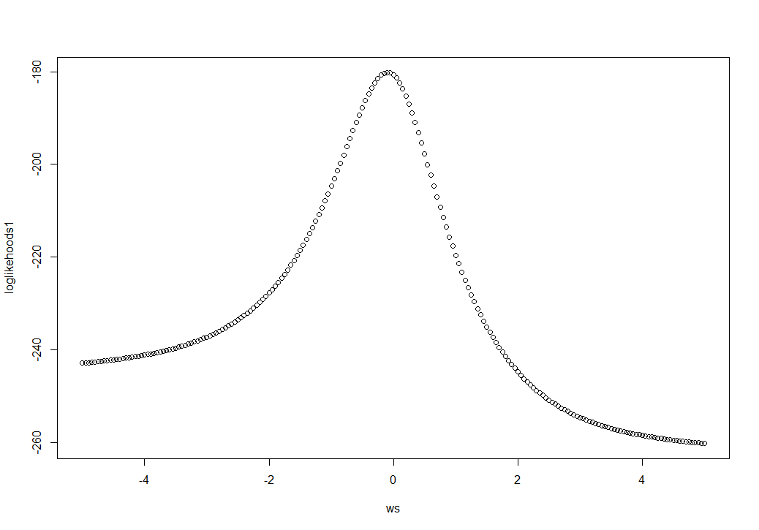

> ws[which.max(loglikehoods1)]

[1] -0.1

**(g)** When the maximum cluster size univariate marginal probabilities are subject to uniform distribution and the exponential tilting parameter

> ests = GMC.est(RandomDraws, Rglobal, wTiltInits, qMaxClusInits, penalty = 0.05)

log likelihood before parameter update is: -180.6811

In iteration 1 , the log-likelihood after wTilt but before qMaxClus update is: -154.2934

In iteration 1 , the log-likelihood after both wTilt and qMaxClus updates is: -154.2934

In iteration 2 , the log-likelihood after wTilt but before qMaxClus update is: -154.2934

In iteration 2 , the log-likelihood after both wTilt and qMaxClus updates is: -154.2934

> ests

$qCompleteData

[1] 0.09090909 0.09090909 0.09090909 0.09090909 0.09090909 0.09090909 0.09090909

[8] 0.09090909 0.09090909 0.09090909 0.09090909

$wTiltingParameter

[1] 1.200603

$Iter

[1] 2

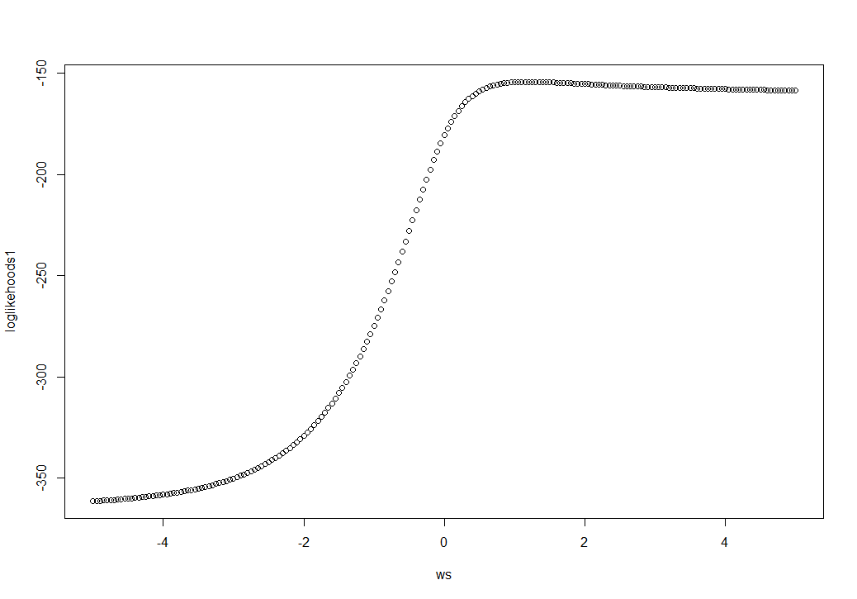

> ws[which.max(loglikehoods1)]

[1] 1.2

**(h)** When the maximum cluster size univariate marginal probabilities are subject to uniform distribution and the exponential tilting parameter

> ests = GMC.est(RandomDraws, Rglobal, wTiltInits, qMaxClusInits, penalty = 0.05)

log likelihood before parameter update is: -180.6811

In iteration 1 , the log-likelihood after wTilt but before qMaxClus update is: -133.9865

In iteration 1 , the log-likelihood after both wTilt and qMaxClus updates is: -133.9865

In iteration 2 , the log-likelihood after wTilt but before qMaxClus update is: -133.9865

In iteration 2 , the log-likelihood after both wTilt and qMaxClus updates is: -133.9865

> ests

$qCompleteData

[1] 0.09090909 0.09090909 0.09090909 0.09090909 0.09090909 0.09090909 0.09090909

[8] 0.09090909 0.09090909 0.09090909 0.09090909

$wTiltingParameter

[1] 3.02654

$Iter

[1] 2

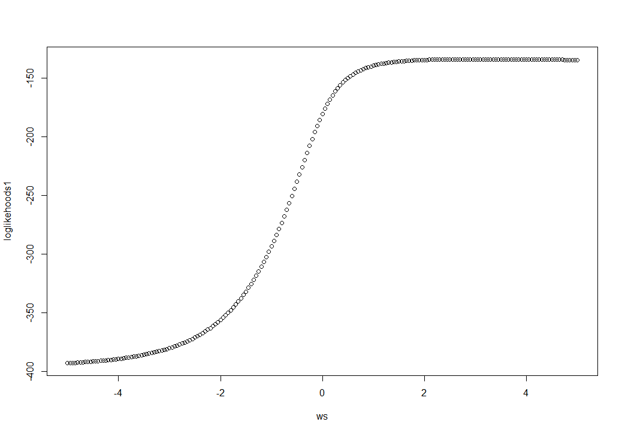

> ws[which.max(loglikehoods1)]

[1] 3.05

**(i)** When the maximum cluster size univariate marginal probabilities are subject to uniform distribution and the exponential tilting parameter

> ests = GMC.est(RandomDraws, Rglobal, wTiltInits, qMaxClusInits, penalty = 0.05)

log likelihood before parameter update is: -180.6811

In iteration 1 , the log-likelihood after wTilt but before qMaxClus update is: -154.2934

In iteration 1 , the log-likelihood after both wTilt and qMaxClus updates is: -154.2934

In iteration 2 , the log-likelihood after wTilt but before qMaxClus update is: -154.2934

In iteration 2 , the log-likelihood after both wTilt and qMaxClus updates is: -154.2934

> ests

$qCompleteData

[1] 0.09090909 0.09090909 0.09090909 0.09090909 0.09090909 0.09090909 0.09090909

[8] 0.09090909 0.09090909 0.09090909 0.09090909

$wTiltingParameter

[1] -1.200603

$Iter

[1] 2

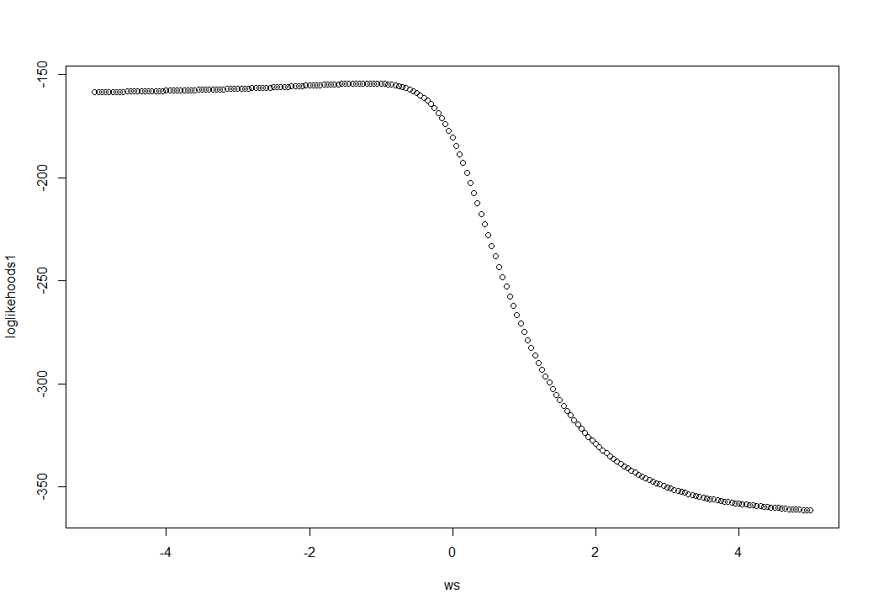

> ws[which.max(loglikehoods1)]

[1] -1.2

**(j)** When the maximum cluster size univariate marginal probabilities are subject to uniform distribution and the exponential tilting parameter

> ests = GMC.est(RandomDraws, Rglobal, wTiltInits, qMaxClusInits, penalty = 0.05)

log likelihood before parameter update is: -180.6811

In iteration 1 , the log-likelihood after wTilt but before qMaxClus update is: -133.9865

In iteration 1 , the log-likelihood after both wTilt and qMaxClus updates is: -133.9865

In iteration 2 , the log-likelihood after wTilt but before qMaxClus update is: -133.9865

In iteration 2 , the log-likelihood after both wTilt and qMaxClus updates is: -133.9865

> ests

$qCompleteData

[1] 0.09090909 0.09090909 0.09090909 0.09090909 0.09090909 0.09090909 0.09090909

[8] 0.09090909 0.09090909 0.09090909 0.09090909

$wTiltingParameter

[1] -3.026539

$Iter

[1] 2

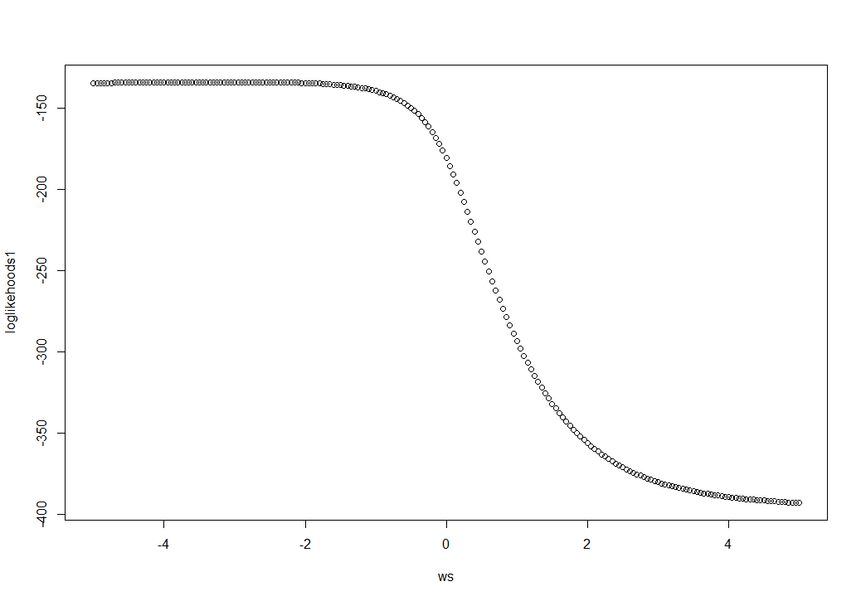

> ws[which.max(loglikehoods1)]

[1] -3.05