From quantity to composition: Income growth and the structure of food demand across Chinese provinces
[Author names, affiliations, and correspondence to be added]
Keywords: food demand; nutrition transition; income elasticity; demand systems; feed grain; China
JEL classification: D12, O12, Q11, Q18

Abstract
The nutritional transition in China has increasingly become a question of food composition rather than aggregate calorie availability. Using a newly constructed panel of 31 Chinese provinces for the period 2015–2024 (accounting for a total of 310 province-year observations), this paper estimates a saturated modified implicitly directly additive demand system (MAIDADS) for six food categories, alongside the other/non-covered residual, with quantities expressed in daily 2,000-kcal accounting units. The preferred specification uses real per capita gross domestic product (GDP) as the budget variable, separates pork from non-pork meat and aquatic products, and expresses the policy-node income axis in World Bank constant 2015 US dollars. At the mean real per capita GDP, staples are significantly income negative (elasticity −0.405), oils are negative but imprecisely estimated (−0.222), and vegetables and fruits (0.390), pork (0.317), non-pork meat and aquatic products (0.153), and dairy and eggs (0.568) remain positive. At GDP nodes ranging from US$15,000 to US$30,000 in constant 2015 dollars, the main margin is dietary recomposition: animal-source elasticities decrease but remain positive, covered energy is near saturation, and protein and fat responses are positive but increasingly imprecise. Conditional feed-grain-equivalent accounting indicates that projected animal-product demand remains a major pressure point, with 2050 feed-grain equivalents accounting for a total of approximately 393 million tons, which are dominated by pork.

1. Introduction
China's food security problem has changed its unit of account. For decades, the central policy concern was whether the country could produce or procure sufficient calories, and grain self-sufficiency was the natural language in which that concern was expressed. As living standards have increased, this question has not disappeared, but it has become less complete. The more difficult question is now compositional: which foods continue to expand with income, which have begun to saturate, and how does the shift from direct staple consumption toward more diverse and animal-source foods reshape the demand for feed grain, land, cold chains, and imports (Fukase & Martin, 2016; Gale & Huang, 2007)?
This shift is evident in China before any model is estimated. Provinces no longer appear to progress along a single path of uniformly increasing food quantities. In lower-income regions, additional income may still offer broader access to several foods; in richer regions, direct consumption of some calorie-dense staples and oils has already flattened or moved downward, whereas vegetables and fruits, pork, non-pork meat and aquatic products, and dairy and eggs remain the margins along which diet quality and variety change. A given increase in income therefore has different meanings at different points in the provincial income distribution. Mean elasticities are useful summaries, but they can conceal the policy-relevant fact that the same food group may be income positive in one part of the transition but close to zero or income negative in another part.
The issue at hand is not merely statistical. Food security planning, nutrition policy, and agricultural supply chain investment all depend on the shape of these Engel relationships. If increasing incomes primarily increase total food calories, then aggregate calorie availability remains the appropriate planning object. If, instead, income growth reallocates consumption across foods while covered energy approaches saturation, then the policy problem becomes one of composition: the balance between food grain and feed grain, the relative importance of pork versus other animal products, the roles played by vegetables, fruits, dairy, and eggs in diet upgrading, and the infrastructure needed to support higher-value perishable foods. China's current transition is therefore best understood not as a simple continuation of past quantity growth but rather as a movement from scarcity-oriented food security toward a system in which quality, diversity, and feed-resource implications become central.
A large stream of literature has documented various elements of this transformation. Demand studies that have been conducted in China on the basis of household surveys, provincial data, and flexible demand systems have reported decreasing grain dependence and increasing demand for animal products, aquatic products, fruit, dairy, and food away from home (Fan et al., 1995; Gould & Villarreal, 2006; Zheng & Henneberry, 2009; Zhou et al., 2015). More recent studies have highlighted heterogeneity by income class, urban–rural status, migration status, and quality upgrading (Chen et al., 2016; Han & Chen, 2016; Hovhannisyan et al., 2019; Li et al., 2021; Ren et al., 2018; Wang et al., 2024). These studies have established the direction of change and revealed that elasticities are not constant across households or products. A topic that is less well measured lies in the continuous income profile itself: how elasticities evolve as provinces move through successive income levels and where policy-relevant thresholds—such as US$15,000, US$20,000, US$25,000, and US$30,000 per person in constant 2015 dollars—place China on that profile.
This same modeling problem has been identified in the global nutrition-transition literature. Gouel and Guimbard (2019) argued that qualitative regularities are well known—diets diversify away from starchy staples, animal-source foods expand, and calorie demand eventually saturates—but that long-term food-demand analysis requires a transparent way to quantify these regularities over the income distribution. The modified implicitly directly additive demand system (MAIDADS) is designed for this task. By allowing both marginal budget shares and subsistence quantities to vary with utility, MAIDADS can represent Engel curves that rise, flatten, and, for some goods, turn downward. This approach therefore permits income elasticities to be estimated as a continuous function of income rather than as a single average or a small set of discrete group estimates.
In this paper, that income-flexible framework is applied to a single large country. We estimate saturated AIDADS and MAIDADS systems by reference to a panel of 31 Chinese provinces for the period from 2015–2024, in which context the preferred specification uses real per capita gross domestic product (GDP) as the budget variable. Food quantities are converted into daily 2,000-kcal accounting units; covered categories are separated into grain, oils and fats, vegetables and fruits, pork, non-pork meat and aquatic products, and dairy and eggs; and the income axis for policy node interpretation is expressed in constant 2015 US dollars using the World Bank WDI conversion factors. Because the covered categories do not exhaust total diets, the results are interpreted as outcomes pertaining to covered food demand and nutrient accounting rather than as complete dietary intake forecasts.
The contributions of this research are threefold. First, the paper provides continuous GDP elasticity profiles for covered food categories in China and reports elasticities with bootstrap-based p values at the four GDP milestones listed above. This approach transforms the idea of a nutrition transition into an estimable schedule that can be read along the income axis. Second, the analysis employs a global income-flexible demand framework to a subnational panel, thereby holding the national statistical environment broadly fixed while exploiting cross-province income differences and within-province growth. Third, by separating pork from non-pork meat and aquatic products, the paper connects consumer demand to a feed-grain-equivalent account in which the composition of animal products (not only their aggregate quantity) is relevant.
The results tell a coherent story. With respect to the mean real per capita GDP, grain is significantly income negative; oils are negative but imprecisely estimated; and vegetables and fruits, pork, non-pork meat and aquatic products, and dairy and eggs remain income positive. Along the US$15,000–US$30,000 constant-2015-dollar income range, the same pattern persists, albeit with decreasing magnitude: covered energy is near saturation, animal-source energy remains positive, and the growth margin shifts from direct calorie provision toward quality, variety, and animal-source composition. The income-flexible MAIDADS system improves fit and out-of-sample prediction relative to AIDADS, but province-block bootstrap evidence leads us to treat this system as the preferred organizing framework rather than as a model that is selected decisively by a standard likelihood-ratio reference distribution. The feed-grain account then translates this compositional transition into a policy margin: projected animal-product demand continues to imply the existence of a large feed-grain-equivalent requirement dominated by pork.
The remainder of the paper is organized as follows. Section 2 presents the empirical model, estimation strategy, inference, and validation design. Section 3 describes the provincial data, calorie-standardized quantities, price construction, GDP conversion, and scenario inputs. Section 4 reports the results of the estimation, elasticity profiles, including policy-node elasticities and diagnostic price responses. Section 5 concludes by outlining policy recommendations, limitations, and directions for future work in this field.

2. Empirical model and estimation

2.1. Income-flexible MAIDADS demand
Following the suggestions of Gouel and Guimbard (2019), the demand system is chosen for the object of the paper rather than for short-term price‒policy simulation. The question is how food quantities change as income increases over a wide range and as some groups approach saturation. MAIDADS is appropriate for this task because it is nonhomothetic, globally regular for income levels above the cost of a minimum bundle, and flexible in income through both marginal budget shares and subsistence quantities.
Let c index a province-year observation and i = 1,...,I index goods. In the preferred specification, I = 7: six covered food groups plus the other/non-covered residual. The fitted demand for good i is
xhat_ci = γ_i(u_c) + [ϕ_i(u_c)/p_ci] [m_c - ∑_j p_cj γ_j(u_c)]. (1)
Here, m_c is real per capita GDP, p_ci is the price of good i, and u_c is the latent utility level. The first term, i.e., γ_i(u_c), is a utility-dependent subsistence quantity. The second term allocates discretionary expenditure—total expenditure net of the cost of the subsistence bundle—according to the utility-dependent marginal budget share ϕ_i(u_c).
The two utility-dependent functions are parameterized as follows:
ϕ_i(u) = [α_i + β_i exp(u)]/[1 + exp(u)], γ_i(u) = [δ_i + τ_i exp(ωu)]/[1 + exp(ωu)]. (2)
The restrictions are ∑_i α_i = ∑_i β_i = 1, 0 ≤ α_i, β_i ≤ 1, δ_i ≥ 0, τ_i ≥ 0, and ω ≥ 0. The parameters α_i and β_i are the limiting marginal budget shares at low and high utility, respectively. The parameters δ_i and τ_i are the corresponding limiting subsistence quantities, and ω governs the speed at which the subsistence requirements shift between the two limits. AIDADS is the restriction δ_i = τ_i for all goods, thus ensuring that subsistence quantities do not vary with utility; the linear expenditure system is the further restriction α_i = β_i.
Utility is defined implicitly by
∑_i ϕ_i(u_c) ln[xhat_ci - γ_i(u_c)] - u_c - κ = 0, (3)
which is solved numerically for each observation and each trial parameter vector. This implicit representation is useful because it generates a complete demand system: adding-up is built into the budget allocation, and the resulting income and price elasticities can be checked for adding-up, homogeneity, Hicksian homogeneity, and Slutsky symmetry after estimation.

2.2. Saturation and continuous GDP elasticity profiles
The empirical specification imposes the saturated MAIDADS restriction used for long-term food-demand analysis: β_i = 0 for the six covered food groups and β_i = 1 for the residual. As utility increases without bound, the marginal budget share of each covered food group therefore approaches zero. This restriction does not imply that diets stop changing. Rather, it indicates that the demand for covered food cannot increase without bound as GDP increases, which is necessary when the model is used to interpret high-income provinces and to construct long-term scenarios.
The saturation restriction is also the reason the model is particularly informative about the central question of this paper. If a food group remains in the rising segment of its Engel curve, the local GDP elasticity is positive. If it is near saturation, the elasticity approaches zero. If income growth mainly substitutes away from that group toward other covered or uncovered categories, the elasticity can become negative. The empirical object is therefore the continuous function η_i(m) = ∂ ln x_i/∂ ln m, i.e., not only its value at a sample mean.
GDP elasticities are computed on the basis of the same prediction function used in the estimation process by central differences in m, holding the vector of 2023 mean prices fixed. To facilitate interpretation of the policy, the continuous curve is evaluated at 15,000, 20,000, 25,000, and 30,000 constant 2015 US dollars per person. The process of mapping between model income and constant-dollar GDP follows the World Bank WDI conversion that is described in Section 3: provincial nominal GDP is converted to constant 2015 US dollars with the China-level annual ratio of constant 2015 US dollar GDP per capita to current-local-currency GDP per capita, and model curves use the sample mean conversion factor.
The elasticity values for covered dietary energy and macronutrients account for elasticities. They weight group-level quantity responses by fixed food-composition coefficients for energy, protein, fat, and carbohydrate within the modeled categories. They are useful for interpreting the direction of dietary recomposition, but they are not estimates of complete dietary intake because food away from home, sugar, pulses, nuts, and several other categories remain in the residual.
MAIDADS is less price-flexible than QUAIDS or EASI are because price responses are functions of budget shares and income elasticities rather than independent substitution parameters. This limitation is acceptable in this research because our main question pertains to income-driven transition profiles. We therefore treat own-price elasticities as diagnostic checks and reserve strong policy interpretation for the GDP-elasticity results.

2.3. Likelihood, inference, and validation
The stochastic specification follows the estimation tradition for implicitly additive systems. Measurement errors are placed on quantities rather than on budget shares:
x_ci = xhat_ci(θ) + ε_ci. (4)
The disturbance vector ε_c is assumed to be mean zero and multivariate normal with covariance matrix Σ across goods. Observations are treated as independent in the concentrated likelihood, whereas the inference later relaxes this assumption by resampling provinces as blocks. Writing W(θ) = N^{-1}∑_c ε_c(θ)ε_c(θ)' for the fitted residual covariance matrix, the concentrated log likelihood is
ln L(θ) = -N/2 { I[1 + ln(2π)] + ln|W(θ)| }. (5)
For each trial θ, the utility equation (3) is solved observation by observation, the predicted quantities are formed on the basis of equation (1), the residuals are computed, and the likelihood indicated in equation (5) is evaluated. The estimation proceeds in stages. AIDADS is estimated first on the basis of stable starting values by reference to observed budget shares and small fractions of minimum observed quantities. The AIDADS solution then initializes the saturated MAIDADS, in which context additional perturbed starting values are used to reduce the risk of selecting a local optimum.
All reported uncertainty measures are based on a province-block bootstrap. Each bootstrap draw involves resampling provinces with replacement and maintains the full 2015–2024 time path for each sampled province, thereby preserving within-province serial dependence and shared measurement features. The main elasticity and parameter inference uses 450 valid province-block draws. For a two-sided p value on a local elasticity, we use the bootstrap sign distribution; if no successful draw crosses zero, the value is reported as p < 0.002.
The comparison between MAIDADS and AIDADS is nonstandard because the MAIDADS speed parameter is unidentified under the AIDADS null. The ordinary chi-square likelihood-ratio reference distribution is therefore not used. Instead, we report the observed likelihood gain alongside a province-block LR bootstrap tail probability. Predictive relevance is evaluated separately through out-of-sample validation, thereby estimating both systems in earlier years and predicting held-out years.

3. Data
We draw on official provincial household survey statistics regarding per capita food consumption quantities and prices, provincial consumer price indices, a national non-food CPI, a Chinese food composition table, a provincial resident population series, and the provincial SSP2 population projections developed by Chen et al. (2020). These sources are not available in model-ready form; thus, each variable is constructed on the basis of the underlying accounting identities described below.

3.1. Provincial panel and food grouping
The estimation sample contains 310 province-year observations that cover all 31 mainland provinces for the period from 2015–2024. The preferred specification distinguishes among six covered food categories—staples; oils and fats; vegetables and fruits; pork; non-pork meat and aquatic products; and dairy and eggs—in addition to the other/non-covered residual. The non-pork meat/aquatic category consists of beef, mutton, poultry, and aquatic products. The separation of pork is essential for both demand interpretation and feed-grain accounting because pork is the dominant feed channel, and its income response differs from those of the remaining animal and aquatic products.
The six covered food categories are those for which provincial quantity and price statistics are consistently published. Sugars, pulses, nuts, food away from home, and several other categories cannot be modeled separately at the provincial level. The residual is therefore not a pure non-food good: it contains uncovered food categories, food away from home, alcohol and tobacco, and genuine non-food expenditure. We consequently interpret only covered-food quantities and feed-grain-equivalent accounting rather than total dietary energy or macronutrient intake.

3.2. Calorie-standardized quantities and prices
In line with the global nutrition-transition literature, food quantities enter the system as daily 2,000-kcal accounting units. Purchased quantities in kilograms are converted to calories on the basis of a Chinese food-composition table; reported energy densities are multiplied by edible shares, and missing or zero energy values are reconstructed on the basis of macronutrients at 4 kcal per gram of protein and carbohydrate and 9 kcal per gram of fat. For covered food group g in province c and year t, the model quantity is
x_gct = annual kcal_gct/(365 × 2,000). (6)
where x_gct = 1 corresponds to one full 2,000-kcal daily diet supplied by group g. The price of each covered group is constructed in such a manner that the price times the model quantity reproduces the real annual expenditure on the group:
p_gct = real expenditure_gct/x_gct. (7)
This construction guarantees internal consistency among quantities, prices, and budget shares, but p_gct is a unit value and may embed quality variation as well as pure price variation (Deaton, 1988). The monetary variables are expressed in 2023 real prices. In the preferred specification, the model budget is real per capita GDP, m = pgdp/monetary_deflator. Covered food prices are deflated by the provincial food CPI; furthermore, the residual price is measured by the national non-food CPI in the main specification and by a derived provincial non-food CPI in the robustness specification.

3.3. Scenario inputs and descriptive patterns
The projection-year population is obtained from provincial SSP2 middle-of-the-road paths and converted to the population units used in the pipeline. The preferred specification uses real per capita GDP directly as the budget variable, m = pgdp/monetary_deflator, fixes prices at mean 2023 values for policy-node calculations, and reports food quantities, covered energy, and macronutrient accounting elasticities for the modeled categories. To express the income axis in internationally comparable terms, the revised figures and GDP-node tables use the World Bank WDI China series for GDP per capita in current LCU and constant 2015 US dollars. For each year, the conversion factor is ratio_t = constant-2015-US$ GDP per capita/current-LCU GDP per capita; provincial nominal per capita GDP is then converted as gdp_2015usd = pgdp_nominal × ratio_t. In the sample, gdp_2015usd/m features a mean of 0.137515 and a standard deviation of 0.0024; thus, the model curves use K = 0.137515 to map m onto constant 2015 US dollars, whereas the observed provincial points use year-specific WDI ratios. The resulting provincial GDP distribution extends across the approximate range of US$4,000–US$25,400 in constant 2015 dollars, with a median of approximately US$8,000. Because the provincial food categories are incomplete relative to the full diet, all nutrient results are interpreted as covered food accounting outcomes rather than total dietary intake projections.
Table 1. Descriptive statistics of the split-pork provincial panel, 2015–2024.
Variable | Value | Unit/interpretation
Real per capita GDP budget m | 68,076.0 (30,754.4) | yuan/person/year, 2023 prices
Per capita GDP, constant 2015 US$ | 9,361 (4,229); median 7,991 | World Bank WDI conversion
Constant 2015 US$ range | 4,031-25,418 | in–min–max across province-years
Real per capita consumption expenditure | 20,783.7 (7,227.4) | reported only for the sake of comparison
Covered-food expenditure | 2,384.2 (395.4) | yuan/person/year, covered categories
Other/non-covered residual | 65,691.8 (30,721.1) | m minus covered-food expenditure
Staples | 0.4123 | daily 2,000-kcal units
Oils and fats | 0.1273 | daily 2,000-kcal units
Vegetables and fruits | 0.0516 | daily 2,000-kcal units
Pork | 0.1059 | daily 2,000-kcal units
Non-pork meat/aquatic | 0.0413 | daily 2,000-kcal units
Dairy and eggs | 0.0300 | daily 2,000-kcal units
Observations | 310 | 31 provinces x 10 years
Note: The unit of observation is the province-year. The values are obtained from the estimated panel and fit summaries. Covered categories are measured in daily 2,000-kcal units; m is measured in 2023 yuan. The constant 2015 U.S. dollar row uses the World Bank WDI conversion described in Section 3.3.
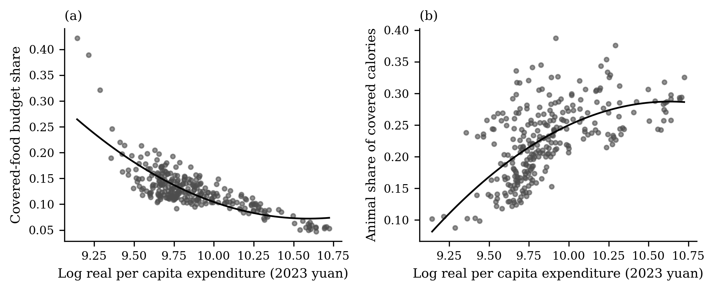
Fig. 1. Engel patterns in the raw provincial panel.
Note: The downward-sloping covered-food budget share and the upward-sloping animal calorie share motivate an income-flexible demand system.

4. Estimation and results
We start by discussing the results of the estimation and their interpretation. We then use the estimated system to trace how the provincial diet changes with income and to locate the 2015–2024 observations on that transition path. The final subsections translate the elasticity profiles into policy-relevant GDP milestones, connect the elasticities to the GDP-driven quantity scenario, compare the estimates with evidence pertaining specifically to China, report price responses as diagnostics, and translate the animal-product component into feed-grain-equivalent demand. The tables, fitted curves, elasticities, and scenario accounts are therefore read jointly rather than as separate pieces of evidence: all of these data represent different views of the same nonhomothetic demand system.

4.1. Estimation results, model selection, and fit
Table 2 summarizes the performance of saturated AIDADS and saturated MAIDADS under the baseline national non-food CPI residual-price specification and the robustness specification on the basis of a derived provincial non-food CPI. Because the residual-price construction changes the scale of the residual quantity, model comparisons are made within (rather than across) residual-price specifications.
This table reports the concentrated likelihood measures, information criteria, in-sample mean food relative RMSE, and out-of-sample RMSE. The out-of-sample exercises estimate each model on the basis of earlier years and evaluate predictions for held-out years; thus, they provide a direct check on the forecast-oriented use of the demand system.
Table 2. Model fit and out-of-sample performance.
Residual-price specification | Model | NLL | AIC | BIC | Mean food relative RMSE | OOS RMSE: 2021-23/2023
National non-food CPI | AIDADS | -4248 | -8469 | -8416 | 0.3091 | 0.03331/0.03402
National non-food CPI | MAIDADS | -4482 | -8919 | -8837 | 0.2738 | 0.03331/0.03358
Derived provincial non-food CPI | AIDADS | -4374 | -8721 | -8668 | 0.2848 | 0.03321/0.03365
Derived provincial non-food CPI | MAIDADS | -4477 | -8910 | -8828 | 0.2716 | 0.03349/0.03378
Note: NLL is the concentrated negative log likelihood. The mean food relative RMSE is in-sample and excludes the residual. OOS RMSE reports the two validation splits: models that were trained on the period from 2015–2020 and tested on the period from 2021–2023 and models that were trained on the period from 2015–2022 and tested on 2023.
The comparisons presented in Table 2 reveal a consistent gain resulting from allowing subsistence quantities to vary with utility in the split-pork GDP-budget specification. Under the national non-food CPI residual-price specification, the shift from AIDADS to MAIDADS lowers the negative log likelihood from -4248 to -4482, decreases the AIC from -8469 to -8919, lowers the BIC from -8416 to -8837, and reduces the mean food relative RMSE from 0.3091 to 0.2738. The derived provincial non-food CPI robustness specification indicates the same ranking, such that MAIDADS decreases the AIC and BIC relative to AIDADS and reduces the mean food relative RMSE from 0.2848 to 0.2716.
The out-of-sample evidence is mixed but strengthens at the most recent horizon. In the main residual-price specification, the mean food OOS RMSE is essentially unchanged between the two systems in the two earlier splits: 0.03331 under AIDADS and 0.03337 under MAIDADS in the 2015–2020 to 2021–2023 split, and 0.03402 versus 0.03358 in the 2015–2022 to 2023 split. In the newest-year holdout, however—fitting 2015–2024 and predicting the 2024 provincial cross-section—MAIDADS clearly outperforms AIDADS, with a mean food OOS RMSE of 0.02931 versus 0.03454, an advantage that holds for every food group. The two systems therefore deliver similar short-horizon predictions in the pre-2024 splits, while the added flexibility of MAIDADS pays off precisely when extrapolating to the newest year, so the case for MAIDADS rests on its in-sample likelihood and interpretive flexibility and, at the most recent horizon, on out-of-sample gains as well. Under the robustness price specification, the two models are close in all three designs, with MAIDADS marginally behind AIDADS in the 2024 holdout (0.03503 versus 0.03428).
The formal likelihood ratio comparison remains deliberately cautious. Under the AIDADS null, the MAIDADS speed parameter is unidentified; thus, ordinary chi-square p values are not used. In the split-pork GDP-budget specification, the observed LR statistic is 466.5 under the national non-food CPI residual-price specification, including a province-block bootstrap tail probability of 0.270; in turn, under the derived provincial non-food CPI residual-price specification, the LR statistic is 205.7, and the bootstrap tail probability is 0.566. These results support the role of MAIDADS as a useful organizing specification without overstating model-selection certainty.
The estimated system is numerically faithful to demand theory: across the full income grid, the maximum absolute violation recorded with respect to adding-up, homogeneity, Hicksian homogeneity, and Slutsky symmetry checks is less than 1.0×10−7. This check is important because the subsequent interpretation relies on the model as a complete demand system rather than on separate Engel regressions.
Table 3. Parameter estimates of the saturated MAIDADS system.
Group | alpha_i [95% CI] | delta_i [95% CI] | tau_i [95% CI]
Staples | 0.0039 [0.0002, 0.0154] | 0.6746 [0.4046, 0.7194] | 0.0296 [0.0275, 0.3097]
Oils and fats | 0.0012 [0.0001, 0.0165] | 0.1708 [0.1024, 0.1928] | 0.0729 [0.0405, 0.1469]
Vegetables and fruits | 0.0178 [0.0105, 0.0281] | 0.0238 [0.0190, 0.0439] | 0.0523 [0.0257, 0.0602]
Pork | 0.0251 [0.0211, 0.0403] | 0.0768 [0.0316, 0.0919] | 0.0010 [0.0007, 0.0293]
Non-pork meat/aquatic | 0.0006 [0.0004, 0.0447] | 0.0325 [0.0000, 0.0365] | 0.0530 [0.0051, 0.1067]
Dairy and eggs | 0.0090 [0.0047, 0.0123] | 0.0070 [0.0000, 0.0193] | 0.0095 [0.0012, 0.0363]
Other/non-covered residual | 0.9423 [0.8912, 0.9527] | 68.6842 [6.4140, 131.2639] | 0.0411 [0.0375, 0.0456]
omega; kappa | 0.7050 [0.3630, 3.6040] | 4.9107 [4.4130, 5.1950]
Note: Entries are bootstrap medians with 2.5th and 97.5th percentile intervals from the main national non-food CPI split-pork specification. The saturation restriction fixes beta_i = 0 for the six covered categories and beta_i = 1 for the residual.
The structural parameters presented in Table 3 explain the economic source of the improved fit. In the split-pork specification, staples and oils have exhibit low-utility subsistence quantities that fall sharply at high utility, thus generating negative GDP responses as income increases. Pork also exhibits a high-utility subsistence level that is much lower than the corresponding low-utility subsistence level, which is consistent with decelerating pork demand. In contrast, non-pork meat/aquatic products and dairy and eggs exhibit near-zero low-utility subsistence levels and positive high-utility subsistence levels, thus helping explain their positive elasticities at the GDP nodes.
The other covered groups entail a different mechanism. Vegetables and fruits exhibit positive high-utility subsistence levels, thus indicating that they become a more regular part of the basket at higher utility levels. The residual accounts for most of the marginal budget share because it absorbs real GDP that is not accounted for by covered foods; thus, it should not be interpreted as a pure non-food luxury good. This interpretation is particularly important because the budget variable is GDP rather than household consumption expenditure.
The speed parameter also features substantive content. Given a bootstrap-median ω of 0.705, the migration between low- and high-utility subsistence baskets unfolds over the observed provincial GDP range rather than only at hypothetical incomes that lie far outside the sample. Accordingly, the elasticity profiles presented below flatten toward saturation within the upper part of the provincial income distribution.
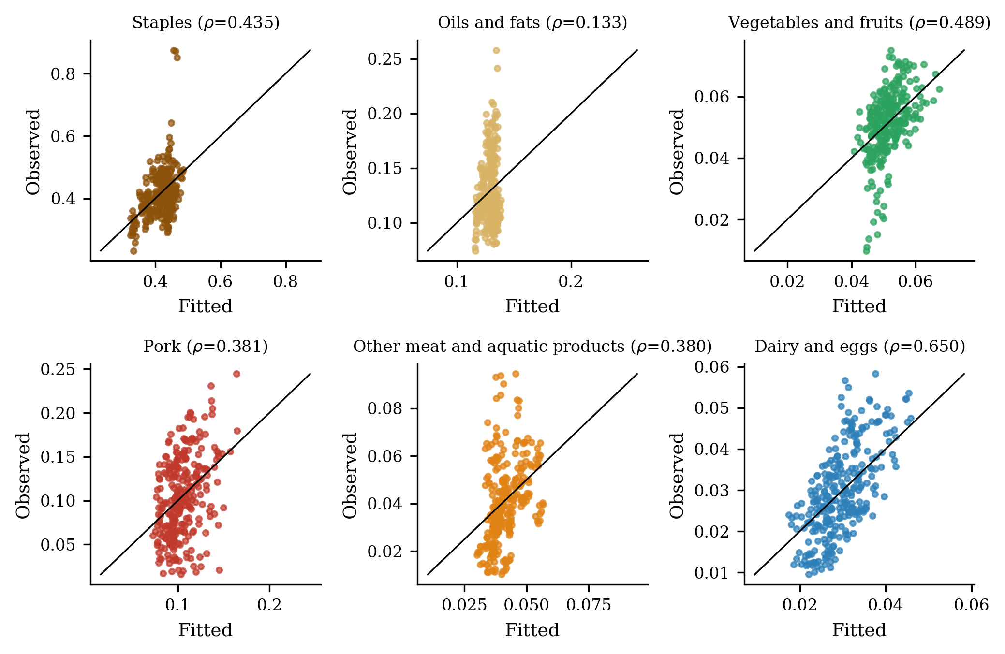
Fig. 2. Observed and fitted quantities by covered food group in the split-pork MAIDADS.
Note: The scatter points compare the observed and fitted quantities for the six covered food groups under the baseline national non-food CPI MAIDADS. The 45-degree line indicates a perfect fit; ρ represents the within-group correlation.
A visual check of the model’s ability to reproduce the main cross-province and within-province patterns is illustrated in Figure 2. In the split-pork revision, the central diagnostic is that pork and non-pork meat/aquatic products are visibly more heterogeneous than staples, vegetables and fruits, and dairy and eggs. The figure therefore motivates two choices regarding the interpretation below: first, the pork and non-pork animal categories should be treated separately, and second, the income-transition patterns and bootstrap uncertainty should be emphasized rather than overinterpreting every provincial residual.

4.2. GDP elasticities and the shape of the provincial transition
Table 4 presents the central split-pork elasticity results at the sample mean real per capita GDP, i.e., 68,076 yuan in 2023 prices. The p values are two-sided province-block bootstrap sign probabilities from 450 valid draws in the baseline specification; when no draw changes sign, the table reports a value of p < 0.002, thus indicating the effective two-sided resolution of the bootstrap.
Table 4. GDP elasticities at mean real per capita GDP in the preferred specification.
Group | GDP elasticity | 95% bootstrap CI | p value | Budget share
Staples | -0.405 | [-0.515, -0.030] | 0.018 | 0.0168
Oils and fats | -0.222 | [-0.309, 0.150] | 0.369 | 0.0316
Vegetables and fruits | 0.390 | [0.228, 0.500] | <0.002 | 0.0222
Pork | 0.317 | [0.205, 0.859] | <0.002 | 0.0147
Non-pork meat/aquatic | 0.153 | [0.119, 1.447] | 0.004 | 0.0212
Dairy and eggs | 0.568 | [0.451, 0.880] | <0.002 | 0.0048
Other/non-covered residual | 1.119 | [1.071, 1.127] | <0.002 | 0.8886
Note: Elasticities are evaluated at the mean real per capita GDP of 68,076 yuan in 2023 prices. Confidence intervals and p values use the 450 valid province-block bootstrap draws for the baseline national non-food CPI specification.
The pattern presented in Table 4 is the demand-system signature of a nutrition transition that has passed its quantity-expansion phase within the covered categories. Staples are significantly inferior in terms of real per capita GDP (elasticity -0.405; p = 0.018). Oils and fats are also negative (-0.222), but the bootstrap distribution crosses zero (p = 0.369). Vegetables and fruits, pork, non-pork meat and aquatic products, and dairy and eggs are all positive, in which context the non-pork meat/aquatic category and dairy and eggs are associated with the greatest mean GDP responses.
This table sharpens the interpretation. Because the model budget is real per capita GDP, the residual accounts for most of the budget, and the covered-food shares are small. The food group elasticities should therefore be read as local responses of calorie-standardized covered quantities to provincial GDP growth rather than as expenditure elasticities from a household budget survey. Despite that caution, the signs are economically informative: direct staple calories are no longer the growing margin, whereas higher-value plant and animal-source foods remain responsive.
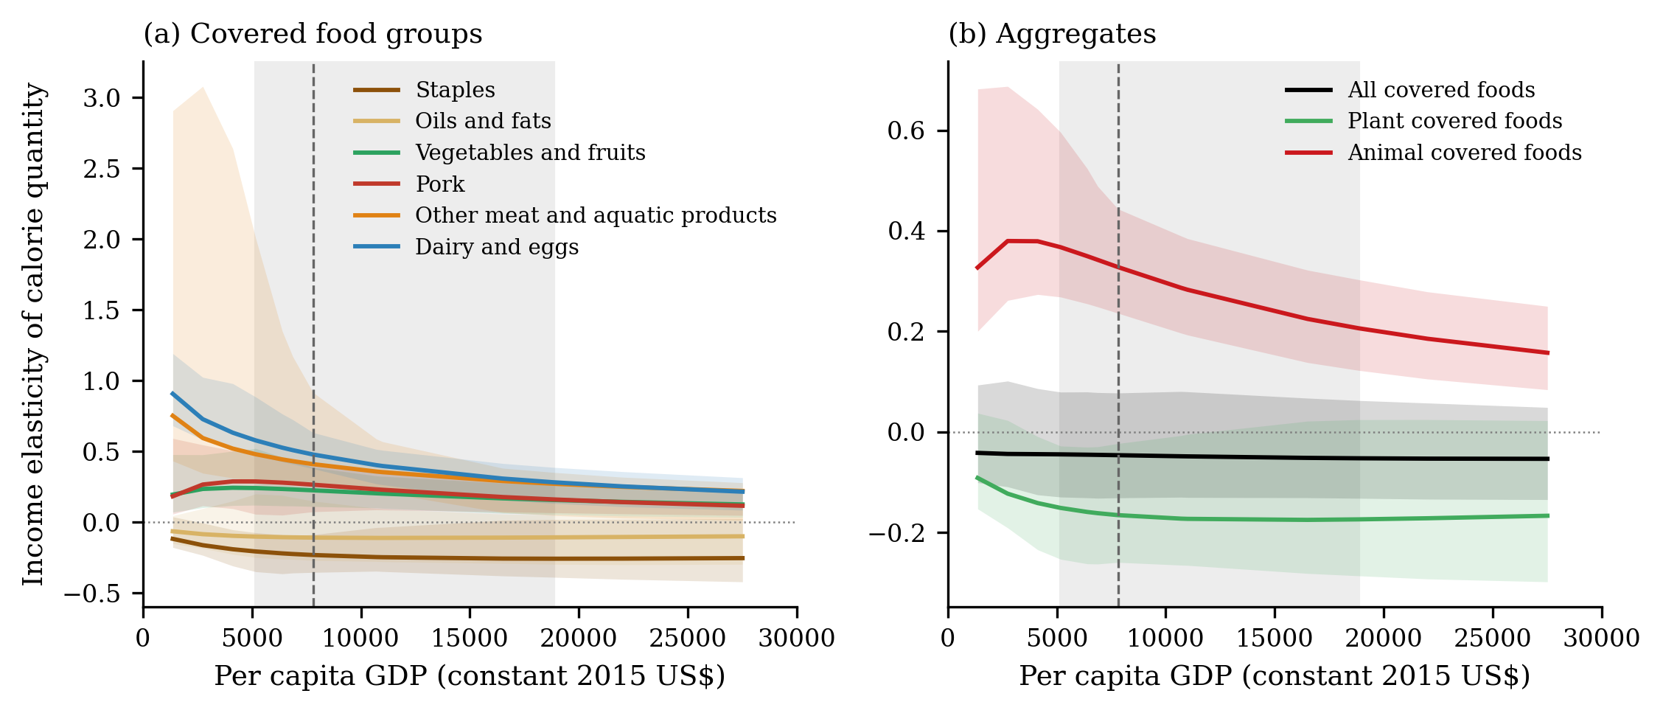
Fig. 3. Split-pork GDP-elasticity profiles over per capita GDP in constant 2015 US dollars.
Note: The lines indicate local log-derivatives from the estimated quantity path at fixed 2023 prices. The horizontal axis is per capita GDP in constant 2015 US dollars, as converted from the model budget using World Bank WDI factors. The gray band indicates the 5th–95th percentile range of observed provincial GDP, and the dashed line indicates the sample median.
The GDP-node elasticities are part of a clear transition profile (Figure 3). Staple and oil elasticities remain negative over the high-income range, but the precision of the staple elasticity becomes weaker beyond the observed support. Vegetables and fruits, pork, non-pork meat/aquatic products, and dairy and eggs remain positive but decrease toward saturation. The aggregate panel presents the core policy results: all covered calories are nearly saturated, plant-source covered calories are weakly negative, and animal-source covered calories remain positive throughout the high-income range.
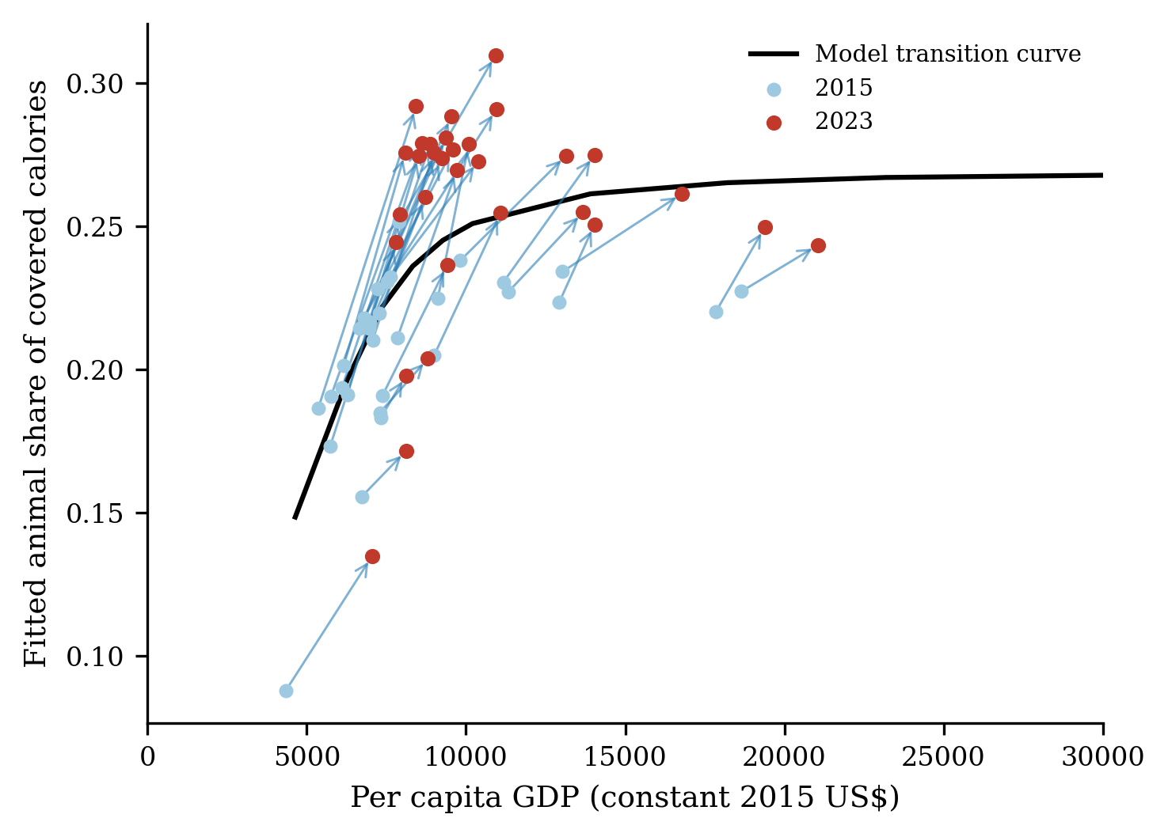
Fig. 4. Provincial positions on the nutrition-transition curve in constant 2015 US dollars.
Note: Each province appears in 2015 and 2023, which are joined by an arrow. The x-axis uses the World Bank WDI constant 2015 US dollar conversion. Provinces that remain in the steep part of the animal share profile are those for which continued income growth has the strongest compositional consequences.
The common transition curve is translated back into provincial observations, as illustrated in Figure 4. The arrows indicate that the same income growth has different implications depending on where a province starts. Higher-income provinces are closer to the flatter part of the animal-share curve; thus, further income growth mainly affects quality, variety, and uncovered consumption. Provinces that remain on the steeper part of the curve retain a stronger compositional response: in this context, income growth can still increase the animal-source share and reduce the relative importance of direct staples. This heterogeneity is one reason why province-level scenario accounting is preferable to the application of a single national elasticity to all regions.

4.3. Elasticities at policy-relevant GDP milestones
To facilitate interpretation of the policy, the smooth GDP profiles are translated into four GDP thresholds: US$15,000, US$20,000, US$25,000, and US$30,000 per person in constant 2015 dollars. These nodes are not treated as precise forecasts. Rather, they are used as policy markers to summarize how marginal demand pressure changes as China transitions from the upper-middle-income range toward the high-income range. Because the observed provincial sample reaches approximately US$25,400 in constant 2015 dollars at the upper end, the US$25,000 and US$30,000 nodes are extrapolated and interpreted more cautiously.
Table 5. Income elasticities of covered food quantities at selected per capita GDP thresholds.
Group | US$15,000 | US$20,000 | US$25,000 | US$30,000
Staples | -0.398 (p=0.013) | -0.393 (p=0.031) | -0.388 (p=0.044) | -0.383 (p=0.049)
Oils and fats | -0.201 (p=0.324) | -0.185 (p=0.307) | -0.172 (p=0.311) | -0.162 (p=0.311)
Vegetables and fruits | 0.265 (p=0.013) | 0.197 (p=0.031) | 0.158 (p=0.018) | 0.132 (p=0.022)
Pork | 0.184 (p=0.053) | 0.111 (p=0.098) | 0.071 (p=0.151) | 0.047 (p=0.231)
Non-pork meat/aquatic | 0.121 (p=0.004) | 0.101 (p=0.004) | 0.088 (p=0.013) | 0.079 (p=0.013)
Dairy and eggs | 0.346 (p=0.004) | 0.236 (p=0.009) | 0.177 (p=0.009) | 0.140 (p=0.018)
Note: The entries are local log-derivatives obtained from the baseline estimated quantity path. Constant 2015 US dollar nodes are converted to model-budget units using K = 0.137515, thus yielding approximately 109,079, 145,439, 181,798, and 218,158 yuan in the model’s real-GDP scale. Parentheses report two-sided p values obtained from 450 valid province-block bootstrap parameter draws that are evaluated at the same nodes; p < 0.002 indicates that no draw changes sign.
Table 5 presents the central food-demand judgment. At US$15,000, staples (-0.398) and oils (-0.201) are negative, but the node-specific bootstrap p values are 0.013 and 0.324, respectively; in turn, vegetables and fruits (0.265), pork (0.184), non-pork meat and aquatic products (0.121), and dairy and eggs (0.346) attain positive values, including stronger bootstrap support. By US$30,000, the positive animal-source margins have decreased but remain economically meaningful: pork features an elasticity of 0.047, non-pork meat and aquatic products feature an elasticity of 0.079, and dairy and eggs feature an elasticity of 0.140. The decrease in these elasticities pertains to the saturation process itself; it does not indicate that animal-product demand is unimportant but rather that each additional percentage point of GDP growth generates a smaller quantity response at higher incomes.
Table 6. Elasticities of covered dietary energy and macronutrients at selected per capita GDP thresholds.
Indicator | US$15,000 | US$20,000 | US$25,000 | US$30,000
Covered energy | -0.139 (p=0.547) | -0.142 (p=0.369) | -0.141 (p=0.324) | -0.139 (p=0.267)
Plant energy | -0.279 (p=0.044) | -0.270 (p=0.049) | -0.261 (p=0.067) | -0.252 (p=0.076)
Animal energy | 0.199 (p=0.018) | 0.131 (p=0.027) | 0.094 (p=0.031) | 0.070 (p=0.036)
Protein | -0.018 (p=0.902) | -0.035 (p=0.987) | -0.043 (p=0.951) | -0.048 (p=0.902)
Fat | 0.005 (p=0.636) | -0.017 (p=0.942) | -0.029 (p=0.858) | -0.036 (p=0.804)
Carbohydrate | -0.278 (p=0.036) | -0.272 (p=0.044) | -0.265 (p=0.067) | -0.258 (p=0.076)
Note: Energy and macronutrient elasticities are constructed by weighting group-level quantity responses by covered-food energy, plant/animal source, and fixed nutrient-composition weights from the calorie-conversion table. They apply only to the modeled covered foods. The two-sided bootstrap p values evaluated at each GDP node are reported in parentheses.
The nutrient elasticities provide the second key judgment. Covered energy is slightly negative at all four nodes, with p values well away from significance, thus confirming that aggregate covered calories are effectively saturated. Plant-source energy is negative and moderately signed (−0.279 at US$15,000, p = 0.044), whereas animal-source energy remains positive and signed across the range (0.199 at US$15,000 declining to 0.070 at US$30,000, with p values near or below 0.05). Protein and fat elasticities are small and slightly negative and are imprecisely estimated (p values near or above one-half), reflecting the fact that high-income recomposition is increasingly a matter of quality, variety, and animal-product mix rather than a large expansion of total modeled calories or macronutrients. Carbohydrate elasticity is negative (−0.278 at US$15,000, p = 0.036), in line with the decline in staple dependence.
These threshold results increase the precision of interpretations of the policy. At US$15,000, the food system still faces positive demand pressure from pork, other animal/aquatic products, dairy and eggs, and vegetables and fruits. By US$30,000, those pressures have become smaller but remain positive. The relevant policy margin is therefore not calorie adequacy; rather, it is the structure of animal-source demand, the resilience of vegetable and fruit supply chains, the distinction between direct food grain and feed grain, and the efficiency with which the livestock and aquaculture sectors convert feed into edible protein.

4.4. GDP-driven covered-food quantity scenario
The auxiliary GDP-driven quantity scenario translates the split-pork elasticity pattern into quantities for the covered categories. It fixes 2023 prices, uses real per capita GDP as the budget variable, and applies the baseline GDP path with SSP2 population weights. The table is therefore a conditional accounting scenario rather than a forecast of total diets.
Table 7. Baseline GDP-driven food quantity scenario for split covered categories.
Group | kg/person/year 2030 | kg/person/year 2035 | kg/person/year 2050 | National total for 2050 in million tons
Staples | 113.3 | 104.1 | 84.4 | 117.7
Oils and fats | 9.4 | 9.1 | 8.3 | 11.5
Vegetables and fruits | 184.3 | 193.4 | 210.1 | 293.1
Pork | 28.5 | 29.4 | 30.5 | 42.5
Non-pork meat/aquatic | 29.3 | 30.0 | 31.4 | 43.8
Dairy and eggs | 30.6 | 32.5 | 35.6 | 49.7
Covered total | 395.4 | 398.4 | 400.4 | 558.4
Note: Values are obtained from the baseline real-GDP-growth scenario. They report covered only food quantities and separated pork from non-pork meat and aquatic products. The same series is visualized in Figure 5.
Table 7 reveals gradual recomposition rather than explosive aggregate growth. Between 2030 and 2050, the per capita covered quantity increases from 395.4 to 400.4 kg per year, but this small aggregate change hides large substitution across categories. Staples decrease from 113.3 to 84.4 kg per person, whereas vegetables and fruits increase from 184.3 to 210.1 kg, pork increases from 28.5 to 30.5 kg, non-pork meat and aquatic products increase from 29.3 to 31.4 kg, and dairy and eggs increase from 30.6 to 35.6 kg. The same pattern is visible in Figure 5: growth margins are observed for vegetables and fruits, non-pork meat/aquatic products, dairy and eggs, and pork, whereas direct staple quantities decrease.
The national totals reveal the scale of the compositional shift. By 2050, vegetables and fruits will account for approximately 293.1 million tons, staples for 117.7 million tons, pork for 42.5 million tons, non-pork meat and aquatic products for 43.8 million tons, and dairy and eggs for 49.7 million tons. The policy message is not that the food system must supply a dramatically larger mass of food but rather that supply chains must adjust to a different product mix.
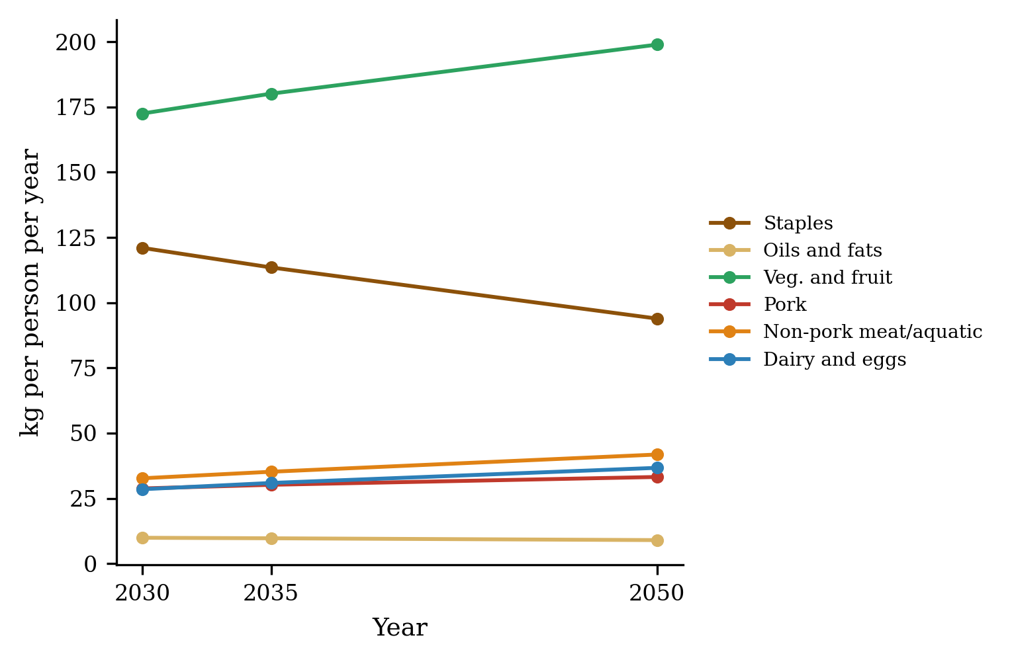
Fig. 5. Baseline GDP-driven covered-food quantity scenario.
Note: Points represent baseline per capita quantities for the six covered categories in 2030, 2035, and 2050. The values are reported as kg per person per year; the series corresponds to Table 7.
The same scenario is plotted in terms of levels in Figure 5. The flatness of total covered kilograms masks a clear rotation: staples fall steadily, vegetables and fruits continue to expand, and all animal-source categories increase, and non-pork meat and aquatic products increased most quickly when measured in kilograms per person.

4.5. Comparison with China-related elasticity estimates
Table 8 presents the mean GDP elasticities in the context of China-related demand system evidence. The comparison is necessarily indicative rather than mechanical because the studies differ in terms of their commodity definitions, data sources, periods, treatment of food away from home, and whether the reported elasticities refer to quantities, expenditures, or quality-adjusted demand.
Table 8. Comparison with China-related elasticity estimates.
Study and scope | Comparable estimates reported in the study | Interpretation relative to this paper
This paper: provinces, 2015-2024, split-pork MAIDADS | Mean-GDP elasticities: staples -0.405 (p=0.018); oils -0.222 (p=0.369); vegetables and fruits 0.390 (p<0.002); pork 0.317 (p<0.002); non-pork meat/aquatic 0.153 (p=0.004); dairy and eggs 0.568 (p<0.002). | Benchmark estimates that measure calorie-standardized quantities under a GDP-budget MAIDADS system and separate pork from other animal/aquatic products.
Zheng & Henneberry (2009): urban Jiangsu, GAIDS | Expenditure elasticities exceed 1 for meats, poultry, aquatic products, and dairy; grain and oils remain positive. | Earlier household estimates are more positive, thus reflecting an earlier transition stage and an expenditure rather than the calorie-quantity margin.
Chen et al. (2016): meta-analysis in China | Income elasticities decline with income; meat and dairy remain important future growth margins. | Consistent with the findings presented in this paper, animal-source elasticities are positive but smaller than older estimates.
Hovhannisyan et al. (2019, 2025): EASI/GEASI evidence | Food expenditure growth increasingly reflects quality and variety, not merely physical quantities. | This research can help reconcile small quantity elasticities with continued food-expenditure upgrading.
Bai et al. (2020): Chinese meat demand | Meat away from home affects meat-demand estimates and projections in China. | This research can support cautious interpretation because the covered categories at the provincial level exclude food away from home.
Burggraf et al. (2015): China and Russia | Meat and dairy demand remains more income-responsive in China than in richer comparison settings. | The positive pork and non-pork elasticities are consistent with a continuing animal-source transition.
Note: Values are aligned only approximately because the commodity definitions, samples, demand systems, and conditioning differ. This paper reports the calorie-standardized quantity elasticities obtained from a GDP-budget split-pork MAIDADS system.
Three points are most informative. First, the negative staple and oil elasticities reported in this paper are lower than many earlier estimates in China, but this change is in the expected direction in light of the shift from earlier household samples to a 2015–2024 provincial panel with GDP as the budget variable. The bootstrap p values are also relevant: the staple decline is statistically supported at mean GDP, whereas the oil decline is not sharply signed.
Second, our animal-source elasticities are much smaller than those that have been reported in studies involving older households and low-income rural areas. This difference does not imply that animal products are unimportant. It does indicate that the extensive phase of China’s meat demand transition has already occurred in much of the provincial sample. The split-pork results refine this statement: pork remains at a positive but declining margin, whereas non-pork meat and aquatic products face greater elasticity at the same GDP nodes.
Third, recent EASI and GEASI evidence concerning China can help reconcile the estimates. These studies have reported that income growth increasingly improves quality and variety rather than merely enhancing physical quantities. This distinction is precisely what is emphasized here: calorie-quantity elasticities can be small or negative even when food expenditures and quality upgrading remain positive. The provincial MAIDADS estimates should therefore be read as evidence regarding the quantity and composition of covered foods, not as a denial of continuing demand for higher-quality foods.

4.6. Price elasticities and robustness
Price responses are reported as diagnostics rather than as the main policy object. In systems that are implicitly directly additive, price flexibility is restricted by the additive structure, and the provincial prices used here are unit values that may contain quality variation as well as pure price variation. Table 9 therefore reports own-price elasticities with bootstrap intervals mainly with the aim of checking signs and magnitudes.
Table 9. Own-price elasticity diagnostics at mean real per capita GDP.
Group | Marshallian own-price elasticity [95% CI] | p value | Hicksian own-price elasticity [95% CI] | p value
Staples | -0.086 [-0.296, 0.000] | 0.053 | -0.093 [-0.299, -0.004] | <0.002
Oils and fats | -0.008 [-0.182, 0.002] | 0.093 | -0.015 [-0.186, -0.002] | <0.002
Vegetables and fruits | -0.327 [-0.406, -0.203] | <0.002 | -0.318 [-0.399, -0.195] | <0.002
Pork | -0.676 [-0.825, -0.567] | <0.002 | -0.671 [-0.818, -0.558] | <0.002
Non-pork meat/aquatic | -0.015 [-0.803, -0.013] | <0.002 | -0.012 [-0.784, -0.008] | <0.002
Dairy and eggs | -0.750 [-0.809, -0.394] | <0.002 | -0.747 [-0.805, -0.390] | <0.002
Other/non-covered residual | -1.020 [-1.027, -0.980] | <0.002 | -0.025 [-0.044, -0.021] | <0.002
Note: Price responses are reported as diagnostics because additivity restricts price flexibility and provincial unit values may embed quality variation. P values are two-sided bootstrap sign probabilities obtained from the mean-GDP bootstrap draws; p < 0.002 indicates that no draw changes sign.
The price block is plausible for pork, vegetables and fruits, dairy and eggs, and the non-pork meat/aquatic category. Pork features the greatest own-price response, including a Marshallian own-price elasticity of approximately -0.676 and a bootstrap p value below 0.002. Dairy and eggs are also price-responsive, and vegetables and fruits exhibit moderate negative own-price elasticity. The weak signs observed with regard to staples and oils in the Marshallian block reinforce the diagnostic interpretation of the price results: they are useful checks on the system but cannot serve as the main basis for price‒policy simulation.
The principal robustness exercise replaces the national non-food CPI residual price with a derived provincial non-food CPI. The ordering of the models is unchanged: MAIDADS exhibits a better fit than AIDADS does within each residual-price specification, and the out-of-sample food RMSE remains slightly lower under MAIDADS. The elasticity configuration is also preserved: staples and oils are negative, whereas vegetables and fruits, pork, non-pork meat/aquatic products, and dairy and eggs are positive. Cross-specification comparisons of likelihood levels are not meaningful because the residual-price construction changes the scale and composition of residual quantity; thus, model comparison is confined to within-specification contrasts.
These diagnostics support the income-transition interpretation but also define a boundary for the use of the estimates. Applications that focus on food taxes, subsidies, or short-term price policy should add a price-flexible comparator such as QUAIDS or EASI and use quality-adjusted prices wherever possible. The comparative advantage of the present MAIDADS specification lies in its ability to represent the nonlinear income path and saturation behavior of food quantities.

4.7. Feed-grain-equivalent accounting
The final result connects the animal-product component of the demand system to feed-grain-equivalent accounting. This step is an accounting translation that is layered onto the demand projection, not a behavioral model of livestock supply. It is included because the policy relevance of the dietary transition in China depends heavily on how animal-product demand maps onto feed demand, and the split-pork specification allows pork to be shown explicitly rather than buried inside an aggregate meat-aquatic category.
Table 10. The feed-grain-equivalent demand associated with animal products is million tons.
Product | 2030 | 2035 | 2050 | 2050 CI (Lower) | 2050 CI (Upper)
Pork | 161.2 | 165.5 | 165.0 | 143.4 | 211.8
Eggs | 56.4 | 59.6 | 62.6 | 53.5 | 68.6
Poultry | 52.5 | 53.5 | 54.1 | 49.7 | 91.0
Beef | 42.9 | 43.7 | 43.8 | 40.1 | 73.6
Mutton | 25.6 | 26.2 | 26.6 | 24.4 | 44.3
Aquatic products | 26.7 | 27.1 | 26.9 | 24.7 | 45.6
Milk | 12.9 | 13.7 | 14.4 | 12.3 | 15.8
Total | 378.3 | 389.3 | 393.4 | 367.3 | 529.9
Note: Entries apply the project’s feed-conversion factors to projected national animal-product quantities. If the coefficients are total-feed rather than feed-grain-equivalent factors, cereal shares must be applied before the entries are read as grain demand.
The feed-grain account is large but relatively stable over the projection horizons. The 2050 point estimate is 393.4 million tons. Pork dominates in this context, accounting for 165.0 million tons, i.e., approximately 42% of the total, followed by eggs at 62.6 million tons, poultry at 54.1 million tons, beef at 43.8 million tons, mutton at 26.6 million tons, aquatic products at 26.9 million tons, and milk at 14.4 million tons. The result is therefore not an explosive upward trajectory in aggregate feed use but rather a persistently high level of feed demand that is concentrated in pork and other animal-source foods.
The uncertainty is as important as the point estimate. The 2050 pork interval alone extends from 143.4 to 211.8 million tons, and the intervals for poultry, beef, and aquatic products are also wide. These intervals reflect demand-parameter uncertainty and the decomposition of aggregate animal demand into individual products; they do not incorporate uncertainty regarding future prices, livestock technology, feed conversion, or the cereal share of total feed. The table should therefore be interpreted as a conditional feed-grain-equivalent account rather than as a policy-ready forecast of grain demand.
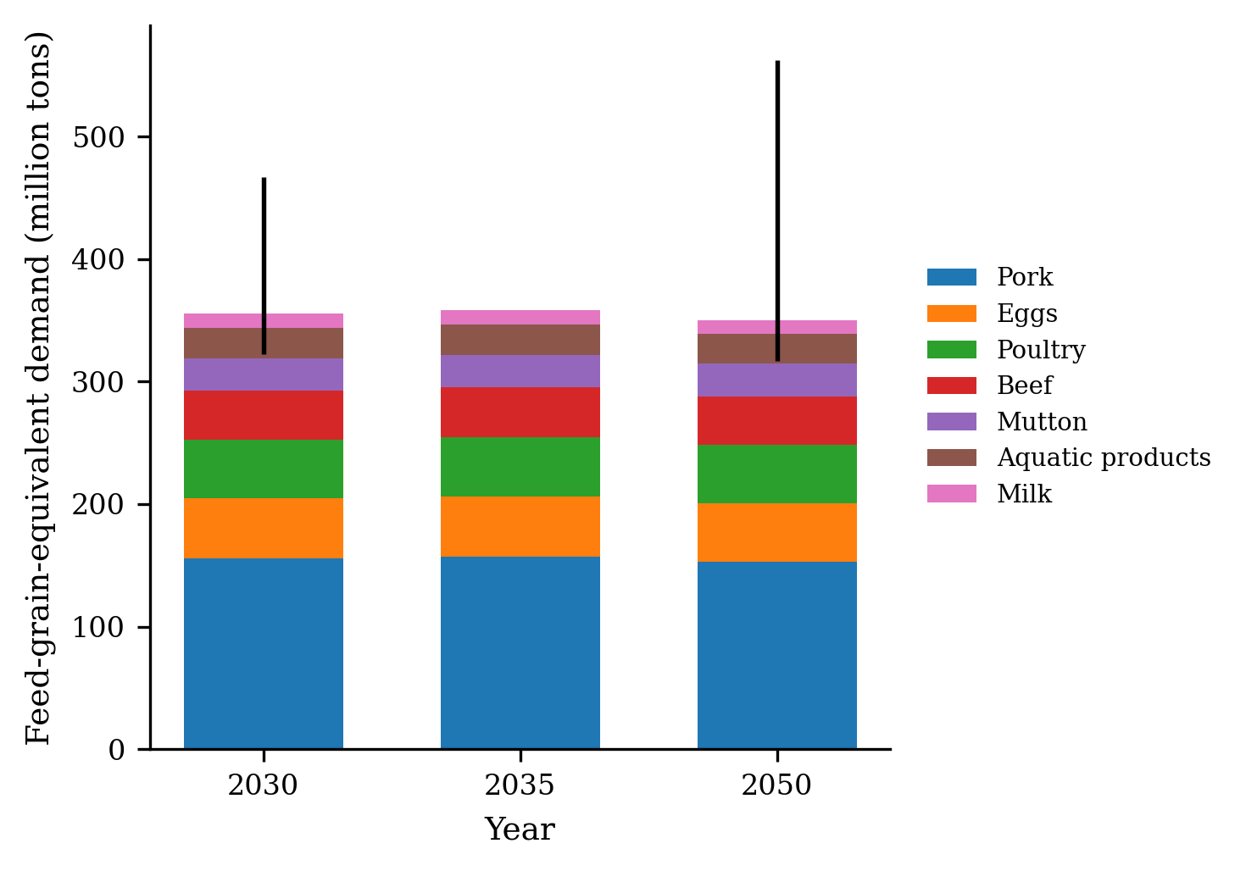
Fig. 6. Feed-grain-equivalent demand by product and horizon.
Note: Stacked bars indicate feed-grain-equivalent demand by animal product for 2030, 2035, and 2050; the whiskers on the annual totals indicated the 95% province-block bootstrap intervals.
Figure 6 reinforces the same message visually. The composition of feed-grain-equivalent demand is stable across horizons, in which context pork serves as the dominant component, whereas eggs, poultry, and beef form the next tier. The presence of wide bootstrap intervals around the totals indicates that the feed-grain account should be treated as a range of plausible demand pressures rather than as a precise forecast.
Taken together, the results presented in Section 4 support a consistent interpretation. The split-pork MAIDADS specification improves the representation of the data because it allows the committed food basket to change with income; the estimated elasticities indicate compositional change rather than calorie expansion, and the policy-node and feed-grain calculations identify the margins that are most relevant to food security planning. The use of constant 2015 US dollars renders the high-income nodes comparable to the international nutrition-transition literature, whereas the bootstrap p values clarify the areas in which inference is strong and those in which high-income extrapolation should be read with caution.

5. Conclusions and policy recommendations
In this paper, an income-flexible MAIDADS demand system for a provincial panel in China is estimated, and the resulting elasticities are used to interpret the current stage of the nutritional transition in China. The preferred specification uses real per capita GDP as the budget variable, separates pork from non-pork meat and aquatic products, and expresses policy-node elasticities on a World Bank constant-2015-US-dollar income axis. The central empirical message of this research is that income growth now operates mainly through food composition rather than through a broad expansion of covered food quantities. With respect to the mean real per capita GDP, direct grain demand is significantly income negative; oils are negative but imprecisely estimated; and vegetables and fruits, pork, non-pork meat and aquatic products, and dairy and eggs remain income positive. At higher GDP milestones, the positive animal-source elasticities decline but remain above zero, whereas covered dietary energy is close to saturation.
The first policy implication is that food security analyses should separate direct food-grain demand from feed-grain pressure. The observation of declining income elasticity for directly consumed staples does not imply that grain demand pressure disappears. Rather, the locus of such pressure shifts toward feed-intensive animal-source foods, particularly pork. Grain policy, reserve management, and import-risk assessment should therefore distinguish household staple consumption from the feed requirements that are generated by the continuing expansion of animal-source demand.
The second implication is that supply chain planning should be product specific rather than based on a single aggregate meat category. The split-pork specification indicates that pork remains at a distinct margin of demand and serves as the dominant component of feed-grain-equivalent accounting. In the 2050 conditional account, the sum of the projected feed-grain equivalents is approximately 393.4 million tons, of which pork contributes approximately 165.0 million tons, accounting for approximately 42% of the total. Policies targeting livestock productivity, feed conversion, cold-chain logistics, disease-risk management, and diversification toward poultry, dairy, eggs, aquatic products, and non-pork meats should therefore be evaluated in light of their different implications for feed and infrastructure.
The third implication pertains to nutrition policy. The GDP-node elasticities indicate that additional income at the upper part of China’s current transition is unlikely to generate large gains in total covered energy. Instead, marginal adjustments are made through quality, diversity, and the animal-versus-plant composition of diets. These findings highlight a policy agenda that focuses primarily on diet quality, balanced protein sources, healthy fat intake, vegetables and fruits, dairy and eggs, and the management of diet-related health risks rather than on aggregate calorie expansion. Because the covered categories exclude food away from home, sugar, pulses, nuts, processed foods, and several minor products, these nutrient elasticities should be read as covered-food accounting indicators rather than as complete dietary intake forecasts.
The fourth implication is methodological. MAIDADS provides a useful organizing framework because it enables elasticity profiles to be estimated continuously over income and allows food groups to saturate or turn downward as income increases. It also improves the in-sample representation of the data and modestly improves held-out prediction relative to AIDADS. Moreover, the province-block LR evidence is not decisive, which is informative in its own right: high-income saturation behavior is difficult to identify on the basis of a short provincial panel. For subnational demand applications, flexible Engel curves should be paired with block-bootstrap inference, out-of-sample validation, explicit support diagnostics, and p values or interval estimates for the elasticities that drive policy interpretation.
Efforts to interpret these results should bear several limitations in mind. The price variables are unit values and may embed quality variation as well as pure prices. The residual price is proxied by national or derived provincial non-food CPI, and the residual itself is the real GDP net of covered-food expenditure rather than a strict household outside good. The set of food categories is incomplete; namely, the model does not separately capture food away from home, sugar, pulses, nuts, processed foods, or all minor food categories. The US$25,000 and US$30,000 constant-2015-dollar nodes lie beyond the upper end of the observed provincial support and should therefore be interpreted as disciplined extrapolations. Finally, the feed-grain-equivalent account is conditional on the demand system, future income path, product decomposition, and feed-conversion coefficients adopted in this context; thus, it does not incorporate future prices, livestock technology, or feed substitution.
These limitations highlight a clear research agenda. Future studies should incorporate direct provincial non-food price indices, broader food coverage, including food away from home, sourced provincial GDP and consumption-expenditure scenarios, price-flexible comparator systems that can facilitate short-term policy analysis, and updated feed-conversion coefficients that can distinguish total feed from cereal feed. These extensions could help sharpen the magnitude of the estimates, but they are unlikely to overturn the central conclusion. The food question in China has become a question of composition: the marginal effects of income growth now depend on where provinces are located on the income profile, which foods have saturated, and how the remaining positive animal-source demand translates into feed, land, infrastructure, and nutrition-policy requirements.

Funding
To be completed before submission.

CRediT authorship contribution statement
To be completed after the author list is finalized.

Declaration of competing interests
To be completed before submission.

Acknowledgments
To be completed before submission.

Appendix A. Out-of-sample validation by food group and split
Table A1. Out-of-sample validation summary by model and split.
Residual-price specification | Model | Training years | Test years | Mean food OOS RMSE | Mean relative RMSE | Mean MAE
National non-food CPI | AIDADS | 2015-2020 | 2021-2023 | 0.03331 | 0.3115 | 0.02685
National non-food CPI | AIDADS | 2015-2022 | 2023 | 0.03402 | 0.3104 | 0.02717
National non-food CPI | MAIDADS | 2015-2020 | 2021-2023 | 0.03331 | 0.3069 | 0.02665
National non-food CPI | MAIDADS | 2015-2022 | 2023 | 0.03358 | 0.3025 | 0.02721
Derived provincial non-food CPI | AIDADS | 2015-2020 | 2021-2023 | 0.03321 | 0.3123 | 0.02679
Derived provincial non-food CPI | AIDADS | 2015-2022 | 2023 | 0.03365 | 0.3074 | 0.02672
Derived provincial non-food CPI | MAIDADS | 2015-2020 | 2021-2023 | 0.03349 | 0.3079 | 0.02674
Derived provincial non-food CPI | MAIDADS | 2015-2022 | 2023 | 0.03378 | 0.3031 | 0.02733
National non-food CPI | AIDADS | 2015-2023 | 2024 | 0.03454 | 0.3071 | 0.02764
National non-food CPI | MAIDADS | 2015-2023 | 2024 | 0.02931 | 0.2690 | 0.02427
Derived provincial non-food CPI | AIDADS | 2015-2023 | 2024 | 0.03428 | 0.3079 | 0.02736
Derived provincial non-food CPI | MAIDADS | 2015-2023 | 2024 | 0.03503 | 0.3093 | 0.02816
Note: Models are estimated on the basis of the training window and evaluated on the basis of the held-out window. The multiyear split holds out 93 province-year observations; the final-year split holds out 31 observations.

Appendix B. Reproducibility
All the model estimates, fit statistics, retained scenarios, and figures included in this article are generated on the basis of the archived estimation and scenario result files. The revised Section 4 uses the estimated output, whose final model set focuses on grain, oil, vegetables and fruits, pork, non-pork meat and aquatic products, dairy and eggs, and the other/non-covered residual. The GDP-axis conversion follows the full results file: World Bank WDI China current-LCU and constant-2015-US-dollar GDP-per-capita series are used to convert provincial nominal GDP into constant 2015 US dollars, in which context K = 0.137515 is used for the model curves. The updated figures are drawn from the final figures archive.

References
Aborisade, O., Carpio, C. E., & Boonsaeng, T. (2024). Food demand estimation from consumption and expenditure data: Meat demand in Nigeria. Agricultural and Resource Economics Review, 53, 144–162.
Akat, S., Dennis, E. J., & Azzam, A. M. (2025). Demand for local meat by US public schools: An EASI application to Iowa. Food Policy, 132, 102858.
Bairagi, S., Mohanty, S., Baruah, S., & Thi, H. T. (2020). Changing food consumption patterns in rural and urban Vietnam: Implications for a future food supply system. Australian Journal of Agricultural and Resource Economics, 64, 750–775.
Bai, J., Seale, J. L., Jr., & Wahl, T. I. (2020). Meat demand in China: To include or not to include meat away from home? Australian Journal of Agricultural and Resource Economics, 64(1), 150–170.
Banks, J., Blundell, R., & Lewbel, A. (1997). Quadratic Engel curves and consumer demand. Review of Economics and Statistics, 79(4), 527–539.
Berning, J., Bonanno, A., & Cleary, R. (2022). Disparities in food insecurity among Black and White households: An analysis by age cohort, poverty, education, and home ownership. Applied Economic Perspectives and Policy.
Bodirsky, B. L., Rolinski, S., Biewald, A., Weindl, I., Popp, A., & Lotze-Campen, H. (2015). Global food demand scenarios for the 21st century. PLoS ONE, 10(11), e0139201.
Burggraf, C., Kuhn, L., Zhao, Q., Teuber, R., & Glauben, T. (2015). Economic growth and nutrition transition: An empirical analysis comparing demand elasticities for foods in China and Russia. Journal of Integrative Agriculture, 14(6), 1008–1022.
Chen, D., Abler, D., Zhou, D., Yu, X., & Thompson, W. (2016). A meta-analysis of food demand elasticities for China. Applied Economic Perspectives and Policy, 38(1), 50–72.
Chen, Y., Guo, F., Wang, J., Cai, W., Wang, C., & Wang, K. (2020). Provincial and gridded population projection for China under shared socioeconomic pathways from 2010 to 2100. Scientific Data, 7, 83.
Cranfield, J. A. L., Preckel, P. V., Eales, J. S., & Hertel, T. W. (2000). On the estimation of an implicitly additive demand system. Applied Economics, 32(15), 1907–1915.
Cranfield, J. A. L., Preckel, P. V., Eales, J. S., & Hertel, T. W. (2002). Estimating consumer demands across the development spectrum: Maximum likelihood estimates of an implicit direct additivity model. Journal of Development Economics, 68(2), 289–307.
Dassow, C., & Almeida, E. (2024). Tax on sugary drinks in Brazil: Simulation of impacts on the purchases of non-alcoholic drinks and family welfare. Food Policy, 128, 102673.
Davies, R. B. (1977). Hypothesis testing when a nuisance parameter is present only under the alternative. Biometrika, 64(2), 247–254.
Deaton, A. (1988). Quality, quantity, and spatial variation of price. American Economic Review, 78(3), 418–430.
Deaton, A., & Muellbauer, J. (1980). An almost ideal demand system. American Economic Review, 70(3), 312–326.
Fan, S., Wailes, E. J., & Cramer, G. L. (1995). Household demand in rural China: A two-stage LES-AIDS model. American Journal of Agricultural Economics, 77(1), 54–62.
Fukase, E., & Martin, W. (2016). Who will feed China in the 21st century? Income growth and food demand and supply in China. Journal of Agricultural Economics, 67(1), 3–23.
Gale, F., & Huang, K. (2007). Demand for food quantity and quality in China (Economic Research Report No. 32). U.S. Department of Agriculture, Economic Research Service.
Gostkowski, M. (2018). Elasticity of consumer demand: Estimation using a Quadratic Almost Ideal Demand System. Econometrics. Advances in Applied Data Analysis, 22(1), 68–78.
Gould, B. W., & Villarreal, H. J. (2006). An assessment of the current structure of food demand in urban China. Agricultural Economics, 34(1), 1–16.
Gouel, C., & Guimbard, H. (2019). Nutrition transition and the structure of global food demand. American Journal of Agricultural Economics, 101(2), 383–403.
Gustavsen, G. W., & Rickertsen, K. (2014). Consumer cohorts and purchases of nonalcoholic beverages. Empirical Economics, 46, 427–449.
Han, X., & Chen, Y. (2016). Food consumption of outgoing rural migrant workers in urban area of China: A QUAIDS approach. China Agricultural Economic Review, 8(2), 230–249.
Hanoch, G. (1975). Production and demand models with direct or indirect implicit additivity. Econometrica, 43(3), 395–419.
Hertel, T. W., Ivanic, M., Preckel, P. V., & Cranfield, J. A. L. (2004). The earnings effects of multilateral trade liberalization: Implications for poverty. World Bank Economic Review, 18(2), 205–236.
Hovhannisyan, V., & Bastian, C. T. (2022). New insights into the structure of consumer preferences for natural and artificial sweeteners. American Journal of Agricultural Economics.
Hovhannisyan, V., & Gould, B. W. (2014). Structural change in urban Chinese food preferences. Agricultural Economics, 45(2), 159–166.
Hovhannisyan, V., Mendis, S., & Bastian, C. (2019). An econometric analysis of demand for food quantity and quality in urban China. Agricultural Economics, 50(1), 3–13.
Hovhannisyan, V., & Shanoyan, A. (2019). Addressing pre-commitment bias with a generalized EASI model: An application to food demand in Russia. Journal of Agricultural and Resource Economics, 44(1), 80–97.
Hovhannisyan, V., Khachatryan, A., & Asci, S. (2025). A comprehensive analysis of urban-rural differences: The case of food consumption in China. European Review of Agricultural Economics, 52(4), 778–817.
Jeon, Y., Hoang, H., Thompson, W., & Abler, D. (2023). A meta-analysis of U.S. food demand elasticities to detect the impacts of scanner data. Applied Economic Perspectives and Policy.
Kimsanova, B., Sanaev, G., & Herzfeld, T. (2023). Dynamics of food demand during political instability: Evidence from Kyrgyzstan. Agricultural Economics.
Law, C., Fraser, I., & Piracha, M. (2020). Nutrition transition and changing food preferences in India. Journal of Agricultural Economics, 71(1), 118–143.
Lee, J. Y., Qian, Y., Gustavsen, G. W., Nayga, R. M., Jr., & Rickertsen, K. (2020). Effects of consumer cohorts and age on meat expenditures in the United States. Agricultural Economics, 51, 505–517.
Lewbel, A. (2025). Direct utility functions for rank two and quadratic logarithmic continuous demand systems. Journal of Productivity Analysis, 63, 285–290.
Lewbel, A., & Pendakur, K. (2009). Tricks with Hicks: The EASI demand system. American Economic Review, 99(3), 827–863.
Li, L., Zhai, S., & Bai, J. (2021). The dynamic impact of income and income distribution on food consumption among adults in rural China. Journal of Integrative Agriculture, 20(1), 330–342.
Li, L., Bai, J., & Zhu, Q. (2023). The effect of rising food prices on nutrient intake among rural-urban migrants in China. China Agricultural Economic Review, 15(3), 642–665.
Lindström, H. (2022). The Swedish consumer market for organic and conventional milk: A demand system analysis. Agribusiness, 38, 505–532.
Liverpool-Tasie, L. S. O., Sanou, A., Reardon, T., & Belton, B. (2021). Demand for imported versus domestic fish in Nigeria. Journal of Agricultural Economics, 72(3), 782–804.
Menon, M., Perali, F., & Tommasi, N. (2017). Estimation of unit values in household expenditure surveys without quantity information. Stata Journal, 17(1), 222–239.
Moro, D. (2000). Heterogeneous preferences in household food consumption in Italy. European Review of Agricultural Economics, 27(3), 305–323.
Perali, F. (2007). Can PIGLOG preferences identify equivalence scales? International Review of Economics, 54, 248–260.
Popkin, B. M. (1993). Nutritional patterns and transitions. Population and Development Review, 19(1), 138–157.
Popkin, B. M., Adair, L. S., & Ng, S. W. (2012). Global nutrition transition and the pandemic of obesity in developing countries. Nutrition Reviews, 70(1), 3–21.
Preckel, P. V., Cranfield, J. A. L., & Hertel, T. W. (2010). A modified, implicit, directly additive demand system. Applied Economics, 42(2), 143–155.
Quach, V. D., Yabe, M., Nomura, H., & Takahashi, Y. (2023). Structural changes in meat consumption in Vietnam: Evidence from household survey data. Journal of Agribusiness in Developing and Emerging Economies, 13(4), 590–612.
Rahman, K. T., Shanoyan, A., & Hovhannisyan, V. (2023). Food commodity price changes and consumer welfare in Bangladesh: Valuable lessons for today. Journal of Agricultural Economics.
Ramírez-Hassan, A. (2021). Bayesian estimation of the exact affine Stone index demand system: Replicating the Lewbel and Pendakur (2009) results. Journal of Applied Econometrics, 36(4), 484–491.
Rask, K. J., & Rask, N. (2011). Economic development and food production-consumption balance: A growing global challenge. Food Policy, 36(2), 186–196.
Ren, Y., Zhang, Y., Loy, J.-P., & Glauben, T. (2018). Food consumption among income classes and its response to changes in income distribution in rural China. China Agricultural Economic Review, 10(3), 406–424.
Rimmer, M. T., & Powell, A. A. (1996). An implicitly additive demand system. Applied Economics, 28(12), 1613–1622.
Roosen, J., Staudigel, M., & Rahbauer, S. (2022). Demand elasticities for fresh meat and welfare effects of meat taxes in Germany. Food Policy, 106, 102194.
Seale, J. L., Jr., & Regmi, A. (2006). Modeling international consumption patterns. Review of Income and Wealth, 52(4), 603–624.
Tacconi, F., Waha, K., Ojeda, J. J., Leith, P., Mohammed, C., Venables, W. N., Rana, J. C., Bhardwaj, R., Yadav, R., Ahlawat, S. P., Hammond, J., & van Wijk, M. (2023). Farm diversification strategies, dietary diversity and farm size: Results from a cross-country sample in South and Southeast Asia. Global Food Security, 38, 100706.
Valin, H., Sands, R. D., van der Mensbrugghe, D., Nelson, G. C., Ahammad, H., Blanc, E., Bodirsky, B., Fujimori, S., Hasegawa, T., Havlik, P., Heyhoe, E., Kyle, P., Mason-D’Croz, D., Paltsev, S., Rolinski, S., Tabeau, A., van Meijl, H., von Lampe, M., & Willenbockel, D. (2014). The future of food demand: Understanding differences in global economic models. Agricultural Economics, 45(1), 51–67.
Wang, C., Wang, R., Fei, X., & Li, L. (2024). Price effects of residents’ consumption carbon emissions: Evidence from rural and urban China. Energy Economics, 135, 107662.
World Bank. (2025). World Development Indicators. Washington, DC: World Bank.
Wong, K. K. G., Zhu, L., & Dang, V. Q. T. (2019). Effects of income distribution in an inverse demand system: Evidence from Chinese household survey data. Applied Economics, 51(49), 5328–5344.
Yotopoulos, P. A. (1985). Middle-income classes and food crises: The “new” food-feed competition. Economic Development and Cultural Change, 33(3), 463–483.
Yu, X., & Abler, D. (2009). The demand for food quality in rural China. American Journal of Agricultural Economics, 91(1), 57–69.
Zhen, C., Finkelstein, E. A., Nonnemaker, J. M., Karns, S. A., & Todd, J. E. (2014). Predicting the effects of sugar-sweetened beverage taxes on food and beverage demand in a large demand system. American Journal of Agricultural Economics, 96(1), 1–25.
Zhen, C., Chen, Y., Lin, B.-H., Karns, S., Mancino, L., & Ver Ploeg, M. (2023). Do obese and nonobese consumers respond differently to price changes? Implications of preference heterogeneity for obesity-oriented food taxes and subsidies. American Journal of Agricultural Economics.
Zheng, Z., & Henneberry, S. R. (2009). An analysis of food demand in China: A case study of urban households in Jiangsu Province. Review of Agricultural Economics, 31(4), 873–893.
Zheng, Z., Henneberry, S. R., Zhao, Y., & Gao, Y. (2019). Predicting the changes in the structure of food demand in China. Agribusiness, 35, 301–328.
Zheng, Z., & Henneberry, S. R. (2011). Household food demand by income category: Evidence from household survey data in an urban Chinese province. Agribusiness, 27(1), 99–113.
Zhou, D., & Yu, X. (2015). Calorie elasticities with income dynamics: Evidence from the literature. Applied Economic Perspectives and Policy, 37(4), 575–601.
Zhou, D., Yu, X., & Herzfeld, T. (2015). Dynamic food demand in urban China. China Agricultural Economic Review, 7(1), 27–44.

