Cheaper Pork, Costlier Food Baskets
Price Offsets and Household Purchases in China
Abstract: How far do falling pork prices relieve household food costs? We link 583,668 active household-month observations for 27,638 households in 24 Chinese provinces during 2020–2022 to provincial retail prices. Revaluing 2020 food baskets at 2022 prices raises their average cost by 2.97% of the eight-group budget. Pork contributes −4.60 percentage points and other meat contributes 0.60; their net contribution offsets approximately 57.3% of the non-meat increase but does not eliminate it. Basket-cost changes range from −7.29% at the tenth percentile to 11.75% at the ninetieth percentile, and reported income-bracket rankings change across category-price scenarios. A participation-adjusted approximate EASI system provides complementary evidence on purchasing responses conditional on the observed food budget. All eight own-price point estimates are negative, with seven 95% intervals below zero. Food-expenditure elasticities exceed one for other meat and oils and are below one for vegetables and fruit. Oil purchase incidence rises from 33.50% in monthly records to 88.86% in annual records, highlighting the relevance of purchasing frequency to short-run responses. These findings show why cheaper pork need not make the average food basket cheaper and why food-affordability monitoring should account for category-price offsets, basket composition, and purchase timing.
Keywords: Food prices; Food-basket costs; Household purchases; Demand elasticities; Purchase frequency

1. Introduction
Food affordability is often discussed through the prices of a few prominent commodities. Households, however, purchase a basket: a decline in the price of an important food can coexist with higher costs elsewhere in that basket. The size of the offset depends on both the combination of price changes and households' expenditure patterns. Research on household inflation has documented substantial differences in price experiences associated with purchased products and prices paid (Kaplan and Schulhofer-Wohl, 2017; Jaravel, 2019; Argente and Lee, 2021). Understanding whether food has become cheaper therefore requires moving beyond individual commodity prices to the composition of household purchases.
This perspective complements the literature on food demand in China. Increases in food expenditure involve changes in category allocation and quality rather than proportional expansion of all purchases (Fan et al., 1995; Yu and Abler, 2009; Hovhannisyan et al., 2019). Existing demand estimates and their meta-analysis provide evidence on these adjustments and their variation across foods and specifications (Chen et al., 2016). Demand elasticities characterize purchasing responses to prices and budgets; basket-cost accounting measures the price pressure on an existing allocation. These are distinct but complementary dimensions of household food affordability.
Monthly transaction records make the composition of purchases observable while bringing purchase timing into focus. A household may buy oils or staples in one month and use them over several months. Research on shopping and inventories shows why short-run purchasing responses can differ from longer-run consumption responses (Aguiar and Hurst, 2007; Hendel and Nevo, 2006, 2013). Commodity boundaries also determine what an elasticity measures (Eales and Unnevehr, 1988). Transaction-based analysis can therefore benefit from combining category-level cost contributions with demand estimates that accommodate nonpurchase, and from interpreting monthly responses alongside purchase coverage over longer windows.
We address two questions. How did the combination of food-price increases and decreases during 2020–2022 change the cost of sampled households' food baskets, and how much did cheaper pork offset increases elsewhere? How do category purchases vary with food prices and the food budget, and what does purchasing frequency imply for interpreting monthly responses? We link 583,668 active household-month observations for 27,638 households in 24 Chinese provinces to external provincial prices for eight food groups. We first revalue 2020 baskets at 2022 prices and decompose the resulting cost changes. We then estimate a participation-adjusted approximate EASI system conditional on the observed food budget and compare purchase coverage across monthly, quarterly, and annual records.
Our first contribution is empirical evidence on category-price offsets in household food costs in China. We measure the contributions of the observed combination of price changes within the same household-month baskets. Comparisons with category-specific scenarios show how the ranking of reported income brackets depends on which prices change. Cheaper pork provides substantial relief without making the average basket cheaper, while the cost distribution spans both increases and decreases. These findings complement research on heterogeneous household inflation by quantifying how opposing food-price movements jointly shape basket costs in the Chinese sample.
Our second contribution is category-level evidence linking short-run purchasing responses to purchase coverage over longer recording windows. Participation-adjusted estimates show that food-budget expansion favors other meat and oils over vegetables and fruit, while low monthly incidence for oils and staples coexists with widespread annual purchasing. Connecting these findings distinguishes budget allocation from purchasing frequency and shows why one month's purchase incidence is an incomplete indicator of a category's importance in household purchasing. Demand-system and commodity-grouping comparisons further assess the sensitivity of this evidence.
Pork contributes −4.60 percentage points to basket costs and other meat 0.60 points. Together they offset approximately 57.3% of the non-meat contribution, yet average basket costs still rise by 2.97%. Other meat and oils respond more than proportionally to the food budget, whereas vegetables and fruit respond less than proportionally. Oil purchase coverage increases from 33.50% in monthly records to 88.86% in annual records. Section 2 describes the data and prices. Section 3 presents the demand specification and inference. Section 4 examines price offsets and basket costs, Section 5 reports purchasing responses and specification comparisons, and Section 6 discusses implications for food-market monitoring.

2. Data and Measurement

2.1 Transactions, active months, and the observed food budget
The CCTV household food transaction records cover January 2020 to December 2022 and report household identifiers, dates, provinces, food categories, expenditure, quantities, reported income and household-size brackets, and household types. The original merged data contain 10,420,107 records, including 285,612 nut transactions. Nuts are excluded because no independently matched external price series is available, leaving 10,134,495 records in the studied categories before the positive-expenditure screen. These transaction counts differ from the aggregated household-month observations used in estimation.
We aggregate positive expenditure to household-month-food-group cells and assign zero expenditure to unrecorded groups within months containing at least one purchase of a studied food. We call these active household-months. Months without any recorded purchase in the eight groups are not inserted as zero-budget observations. The resulting unbalanced panel comprises 27,638 households, 583,668 active household-months, and 4,669,344 household-month-group cells, covering 24 provincial regions and 36 calendar months. Household characteristics follow the last recorded transaction in each month.
The sum of purchases in the eight groups defines the observed food budget. Mean household expenditure is RMB 457.29 per month and the median is RMB 340.00. Mean expenditure per proxy household member is RMB 217.14. The budget is a food-purchasing sub-budget: eggs are not separately represented and food away from home is incompletely recorded. Food-expenditure elasticities refer to allocation within this budget (Fan et al., 1995; Bai et al., 2020).
Statistics weight active household-months equally and describe the sampled households in months with recorded purchases. The data do not supply population expansion weights, a complete sampling design, or an unambiguous urban–rural indicator. The number of active months can differ across households.

2.2 Food groups and purchasing patterns
The eight groups are staples, edible oils, vegetables, fruit, pork, other meat, seafood, and dairy. Staples include rice, flour, noodles, and instant noodles. Other meat includes poultry, beef, mutton, and the original miscellaneous-meat category. Dairy includes milk, yogurt, cheese, butter, and adult milk powder. Supplementary Table S1 reports priced-expenditure coverage; within-group price weights accompany the replication files.
The eight-group classification combines the original poultry/miscellaneous-meat and beef/mutton groups. Transactions and household-month total food expenditure remain unchanged, while group expenditure, purchase indicators, price weights, and purchase histories are reconstructed. The merger was prompted by earlier nine-group model diagnostics and is an exploratory aggregation choice. Section 5.3 retains the original-group comparison.
Table 1 summarizes budget allocation and monthly purchasing. Dairy, fruit, and other meat account for 18.85%, 16.87%, and 13.20% of the average budget. Vegetables and fruit are purchased in more than 83% of active months, compared with 33.50% for oils. Oils have a mean share of 7.70% across all active months but 23.00% among purchasers. Thus, infrequent purchasing can coexist with a substantial budget allocation when a purchase occurs.
Table 1. Budget shares and monthly purchase incidence
Food group | Mean budget  share (%) | Monthly  purchase (%) | Share among  purchasers (%) | Share SD
Staples | 9.48 | 59.29 | 15.99 | 0.155
Oils | 7.70 | 33.50 | 23.00 | 0.154
Vegetables | 12.50 | 83.20 | 15.02 | 0.131
Fruit | 16.87 | 83.40 | 20.23 | 0.175
Pork | 12.51 | 62.48 | 20.02 | 0.153
Other meat | 13.20 | 58.34 | 22.63 | 0.169
Seafood | 8.89 | 53.35 | 16.67 | 0.126
Dairy | 18.85 | 70.95 | 26.57 | 0.230
Notes: 583,668 active household-months. Mean shares include category nonpurchases; purchaser shares condition on a positive purchase in that group. Share standard deviations use the 0–1 scale.

2.3 External prices
External prices come from grain-retail and urban household food-retail monitoring series, assembled at province-month level. Fifteen priced transaction categories have actual province-month observations; national averages and prices from other food groups are not used to fill gaps. Let $P_{cpt}$ denote the external price of category $c$ in province $p$ and month $t$, and let $C_{g}^{P}$ be the set of priced categories in group $g$. Group log prices are defined as
$l_{gpt}=\sum_{c∈C_{g}^{P}}{ω_{cg}}lnP_{cpt}, ω_{cg}=\frac{E_{c,2021}}{\sum_{k∈C_{g}^{P}}{E_{k,2021}}}$ (1)
Here, $E_{c,2021}$ is positive sample expenditure on the category in 2021. Within-group weights are fixed across provinces and months. Poultry, beef, mutton, and miscellaneous meat receive weights of 38.1494%, 45.6805%, 14.0722%, and 2.0979% in other meat. The two original meat groups therefore account for 40.2473% and 59.7527% of the new index. The complete price grid contains 24 × 36 × 8 = 6,912 province-month-group cells, with all eight prices available for retained household-months.
Priced categories cover 90.06% of staple expenditure and 62.23% of dairy expenditure in 2021, and 100% in the other six groups. Dairy prices use shelf-stable milk, fresh milk, and adult milk powder. Yogurt, cheese, and butter remain in expenditure but not in the price-weight denominator; staples follow the same principle. The priced sub-baskets proxy the full groups and do not cover all brand, quality, or channel differences. The other-meat elasticity refers to the combined commodity, not substitution within it.
Figure 1 shows the price setting behind our main question. Pork prices fluctuate markedly, vegetables and fruit have episodic movements, and oil prices trend upward. Because categories do not move together, whether cheaper pork lowers a household's basket cost depends on these price paths and the household's initial purchases. Section 4 evaluates their combined contributions.
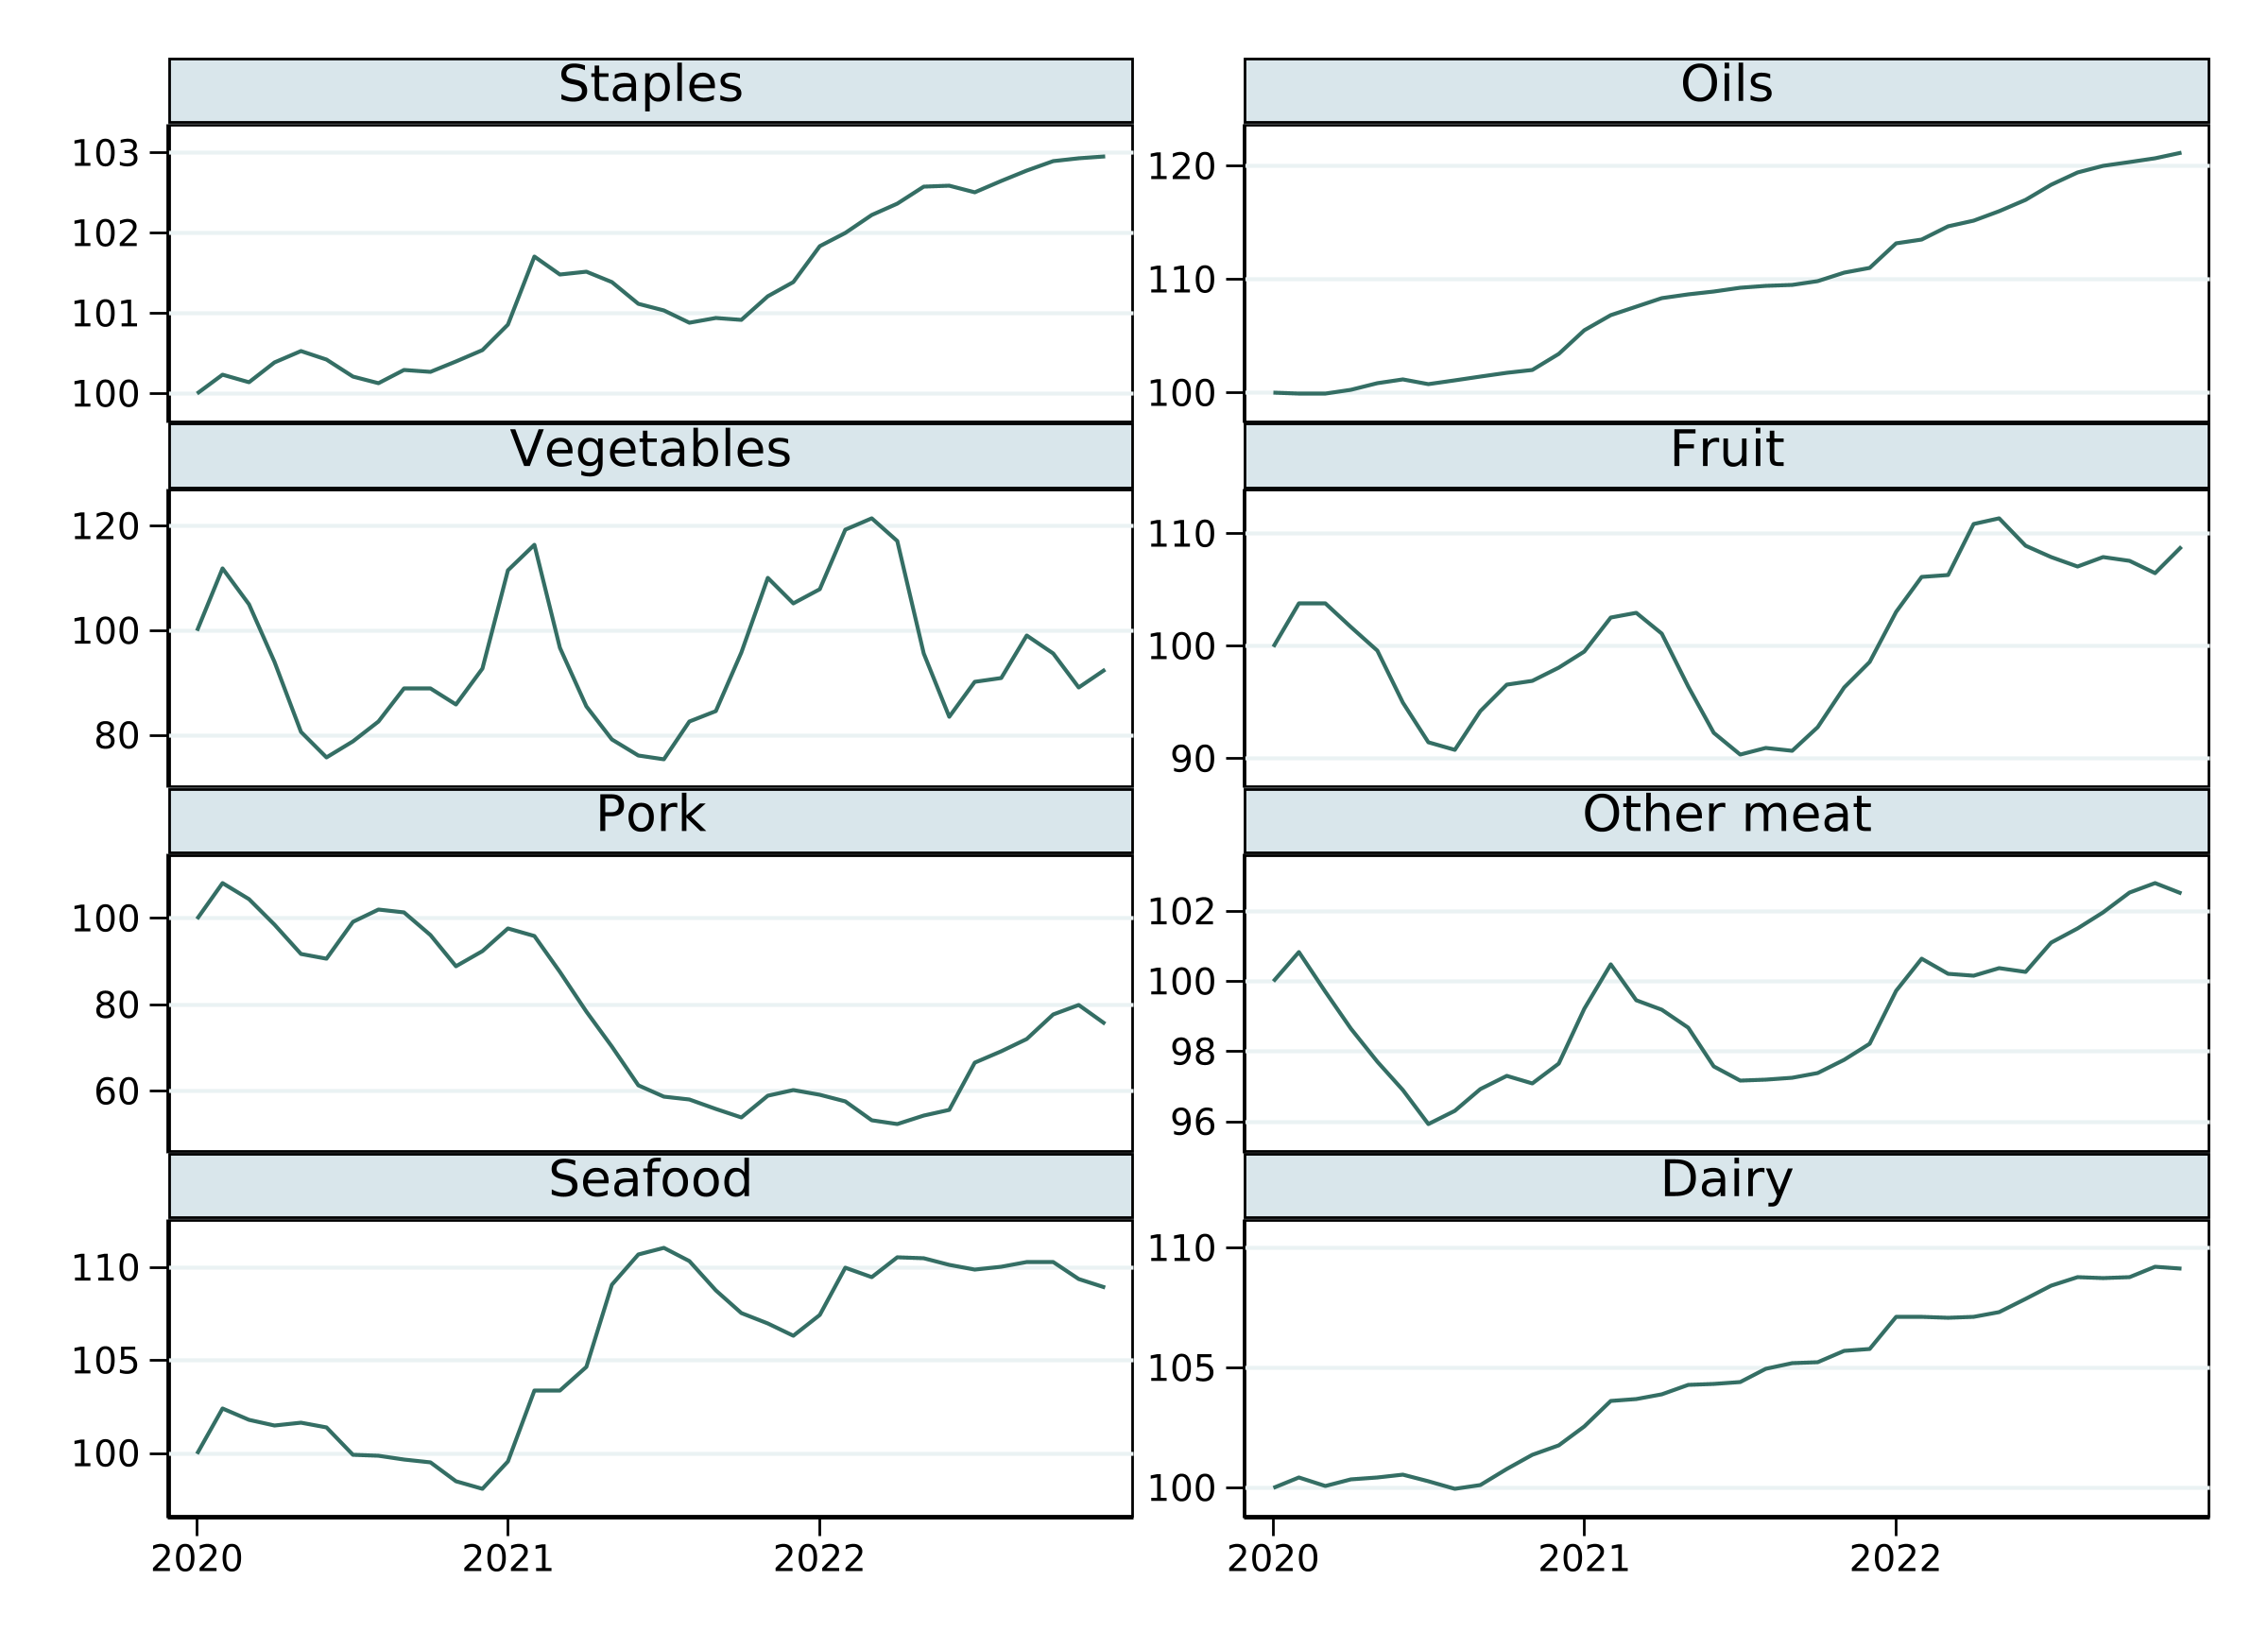
Figure 1. External price paths for eight food groups
Notes: Exponentiated equal-province mean log prices, normalized to January 2020 = 100. Panels use different vertical scales; the series are not population weighted.

2.4 Household characteristics and controls
Reported income retains five source brackets: below RMB 5,000; 5,001–7,000; 7,001–9,000; 9,001–12,000; and above 12,000. The first two define the lower-income indicator. The source does not specify the reporting period, so we retain the term reported income bracket. Assignment follows each month's record. Household-months belong to one bracket, but households changing brackets can appear in several distinct-household counts. Supplementary Table S2 reports sample sizes and expenditure.
Household-size brackets of 1–2, 3, 4, and at least 5 receive proxies of 1.5, 3, 4, and 5.5 members. All per-member measures use this proxy. The last two brackets define large households; elderly-household status follows the recorded household type. Controls also include six standardized measures covering prices, pandemic conditions, holidays, temperature, precipitation, and agricultural wholesale prices, together with calendar-month and year indicators.

3. Demand Specification and Inference

3.1 Conditional purchasing responses
Let $x_{it}$ denote expenditure on the eight groups by household $i$ in month $t$, $x_{git}$ expenditure on group $g$, and $n_{it}$ the size proxy. Then $B_{it}=x_{it}/n_{it}$ is the budget per proxy member and $w_{git}=x_{git}/x_{it}$ is the group budget share. Province refers to the household's recorded location that month. The demand subsystem maintains weak separability from excluded consumption and conditional exogeneity of the nominal food budget. An upper-stage income-to-food-budget equation is not estimated.
Overall purchasing responses allow both purchase probabilities and expenditure allocation to change, conditional on the eight-group budget. The associated food-expenditure and uncompensated price elasticities therefore describe adjustments within this sub-budget. Overall distinguishes these responses from those holding participation fixed.
Category-level monthly nonpurchases enter estimation, with purchase probabilities modeled by Probit equations. Quarterly and annual aggregates describe purchase coverage over longer active windows and complement the participation correction.

3.2 Participation-adjusted approximate EASI
We construct a Stone real-expenditure approximation using province-month mean observed shares ${\overline{w}}_{gpt}$ and use vegetables, group 3, as the relative-price reference:
$y_{it}=lnB_{it}-\sum_{g=1}^{8}{{\overline{w}}_{gpt}}l_{gpt}, r_{gpt}=l_{gpt}-l_{3pt}$ (2)
Real expenditure is log nominal expenditure per proxy member less the Stone price term. Relative prices subtract the vegetable log price. Province-month share weights vary over time, unlike the fixed within-group category weights in equation (1). Define household means ${\overline{v}}_{i}=\left({\overline{y}}_{i},{\overline{r}}_{1i},{\overline{r}}_{2i},{\overline{r}}_{4i},…,{\overline{r}}_{8i}\right)'$ over observed active months. The seven free latent-share functions are
$\begin{aligned}f_{git}=α_{g}+β_{g}y_{it}+λ_{g}y_{it}^{2}+\sum_{j≠3}{A_{gj}}r_{jpt}+y_{it}\sum_{j≠3}{C_{gj}}r_{jpt} \\ +D_{g}'z_{it}+M_{g}'{\overline{v}}_{i}+T_{g}'τ_{t}, g≠3\end{aligned}$ (3)
The latent function is the share component before the participation transformation. $z_{it}$ includes three household indicators and six auxiliary controls; $τ_{t}$ contains eleven calendar-month and two year indicators. The quadratic budget term captures Engel curvature, while budget–price interactions allow price responses to vary with the real food budget. Household means follow the correlated-heterogeneity motivation of Mundlak (1978). They are not household fixed effects; the main specification contains neither province effects nor full year-month effects.
The full eight-dimensional price matrices $A$ and $C$ are symmetric with zero row and column sums, each having 28 free parameters. Latent intercepts sum to one and other nonprice coefficients sum to zero. We call this a Stone-approximate EASI model to distinguish it from the implicit real-expenditure definition in exact EASI. Both implementations use quadratic Engel terms, but their real-expenditure and price-interaction structures differ.
Define $d_{git}=1\left(x_{git}>0\right)$, where the indicator equals one for a positive purchase of the group that month. The first stage estimates eight Probits:
$\begin{aligned}Pr\left(d_{git}=1∣V_{git}\right)=Φ\left(s_{git}\right), \\ s_{git}=a_{g}^{P}+b_{g}^{P}y_{it}+\sum_{j≠3}{ρ_{gj}^{P}}r_{jpt}+ξ_{g}'z_{it} \\ +μ_{g}'{\overline{v}}_{i}+ν_{g}'τ_{t}+γ_{g}'H_{git}\end{aligned}$ (4)
Here, $Φ$ is the standard normal distribution, $V_{git}$ the first-stage covariates, and $s_{git}$ the index. $H_{git}$ contains indicators for a recorded purchase in the previous calendar month and no visible prior purchase, together with recency $1/\left(1+Δ_{git}\right)$, where $Δ_{git}$ is months since the last visible purchase. Recency is zero without visible history, with a separate flag. If the previous month is inactive, lagged purchasing is zero, meaning no visible prior-month purchase. The first stage includes linear real expenditure and seven relative prices, but not the quadratic or budget–price interactions. Historical variables precede the current month and are excluded from share equations; Section 5 reports a specification removing these exclusions.
The second stage follows the two-step participation correction of Shonkwiler and Yen (1999):
$\begin{aligned}w_{git}=Φ\left(s_{git}\right)f_{git}+σ_{g}ϕ\left(s_{git}\right)+ε_{git}, g≠3; \\ {\hat{w}}_{3it}=1-\sum_{g≠3}{{\hat{w}}_{git}}\end{aligned}$ (5)
Here, $ϕ$ is the standard normal density, $σ_{g}$ the correction coefficient, and $ε_{git}$ the share error. Constrained feasible generalized least squares estimates seven free equations; vegetable predictions are one minus the other seven predicted shares. The second stage has 294 parameters. Because participation transformations change observed-share derivatives, restrictions on latent parameters and properties of the observed system are assessed separately.

3.3 Comparisons and elasticity evaluation
Functional-form comparisons use exact AIDS, QUAIDS, and quadratic EASI (Deaton and Muellbauer, 1980; Banks et al., 1997; Lewbel and Pendakur, 2009). All three use the same 583,668 household-months, 22 controls, and internal budget instruments, without household means, purchase histories, or participation correction. QUAIDS adds a quadratic Engel term with a specific price denominator to AIDS (Poi, 2012). Exact EASI defines real expenditure through an implicit cost function and uses a constant price matrix without the main model's budget–price interaction. Each is estimated by fixed-weight one-step GMM. Supplementary Section S2 and Table S3 give equations, instruments, and estimation information.
Comparisons among the three exact systems focus on functional form. Differences from the main model additionally involve participation, household means, and price interactions. The commodity-grouping comparison retains archived nine-group estimates and re-evaluates old and new systems on their common positive-prediction support. This holds the evaluation observations, not the estimation procedures, common and is used as an exploratory aggregation check.
Quantity equivalents per proxy member are ${\hat{q}}_{git}=B_{it}{\hat{w}}_{git}/exp\left(l_{gpt}\right)$, constructed from expenditure and group prices rather than common physical units. Shares and quantities in the following expressions are predicted. Holding other covariates and the size proxy fixed, food-expenditure elasticity $η_{git}$ and uncompensated price elasticity $e_{gj,it}^{M}$ are
$η_{git}=1+\frac{∂{\hat{w}}_{git}/∂lnB_{it}}{{\hat{w}}_{git}}, e_{gj,it}^{M}=\frac{∂{\hat{w}}_{git}/∂l_{jpt}}{{\hat{w}}_{git}}-1\left(g=j\right)$ (6)
Price derivatives hold the nominal food budget fixed. The indicator is one for an own-price response and zero for a cross-price response. For evaluation sample $S$, aggregate elasticities weight household-month responses by predicted quantity equivalents:
${\overline{e}}_{gj}^{M}=\frac{\sum_{\left(i,t\right)∈S}{{\hat{q}}_{git}}e_{gj,it}^{M}}{\sum_{\left(i,t\right)∈S}{{\hat{q}}_{git}}}, {\overline{η}}_{g}=\frac{\sum_{\left(i,t\right)∈S}{{\hat{q}}_{git}}η_{git}}{\sum_{\left(i,t\right)∈S}{{\hat{q}}_{git}}}$ (7)
Equation (7) gives the response of aggregate predicted quantity equivalents to a common proportional price or budget change. Main-model derivatives fix province-month Stone share weights and household means while allowing participation probabilities to change. All 583,668 household-months, including observed category nonpurchases, enter estimation.
Elasticity evaluation requires all eight predicted shares to exceed ${10}^{-8}$, retaining 574,172 observations, or 98.37% of the estimation sample. The three exact systems share 579,066 observations with positive predictions and valid utility inversion, or 99.21%. Predictions are neither clipped nor renormalized. Supplementary Tables S9–S11 report raw-sample responses, response margins, and prediction support.

3.4 Inference, identifying assumptions, and diagnostics
Households share external prices within province-months. Primary inference clusters by 24 provinces and propagates first-stage Probit uncertainty through second-stage parameters and elasticities using joint influence functions. We use 999 studentized Webb province-score multiplier draws for p-values and confidence intervals, and simultaneous 95% bands for the sixteen expenditure and own-price elasticities (Cameron and Miller, 2015; MacKinnon et al., 2023). Stars indicate zero-elasticity score tests at the 1%, 5%, and 10% levels; marginal and simultaneous intervals are reported separately.
Score perturbations propagate two-stage parameter uncertainty conditional on price weights, Stone weights, household means, and evaluation support. Parameter-block tests use maximum absolute-t score statistics. Exact-system quadratic-term tests divide a seven-restriction Wald statistic by seven and use an approximate F reference with (7, 23) degrees of freedom. Supplementary Tables S6–S8 report these tests and simultaneous bands.
Each group has 864 province-month price cells. Province, calendar-month, and year controls leave 4.29% of original other-meat log-price variance and 32.44% for pork. Province and full year-month effects leave 3.64% and 2.77%, respectively. Supplementary Table S1 reports this descriptive price-variation exercise; the demand model retains the calendar-month, year, and household-mean specification above.
A demand interpretation maintains that prices and the nominal food budget are conditionally uncorrelated with share errors and that purchase history enters only through participation. External prices avoid constructing unit values from each household's own expenditure but do not by themselves remove local supply–demand shocks. History may also affect amounts through inventory (Dhar et al., 2003; Hovhannisyan and Bozic, 2017). These assumptions delimit causal interpretation of the elasticities. The fixed-basket analysis in Section 4 instead uses observed shares and prices independently of the estimated substitution relationships.
Diagnostics assess prediction positivity, symmetry, and negative semidefiniteness. Household-month standardized compensation matrices are constructed from the share derivatives in equation (6) and averaged with equal household-month weights:
$\begin{aligned}S_{gj,it}=\frac{∂{\hat{w}}_{git}}{∂l_{jpt}}+\left({\hat{w}}_{git}+\frac{∂{\hat{w}}_{git}}{∂lnB_{it}}\right){\hat{w}}_{jit}-1\left(g=j\right){\hat{w}}_{git}, \\ \overline{S}=\frac{1}{\left|S\right|}\sum_{\left(i,t\right)∈S}{S_{it}}\end{aligned}$ (8)
For integrable demand, $S_{gj}=w_{g}e_{gj}^{H}$, where H denotes compensated elasticity. For the participation-adjusted system, equation (8) is a formal compensation diagnostic. We report mean-matrix asymmetry $\max_{g,j}\left|{\overline{S}}_{gj}-{\overline{S}}_{jg}\right|$ and the largest eigenvalue of its symmetric part $\left(\overline{S}+\overline{S}'\right)/2$. A positive eigenvalue indicates failure of negative semidefiniteness.

4. Price Offsets and Food-Basket Costs

4.1 Fixed-configuration accounting
Revaluing an initial configuration at alternative prices decomposes category contributions to basket costs. Let annual group prices in province $p$ and year $a$ be geometric means of monthly prices, ${\overline{P}}_{gp,a}=exp\left({12}^{-1}\sum_{t∈a}{l_{gpt}}\right)$. We use observed 2020 household-month budget shares and 2020 annual-average prices as the base, and revalue the configuration at 2022 prices:
$Δ_{gp}=\frac{{\overline{P}}_{gp,2022}}{{\overline{P}}_{gp,2020}}-1, L_{it}=\sum_{g=1}^{8}{w_{git,2020}}Δ_{gp}, ΔC_{it}^{pc}=B_{it,2020}L_{it}$ (9)
Here, $Δ_{gp}$ is the proportional, not log, group-price change. $L_{it}$ is the cost change relative to the eight-group budget and $ΔC_{it}^{pc}$ its monetary amount per proxy member. Restricting the sum to selected groups gives category contributions, all expressed as percentage points of the full food budget.
The accounting fixes base quantity equivalents using external group prices and observed shares rather than repricing individual physical transactions. Percentage and monetary changes are calculated for each household-month and averaged separately: $\overline{BL}$ generally differs from $\overline{B} \overline{L}$. The measure describes the cost of maintaining the initial basket without assuming households actually keep their purchases unchanged.

4.2 Category offsets and the distribution of basket costs
Table 2 uses 182,676 active household-months in 2020 as the base. Revaluation at 2022 prices raises average basket costs by 2.97%, or RMB 4.43 per proxy member per month. Pork contributes −4.60 percentage points and other meat 0.60, giving a net meat contribution of −4.00 points. Non-meat foods contribute 6.97 points, approximately 57.3% of which is offset by the net meat contribution (Figure 2). Cheaper pork therefore provides substantial relief without eliminating the combined increase elsewhere. Dairy contributes 1.74 percentage points, staples and oils 1.67, and vegetables, fruit, and seafood together 3.56. Supplementary Table S16 gives all eight contributions.
Table 2. Cost of 2020 food baskets revalued at 2022 prices
Reported income  (RMB) | Cost change  (%) | RMB per proxy  member/month | Meat  contribution (pp) | Dairy  contribution (pp) | Staples/oils  contribution (pp)
All | 2.97 | 4.43 | −4.00 | 1.74 | 1.67
<5000 | 2.14 | 2.04 | −4.47 | 1.59 | 1.56
5001—7000 | 2.36 | 2.96 | −4.32 | 1.62 | 1.64
7001—9000 | 2.72 | 3.87 | −4.16 | 1.75 | 1.68
9001—12000 | 3.19 | 5.28 | −3.87 | 1.74 | 1.69
>12000 | 3.75 | 6.22 | −3.56 | 1.86 | 1.72
Notes: 182,676 active household-months in 2020. Percentage costs and contributions use the eight-group budget as denominator; monetary costs use the size proxy. Meat combines pork and other meat. Unlisted components are vegetables, fruit, and seafood. Percentage and monetary amounts are averaged separately after household-month calculation.
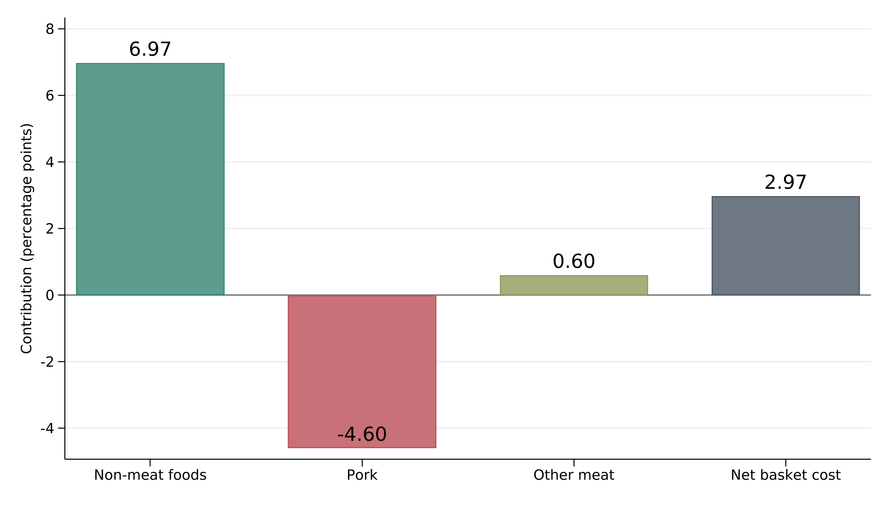
Figure 2. Price contributions to the cost of the 2020 food basket
Notes: Same 2020 baseline as Table 2. Bars are percentage-point contributions; non-meat includes six food groups. Net cost is the sum of all three category contributions.
A higher mean does not imply that every basket becomes more expensive. Cost changes are −7.29% at the tenth percentile and 11.75% at the ninetieth percentile. These percentiles describe the household-month cost distribution, not a confidence interval for the mean. Basket composition and provincial price paths jointly determine the extent of the offset, producing cost experiences that differ substantially around the average.
The lowest and highest reported income brackets have cost changes of 2.14% and 3.75%, or RMB 2.04 and RMB 6.22 per proxy member per month. Meat contributes −4.47 and −3.56 percentage points, while dairy contributes 1.59 and 1.86. Under this historical price combination, the lower bracket receives a larger meat-price offset and the higher bracket has a larger dairy contribution.
These bracket comparisons use the eight-group food budget as denominator and combine basket composition with provincial composition; they are not costs relative to income. The next subsection applies equal-sized category-price changes to examine how the ranking depends on the price combination.

4.3 Equal-sized category-price increases
Setting category-price increases to 10% makes their budget-weight implications comparable. Across all 583,668 active household-months, a meat-only increase raises average basket costs by 2.57%, a dairy-only increase by 1.88%, and a staples-and-oils increase by 1.72%. A uniform eight-group increase raises costs by 10% by construction, or RMB 21.71 per proxy member per month.
Table 3 shows that the income-bracket ranking changes with the category. A dairy increase raises costs by 1.77% in the lowest bracket and 1.97% in the highest; staples and oils give 1.73% and 1.69%; meat gives 2.58% and 2.57%. The higher bracket's larger cost change under the historical combination therefore does not generalize to every category shock.
Table 3. Fixed-basket costs of 10% food-group price increases
Reported income  (RMB) | All eight  groups (%) | Meat  (%) | Dairy  (%) | Staples/oils  (%)
All | 10.00 | 2.57 | 1.88 | 1.72
<5000 | 10.00 | 2.58 | 1.77 | 1.73
5001—7000 | 10.00 | 2.59 | 1.79 | 1.75
7001—9000 | 10.00 | 2.57 | 1.88 | 1.74
9001—12000 | 10.00 | 2.55 | 1.91 | 1.71
>12000 | 10.00 | 2.57 | 1.97 | 1.69
Notes: All 583,668 active household-months during 2020–2022. Columns are separate scenarios; selected group prices rise 10% and other prices are unchanged. Configurations are fixed and costs are percentages of the eight-group budget. Meat combines pork and other meat.
The category decomposition and scenarios reveal the variation behind an average food-price movement: which foods rise, which fall, and what households initially purchase jointly determine fixed-configuration costs. This is price pressure before purchasing adjustment. The next section examines the direction and magnitude of purchasing responses to prices and budgets.

5. Household Purchasing Responses

5.1 Food-budget allocation and own-price responses
Table 4 shows substantial reallocation as the food budget expands. Food-expenditure elasticities are 1.268 for other meat and 1.213 for oils, with 95% intervals above one, compared with 0.668 for vegetables and 0.885 for fruit, with intervals below one. Staples, pork, seafood, and dairy are close to unit elasticity and their intervals include one. These within-budget responses complement the evidence on the cost of existing baskets in Section 4.
Table 4. Food-expenditure and own-price elasticities
Food group | Expenditure  elasticity | SE | 95% interval | Own-price  elasticity | SE | 95% interval
Staples | 1.012*** | 0.025 | [0.964, 1.060] | −1.503*** | 0.320 | [−2.118, −0.888]
Oils | 1.213*** | 0.027 | [1.163, 1.262] | −0.496* | 0.297 | [−1.047, 0.055]
Vegetables | 0.668*** | 0.023 | [0.622, 0.713] | −0.860*** | 0.153 | [−1.130, −0.590]
Fruit | 0.885*** | 0.018 | [0.850, 0.920] | −1.140*** | 0.075 | [−1.278, −1.002]
Pork | 1.026*** | 0.028 | [0.971, 1.081] | −0.698*** | 0.051 | [−0.797, −0.600]
Other meat | 1.268*** | 0.028 | [1.218, 1.317] | −1.059*** | 0.324 | [−1.648, −0.470]
Seafood | 0.991*** | 0.012 | [0.969, 1.013] | −0.931*** | 0.169 | [−1.242, −0.620]
Dairy | 0.962*** | 0.024 | [0.918, 1.007] | −0.972*** | 0.285 | [−1.515, −0.429]
Notes: 574,172 common positive-prediction household-months; predicted quantity-equivalent weights. Standard errors cluster by 24 provinces and incorporate participation-stage uncertainty. Marginal 95% intervals use 999 studentized Webb score draws. ***, **, and * indicate zero-elasticity tests at 1%, 5%, and 10%. The oil own-price p-value is 0.077; its 95% interval includes zero.
Holding other covariates and the size proxy fixed, a local 1% increase in the food budget corresponds to approximately 1.268% more predicted other-meat purchases and 0.668% more vegetable purchases in quantity-equivalent terms. Budget changes thus alter the composition as well as the scale of food purchases.
All eight own-price point estimates are negative. They are −1.503 for staples, −1.140 for fruit, −1.059 for other meat, −0.698 for pork, −0.860 for vegetables, −0.931 for seafood, −0.972 for dairy, and −0.496 for oils. Seven are significant at 1%; oils are significant at 10%. Conditional on the food budget, higher own prices correspond to lower predicted quantity-equivalent purchases. Cross-category magnitude rankings are descriptive point-estimate comparisons.
Figure 3 reports province two-step marginal 95% intervals. Marginal and simultaneous own-price intervals lie below zero for seven groups. Oils are estimated less precisely, with a 95% interval covering zero. Supplementary Table S8 gives simultaneous bands for all sixteen main elasticities.
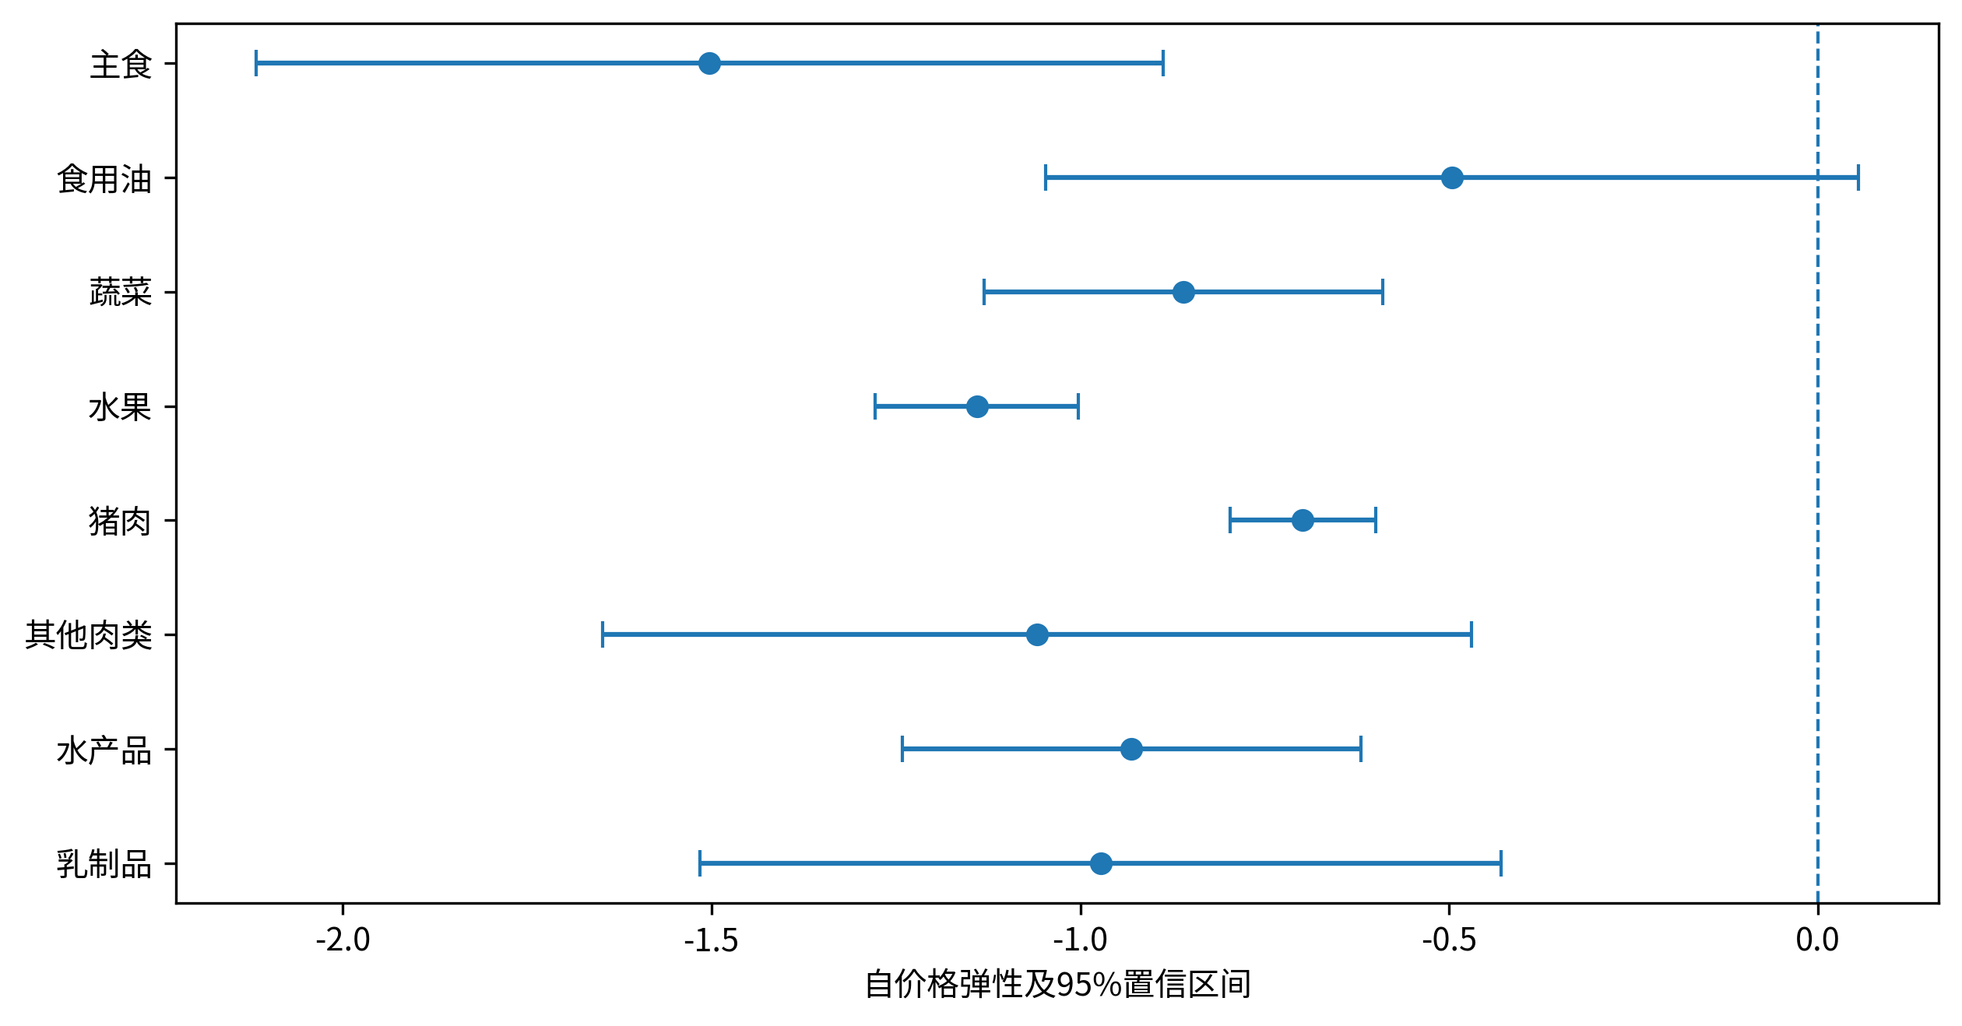
Figure 3. Own-price elasticities and province two-step 95% confidence intervals
Notes: Evaluation sample and inference follow Table 4. The dashed line marks zero; horizontal lines are marginal 95% intervals.

5.2 Purchasing frequency and recording windows
Purchasing responses occur at particular shopping dates. The relatively large monthly staple response and low oil purchase incidence make longer recording windows informative. Inventory research shows that short-run purchasing and longer-run consumption responses can differ for storable products (Hendel and Nevo, 2006, 2013). Table 5 aggregates the same transactions to active household-quarters and household-years to describe this timing dimension.
Table 5. Purchase incidence across active recording windows
Food group | Monthly (%) | Quarterly (%) | Annual (%)
Staples | 59.29 | 85.93 | 95.55
Oils | 33.50 | 63.25 | 88.86
Vegetables | 83.20 | 92.62 | 96.97
Fruit | 83.40 | 94.04 | 97.69
Pork | 62.48 | 81.97 | 92.54
Other meat | 58.34 | 80.18 | 92.63
Seafood | 53.35 | 73.34 | 87.57
Dairy | 70.95 | 91.08 | 96.71
Notes: A window enters the denominator if it contains at least one positive food purchase. There are 583,668 active household-months, 203,337 household-quarters, and 58,150 household-years. Median active months per window are 1, 3, and 12, respectively. Sample composition differs across windows.
Other-meat coverage rises from 58.34% monthly to 80.18% quarterly and 92.63% annually. Oils rise from 33.50% to 63.25% and 88.86%, and staples from 59.29% to 85.93% and 95.55%. Vegetables and fruit already have monthly incidence above 83%, so extending the window adds less coverage.
For oils and staples, frequent monthly zeros therefore coexist with widespread purchasing over longer periods. Monthly price responses combine purchasing allocation and timing. An absence of recorded purchasing in one month is not sufficient evidence of a persistent absence of demand for that food.
Each window uses its own active sample, so differences reflect aggregation and sample composition. The comparison describes purchasing frequency rather than estimating inventory holdings or long-run consumption elasticities.

5.3 Functional form, commodity aggregation, and specification sensitivity
Tests support nonlinear budget responses. The main-model maximum absolute-t score test for removing quadratic Engel terms has p = 0.001. Exact QUAIDS and EASI give approximate F statistics of 84.47 and 88.29 with (7, 23) reference degrees of freedom. Supplementary Tables S6–S7 report details.
Supplementary Tables S4–S5 compare the exact systems with the main model. Exact-system expenditure elasticities are approximately 1.22–1.26 for other meat and 0.90 for fruit, consistent with the main model's direction of nonproportional budget allocation. Some foods are more specification sensitive: vegetables have elasticity 0.668 in the main model and approximately 0.946–1.015 in exact systems; oils change from 1.213 to 1.083, 0.932, and 0.931.
Exact-system other-meat own-price point estimates are −0.447, −0.462, and −0.473, smaller in absolute value than the participation-adjusted main estimate. All own-price point estimates remain negative, but differences involve participation treatment, household means, and price interactions together and cannot be attributed to one correction alone.
Commodity comparisons further illustrate the relevance of group boundaries. In earlier nine-group estimates, poultry/miscellaneous-meat own-price responses were close to zero and positive in all three exact systems, whereas beef/mutton responses were negative. The exploratory eight-group re-estimation prompted by those diagnostics reconstructs shares, prices, and histories and yields negative responses for combined other meat (Table 6). It does not average the two original elasticities.
Table 6. Meat own-price responses before and after exploratory aggregation
Exact model | Original  poultry | Original  beef/mutton | Combined  other meat | Combined,  matched sample
AIDS | 0.023 | −1.118 | −0.447 | −0.447
QUAIDS | 0.028 | −1.108 | −0.462 | −0.463
Exact EASI | 0.026 | −1.122 | −0.473 | −0.474
Notes: The original poultry group includes miscellaneous meat. The first two columns use common positive-prediction support for the nine-group exact systems; the third uses support for the eight-group systems. The final column re-evaluates the eight-group systems on the six-system intersection of 569,808 household-months, keeping estimated parameters unchanged. Entries are point estimates; negative own-price responses were not imposed.
Re-evaluation on the six-system intersection leaves the original and combined groups' sign difference intact, indicating that evaluation-sample changes are not the whole explanation. Product scope and the price proxy change together, and the classification was selected after earlier diagnostics. The comparison therefore documents aggregation sensitivity rather than upward-sloping poultry demand or resolution of identification problems (Eales and Unnevehr, 1988; Gallet, 2010).
Table 7 reports five specification changes. Relative to the quadratic baseline, linear Engel terms produce a maximum expenditure-elasticity change of 0.436 and cubic terms 0.125. Removing participation correction or purchase-history exclusions changes own-price elasticities by at most 0.387 and 0.406; other-meat estimates become −0.980 and −1.137. The no-correction specification re-estimates parameters rather than simply removing the original fitted participation transformation.
Table 7. Main-model specification sensitivity
Specification | Positive  prediction N | Coverage  (%) | Maximum  own-price change | Maximum  expenditure change
Quadratic baseline | 574,172 | 98.37 | 0.000 | 0.000
Linear Engel | 574,757 | 98.47 | 0.128 | 0.436
Cubic Engel | 573,762 | 98.30 | 0.032 | 0.125
No participation  correction | 575,519 | 98.60 | 0.387 | 0.079
No history  exclusions | 580,004 | 99.37 | 0.406 | 0.064
Pork omitted | 572,821 | 98.14 | 0.237 | 0.031
Notes: All specifications are re-estimated on 583,668 household-months and evaluated on their own common positive-prediction samples. Maximum differences are the largest absolute changes across eight groups relative to the baseline, combining specification and evaluation-support differences. They are not significance tests. Own-price point estimates remain negative and expenditure estimates positive.
Changing the residual-share equation from vegetables to pork produces a maximum own-price difference of 0.237, with other meat at −1.230. All five re-estimations retain negative own-price and positive expenditure point estimates, although magnitudes vary. Supplementary Table S14 reports category-level results.

5.4 Reported-income comparisons and system diagnostics
Evaluating the same full-sample model within reported income brackets gives staple expenditure elasticities of 1.045 and 0.954 in the lowest and highest brackets, vegetable elasticities of 0.600 and 0.750, and dairy elasticities of 0.995 and 0.915. Other meat gives 1.280 and 1.262, with own-price estimates close to −1.059 in both brackets (Supplementary Table S13). There is no common direction of bracket differences across foods.
These conditional responses provide different information from basket costs in Section 4. Responses evaluate one model over different household compositions; costs directly combine observed shares and provincial price paths. Cost rankings are not inferred from elasticity rankings, and cross-bracket elasticity differences have not been jointly tested.
Model diagnostics consider prediction support and theoretical properties. Common positive-prediction coverage is 98.37%; vegetables have a 1.518% negative-prediction rate. Removing participation transformations while fixing the original parameters gives 57.33% common positive support, which differs from re-estimating the no-correction specification in Table 7. Supplementary Tables S10–S11 report support and response margins.
In Table 8, the main model's mean formal-compensation matrix has asymmetry 0.095858 and largest symmetric-part eigenvalue 0.022460. The exact systems' mean matrices are symmetric at exported precision but have largest eigenvalues around 0.046. These matrices fail negative-semidefiniteness diagnostics. We consequently use the demand estimates for conditional purchasing responses and retain observed-share accounting for basket costs.
Table 8. Mean standardized compensation-matrix diagnostics
Model | Positive  prediction N | Mean-matrix  asymmetry | Maximum  eigenvalue
Participation-  adjusted EASI | 574,172 | 0.095858 | 0.022460
AIDS | 579,066 | 0.000000 | 0.045870
QUAIDS | 579,066 | 0.000000 | 0.046260
Exact EASI | 579,066 | 0.000000 | 0.045907
Notes: Household-month matrices are averaged with equal weights on each model's evaluation sample. The main model is a formal compensation diagnostic. Maximum eigenvalues refer to the symmetric part; positive values indicate failure of negative semidefiniteness. Asymmetry is shown to six decimals.
Supplementary Table S12 reports uncompensated cross-price estimates. Taken together, the demand and basket-cost results show how initial allocation determines the first-round category costs while purchasing responses characterize adjustment directions within a given food budget. Neither result substitutes for the other.

6. Discussion and Conclusion

6.1 Main findings
The link between food-price movements and household food costs depends on the entire basket. Our evidence shows that cheaper pork during 2020–2022 provided a substantial offset but did not make the average sampled basket cheaper. At the 2020 configuration, pork contributes −4.60 percentage points and other meat 0.60; their net contribution offsets approximately 57.3% of the non-meat increase, yet basket costs rise by 2.97%. The tenth-to-ninetieth-percentile range extends from −7.29% to 11.75%. Neither a single commodity's price decline nor the average basket change captures this variation.
Purchasing responses provide complementary adjustment information. Conditional on the eight-group budget, expenditure elasticities exceed one for other meat and oils and are below one for vegetables and fruit. Seven own-price 95% intervals lie below zero. Oils and staples have much greater purchase coverage over longer windows than in monthly records. Short-run transactions therefore reflect purchasing timing as well as expenditure allocation, making purchasing frequency relevant to food-demand monitoring.
The paper adds evidence on category offsets and household-level dispersion under the observed price combination, and on how income-bracket cost rankings change with price scenarios. It also connects category purchasing elasticities to purchase coverage over longer windows. Demand-system and aggregation comparisons show that the magnitudes of short-run adjustments also depend on commodity boundaries and specification.
Three scope limitations matter. Transactions cover a food sub-budget and provincial composite prices incompletely capture quality and channels. Causal interpretation of demand elasticities requires the price, food-budget, and participation-exclusion assumptions. The estimated systems also fail the reported mean-matrix curvature diagnostic. Accordingly, the cost evidence measures fixed-basket price pressure and the elasticities describe conditional purchasing responses. Future work combining complete food expenditure, inventories, independent price shocks, and finer purchasing-channel information could examine how these short-run pressures and adjustments translate into living costs and nutrition.

6.2 Implications for food-market monitoring
Food-cost monitoring should report category contributions alongside prominent commodity prices. Linking baseline household baskets to comparable price paths and displaying total costs, offsets, and their distribution can identify situations in which cheaper pork coexists with a costlier basket. Separate category-price scenarios also help avoid treating a historical income-bracket ranking as a general distributional result.
Demand monitoring should pair monthly purchase incidence with coverage over longer windows. For oils and staples, quarterly and annual records help distinguish short-run nonpurchase from sustained purchasing contraction and provide information on procurement timing for production, processing, and distribution decisions.
More complete dairy prices, exact household size, and income with a clear reporting period would improve comparability. Linking these records to total living expenditure and actual prices paid is the next step toward using food-basket monitoring in assessments of household support and nutrition.

References
Aguiar, M., & Hurst, E. (2007). Life-Cycle Prices and Production. American Economic Review, 97(5), 1533–1559. doi: 10.1257/aer.97.5.1533.
Argente, D., & Lee, M. (2021). Cost of Living Inequality During the Great Recession. Journal of the European Economic Association, 19(2), 913–952. doi: 10.1093/jeea/jvaa018.
Bai, J., Seale, J. L., Jr., & Wahl, T. I. (2020). Meat Demand in China: To Include or Not to Include Meat Away from Home?. Australian Journal of Agricultural and Resource Economics, 64(1), 150–170. doi: 10.1111/1467-8489.12362.
Banks, J., Blundell, R., & Lewbel, A. (1997). Quadratic Engel Curves and Consumer Demand. The Review of Economics and Statistics, 79(4), 527–539. doi: 10.1162/003465397557015.
Cameron, A. C., & Miller, D. L. (2015). A Practitioner’s Guide to Cluster-Robust Inference. Journal of Human Resources, 50(2), 317–372. doi: 10.3368/jhr.50.2.317.
Chen, D., Abler, D., Zhou, D., Yu, X., & Thompson, W. (2016). A Meta-analysis of Food Demand Elasticities for China. Applied Economic Perspectives and Policy, 38(1), 50–72. doi: 10.1093/aepp/ppv006.
Deaton, A., & Muellbauer, J. (1980). An Almost Ideal Demand System. American Economic Review, 70(3), 312–326.
Dhar, T., Chavas, J.-P., & Gould, B. W. (2003). An Empirical Assessment of Endogeneity Issues in Demand Analysis for Differentiated Products. American Journal of Agricultural Economics, 85(3), 605–617. doi: 10.1111/1467-8276.00459.
Eales, J. S., & Unnevehr, L. J. (1988). Demand for Beef and Chicken Products: Separability and Structural Change. American Journal of Agricultural Economics, 70(3), 521–532. doi: 10.2307/1241490.
Fan, S., Wailes, E. J., & Cramer, G. L. (1995). Household Demand in Rural China: A Two-Stage LES-AIDS Model. American Journal of Agricultural Economics, 77(1), 54–62. doi: 10.2307/1243888.
Gallet, C. A. (2010). Meat Meets Meta: A Quantitative Review of the Price Elasticity of Meat. American Journal of Agricultural Economics, 92(1), 258–272. doi: 10.1093/ajae/aap008.
Hendel, I., & Nevo, A. (2006). Measuring the Implications of Sales and Consumer Inventory Behavior. Econometrica, 74(6), 1637–1673. doi: 10.1111/j.1468-0262.2006.00721.x.
Hendel, I., & Nevo, A. (2013). Intertemporal Price Discrimination in Storable Goods Markets. American Economic Review, 103(7), 2722–2751. doi: 10.1257/aer.103.7.2722.
Hovhannisyan, V., & Bozic, M. (2017). Price Endogeneity and Food Demand in Urban China. Journal of Agricultural Economics, 68(2), 386–406. doi: 10.1111/1477-9552.12175.
Hovhannisyan, V., Mendis, S., & Bastian, C. (2019). An Econometric Analysis of Demand for Food Quantity and Quality in Urban China. Agricultural Economics, 50(1), 3–13. doi: 10.1111/agec.12461.
Jaravel, X. (2019). The Unequal Gains from Product Innovations: Evidence from the U.S. Retail Sector. The Quarterly Journal of Economics, 134(2), 715–783. doi: 10.1093/qje/qjy031.
Kaplan, G., & Schulhofer-Wohl, S. (2017). Inflation at the Household Level. Journal of Monetary Economics, 91, 19–38. doi: 10.1016/j.jmoneco.2017.08.002.
Lewbel, A., & Pendakur, K. (2009). Tricks with Hicks: The EASI Demand System. American Economic Review, 99(3), 827–863. doi: 10.1257/aer.99.3.827.
MacKinnon, J. G., Nielsen, M. Ø., & Webb, M. D. (2023). Cluster-Robust Inference: A Guide to Empirical Practice. Journal of Econometrics, 232(2), 272–299. doi: 10.1016/j.jeconom.2022.04.001.
Mundlak, Y. (1978). On the Pooling of Time Series and Cross Section Data. Econometrica, 46(1), 69–85. doi: 10.2307/1913646.
Poi, B. P. (2012). Easy Demand-System Estimation with quaids. The Stata Journal, 12(3), 433–446. doi: 10.1177/1536867X1201200306.
Shonkwiler, J. S., & Yen, S. T. (1999). Two-Step Estimation of a Censored System of Equations. American Journal of Agricultural Economics, 81(4), 972–982. doi: 10.2307/1244339.
Yu, X., & Abler, D. (2009). The Demand for Food Quality in Rural China. American Journal of Agricultural Economics, 91(1), 57–69. doi: 10.1111/j.1467-8276.2008.01159.x.

