Monthly Food Purchases, Commodity Aggregation, and Price Exposure in China: An Eight-Group Comparison of EASI, AIDS, and QUAIDS
Author names, affiliations, and funding information to be supplied for submission.

Abstract
Using 583,668 active household-months from 27,638 households in 24 provincial regions during 2020–2022, this paper links household food transactions to external provincial prices and studies conditional food purchasing and basket-price exposure. Eight groups cover staples, oils, vegetables, fruit, pork, other meat, seafood, and dairy. Other meat combines poultry, beef, mutton, and the original miscellaneous-meat category. A participation-adjusted Stone-approximate EASI system is compared with exact AIDS, QUAIDS, and quadratic EASI systems under a common specification. All eight main-model own-price point estimates are negative. Other meat has an uncompensated own-price elasticity of −⁠1.059, a province two-step 95% interval of [−⁠1.648, −⁠0.470], and a food-expenditure elasticity of 1.268. Its own-price elasticities in the three exact models are −0.447, −0.462, and −0.473, compared with positive poultry responses under the original nine-group classification. This sign difference persists when evaluated on identical household-months. Tests favor retaining quadratic Engel terms under the maintained assumptions, while the evaluated systems still fail aggregate curvature diagnostics. Purchase incidence rises substantially at quarterly and annual frequencies, limiting the interpretation of monthly nonpurchase as nonconsumption. Revaluing recorded 2020 configurations at 2022 group prices yields average fixed-basket exposure of 2.97% of the eight-group food budget, or 4.43 yuan per proxy household member per month. The analysis separates conditional purchase responses, sensitivity to commodity boundaries, and basket affordability, and retains explicit qualifications concerning budget exogeneity, price measurement, participation, and theoretical regularity.
Keywords: Food purchases; EASI; AIDS; QUAIDS; commodity aggregation; nonpurchase; price exposure.
JEL codes: D12; Q11; Q18; C33.

1. Introduction
Food-price changes affect households through the composition of their purchases and their capacity to adjust. A household may consume a food without purchasing it in a particular month, or purchase larger quantities when prices are favorable. Monthly transaction data therefore reflect purchase timing and inventories as well as food allocation. Demand systems place these purchases within a common budget, but interpretation as consumption substitution or welfare change also requires credible price measurement, budget identification, and theoretical regularity.
This paper uses CCTV household food transaction records to study purchasing conditional on the observed food budget. AIDS, QUAIDS, and EASI offer alternative Engel and price structures. Deaton and Muellbauer (1980) introduced AIDS; Banks et al. (1997) developed QUAIDS; Lewbel and Pendakur (2009) formulated EASI implicit Marshallian demand. We implement these systems in Stata/Mata, distinguish participation-adjusted Stone-approximate EASI from exact structural models, and compare their expenditure responses, price responses, and prediction support.
Commodity definitions matter for transaction-based demand measurement. Poultry and beef/mutton are distinct foods, yet their separate monthly purchase incidence is limited and the recorded purchasing mix does not perfectly match external category prices. Fine classification may leave responses dependent on sparse local purchases and price proxies; broad classification suppresses within-group substitution. We combine poultry, beef, mutton, and original miscellaneous meat into “other meat,” while disclosing results from the previous nine-group system. The resulting elasticity concerns a composite food group and cannot be interpreted as the elasticity of poultry alone.
The merger was motivated by positive poultry own-price point estimates in the nine-group exact systems. The eight-group baseline is consequently a revised exploratory specification rather than a classification validated independently of the earlier diagnostics. We neither impose negative own-price elasticities nor average the two previous meat elasticities. Shares, participation indicators, prices, Stone variables, and purchase histories are reconstructed before re-estimation. Matched-support comparisons check whether changes in the elasticity evaluation sample explain the sign difference.
Three further issues determine the scope of interpretation. First, transaction unit values combine market prices, quality, and composition, as discussed by Deaton (1988). External provincial prices reduce a direct mechanical link to each household’s expenditure but may still covary with local demand shocks. Research on price endogeneity in Chinese food demand (Hovhannisyan and Bozic, 2017) underscores why an external source alone does not establish exogeneity.
Second, a zero transaction is nonpurchase and need not be nonconsumption. Studies of zero expenditure and food demand address this distinction and related censoring problems (Deaton and Irish, 1984; Yen et al., 2004). Purchase history predicts participation but may affect current amounts through inventory. Relevance in the participation equation does not establish exclusion from the share equation. We examine alternative participation specifications and describe incidence at longer recording windows.
Third, the total food budget may respond to unobserved preferences and short-run shocks. Flexible Engel curves, household means, and numerical convergence do not resolve budget endogeneity. The reported elasticities are conditional on a given food budget. The internal budget instruments in the exact systems also maintain an exogenous nominal-budget assumption. These considerations motivate separating fixed-basket price exposure from welfare measures that depend on substitution structure.
Existing work applies EASI to Chinese food prices and welfare (Hovhannisyan and Shanoyan, 2020). Our transaction unit and restricted budget differ, and our comparison brings purchase participation, composite price measurement, and diagnostics of the actual prediction functions together. Expenditure divided by a group price yields a quantity equivalent, which does not establish changes in physical or nutritional intake. The distinction between quantity and quality remains relevant (Hovhannisyan et al., 2019).
The paper first describes the data and eight-group prices, then presents demand systems and inference. It reports purchase responses, the classification comparison, specification sensitivity, and regularity diagnostics before examining basket affordability and its limitations.

2. Data, Commodity Classification, and Prices

2.1 Transaction sample and the conditional food budget
The observation period is January 2020 through December 2022. Records contain household identifiers, transaction dates, provinces, categories, expenditure, and quantities, alongside reported income brackets, household-size brackets, and household types. The archived ten-group mapping contains 10,420,107 transactions. The conditional food budget includes 10,134,495 records and excludes nuts. Combining the original poultry/miscellaneous-meat group with beef/mutton changes neither transactions nor household-month total food expenditure.
Positive recorded expenditure is aggregated by household, month, and food group. Unrecorded groups within active household-months receive zero expenditure. Months without any transaction in the studied foods are not inserted as observed zero-budget months. The retained eight-group budget is positive in all 583,668 household-months, comprising 27,638 households, 24 provincial regions, and 36 calendar months. This yields 4,669,344 household-month-group cells. Household attributes follow the last recorded transaction in the month.
The maximum absolute share adding-up error is $4.44×{10}^{−16}$. Mean monthly household food expenditure is 457.29 yuan and the median is 340.00 yuan. The mean per proxy household member is 217.14 yuan. This budget does not cover all foods or total household consumption and cannot recover complete expenditure on eating out.
Dairy and fruit have the largest mean budget shares, 18.85% and 16.87% (Table 1). Other meat accounts for 13.20% and is purchased in 58.34% of active household-months. Its merger therefore leaves 41.66% of active months without a recorded purchase. Vegetable and fruit incidence exceeds 83%, whereas oil incidence is 33.50%. Aggregation reduces meat nonpurchase without removing the monthly-zero problem.
Table 1. Budget shares and purchase incidence for eight food groups
Food group | Budget share % | Monthly purchase % | Share if purchased % | Share SD
Staples | 9.48 | 59.29 | 15.99 | 0.155
Oils | 7.70 | 33.50 | 23.00 | 0.154
Vegetables | 12.50 | 83.20 | 15.02 | 0.131
Fruit | 16.87 | 83.40 | 20.23 | 0.175
Pork | 12.51 | 62.48 | 20.02 | 0.153
Other meat | 13.20 | 58.34 | 22.63 | 0.169
Seafood | 8.89 | 53.35 | 16.67 | 0.126
Dairy | 18.85 | 70.95 | 26.57 | 0.230
Notes: The denominator is 583,668 active household-months. Shares conditional on purchase average only observations with positive purchases in the relevant group.

2.2 Household characteristics and reported income
Reported income brackets are below 5,000 yuan, 5,001–7,000, 7,001–9,000, 9,001–12,000, and above 12,000. They are not sample quintiles. The source does not provide a verifiable income reporting period, so these brackets are not relabeled monthly or annual income. The first two form the main low-income indicator. Households may change brackets; assignment uses the current month, and distinct-household counts can overlap across brackets.
Household-size brackets of 1–2, 3, 4, and at least 5 use proxies of 1.5, 3, 4, and 5.5 members. The large-household indicator covers the last two brackets; elderly-household status follows recorded household type. Per-capita expenditure and exposure thus refer to a size proxy, rather than an exact member count. No verifiable population expansion weights are supplied; sample means do not identify national population parameters.

2.3 External group prices and the meat merger
Archived grain-retail and urban food-retail monitoring series supply external prices. Available markets and dates are aggregated to province-month category prices. Fifteen transaction categories have external observations; national averages and cross-group substitutions are not used. Group log prices are fixed-weight geometric indices:
ℓgpt=c∈g​ωcg,2021logPcpt,ωcg,2021=Ec,2021k∈g, priced​Ek,2021 (1)
Here $E_{c,2021}$ denotes positive expenditure on priced categories in 2021. Weights remain fixed across provinces and months. New other-meat weights are normalized jointly across poultry, beef, mutton, and original miscellaneous meat. At the original group level, poultry/miscellaneous meat and beef/mutton contribute 40.2473% and 59.7527%, giving
$$ℓ_{6pt}^{(8)}=0.402473 ℓ_{6pt}^{(9)}+0.597527 ℓ_{7pt}^{(9)} (2)$$
The new index is constructed from original category prices and renormalized weights; equation (2) is checked for numerical equivalence. The six unaffected prices retain their definitions, while seafood and dairy become groups 7 and 8. The complete grid contains $24×36×8=6,912$ cells without missing prices for retained household-months.
Priced categories cover 90.06% of staple expenditure and 62.23% of dairy expenditure in 2021, and 100% in the other six accounting groups. Dairy prices chiefly correspond to independently priced milk and adult milk powder, although the budget also includes other dairy products. Accounting coverage does not guarantee matching of every brand, quality, or channel. Nuts are excluded rather than assigned an oil price proxy.
These composite prices are fixed-basket measurement proxies, not empirically validated exact group cost-of-living functions. Broader aggregation imposes stronger within-group requirements and suppresses identification of poultry–beef/mutton substitution. Figures 1 and 2 show prices, shares, and nonpurchase.
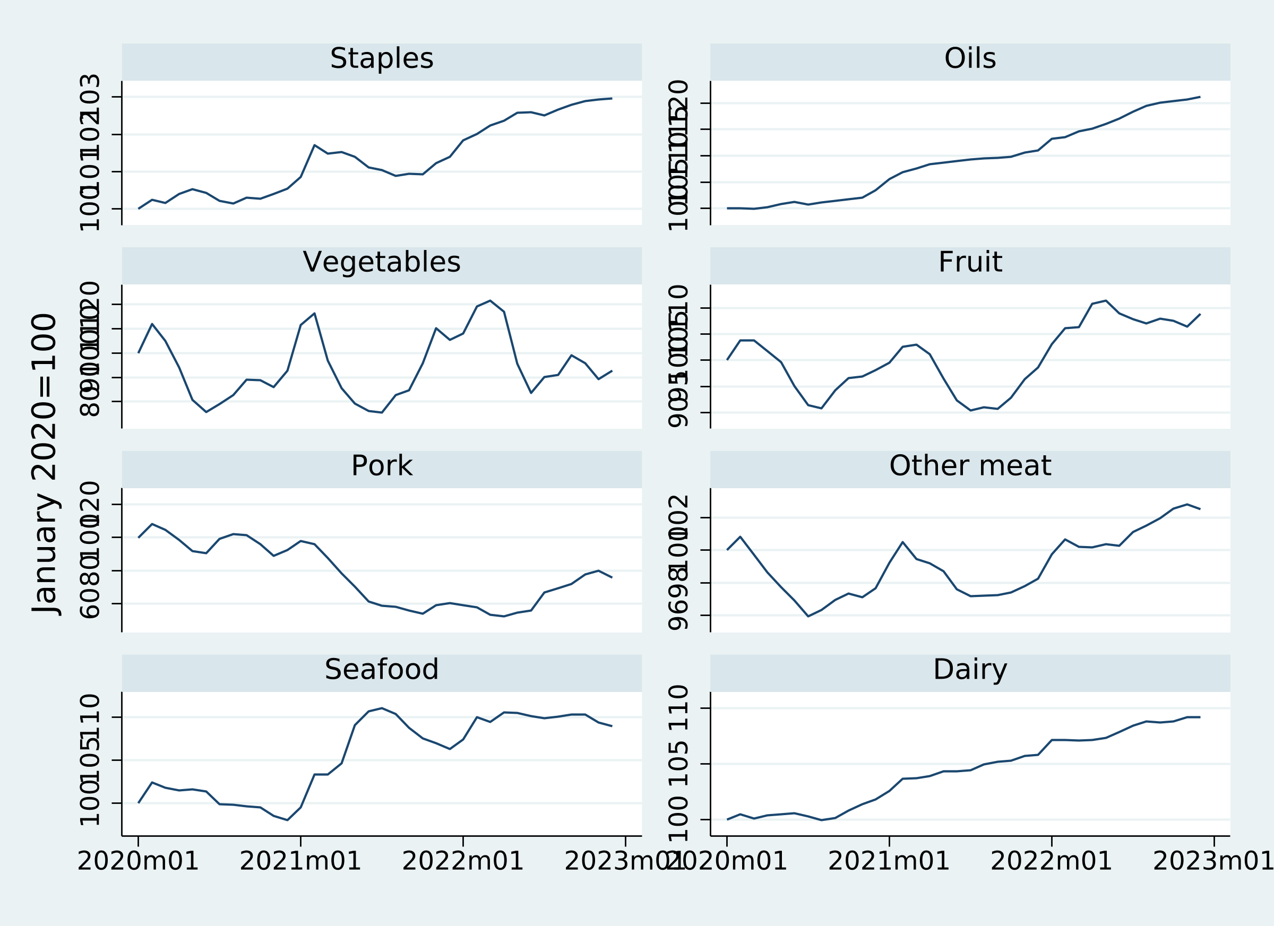
Figure 1. External prices for eight food groups
Notes: Exponentiated equal-province mean group log prices, normalized to January 2020 = 100. Panels use different vertical scales; no population weighting is implied.
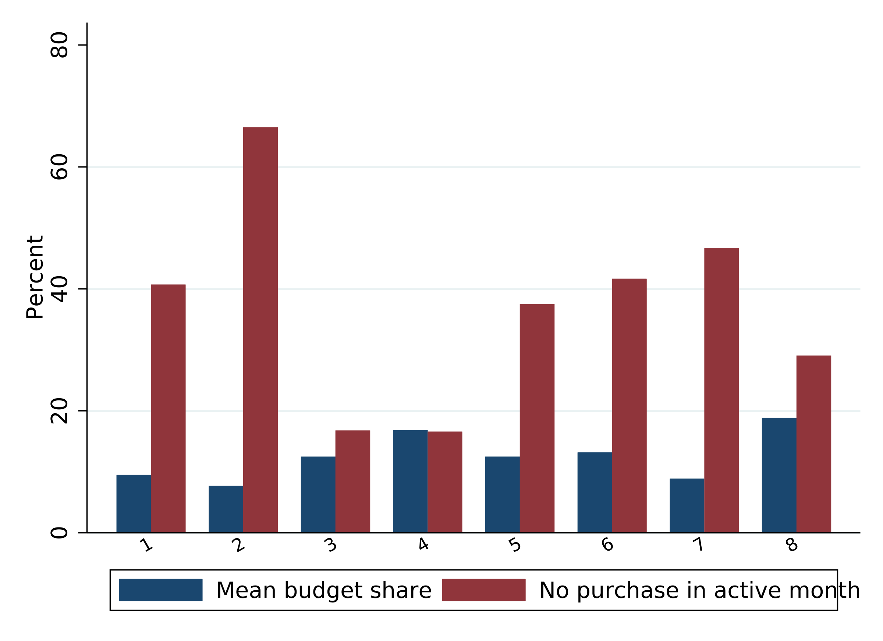
Figure 2. Budget shares and nonpurchase by food group
Notes: Nonpurchase is measured within active eight-group food-budget household-months.

2.4 Price variation available for identification
Each group has 864 province-month price cells. The household sample size is therefore not a count of independent price experiments. Province, calendar-month, and year controls leave 4.29% of other-meat log-price variance; province and full year-month effects leave 3.64%. Corresponding pork figures are 32.44% and 2.77% (Table A1). These are residual-variation diagnostics, not instrument-strength or exogeneity tests.
A household’s own transaction expenditure does not mechanically enter its price, but fixed price weights are based on sample expenditure and monitoring prices may respond to local demand and retail composition. Macro, pandemic, and weather controls and province clustering do not establish an external supply-shock design. Responses require the stated conditional-mean and price-exogeneity assumptions.

3. Demand Systems, Elasticities, and Inference

3.1 Budget definition and Stone approximation
Let $x_{it}$ be household monthly expenditure on the eight groups, $n_{it}$ the size proxy, $B_{it}=x_{it}/n_{it}$, $w_{git}=x_{git}/x_{it}$, and $p_{gpt}=\text{exp}(ℓ_{gpt})$. We study allocation conditional on the food budget. A demand interpretation maintains weak separability from excluded goods, which these records cannot identify. Food-expenditure elasticity differs from total-income elasticity.
Province-month mean observed shares construct the Stone approximation, with vegetables as the relative-price reference:
$$\begin{matrix}y_{it}=\text{log}B_{it}−\sum_{g=1}^{8}{{\overline{w}}_{gpt}}ℓ_{gpt}, \\ r_{gpt}=ℓ_{gpt}−ℓ_{3pt} (3)\end{matrix}$$
Stone weights change by province-month and differ from fixed within-group category weights in equation (1). After aggregation, Stone weights, real-budget terms, household means, and relative prices are reconstructed. Retaining old budget regressors while renaming goods would address a different specification.

3.2 Participation-adjusted approximate EASI
Seven free latent-share equations are specified as
fgit=αg+βgyit+λgyit2+j≠3​Agjrjpt+yitj≠3​Cgjrjpt+Dg′zit+Mg′zi+Tg′tt, g≠3 (4)
Controls include low-income, elderly, and large-household indicators and six standardized macro/weather variables: prices, pandemic conditions, holidays, temperature, precipitation, and the agricultural wholesale index. Time indicators cover eleven calendar months and two years. Household means of real expenditure and seven relative prices follow the correlated-heterogeneity motivation of Mundlak (1978), but do not remove correlation between current expenditure and share errors.
The symmetric seven-dimensional free blocks of $A$ and $C$ each have 28 parameters. Adding-up restrictions recover full eight-dimensional matrices and nonprice coefficients. The Stone budget makes this an approximate EASI specification; exact EASI instead defines real expenditure implicitly through its cost function (Lewbel and Pendakur, 2009; Pendakur, 2008).
For $d_{git}=1\{x_{git}>0\}$, eight Probits estimate purchase participation:
$$\text{Pr}(d_{git}=1∣v_{git})=Φ(v_{git}′π_{g}) (5)$$
Alongside corresponding covariates, participation includes three strictly historical group variables: recorded purchase in the previous calendar month, recency of the last visible purchase, and absence of previous visible purchases. They are regenerated after the meat merger. They exclude current and future purchases but may affect current amounts through inventories, so exclusion validity remains an assumption.
Following Shonkwiler and Yen (1999), seven observed-share equations use
$$w_{git}=Φ_{git}f_{git}+σ_{g}ϕ_{git}+u_{git}, g≠3 (6)$$
Vegetable predictions equal one minus the other seven predictions. Symmetric underlying parameters and residual adding up do not establish that this independently participation-adjusted purchasing system derives from one integrable utility function. Constrained FGLS starts with identity residual weights and updates covariance twice. Stata estimates Probits and Mata fits the system, which has 294 share parameters and full constrained-design rank.

3.3 Exact AIDS, QUAIDS, and quadratic EASI
The exact systems share 22 controls: three household indicators, six macro/weather measures, eleven month indicators, and two year indicators. They exclude household means, purchase-history exclusions, and SY adjustment. Define centered $h=\text{log}B−\overline{\text{log}B}$ and $P_{g}=ℓ_{g}−{\overline{ℓ}}_{g}$ using full-sample means; normalize the Translog constant $α_{0}$ to zero. Then
$$\begin{matrix}\text{log}a(P,z)=α(z)′P+1/2P′ΓP, \\ b(P)=\text{exp}(β′P), (7)\end{matrix}$$
with $K=h−\text{log}a(P,z)$, QUAIDS shares are
$$f_{g}=α_{g}(z)+{\left(ΓP\right)}_{g}+β_{g}K+\frac{λ_{g}}{b(P)}K^{2} (8)$$
Restrictions impose g​αg=1, g​βg=g​λg=0, zero sums on other shifters, and symmetric, zero-row-sum $Γ$. AIDS sets all $λ_{g}$ to zero. QUAIDS uses the specific quadratic price denominator in equation (8), rather than the approximate EASI expenditure–price interaction (Banks et al., 1997; Poi, 2012).
Exact EASI here uses a constant price matrix without the main model’s expenditure–price interaction:
$$\begin{matrix}\text{log}c(P,u,z)=u+α(z)′P+1/2P′ΓP+(β′P)u+(λ′P)u^{2}, \\ f=α(z)+ΓP+βu+λu^{2} (9)\end{matrix}$$
Its observed implicit-budget index is $u^{obs}=h−w′P+1/2P′ΓP$. Because this contains observed shares, centered nominal expenditure and its square act as internal instruments, together with a constant, 22 controls, and seven relative prices. All three exact systems omit dairy and, with $Ω=N^{−1}Z′Z$, use the same fixed one-step GMM weight:
$$\hat{θ}=\text{arg}\underset{θ}{\text{min}}m(θ)′Wm(θ), W=I_{7}⊗Ω^{−1} (10)$$
Exact sufficient moments are compressed to 5,163 province-month/household-indicator cells while representing all 583,668 observations. The implementation checks compressed against observation-level moments, analytic gradients, and Jacobian rank. The objective is not reported as a Hansen test; internal budget instruments do not establish nominal food-budget exogeneity.
Table 2. Estimation information for the exact demand systems
Model | Estimation N | Parameters | Jacobian rank | Converged | GMM criterion
AIDS | 583,668 | 196 | 196 | 1 | 0.0003218
QUAIDS | 583,668 | 203 | 203 | 1 | 0.0001475
Exact EASI | 583,668 | 203 | 203 | 1 | 0.0001476
Notes: Each uses 583,668 observations and 24-province covariance, with common controls, seven relative prices, and budget instruments. The objective describes the specified one-step GMM criterion.

3.4 Elasticities, aggregation, and evaluation support
Predicted quantity equivalents per proxy member are ${\hat{q}}_{git}=B_{it}{\hat{w}}_{git}/p_{gpt}$. These are not recorded physical quantities and do not separate quality. Holding the size proxy and other covariates at baseline,
$$\begin{matrix}η_{git}=1+\frac{∂{\hat{w}}_{git}/∂\text{log}B_{it}}{{\hat{w}}_{git}}, \\ e_{gj,it}^{M}=\frac{∂{\hat{w}}_{git}/∂ℓ_{jpt}}{{\hat{w}}_{git}}−1\{g=j\} (11)\end{matrix}$$
Reported aggregate elasticities divide summed quantity-equivalent derivatives by summed baseline quantity equivalents. They are quantity-weighted responses, not simple means of individual elasticities or national physical-demand elasticities. Approximate-system short-run derivatives fix Stone weights and household means. Unconditional derivatives allow participation changes; fixed-participation derivatives hold probabilities fixed; latent derivatives remove the participation transformation.
Estimation retains observed nonpurchases. Reporting distinguishes full raw prediction samples from positive-prediction evaluation support. The main model requires all eight predicted shares above ${10}^{−8}$, retaining 574,172 observations (98.37%). Exact systems require strictly positive raw shares and valid utility inversion; their common intersection contains 579,066 observations (99.21%). Evaluation filtering follows estimation rather than dropping observed zeros before fitting. Predictions are not clipped or renormalized, and Delta derivatives fix the baseline support partition.
Regularity diagnostics average standardized compensated matrices computed at each household-month. For integrable demand, $e_{gj}^{H}=e_{gj}^{M}+η_{g}{\hat{w}}_{j}$ and $S_{gj}={\hat{w}}_{g}e_{gj}^{H}$. For independently participation-adjusted purchases, this construction is a formal compensation diagnostic, not evidence of validated Hicksian demand. Even a symmetric, negative-semidefinite mean matrix would not establish regularity for every household over the full price domain.

3.5 Province two-step inference
Province-month prices are shared by households. Primary inference clusters by 24 provinces; household clustering represents an alternative dependence assumption. Joint influence functions propagate first-stage Probit scores through FGLS coefficients and elasticities. The first stage uses expected Fisher information under the specified Probit mean; province clustering does not guarantee robustness to arbitrary participation-mean misspecification. Interpretation follows the cluster-inference literature (Cameron and Miller, 2015; MacKinnon et al., 2023).
Main intervals use 999 studentized Webb province-score multipliers. Simultaneous bands cover the sixteen expenditure and own-price elasticities as one family. Perturbations do not re-estimate price weights, Stone weights, household means, or support selection and are not a full-pipeline bootstrap. Maximum absolute-$t$ score tests avoid inverting covariance blocks when restrictions exceed province covariance rank. Exact quadratic-term tests use seven restrictions with an approximate F reference and 23 denominator degrees of freedom.

4. Eight-Group Demand Results

4.1 Main expenditure and own-price responses
All main unconditional own-price point estimates are negative, from −0.496 for oils to −1.503 for staples (Table 3). Other meat is −⁠1.059, with province two-step SE 0.324 and marginal interval [−⁠1.648, −⁠0.470]. Its simultaneous band also lies below zero. The marginal oil interval includes zero; negative point estimates do not establish precisely negative responses for every food.
Other meat and oils have expenditure point responses of 1.268 and 1.213; vegetables and fruit have 0.668 and 0.885. Staples, pork, seafood, and dairy are closer to unit expenditure response. Expenditure means the conditional food budget; it does not identify the effect of earnings or transfers on total budget allocation. Narrow expenditure intervals do not establish budget exogeneity.
Table 3. Main SY-EASI unconditional elasticities and province two-step inference
Food group | Expend. | Prov. SE | 95% interval | Own price | Prov. SE | 95% interval
Staples | 1.012 | 0.025 | [0.964, 1.060] | −⁠1.503 | 0.320 | [−⁠2.118, −⁠0.888]
Oils | 1.213 | 0.027 | [1.163, 1.262] | −⁠0.496 | 0.297 | [−⁠1.047, 0.055]
Vegetables | 0.668 | 0.023 | [0.622, 0.713] | −⁠0.860 | 0.153 | [−⁠1.130, −⁠0.590]
Fruit | 0.885 | 0.018 | [0.850, 0.920] | −⁠1.140 | 0.075 | [−⁠1.278, −⁠1.002]
Pork | 1.026 | 0.028 | [0.971, 1.081] | −⁠0.698 | 0.051 | [−⁠0.797, −⁠0.600]
Other meat | 1.268 | 0.028 | [1.218, 1.317] | −⁠1.059 | 0.324 | [−⁠1.648, −⁠0.470]
Seafood | 0.991 | 0.012 | [0.969, 1.013] | −⁠0.931 | 0.169 | [−⁠1.242, −⁠0.620]
Dairy | 0.962 | 0.024 | [0.918, 1.007] | −⁠0.972 | 0.285 | [−⁠1.515, −⁠0.429]
Notes: 574,172 positive-support observations; predicted quantity-equivalent weighting. Intervals use 999 studentized Webb score multipliers and include participation-stage uncertainty, while conditioning on other generated variables.
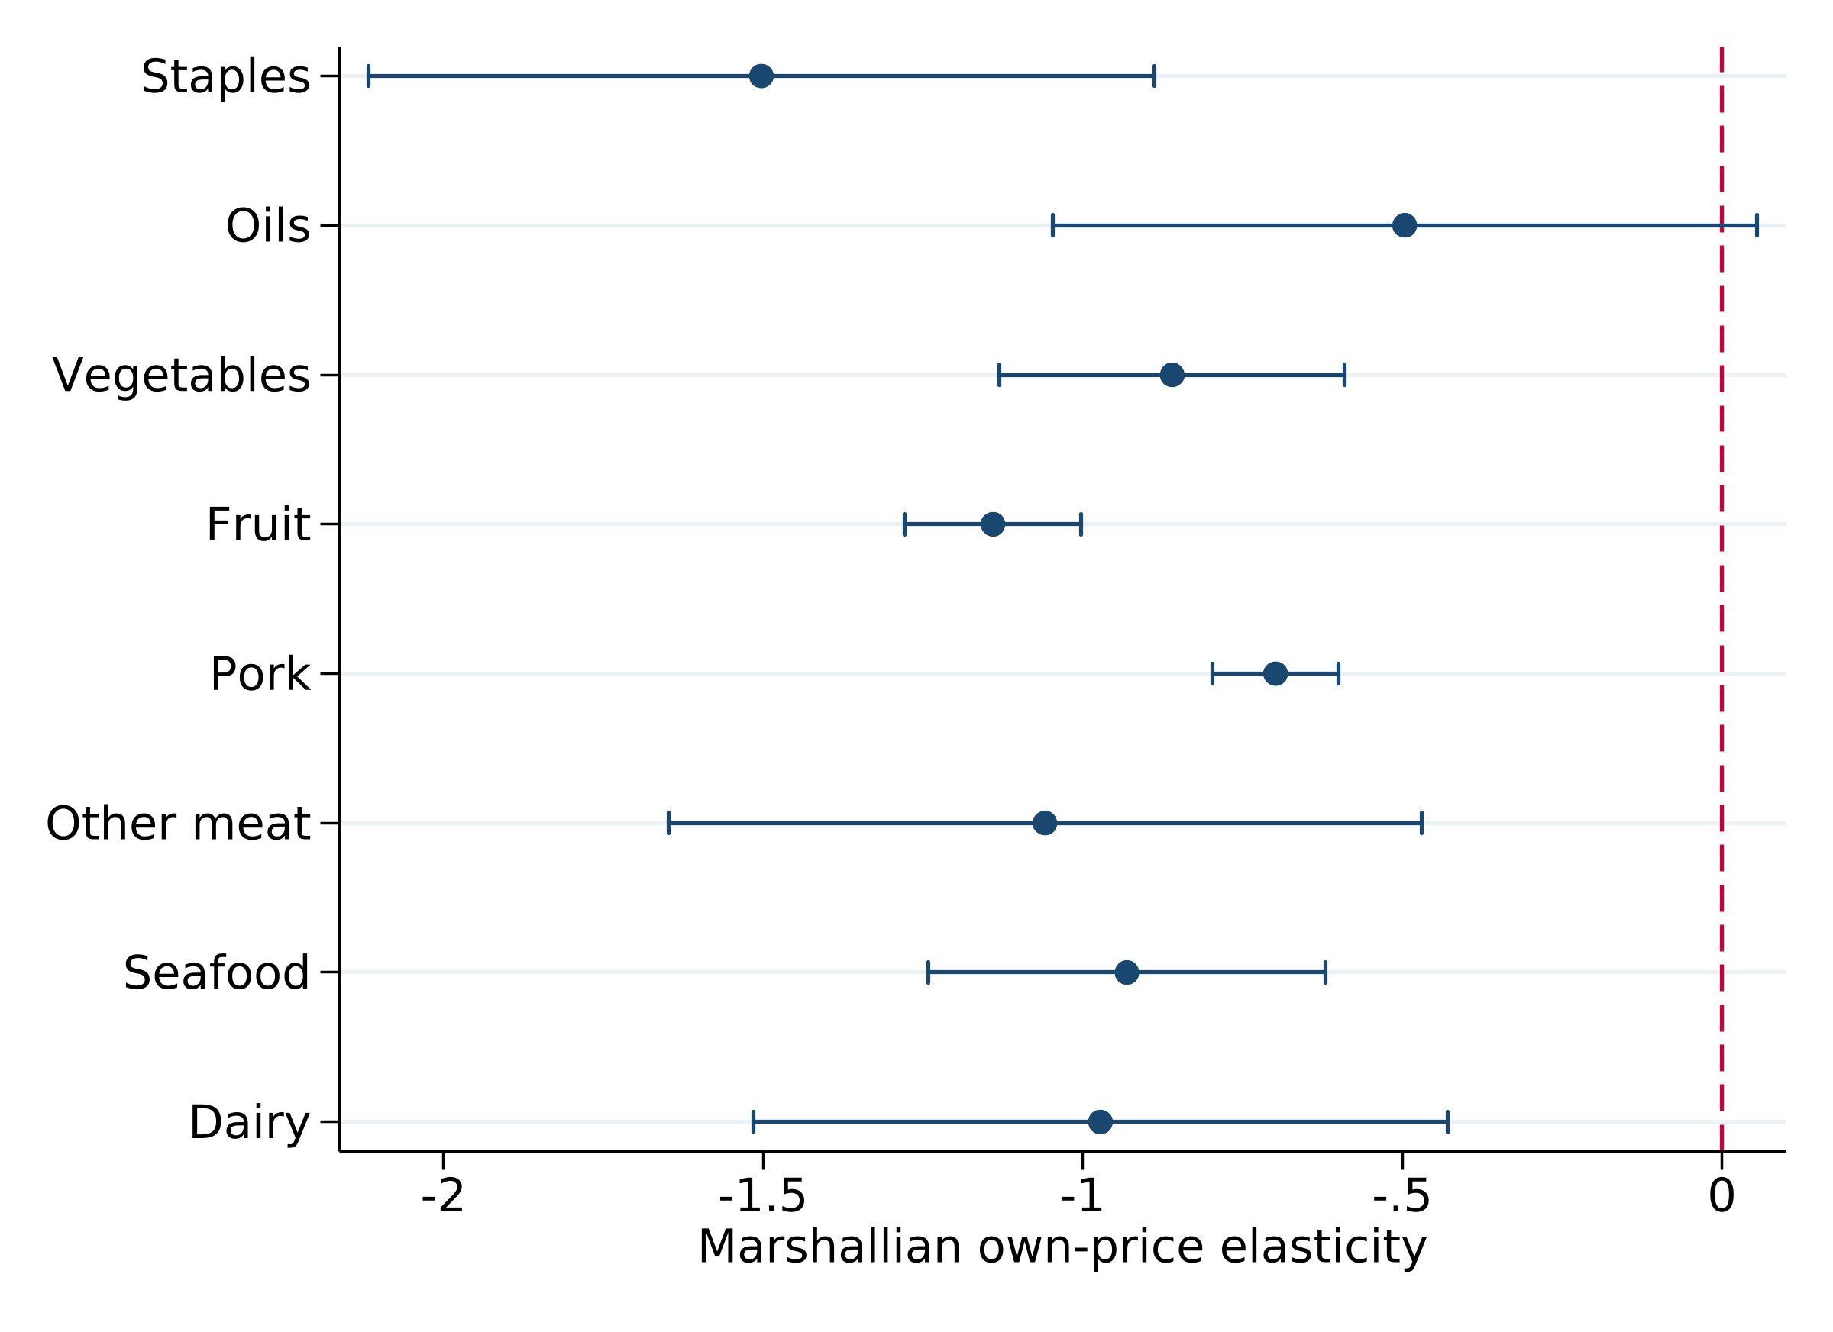
Figure 3. Main own-price responses and province two-step intervals
Notes: Same support and marginal intervals as Table 3. The oil interval includes zero. Household SEs are saved in replication outputs; simultaneous bands appear in Table A7.
On the full raw prediction sample, other-meat own-price elasticity is −1.0592, compared with −1.0590 on positive support; expenditure elasticity is 1.2651 versus 1.2676. Similarity for this group does not establish support insensitivity throughout the system. Latent margins use a different positive sample, so differences cannot be attributed entirely to participation behavior.

4.2 Functional-form comparison
All exact-model own-price point estimates are negative on their common 579,066-observation support (Tables 4–5). Other-meat responses are −0.447, −0.462, and −0.473 in AIDS, QUAIDS, and exact EASI. Their compensated own-price responses are −0.247, −0.250, and −0.261. Their magnitudes are smaller than the main SY response; a common sign does not establish statistical or structural equivalence.
The exact systems hold controls, instruments, and covariance settings common, concentrating their comparison on functional form. The main model additionally uses participation transformations, household means, and expenditure–price interactions. Its differences from exact models combine these assumptions. Vegetable expenditure elasticity is 0.668 in the main model and approximately 0.946–1.015 in the exact systems; this contrast cannot be assigned solely to quadratic Engel terms.
Table 4. Uncompensated own-price elasticities
Food group | AIDS | QUAIDS | Exact EASI | SY-EASI
Staples | −⁠1.123 | −⁠1.114 | −⁠1.126 | −⁠1.503
Oils | −⁠1.425 | −⁠1.436 | −⁠1.439 | −⁠0.496
Vegetables | −⁠1.491 | −⁠1.486 | −⁠1.486 | −⁠0.860
Fruit | −⁠1.376 | −⁠1.376 | −⁠1.376 | −⁠1.140
Pork | −⁠0.904 | −⁠0.896 | −⁠0.897 | −⁠0.698
Other meat | −⁠0.447 | −⁠0.462 | −⁠0.473 | −⁠1.059
Seafood | −⁠0.568 | −⁠0.567 | −⁠0.572 | −⁠0.931
Dairy | −⁠0.561 | −⁠0.559 | −⁠0.568 | −⁠0.972
Notes: Exact systems share 579,066 observations; SY-EASI uses 574,172. Quantity-equivalent-weighted point estimates; exact elasticity intervals are not provided here.
Table 5. Food-expenditure elasticities
Food group | AIDS | QUAIDS | Exact EASI | SY-EASI
Staples | 0.741 | 0.815 | 0.814 | 1.012
Oils | 1.083 | 0.932 | 0.931 | 1.213
Vegetables | 0.946 | 1.015 | 1.015 | 0.668
Fruit | 0.903 | 0.897 | 0.896 | 0.885
Pork | 1.124 | 1.082 | 1.083 | 1.026
Other meat | 1.219 | 1.258 | 1.259 | 1.268
Seafood | 1.199 | 1.198 | 1.199 | 0.991
Dairy | 0.764 | 0.754 | 0.753 | 0.962
Notes: Supports as in Table 4. Expenditure refers to the food budget at fixed proxy household size, not reported income or total household income.
QUAIDS and exact EASI quadratic-term tests produce F-reference statistics of 84.47 and 88.29, with full-rank seven-restriction province covariance blocks (Table A2). They favor retaining quadratic flexibility under maintained assumptions without testing instrument exclusion or establishing nonnested equivalence. Lower quadratic-model GMM objectives describe improved fitting of specified moments, not causal or welfare validity.

4.3 Aggregation and matched-support comparisons
Table 6 discloses the diagnostic motivating the revision. Original poultry/miscellaneous-meat own-price estimates range from 0.023 to 0.028, while beef/mutton responses are approximately −1.11. Re-estimated composite other-meat responses are negative. The old and new goods differ; a weighted average of their old elasticities cannot substitute for re-estimation.
Table 6. Meat own-price responses before and after aggregation
Exact model | Original poultry | Original beef/mutton | Merged other meat | Merged, matched N
AIDS | 0.023 | −⁠1.118 | −⁠0.447 | −⁠0.447
QUAIDS | 0.028 | −⁠1.108 | −⁠0.462 | −⁠0.463
Exact EASI | 0.026 | −⁠1.122 | −⁠0.473 | −⁠0.474
Notes: The first two columns use the original nine-group exact-system common support; the third uses eight-group exact common support. The final column evaluates unchanged full-sample estimates on the intersection of all six systems’ positive supports, 569,808 identical household-months. No negative-elasticity constraint is imposed.
On this identical sample, original poultry remains positive while merged other meat remains negative. The difference therefore is not explained solely by the evaluation sample. Shares, composite prices, purchase incidence, and system parameters change together. Since the classification responds to earlier diagnostics, this is exploratory grouping sensitivity rather than independent confirmation of a negative poultry elasticity.

4.4 Reported-income patterns
Table 7 compares the lowest and highest reported brackets; Figure 4 covers all five. Other-meat expenditure responses are 1.280 and 1.262, while both own-price responses are approximately −1.059. Patterns differ across foods and do not support a universal monotonic relation between reported income and responsiveness.
Table 7. Main-model elasticities in the lowest and highest reported brackets
Food group | Lowest: expend. | Lowest: own price | Highest: expend. | Highest: own price
Staples | 1.045 | −⁠1.477 | 0.954 | −⁠1.611
Oils | 1.233 | −⁠0.517 | 1.208 | −⁠0.501
Vegetables | 0.600 | −⁠0.853 | 0.750 | −⁠0.867
Fruit | 0.886 | −⁠1.135 | 0.877 | −⁠1.135
Pork | 1.027 | −⁠0.714 | 1.033 | −⁠0.700
Other meat | 1.280 | −⁠1.059 | 1.262 | −⁠1.058
Seafood | 0.988 | −⁠0.917 | 1.001 | −⁠0.959
Dairy | 0.995 | −⁠0.977 | 0.915 | −⁠0.967
Notes: Evaluations of one pooled model, not separate bracket estimates. Positive-support counts are 82,395 for below 5,000 yuan and 182,834 for above 12,000. Point estimates are not formal between-bracket tests.
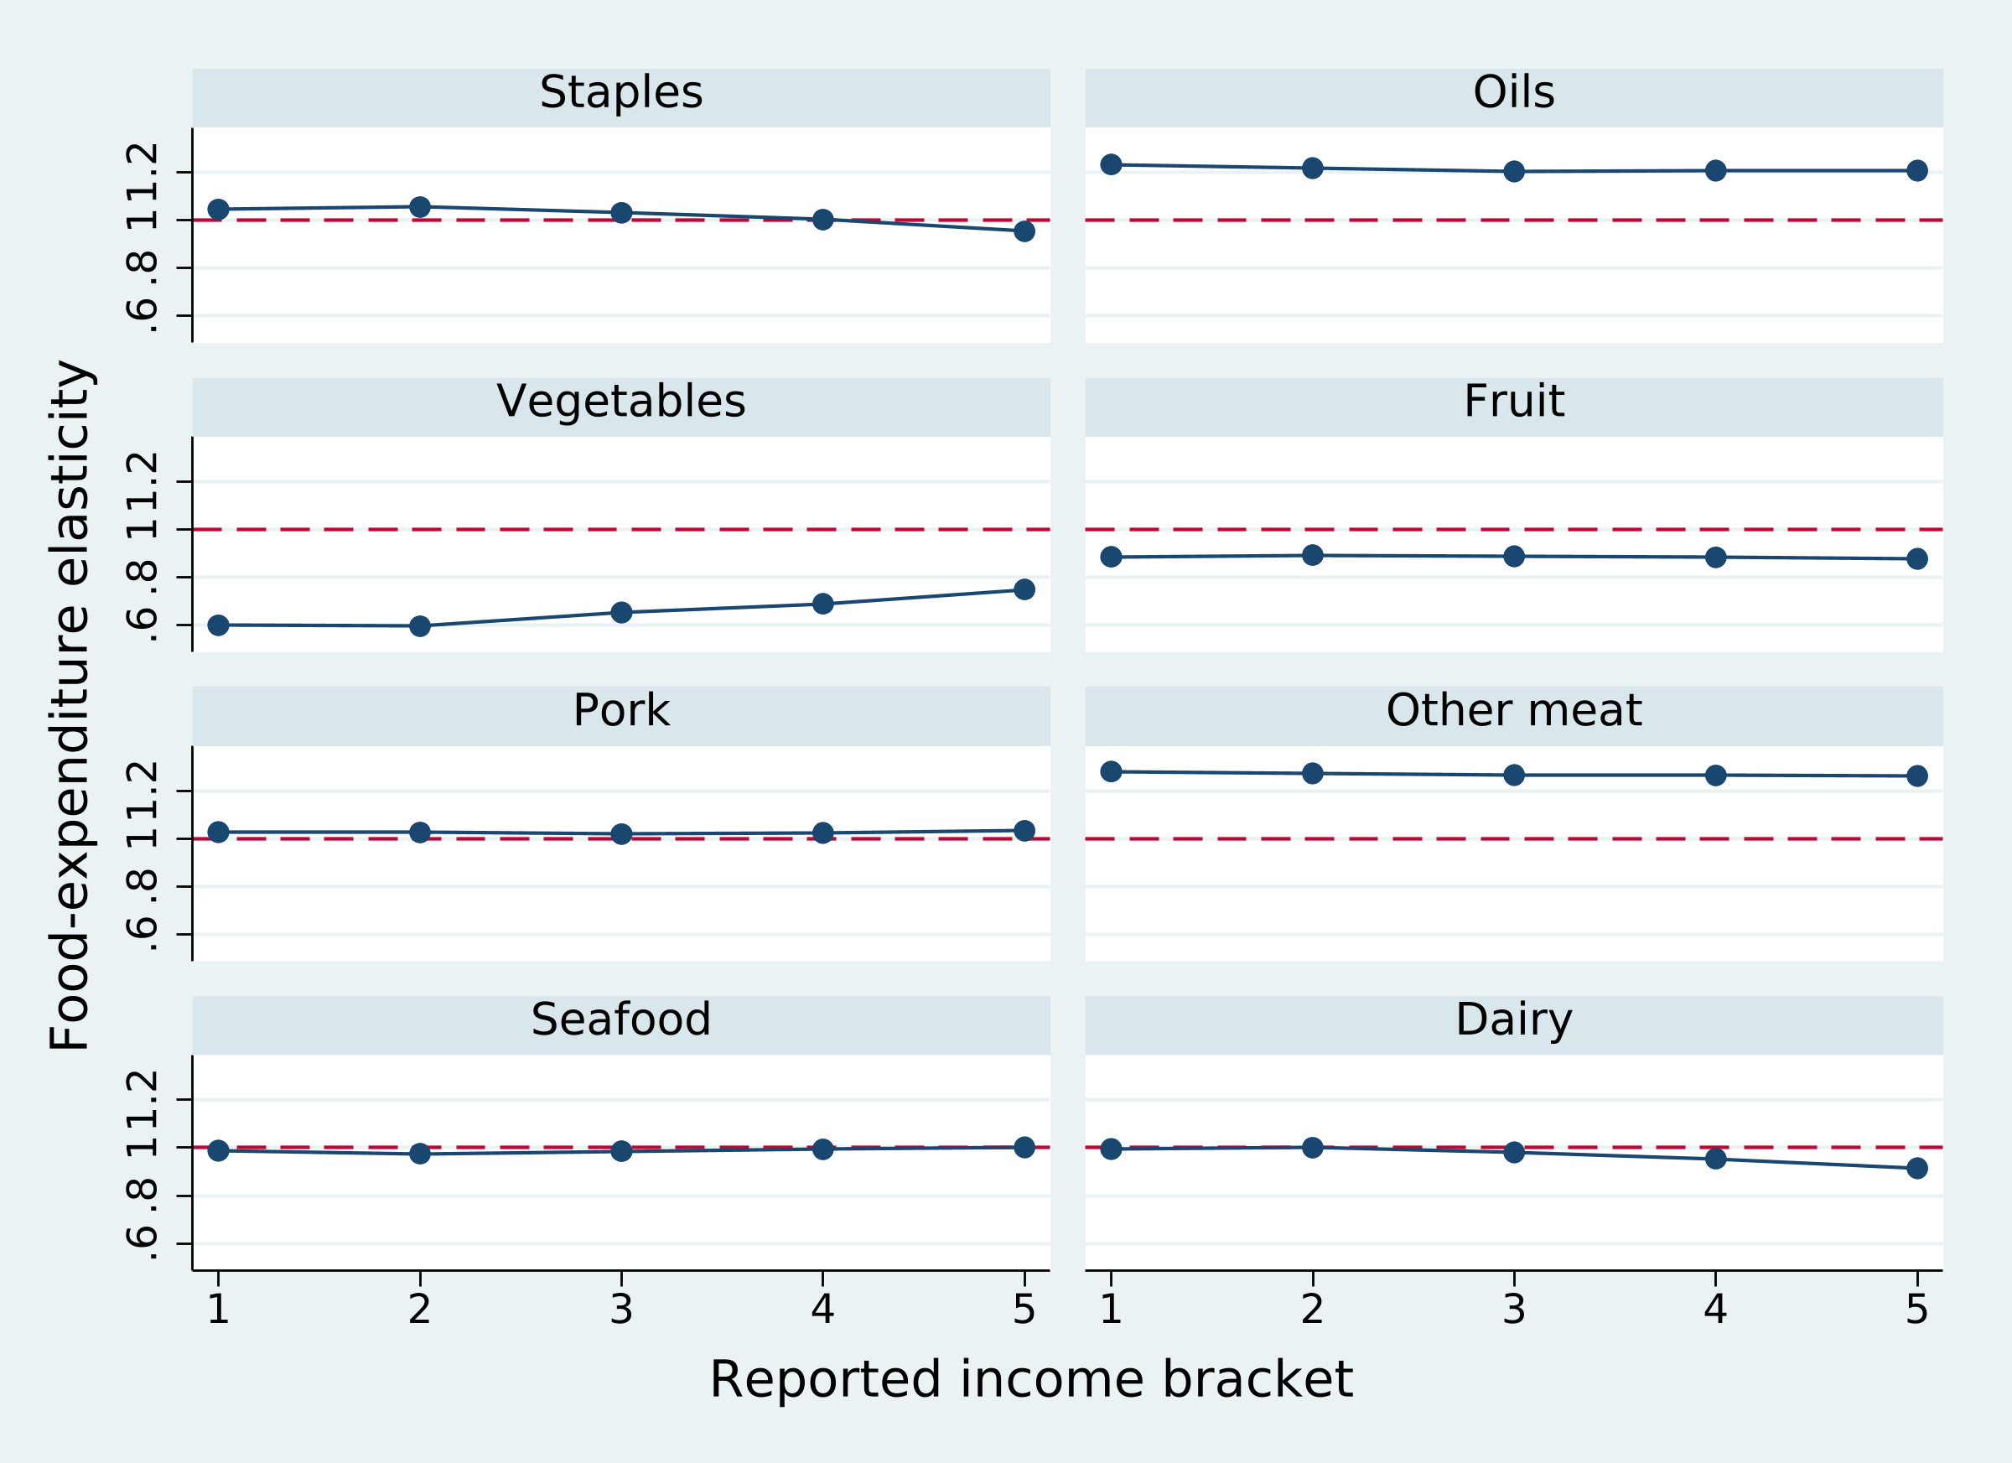
Figure 4. Food-expenditure responses by reported income bracket
Notes: Brackets are not income quintiles. The dashed line denotes unit expenditure elasticity. Households may change brackets over time.
The income variable lacks a continuous amount and verified period. The main low-income indicator combines the first two brackets; evaluated responses also reflect their expenditure, prices, and demographic composition. These are conditional purchasing patterns, not causal effects of income growth or transfers.

5. Purchase Windows, Specification Sensitivity, and Regularity

5.1 Monthly nonpurchase and longer recording windows
Aggregating the same transaction support to active quarters and years raises other-meat incidence from 58.34% to 80.18% and 92.63%, and oil incidence from 33.50% to 63.25% and 88.86% (Table 8). Widespread purchases over longer windows limit the interpretation of monthly zeros as persistent zero-consumption corners.
Table 8. Purchase incidence by active recording window
Food group | Monthly % | Quarterly % | Annual %
Staples | 59.29 | 85.93 | 95.55
Oils | 33.50 | 63.25 | 88.86
Vegetables | 83.20 | 92.62 | 96.97
Fruit | 83.40 | 94.04 | 97.69
Pork | 62.48 | 81.97 | 92.54
Other meat | 58.34 | 80.18 | 92.63
Seafood | 53.35 | 73.34 | 87.57
Dairy | 70.95 | 91.08 | 96.71
Notes: Active-window counts are 583,668 household-months, 203,337 household-quarters, and 58,150 household-years. Each window must contain a positive studied-food transaction. Median active months per window are 1, 3, and 12.
Aggregation changes both the window and the active sample composition; it is not an inventory experiment on a balanced panel. An annual purchase does not establish consumption in every month. This exercise describes purchase frequency without turning purchases into intake or validating monthly participation exclusions.

5.2 Five re-estimated sensitivity specifications
Table 9 covers linear and cubic Engel forms, no SY correction, no purchase-history exclusions, and omission of pork rather than vegetables. All use 583,668 observations for estimation, return full constrained-design rank, and have negative own-price and positive expenditure point estimates on their respective supports. Signs persist while magnitudes remain specification dependent.
Table 9. Sensitivity of the eight-group main system
Specification | Positive N | Support % | Largest own change | Largest expend. change | Nonnegative own
Quadratic main model | 574,172 | 98.37 | 0.000 | 0.000 | 0
Linear Engel term | 574,757 | 98.47 | 0.128 | 0.436 | 0
Cubic Engel term | 573,762 | 98.30 | 0.032 | 0.125 | 0
Without SY correction | 575,519 | 98.60 | 0.387 | 0.079 | 0
Without purchase-history exclusions | 580,004 | 99.37 | 0.406 | 0.064 | 0
Pork equation omitted | 572,821 | 98.14 | 0.237 | 0.031 | 0
Notes: Changes are relative to the quadratic main model, using each specification’s own positive support. They include support changes and are not formal cross-specification difference tests. Linear and cubic variants retain expenditure–price interactions.
The largest expenditure-response changes are 0.436 for the linear model and 0.125 for the cubic model. Removing purchase-history exclusions and SY correction gives maximum own-price changes of 0.406 and 0.387. Other-meat own-price responses are −⁠1.137 and −⁠0.980, respectively, retaining the need to discuss participation and inventory assumptions after aggregation.
Omitting pork gives an other-meat response of −⁠1.230 and a maximum own-price change of 0.237. A theoretically consistent complete system should avoid substantive dependence on an arbitrary omitted equation. Independent participation transformations and residual-share recovery can create such sensitivity, which should not be interpreted as preference change or resolved merely by negative signs.
Maximum absolute-$t$ score tests for quadratic Engel terms, demographics, household means, SY terms, and two price blocks reach the simulation’s minimum reportable $p=0.001$ (Table A3). For example, 56 household-mean restrictions have province covariance rank 23; ordinary inverse-covariance Wald tests are not reported for these singular blocks. Block relevance is not an exclusion or budget-exogeneity test.

5.3 Prediction support and Slutsky diagnostics
The main unconditional positive support is 98.37%; negative raw predictions chiefly affect vegetables, in 1.518% of all household-months. Other meat has no negative unconditional raw shares. This improves group-level computational behavior without validating the whole system.
Removing participation transformations leaves only 334,603 observations with all latent shares positive, or 57.33%. Staple and oil latent negative rates are 23.07% and 24.23% (Table A4). These latent functions are untransformed SY components, not observed conditional-consumption shares. Selection terms can produce positive unconditional predictions while the underlying function lacks broad positive support. It cannot be treated as a validated consumption utility demand.
Table 10. Mean standardized compensation-matrix diagnostics
Model/margin | Positive-support N | Mean asymmetry | Maximum eigenvalue
SY unconditional | 574,172 | 0.095858 | 0.022460
AIDS | 579,066 | 0.000000 | 0.045870
QUAIDS | 579,066 | 0.000000 | 0.046260
Exact EASI | 579,066 | 0.000000 | 0.045907
Notes: Matrices are calculated observation by observation and then averaged. The main system uses formal compensation diagnostics; exact systems use structural derivatives. Maximum eigenvalues refer to symmetric parts, with supports as in Table 4.
Main unconditional asymmetry is 0.09586 and the maximum symmetric-part eigenvalue is 0.02246. The exact systems are numerically symmetric, but maximum eigenvalues around 0.046 fail negative-semidefiniteness on the evaluated mean matrices. For constant-price-matrix exact EASI, $S=Γ+ff′−\text{diag}(f)$. Positive shares make the last two terms negative semidefinite, yet unrestricted $Γ$ can still violate curvature.
Aggregation removes a positive composite own-price point estimate without repairing every theoretical property. We do not compute compensating variation or transfer requirements from these unvalidated substitution models, and do not carry over curvature-constrained welfare values from another classification. Tables A6a–A6b describe cross-price structure; uncompensated cross signs alone do not identify Hicksian substitution.

6. Fixed-Basket Affordability and Price Exposure

6.1 Measurement and budget scope
Fixed-basket exposure does not require estimated substitution matrices. Annual group prices are exponentiated twelve-month mean log prices. With $δ_{gp}=p_{gp,2022}/p_{gp,2020}−1$, exposure for recorded 2020 configurations is
$$\begin{matrix}L_{it}=\sum_{g=1}^{8}{w_{git}}δ_{g,p(i,t)}, \\ C_{it}^{pc}=B_{it}L_{it}, t∈2020 (12)\end{matrix}$$
The percentage measures the cost of preserving baseline quantity-equivalent configurations under group price proxies; the amount uses proxy membership. Their means imply different budget weighting. Multiplying mean exposure by the whole-period mean budget does not recover mean cost. Bracket and province patterns reflect observed shares and price paths without population weights.
This is a group-index calculation, not repricing each transaction’s physical quantity. Aggregation changes the meat price proxy, so historical exposure is recomputed despite unchanged total food budgets. The measure holds configurations fixed and omits substitution, quality, inventories, and excluded consumption. It describes affordability rather than an exact cost-of-living or utility-loss measure.

6.2 Observed 2020–2022 price changes
The 2020 base contains 182,676 household-months. Revaluation at 2022 group prices increases average cost by 2.97% of the food budget, or 4.43 yuan per proxy member per month (Table 11). Pork and other meat jointly contribute −⁠4.00%; dairy and staples/oils contribute 1.74% and 1.67%. Falling meat prices partly offset other increases, illustrating why a uniform inflation assumption differs from observed basket-price paths.
Table 11. Exposure of recorded 2020 configurations to 2022 prices
Reported income (yuan) | All food % | Yuan/member/month | Meat contrib. % | Dairy contrib. % | Staples/oils %
All | 2.97 | 4.43 | −⁠4.00 | 1.74 | 1.67
<5,000 | 2.14 | 2.04 | −⁠4.47 | 1.59 | 1.56
5,001–7,000 | 2.36 | 2.96 | −⁠4.32 | 1.62 | 1.64
7,001–9,000 | 2.72 | 3.87 | −⁠4.16 | 1.75 | 1.68
9,001–12,000 | 3.19 | 5.28 | −⁠3.87 | 1.74 | 1.69
>12,000 | 3.75 | 6.22 | −⁠3.56 | 1.86 | 1.72
Notes: 182,676 active 2020 household-months. Amounts are yuan per proxy member per month. All category contributions use the complete eight-group budget; unlisted contributions include vegetables, fruit, and seafood.
Lowest- and highest-bracket mean exposure is 2.14% and 3.75%, with amounts of 2.04 and 6.22 yuan. The overall tenth and ninetieth percentiles are −⁠7.29% and 11.75%. These describe household-month dispersion, not confidence bounds on a mean; average increases do not imply that every recorded basket becomes more expensive.
The bracket ranking identifies neither the causal effect of income nor burden relative to income. Unverified income periods, proxy membership, active-purchase selection, and channel-price differences limit distributional and national interpretation.

6.3 Ten-percent price scenarios and policy interpretation
For all 583,668 active household-months, prices of specified groups rise by 10% at fixed observed configurations (Table 12). A uniform increase across all eight groups produces 10% exposure by definition, or 21.71 yuan per proxy member per month. Increasing pork and other meat gives 2.57%; dairy gives 1.88%; staples and oils give 1.72%.
Table 12. Fixed-basket exposure to 10% price increases, as a percentage of the food budget
Reported income (yuan) | All food +10% | Meat +10% | Dairy +10% | Staples/oils +10%
All | 10.00 | 2.57 | 1.88 | 1.72
<5,000 | 10.00 | 2.58 | 1.77 | 1.73
5,001–7,000 | 10.00 | 2.59 | 1.79 | 1.75
7,001–9,000 | 10.00 | 2.57 | 1.88 | 1.74
9,001–12,000 | 10.00 | 2.55 | 1.91 | 1.71
>12,000 | 10.00 | 2.57 | 1.97 | 1.69
Notes: Complete active sample, specified group prices rise proportionally, other prices and configurations remain fixed. Meat covers pork and other meat.
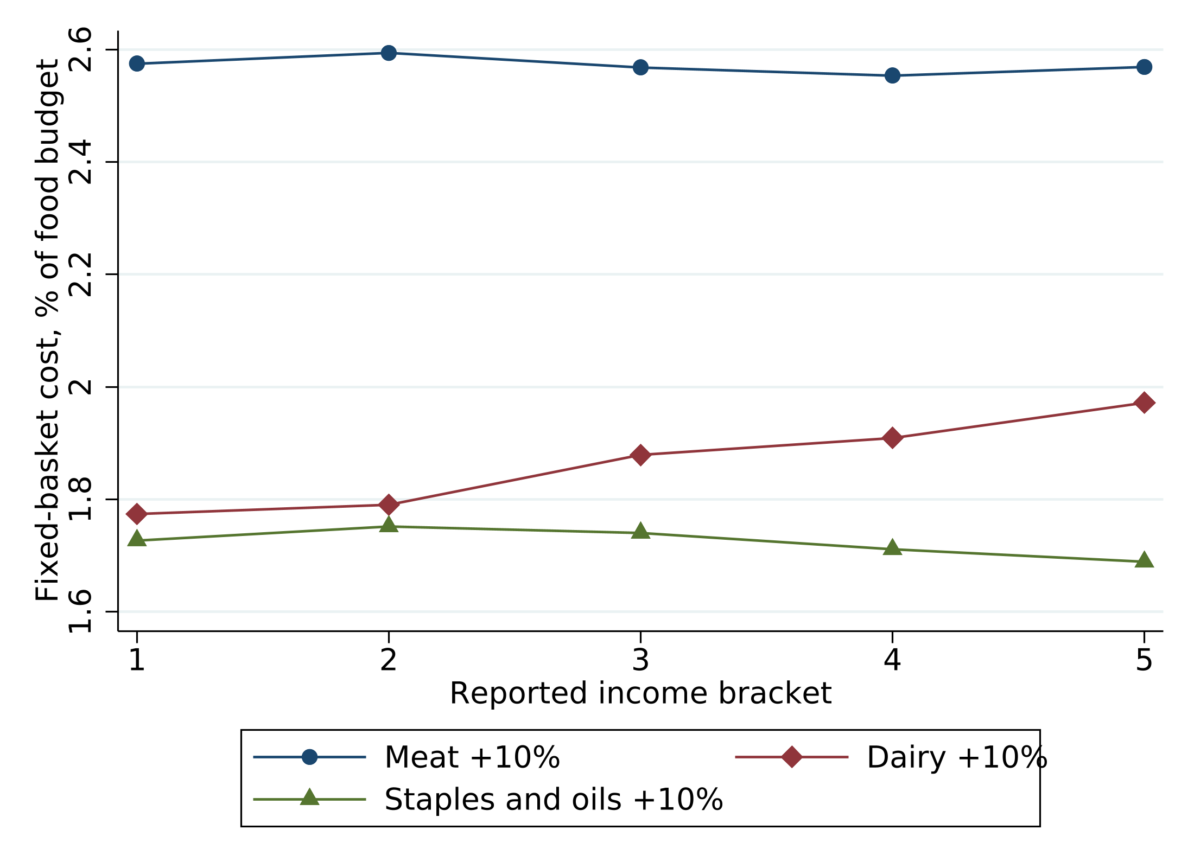
Figure 5. Fixed-basket exposure to 10% category-price increases
Notes: Point measures by reported bracket, not income shares or utility compensation. Uniform food-price exposure is 10% by construction and is not plotted.
Identical group shocks have different burdens across purchasing baskets. Dairy exposure rises from 1.77% in the lowest bracket to 1.97% in the highest; staples/oils give approximately 1.73% and 1.69%. Rankings vary by shock. Affordability monitoring should therefore track specific price paths and procurement composition rather than represent every household by one inflation rate or price elasticity.
Demand estimates describe conditional purchasing adjustments, whereas fixed-basket measures show group-cost exposure before adjustment. Transfers also change food budgets and excluded consumption, and no upper-stage budget model is estimated here. Nutrition requires comparable physical and quality data. Structural compensation requires credible budget and price identification and positive, monotone, curvature-consistent demand over the relevant domain. Present results do not justify operational compensation amounts.

7. Discussion and Conclusion
The eight-group revision reconstructs the CCTV monthly purchase panel and compares participation-adjusted Stone-approximate EASI with exact AIDS, QUAIDS, and quadratic EASI. The sample covers 24 provinces, 27,638 households, and 583,668 active household-months in 2020–2022. Other meat has a 13.20% budget share and 58.34% purchase incidence; price and history variables are regenerated under the new classification.
All main own-price point estimates are negative. Other meat has a response of −⁠1.059 and food-expenditure elasticity of 1.268. Its exact-model responses are also negative, in contrast to original poultry, and matched-support evaluation preserves that contrast. This demonstrates grouping and measurement sensitivity rather than confirmatory identification of poultry demand. Quadratic-term tests favor nonlinearity under maintained assumptions, while participation, history, and omitted-equation choices affect magnitudes.
Regularity diagnostics preserve the boundaries of interpretation. The main latent function has limited all-good positive support and the observed-purchase compensation matrix is asymmetric. Exact systems are symmetric but fail aggregate curvature. Negative own-price point estimates can coexist with these failures. We therefore report conditional purchasing and fixed-basket exposure without claiming validated consumption welfare.
Revaluing 2020 configurations at 2022 eight-group prices gives 2.97% mean budget exposure and 4.43 yuan per proxy member per month, with meat-price offsets and substantial dispersion. Bracket rankings vary across price scenarios, supporting monitoring of specific prices and purchasing composition. The exercise does not identify income-relative burden, post-substitution utility loss, or required transfers.
Further work can combine longer histories, independent inventory information, and comparable physical quantities and quality measures, estimate an upper food-budget stage, and seek credible supply or budget variation. Composite prices require within-group aggregation checks; welfare applications require coherent nonpurchase mechanisms and curvature over the relevant domain. The Stata/Mata implementation and explicit support definitions provide a reproducible basis for those extensions.
Replication materials. Stata/Mata generates transformations, estimates, inference, sensitivity exercises, exposures, and scientific figures. Manuscript programs only select computed rows, format units, and prepare documents. Author identification and data-use statements remain subject to submission requirements.

References
Banks, J., Blundell, R., Lewbel, A., 1997. Quadratic Engel curves and consumer demand. Review of Economics and Statistics 79(4), 527–539. Publisher DOI.
Cameron, A.C., Miller, D.L., 2015. A practitioner’s guide to cluster-robust inference. Journal of Human Resources 50(2), 317–373. Author manuscript.
Deaton, A., 1988. Quality, quantity, and spatial variation of price. American Economic Review 78(3), 418–430. Author manuscript.
Deaton, A., Irish, M., 1984. Statistical models for zero expenditures in household budgets. Journal of Public Economics 23, 59–80. Author publication page.
Deaton, A., Muellbauer, J., 1980. An almost ideal demand system. American Economic Review 70(3), 312–326. Original article.
Hovhannisyan, V., Bozic, M., 2017. Price endogeneity and food demand in urban China. Journal of Agricultural Economics 68(2), 386–406. Publisher article.
Hovhannisyan, V., Mendis, S., Bastian, C., 2019. An econometric analysis of demand for food quantity and quality in urban China. Agricultural Economics 50(1), 3–13. Publisher article.
Hovhannisyan, V., Shanoyan, A., 2020. An empirical analysis of the welfare consequences of rising food prices in urban China: The EASI approach. Applied Economic Perspectives and Policy 42(4), 796–814. Publisher article.
Lewbel, A., Pendakur, K., 2009. Tricks with Hicks: The EASI demand system. American Economic Review 99(3), 827–863. Publisher article.
MacKinnon, J.G., Nielsen, M.Ø., Webb, M.D., 2023. Cluster-robust inference: A guide to empirical practice. Journal of Econometrics 232, 272–299. Author article and replication page.
Mundlak, Y., 1978. On the pooling of time series and cross section data. Econometrica 46(1), 69–85. Publisher DOI.
Pendakur, K., 2008. EASI made easier. Working paper, Simon Fraser University, December. Author manuscript.
Poi, B.P., 2012. Easy demand-system estimation with quaids. Stata Journal 12(3), 433–446. Publisher article.
Shonkwiler, J.S., Yen, S.T., 1999. Two-step estimation of a censored system of equations. American Journal of Agricultural Economics 81(4), 972–982. Publisher article.
Yen, S.T., Fang, C., Su, S.-J., 2004. Household food demand in urban China: A censored system approach. Journal of Comparative Economics 32(3), 564–585. Publisher article.

Appendix A. Supplementary Data and Diagnostics

A.1 Classification and historical variables
Other meat covers original poultry, miscellaneous meat, beef, and mutton transactions; pork remains separate. Staples include rice, flour, noodles, and instant noodles. Dairy budgets include shelf-stable and fresh milk, yogurt, cheese, butter, and adult milk powder, while independently available external prices cover a subset. Seafood uses the corresponding retail series. These are expenditure categories, not homogeneous physical units.
The previous-month indicator is one only if the previous calendar month has an active household record and a positive purchase in the merged group. Otherwise it is zero, without implying observed nonconsumption. Recency is $1/[1+(t−t^{last})]$, where the last visible positive purchase strictly precedes the current month. With no prior visible history, recency is zero and a separate missing-history marker is one. Histories are rebuilt after aggregation, not averaged across old groups.
Table A1. Priced expenditure coverage and residual price variation
Food group | Priced coverage % | Province/month/year % | Province/year-month %
Staples | 90.06 | 12.89 | 12.73
Oils | 100.00 | 7.21 | 6.65
Vegetables | 100.00 | 21.16 | 12.52
Fruit | 100.00 | 17.53 | 13.04
Pork | 100.00 | 32.44 | 2.77
Other meat | 100.00 | 4.29 | 3.64
Seafood | 100.00 | 7.03 | 5.50
Dairy | 62.23 | 10.20 | 10.02
Notes: Coverage divides priced-category expenditure by complete group expenditure in 2021. Residual variation is residual variance divided by raw group log-price variance. Price-grid cells receive equal weights.

A.2 Quadratic terms and main-system blocks
Table A2. Exact-system quadratic Engel tests
Model | Restrictions | Covariance rank | F reference | Reference df | Reference p
QUAIDS | 7 | 7 | 84.47 | (7,23) | 6.89e−15
Exact EASI | 7 | 7 | 88.29 | (7,23) | 4.23e−15
Notes: QUAIDS restrictions nest AIDS; exact EASI restrictions remove its highest Engel order. Province covariance and approximate F references; these do not test instrument validity.
Table A3. Main-system maximum absolute-t score tests
Main coefficient block | Restrictions | Province rank | Max abs. t | Score p
quadratic_Engel | 7 | 7 | 23.67 | 0.001
demographics | 21 | 21 | 13.65 | 0.001
Mundlak_means | 56 | 23 | 19.21 | 0.001
SY_correction | 7 | 7 | 34.87 | 0.001
A_prices | 28 | 23 | 7.68 | 0.001
C_price_expenditure | 28 | 23 | 7.58 | 0.001
Notes: 999 studentized Webb province-score multipliers; minimum reportable p is 0.001. Province covariance has usable rank at most 23. Blocks exceeding that rank do not receive ordinary inverse-covariance Wald tests.

A.3 Prediction support and response margins
Table A4. Raw negative predictions and monthly purchase incidence
Food group | Uncond. negative % | Latent negative % | Purchase %
Staples | 0.004 | 23.066 | 59.29
Oils | 0.109 | 24.232 | 33.50
Vegetables | 1.518 | 3.664 | 83.20
Fruit | 0.000 | 0.101 | 83.40
Pork | 0.000 | 2.050 | 62.48
Other meat | 0.000 | 5.701 | 58.34
Seafood | 0.002 | 2.190 | 53.35
Dairy | 0.001 | 0.412 | 70.95
Notes: Unclipped negative-share rates use all 583,668 observations. Negative predictions differ from observed nonpurchase. Latent shares are untransformed components.
Unconditional and fixed-participation margins share 574,172 positive-support observations; latent margins have 334,603. These differing evaluation samples also affect aggregate elasticities.
Table A5. Main-system elasticities by response margin
Food group | Uncond. expenditure | Uncond. own | Fixed-participation own | Latent own
Staples | 1.012 | −⁠1.503 | −⁠1.788 | −⁠4.937
Oils | 1.213 | −⁠0.496 | −⁠0.475 | 0.602
Vegetables | 0.668 | −⁠0.860 | −⁠0.849 | −⁠0.982
Fruit | 0.885 | −⁠1.140 | −⁠1.131 | −⁠1.145
Pork | 1.026 | −⁠0.698 | −⁠0.709 | −⁠0.559
Other meat | 1.268 | −⁠1.059 | −⁠1.058 | −⁠1.090
Seafood | 0.991 | −⁠0.931 | −⁠0.904 | −⁠1.024
Dairy | 0.962 | −⁠0.972 | −⁠0.977 | −⁠0.958
Notes: Each margin uses its own raw positive support. Unconditional and fixed-participation predictions coincide but derivatives differ; latent predictions remove participation transformations.

A.4 Cross-price responses and simultaneous bands
Table A6a. Main SY unconditional Marshallian price-elasticity matrix
Demand/price | Staples | Oils | Veg. | Fruit | Pork | Other meat | Seafood | Dairy
Staples | −⁠1.503 | −⁠0.465 | −⁠0.301 | 0.567 | −⁠0.358 | 0.327 | 0.513 | 0.208
Oils | −⁠0.480 | −⁠0.496 | 0.338 | −⁠0.330 | 0.024 | −⁠0.171 | 0.051 | −⁠0.149
Vegetables | −⁠0.465 | 0.726 | −⁠0.860 | 0.274 | −⁠0.338 | −⁠0.018 | −⁠0.215 | 0.229
Fruit | 0.406 | −⁠0.307 | 0.214 | −⁠1.140 | 0.137 | −⁠0.006 | 0.036 | −⁠0.224
Pork | −⁠0.271 | 0.062 | −⁠0.276 | 0.091 | −⁠0.698 | 0.096 | −⁠0.021 | −⁠0.008
Other meat | 0.219 | −⁠0.182 | −⁠0.064 | −⁠0.039 | 0.054 | −⁠1.059 | −⁠0.185 | −⁠0.012
Seafood | 0.579 | −⁠0.114 | −⁠0.198 | −⁠0.166 | −⁠0.005 | −⁠0.158 | −⁠0.931 | 0.002
Dairy | 0.096 | −⁠0.053 | 0.096 | −⁠0.139 | 0.005 | 0.012 | −⁠0.007 | −⁠0.972
Notes: Rows indicate demand groups and columns price groups. Quantity-equivalent-weighted estimates on 574,172 observations. Uncompensated cross signs do not establish Hicksian substitution or complementarity. Cross-price intervals are not supplied.
Table A6b. Exact EASI Marshallian price-elasticity matrix
Demand/price | Staples | Oils | Veg. | Fruit | Pork | Other meat | Seafood | Dairy
Staples | −⁠1.126 | 0.053 | −⁠0.082 | 0.655 | −⁠0.260 | 0.212 | −⁠0.442 | 0.176
Oils | 0.044 | −⁠1.439 | 0.113 | 0.835 | −⁠0.136 | −⁠0.101 | −⁠0.228 | −⁠0.019
Vegetables | −⁠0.069 | 0.064 | −⁠1.486 | −⁠0.043 | −⁠0.326 | 0.382 | 0.185 | 0.279
Fruit | 0.339 | 0.431 | −⁠0.021 | −⁠1.376 | 0.106 | −⁠0.603 | 0.208 | 0.019
Pork | −⁠0.179 | −⁠0.092 | −⁠0.312 | 0.092 | −⁠0.897 | 0.238 | 0.029 | 0.039
Other meat | 0.073 | −⁠0.078 | 0.271 | −⁠0.639 | 0.176 | −⁠0.473 | −⁠0.087 | −⁠0.502
Seafood | −⁠0.374 | −⁠0.194 | 0.200 | 0.259 | 0.021 | −⁠0.122 | −⁠0.572 | −⁠0.416
Dairy | 0.096 | 0.006 | 0.256 | 0.041 | 0.079 | −⁠0.431 | −⁠0.232 | −⁠0.568
Notes: Common exact-system positive support of 579,066 observations. The quadratic eight-group exact model fails aggregate curvature; this matrix does not validate welfare simulations.
Table A7. Province simultaneous bands for sixteen main elasticities
Food group | Simultaneous expend. band | Simultaneous own band
Staples | [0.945, 1.079] | [−⁠2.346, −⁠0.660]
Oils | [1.141, 1.285] | [−⁠1.278, 0.286]
Vegetables | [0.608, 0.727] | [−⁠1.264, −⁠0.456]
Fruit | [0.837, 0.933] | [−⁠1.337, −⁠0.944]
Pork | [0.952, 1.101] | [−⁠0.833, −⁠0.563]
Other meat | [1.195, 1.340] | [−⁠1.910, −⁠0.208]
Seafood | [0.960, 1.022] | [−⁠1.375, −⁠0.486]
Dairy | [0.898, 1.026] | [−⁠1.722, −⁠0.223]
Notes: 999 studentized Webb score perturbations cover eight expenditure and eight own-price elasticities jointly on the same support. Marginal and simultaneous intervals have different coverage targets.

A.5 Reported-income sample
Table A8. Sample counts and food expenditure by reported bracket
Reported bracket (yuan) | Household-months | Distinct households | Household food/month | Proxy per-capita/month
<5,000 | 82,983 | 5,886 | 387.67 | 226.26
5,001–7,000 | 99,428 | 7,289 | 434.09 | 233.18
7,001–9,000 | 103,394 | 7,406 | 454.71 | 228.18
9,001–12,000 | 110,455 | 7,813 | 467.37 | 217.05
>12,000 | 187,408 | 11,308 | 495.92 | 198.55
Notes: Household-months are mutually exclusive across brackets; distinct households can overlap as they change brackets. No income reporting period is inferred. Per-capita amounts use bracket-based membership proxies.

Appendix B. Computation, Support, and Interpretation
Stata 17 integrates eight-group shares, original external prices, and 2021 expenditure weights. Statistical results and figures do not depend on manuscript programs for estimation. The main FGLS design rank is 294; exact-system moment-Jacobian ranks are 196, 203, and 203. All eight main participation equations converge.
Independent finite-difference checks confirm analytic share derivatives: maximum main-model budget and price derivative errors over all household-months are approximately $9.0×{10}^{−11}$ and $1.3×{10}^{−10}$. Exact-model expenditure, Marshallian, and Hicksian elasticity errors at representative common-support points are below ${10}^{−9}$. Compressed and observation-level GMM moments differ by less than ${10}^{−15}$. These checks establish implementation consistency, not identification or theoretical validity.
Province inference fixes price baskets, Stone weights, household means, and positive-support partitions while including participation-stage uncertainty. Exact parameter covariance is saved; manuscript exact elasticities remain point estimates. Bracket patterns, sensitivity differences, and basket distributions are not presented as completed formal difference or causal-policy tests.
Material limitations include active-month selection, the restricted food-budget boundary, uncertain income period, household-size proxies, absent population weights, price/quality/channel mismatches, within-group aggregation, price and budget exogeneity, historical exclusions, limited latent support, and failed curvature. Fixed-basket exposure avoids estimated substitution matrices but retains its own price-proxy and budget limitations. Reporting these conditions alongside negative own-price estimates makes their economic scope explicit.

