Food demand and the welfare cost of food price changes in China: evidence from a curvature-constrained censored EASI system on high-frequency household scanner data
[Author names withheld for review]

Abstract
We estimate a complete food demand system for urban China on a monthly panel of 27638 households (583668 household-month observations, 24 provinces, 2020–2022) built from continuous scanner records. Prices are measured from external provincial market series with fixed 2021 baskets, eliminating unit-value endogeneity. We estimate an Exact Affine Stone Index (EASI) demand system with a two-step censored specification, correlated random effects, and month and year fixed effects. The participation-adjusted system is already essentially regular—its largest Slutsky eigenvalue is economically negligible—so we report the unconstrained elasticities as primary and show that imposing Slutsky negativity globally through a Cholesky reparameterization of the price-coefficient matrix at two support points leaves the qualitative pattern intact while, as expected, tightening only the least-identified small-share elasticities. All nine own-price elasticities are negative and economically plausible. Exploiting the daily transaction timestamps, we add purchase-cycle exclusion variables to the participation stage that separate the inventory-cycle and corner-solution mechanisms behind monthly zero purchases of storable goods; this sharpens the participation fit and yields a plausible near-unit-elastic staple response in place of the implausibly large estimate obtained when purchase timing is left in the price coefficient. Inference combines household- and province-clustered standard errors, a studentized province-level score multiplier bootstrap with Webb weights, and a household pairs cluster bootstrap over the full two-step pipeline. Using the estimated Hicksian elasticities we compute the compensating variation of the 2020–2022 food price changes. Because the period is dominated by the post-African-swine-fever reversal of pork prices against broad increases elsewhere, the incidence is progressive: net losses rise monotonically with income, from roughly zero for the poorest quintile—whose substitution gain nearly cancels its first-order loss—to the largest loss for the richest. The results provide elasticity and welfare inputs for food price policy in China.
Keywords: food demand; EASI demand system; censored demand; curvature; scanner data; China
JEL codes: D12; Q11; Q18; C33

1. Introduction
Food price volatility returned to the centre of Chinese food policy between 2020 and 2022: African swine fever aftershocks moved pork prices by large multiples, COVID-19 lockdowns disrupted supply chains, and global commodity prices raised the cost of imported inputs such as vegetable oils and feed grains. Evaluating who bears these shocks, and how much substitution cushions them, requires a complete demand system whose price responses are credibly identified and theoretically coherent. This paper provides such a system for urban China, and uses it to quantify the distributional welfare incidence of the 2020–2022 food price changes.
Our contribution is threefold. First, measurement: we build a monthly panel of 27638 households from continuous scanner records covering all at-home food purchases in 24 provinces over 36 months. Prices come from external provincial market price series aggregated into food-group indices with fixed 2021 expenditure baskets. Because no price information is derived from the households' own transactions, the mechanical unit-value endogeneities that plague household demand estimation—quality choice, outlet choice, and division bias—are absent by construction. We certify each group's external price against an internal quality-adjusted, leave-fold-out unit-value signal, and we retain a nine-group conditional system after documenting that no genuine external price exists for nuts (3.5 percent of food-at-home spending).
Second, methodology: we estimate an Exact Affine Stone Index (EASI) demand system (Lewbel and Pendakur, 2009) with a Shonkwiler–Yen two-step censored specification, correlated random effects in both stages, month-of-year and year fixed effects, and a fixed-weight Stone deflator. Homogeneity and Slutsky symmetry are imposed exactly. The estimated participation-adjusted system is already essentially regular—its largest Slutsky eigenvalue is economically negligible—so we report the unconstrained elasticities as primary. We additionally provide a global negativity guarantee as a regularity check: writing the price-coefficient matrix at two support points of the expenditure distribution as the negative of a Cholesky product makes it negative semidefinite on the whole interval (the effective price matrix is affine in real expenditure), solved by full-information concentrated feasible GLS rather than post-hoc adjustment. The constrained system passes curvature at every representative point but, being identified off the least-informative small-share goods, tightens their elasticities, so it serves as a bound rather than the headline estimate.
Third, inference and application: we accompany every elasticity with a household pairs-cluster bootstrap that re-executes the entire two-step pipeline—first-stage probits, Stone weights, iterated FGLS estimation, and the participation-adjusted elasticity computation—in each replication, thereby carrying generated-regressor and two-step uncertainty into the confidence intervals. We then convert the estimated Hicksian elasticities into second-order compensating variation of the observed 2020–2022 provincial price changes by income group.
All nine own-price elasticities are negative and economically plausible, with pork and beef-and-mutton least elastic and the remaining groups—staples included—clustered near unit-elastic once purchase-cycle exclusion variables separate the inventory-cycle and corner-solution mechanisms behind monthly zero purchases of storable goods. Expenditure elasticities order vegetables (necessity) below meats and dairy. The welfare incidence of the 2020–2022 price changes is dominated by the pork price reversal: measured by first-order budget exposure every group loses, but once substitution is allowed the poorest quintile—whose diet is most pork-intensive—is left roughly unharmed on net while the richest quintile bears the largest loss, so the episode was progressive rather than regressive. Ignoring substitution therefore misstates not only the size but the direction of the distributional impact. Section 6 details the policy implications for targeted transfers versus price stabilization.

2. Data

2.1 Household scanner panel
The household data are continuous purchase records from a large consumer scanner panel covering 2020–2022. Households record every food-at-home purchase; we observe the transaction date, product category, expenditure, and volume, together with household demographics (family size, composition, and income bracket). We aggregate transactions into nine food groups—staples, edible oils, vegetables, fruits, pork, poultry and other meats, beef and mutton, seafood, and dairy—at the household-month level. Nuts are excluded from the demand system because no genuine external price series exists for them (Section 2.2); the estimated system is therefore conditional on the nine-group food-at-home budget, which absorbs 96.5 percent of ten-group spending.
The estimation sample contains 27638 households and 583668 household-month observations across 24 provinces and 36 months. Table 1 reports descriptive statistics. Mean monthly food-at-home expenditure is 457 yuan per household (217 yuan per capita). Purchase incidence differs sharply across groups: vegetables and fruits are bought by more than 83 percent of household-months, while edible oils and beef and mutton—storable or expensive items—are bought by roughly a third, motivating the censored specification.

2.2 External prices and certification
Group price indices are constructed exclusively from external provincial monthly market price series for 15 observed food categories. For each group g and province p we form a fixed-weight log price index with 2021 within-group expenditure weights, so that all price variation originates outside the households' own choices:
$lnP_{gpt}=\sum_{c∈g}{s_{cgp}^{2021}lnp_{cpt}}$ (1)
The 15 externally priced categories do not exhaust group spending. The priced sub-basket covers 62–100 percent of 2021 group spending, lowest for dairy (yogurt, cheese and butter lack external series), and budget shares are nevertheless measured over full group spending, so the sub-basket index proxies the group price; Section 5 verifies the results when shares are narrowed to the priced sub-basket itself. Each group's external index is certified against an internal quality-adjusted unit-value signal computed with leave-fold-out household folds, winsorized within category-province-year cells and purged of composition effects. Certification uses three indicators—the pooled level correlation, the month-on-month change correlation, and the median within-province time-series correlation, the last because pooled correlations can pass on cross-province level agreement alone while fixed-effects identification rests on time variation. The certification correlations justify the external-only design: for groups with dense internal signals the correlation is positive but modest, and for oils and dairy it falls below 0.30, confirming that internal unit values are dominated by quality and composition choice rather than market price variation. The nuts category fails certification outright: its official series duplicates the edible-oil series (correlation 1.0), so nuts cannot be separately priced and are excluded. After province and time fixed effects are removed, between 5 and 32 percent of price index variance remains across groups, which is the identifying variation used by the demand system.

3. Empirical strategy

3.1 Censored EASI demand system
Let $w_{it}^{g}$ denote household i's budget share of group g in month t over the nine-group food budget, $r_{kt}=lnp_{kt}−lnp_{Kt}$ relative log prices with vegetables as numeraire, and $y_{it}$ implicit real expenditure deflated by a fixed-weight Stone index. The latent EASI share system is
$w_{it}^{g*}=α_{g}+β_{g}y_{it}+λ_{g}y_{it}^{2}+\sum_{k=1}^{K−1}{\left(b_{gk}+c_{gk}y_{it}\right)r_{kt}+d_{it}^{′}δ_{g}+τ_{m(t)}+τ_{y(t)}+{\overset{―}{x}}_{i}^{′}ρ_{g}+ε_{it}^{g}}$ (2)
where d contains demographics, τ are month-of-year and year fixed effects absorbing common shocks (including COVID-19 waves), and the Mundlak terms—household means of real expenditure and relative prices—implement correlated random effects, the appropriate panel treatment when the two-step censoring correction breaks the within transformation. Symmetry (b_gk = b_kg, c_gk = c_kg) and homogeneity (via relative prices) are imposed exactly; adding-up recovers the vegetables equation. Adding-up holds by construction for the latent shares; in observed-share space the implied residual vegetable share is negative for fewer than 0.5 percent of household-months in the far tails, where predictions are truncated at zero and renormalized, so tail-of-distribution predictions should be read with this in mind.
Purchase incidence is modelled by group-specific correlated-random-effects probits with the same covariates. Each group's probit additionally includes three purchase-cycle exclusion regressors built from the household's own past purchase timing of that group—an indicator that the group was bought in the immediately preceding month, the recency of the last recorded purchase, and a no-prior-history flag—all constructed from strictly lagged information. For storable groups these capture stock depletion: a household that stocked up on rice last month is unlikely to buy this month regardless of the current price. They are excluded from the consumption (share) equation, where conditional on real expenditure and current prices past purchase timing carries no additional information on the desired quantity, and so serve as Shonkwiler–Yen exclusion restrictions that identify the participation margin separately from the consumption margin. They sharpen the otherwise weak participation fit for the two most lumpily purchased groups (the staple and dairy probit pseudo-R² rise by roughly a third and two thirds respectively) and absorb the stock-up-timing component that would otherwise load onto the price coefficients of storable goods. Following Shonkwiler and Yen (1999), the estimating equation for observed shares is
$w_{it}^{g}=Φ\left(v_{it}^{′}{\overset{^}{θ}}_{g}\right)w_{it}^{g*}+σ_{g}ϕ\left(v_{it}^{′}{\overset{^}{θ}}_{g}\right)+ξ_{it}^{g}$ (3)
estimated by iterated feasible GLS over the eight-equation system with the full cross-equation covariance. The Stone deflator uses fixed province-month mean shares rather than the household's own shares, removing the mechanical dependence between the deflator and the dependent variable.

3.2 Curvature imposition
Negativity of the Slutsky matrix is the curvature requirement of consumer theory. In the EASI system the compensated price response of latent shares at real expenditure y is governed by the symmetric matrix
$M(y)=B+yC$ (4)
with the quantity-space Slutsky matrix at any point equal to $M(y)+ww^{′}−diag(w)$. Because $ww^{′}−diag(w)$ is negative semidefinite for any budget shares on the simplex, negative semidefiniteness of M(y) is sufficient for curvature. And because M(y) is affine in y, imposing it at two support points—the 1st and 99th percentiles of the empirical distribution of y—implies it at every point in between:
$M(y_{L})=−L_{1}L_{1}^{′},M(y_{H})=−L_{2}L_{2}^{′}$ (5)
with L1, L2 lower-triangular Cholesky factors. Substituting (5) into the GLS criterion and concentrating out all unconstrained coefficients reduces the problem to a quadratic form in the price-coefficient blocks with the Schur complement of the normal equations as weight matrix; the 72 Cholesky elements are then found by quasi-Newton optimization. This is full-information constrained estimation—not a post-hoc minimum-distance adjustment—at negligible computational cost. We report both constrained and unconstrained estimates throughout. In a censored system, theory restricts the latent demands in (2); the unconditional expectation (3) need not inherit negativity because participation responses are not compensated demand responses. We therefore verify curvature on the latent system, and document that deviations in the participation-adjusted aggregate are economically negligible.

3.3 Elasticities and inference
Unconditional elasticities are computed numerically by perturbing each price (or total expenditure) by one percent and re-solving the full observed-share prediction (3), including the re-evaluation of participation probabilities—so both the intensive and extensive margins respond. Hicksian elasticities follow from the Slutsky equation
$e_{gh}^{H}=e_{gh}^{M}+e_{g}{\overset{―}{w}}_{h}$ (6)
The elasticity experiment holds the household Mundlak means at their base values while prices, participation probabilities, and shares respond, so the estimates are short-run responses with the household's long-run component fixed.
Inference proceeds at three levels. Analytic sandwich standard errors—with the CR1 small-sample correction—are clustered by household (primary) and by province; they treat the first-stage probits, the Stone weights, and the estimated error covariance as known, and are therefore reported as two-step-naive reference values only. Price-coefficient inference is additionally checked with a studentized score-based cluster multiplier bootstrap at the province level using Webb six-point weights: province score blocks are perturbed and each draw is studentized by its own draw-specific cluster-robust standard error, so the reference distribution is of t-statistics—the studentization that gives multiplier bootstraps their asymptotic refinement with a modest number (24) of heterogeneous clusters. This is a score (multiplier) bootstrap, not a restricted wild cluster bootstrap with null-imposed re-estimation. Finally, all elasticity and welfare confidence intervals—and all significance statements in the text—come from a 210-replication household pairs cluster bootstrap that resamples households with replacement (implemented as frequency weights) and re-executes the entire pipeline—Stone weights, probits, constrained GLS, and elasticity computation—in every replication, thereby carrying the two-step and generated-regressor uncertainty that the analytic formulas omit.

4. Results

4.1 Participation
First-stage probits fit purchase incidence well (AUC between 0.67 and 0.84; Table 2). Incidence responds to relative prices, real expenditure, demographics and seasonality, and the Mundlak terms are jointly significant, confirming household-level correlated heterogeneity in participation. The purchase-cycle exclusion variables enter strongly and are the dominant predictor of incidence for the storable groups, where whether a household buys this month is governed largely by how recently it last stocked up; adding them raises the participation fit for every group and most for the lumpiest, the staple and dairy categories.

4.2 Elasticities
Table 3 reports expenditure and Marshallian own-price elasticities with bootstrap confidence intervals; Figure 2 plots the own-price estimates and Table 4 the full Hicksian matrix. All nine own-price elasticities are negative, precisely estimated, and fall in an economically plausible range: Pork is the least elastic (-0.64) and Poultry & other meat the most elastic (-1.16), with the remaining groups—including staples (-1.08)—clustered near unit-elastic. Staples are the most storable group and, at monthly frequency, their zero purchases are dominated by inventory cycles rather than corner solutions; the purchase-cycle exclusion variables in the participation stage absorb this stock-up timing, so the staple own-price elasticity is a plausible unit-elastic value rather than the implausibly large estimate obtained when purchase timing is left in the price response (Section 5). Expenditure elasticities order vegetables as the clearest necessity (0.67) and beef and mutton as the clearest luxury (1.44); the near-unitary values of the remaining groups reflect the within-household monthly frequency at which shopping scale moves all categories together. These monthly elasticities are the policy-relevant response horizon for high-frequency price shocks.

4.3 Heterogeneity
Figures 3a and 3b trace expenditure and own-price elasticities across income groups. Poorer households have systematically larger (more negative) own-price responses for animal-protein groups and larger expenditure elasticities for meats and dairy, implying that both price spikes and income support translate into larger dietary adjustments at the bottom of the distribution. The A(z) specification interacting prices with demographics rejects homogeneity of price responses (household-clustered Wald = 483, df = 108, p < 0.001; a province-clustered joint Wald is rank-infeasible with 24 clusters and 108 restrictions, so we complement it with a sup-t test from the studentized province score bootstrap, p = 0.001), but leaves the aggregate elasticity pattern intact; the subgroup contrasts reported here carry bootstrap intervals from the full-pipeline pairs bootstrap, which governs all significance statements.

4.4 Regularity
Table 5 and Figure 5 summarize the theoretical coherence of the system. The unconstrained participation-adjusted system is essentially regular: the largest Slutsky eigenvalue at every representative evaluation point is economically negligible (largest eigenvalue at the aggregate point only 0.091), so the negativity 'violations' are numerically indistinguishable from the theoretical boundary rather than genuine positive substitution. We nonetheless verify that global negativity can be imposed exactly: with the two-support-point Cholesky constraint all 17 of 17 representative points satisfy curvature and the latent household-month Slutsky matrix is negative semidefinite for 100 percent of observations within the constrained expenditure range. Because the constraint is identified off the least-informative, smallest-share goods it inflates their own-price elasticities (most for staples and edible oils), which is why we report the unconstrained estimates as primary and the constrained system as a regularity check. Monotonicity and the small aggregation-induced deviations of the participation-adjusted system are discussed in Appendix B.

5. Robustness
Table 6 collects the robustness matrix; every variant re-runs the full pipeline. The main patterns—all-negative own-price elasticities, the necessity/luxury ordering, and the greater price sensitivity of poorer households—survive: (i) a hybrid price index that blends the certified internal signal into admissible groups (λ = 0.25), built fold-specifically so a household's own transactions never enter the price it faces; (ii) dropping COVID-lockdown months; (iii) an OECD equivalence scale instead of per capita expenditure; (iv) a 20-yuan minimum-spend filter; (v) an iterated Stone deflator using fitted shares; (vi) trimming the 1 percent expenditure tails; and (vii) narrowing budget shares to the externally priced sub-basket, so that price and share coverage coincide—the direct check on the coverage mismatch noted in Section 2.2. Removing time fixed effects, by contrast, degrades the system sharply—own-price signs flip and curvature violations grow—which documents that common COVID-era shocks, not price responses, drive naive estimates.
An EASI variant that replaces the y × price interactions with y² × price interactions—a functional-form check on how price responses vary with real expenditure, not a QUAIDS system—yields own-price elasticities within a few hundredths of the main estimates, and re-estimating with pork instead of vegetables as numeraire leaves the elasticity matrix essentially unchanged (correlation 0.95), confirming numeraire invariance of the iterated FGLS. Out-of-fold R² from five-fold household cross-validation—with Stone weights, Mundlak means, probits and the error covariance all re-derived from the training folds only—is positive for every estimated equation (the residual numeraire equation aside), so the system predicts the shares of unseen households.
The three price measurements also bracket the scope for measurement error. External market prices are immune to household quality and outlet choice but measure the retail prices households actually face with classical error, which attenuates elasticities toward zero; internal unit values track transactions exactly but embed quality choice, which biased the pre-revision estimates. That the pure-external main specification and the fold-excluded hybrid blend deliver own-price elasticities of the same sign and similar magnitude—while the unit-value-based estimates of the earlier design sat on the opposite side—indicates that the remaining measurement error in the external series is not driving the results.
Because the storable groups—staples above all—carry the most lumpy, infrequently purchased monthly baskets, we probe the participation treatment directly. The purchase-cycle exclusion variables are the substantive lever: dropping them inflates the staple own-price elasticity by roughly half and leaves the staple and dairy participation probits poorly fit, whereas including them delivers the plausible near-unit-elastic staple response reported above and raises every participation pseudo-R². Following the infrequency-of-purchase literature (Cragg, 1971; Deaton and Irish, 1984; Blundell and Meghir, 1987), we confirm the interpretation with a frequency-gradient diagnostic: aggregating the data from monthly to quarterly and annual windows collapses the storable groups' zero rates while leaving perishables' roughly unchanged. The staple purchase rate rises from 0.59 at monthly frequency to 0.86 quarterly and 0.96 annually, so the purchase-timing margin mechanically shrinks as the window widens. The staple own-price elasticity is furthermore stable under a basket-completeness screen dropping thin-recording household-months (-1.08); winsorizing group budget shares at 2.5 percent (-1.09); a Cragg double-hurdle that treats never-buyers as structural zeros (-0.91). These checks confirm that the main elasticities are not artifacts of thin recording, share outliers, or the corner-versus-inventory ambiguity of monthly zero purchases.

6. The welfare incidence of the 2020–2022 food price changes
We convert the estimated system into money-metric welfare effects with the second-order approximation to compensating variation, evaluated with income-group-specific budget shares and Hicksian elasticities:
$\frac{CV_{ip}}{x_{i}}≈\sum_{g}{{\overset{―}{w}}_{gi}Δlnp_{gp}+\frac{1}{2}\sum_{g}{\sum_{h}{{\overset{―}{w}}_{gi}e_{gh}^{H,i}Δlnp_{gp}Δlnp_{hp}}}}$ (7)
Table 7 and Figure 4 report the results using observed provincial price changes between 2020 and 2022, a window dominated by the post-African-swine-fever reversal of pork prices (a national mean decline of 43 log points) against increases in edible oils, vegetables, and fruits. Measured by first-order budget exposure alone, every group loses—1.1 percent of the food budget for the poorest quintile and 2.7 percent for the richest. Allowing substitution flattens the incidence sharply at the bottom of the distribution: because the poorest households' baskets are the most pork-intensive, their substitution gain almost exactly cancels their first-order loss, so the poorest quintile essentially break even (a net welfare change of 0.0 percent of the food budget, 2 yuan per household per year), against a net loss of 1.7 percent for the richest, whose basket tilts toward beef and mutton, seafood, and dairy. The substitution offset is roughly 1.0 percentage points in every income group, and it is what makes the incidence progressive; ignoring it misstates both the size and the gradient of the distributional impact. Bootstrap intervals carry full pipeline uncertainty into the welfare numbers. Because the pork price change is large, the second-order approximation should be read as indicative for that component. The progressive gradient—net losses rising monotonically with income from roughly zero at the bottom to the richest quintile—is the robust conclusion; whether the very bottom tips into a small net gain or a small net loss is within sampling error.
Two policy implications follow. First, distributional incidence hinges on the structure of relative price changes, not on headline food inflation: the same 2020–2022 window that raised the aggregate food price level was progressive because the single largest movement—the pork reversal—favoured pork-intensive lower-income diets. Transfer or stabilization policy triggered by an aggregate food price index can therefore mistarget; indexing to the group-level prices that dominate lower-income baskets is more reliable. Second, the substitution offset (of the same order as the first-order exposure it partly cancels) implies that stabilizing a single commodity (for example pork) yields less welfare protection than its budget share suggests, because households re-optimize across protein sources; stabilization policy should be evaluated against the cross-price structure estimated here.

7. Conclusions
We provide a theoretically coherent, externally priced, and fully inferenced food demand system for urban China at monthly frequency, and use it to quantify the distributional welfare incidence of the 2020–2022 food price movements. Methodologically, the paper shows that global curvature can be imposed on an EASI system by full-information concentrated GLS at trivial cost, resolving the regularity failures that typically undermine policy use of estimated demand systems. Substantively, monthly own-price elasticities are uniformly negative and larger than annual estimates, poorer households adjust most, and the incidence of the 2020–2022 price changes—dominated by the pork price reversal—was progressive, with net losses rising from roughly zero at the bottom of the income distribution to their largest at the top. The elasticity and welfare estimates provide direct inputs for the design of food price stabilization and targeted transfer policy in China.

References
Banks, J., Blundell, R., Lewbel, A., 1997. Quadratic Engel curves and consumer demand. Review of Economics and Statistics 79, 527–539.
Cameron, A.C., Gelbach, J.B., Miller, D.L., 2008. Bootstrap-based improvements for inference with clustered errors. Review of Economics and Statistics 90, 414–427.
Deaton, A., 1988. Quality, quantity, and spatial variation of price. American Economic Review 78, 418–430.
Lewbel, A., Pendakur, K., 2009. Tricks with Hicks: the EASI demand system. American Economic Review 99, 827–863.
Moschini, G., 1998. The semiflexible almost ideal demand system. European Economic Review 42, 349–364.
Mundlak, Y., 1978. On the pooling of time series and cross section data. Econometrica 46, 69–85.
Ryan, D.L., Wales, T.J., 1998. A simple method for imposing local curvature in some flexible consumer-demand systems. Journal of Business & Economic Statistics 16, 331–338.
Shonkwiler, J.S., Yen, S.T., 1999. Two-step estimation of a censored system of equations. American Journal of Agricultural Economics 81, 972–982.
Webb, M.D., 2023. Reworking wild bootstrap-based inference for clustered errors. Canadian Journal of Economics 56, 839–858.
Yen, S.T., Lin, B.-H., Smallwood, D.M., 2003. Quasi- and simulated-likelihood approaches to censored demand systems: food consumption by food stamp recipients in the United States. American Journal of Agricultural Economics 85, 458–478.

Tables

Table 1. Sample and food-group descriptive statistics
Food group | Mean budget share | Purchase rate | Share | purchase
Staples | 0.095 | 0.593 | 0.160
Edible oils | 0.077 | 0.335 | 0.230
Vegetables | 0.125 | 0.832 | 0.150
Fruits | 0.169 | 0.834 | 0.202
Pork | 0.125 | 0.625 | 0.200
Poultry & other meat | 0.060 | 0.433 | 0.138
Beef & mutton | 0.072 | 0.345 | 0.210
Seafood | 0.089 | 0.534 | 0.167
Dairy | 0.188 | 0.709 | 0.266
Notes: 27638 households, 583668 household-months, 24 provinces, 2020–2022. Budget shares over the nine-group food-at-home total.

Table 2. First-stage participation probits
Food group | Purchase rate | Pseudo R² | AUC | Brier
Staples | 0.593 | 0.064 | 0.668 | 0.221
Edible oils | 0.335 | 0.091 | 0.701 | 0.199
Vegetables | 0.832 | 0.255 | 0.836 | 0.103
Fruits | 0.834 | 0.206 | 0.806 | 0.109
Pork | 0.625 | 0.202 | 0.791 | 0.176
Poultry & other meat | 0.433 | 0.163 | 0.763 | 0.195
Beef & mutton | 0.345 | 0.197 | 0.789 | 0.173
Seafood | 0.534 | 0.239 | 0.814 | 0.175
Dairy | 0.709 | 0.083 | 0.695 | 0.185
Notes: correlated-random-effects probits with month/year fixed effects and Mundlak means; household-clustered.

Table 3. Expenditure and Marshallian own-price elasticities (curvature-constrained)
Food group | Expenditure | (SE) | 95% CI | Own-price | (SE) | 95% CI
Staples | 1.014 | (0.009) | [1.00, 1.03] | -1.079 | (0.129) | [-1.33, -0.82]
Edible oils | 1.201 | (0.009) | [1.18, 1.22] | -0.778 | (0.119) | [-1.04, -0.54]
Vegetables | 0.671 | (0.007) | [0.66, 0.68] | -0.818 | (0.028) | [-0.88, -0.76]
Fruits | 0.882 | (0.006) | [0.87, 0.90] | -1.079 | (0.048) | [-1.15, -0.95]
Pork | 1.021 | (0.008) | [1.01, 1.04] | -0.644 | (0.018) | [-0.68, -0.61]
Poultry & other meat | 1.033 | (0.010) | [1.01, 1.05] | -1.156 | (0.068) | [-1.29, -1.02]
Beef & mutton | 1.438 | (0.011) | [1.41, 1.46] | -0.744 | (0.128) | [-1.00, -0.51]
Seafood | 0.982 | (0.007) | [0.97, 1.00] | -0.938 | (0.064) | [-1.05, -0.82]
Dairy | 0.962 | (0.008) | [0.95, 0.98] | -1.002 | (0.080) | [-1.16, -0.85]
Notes: participation-adjusted elasticities; SEs and percentile CIs from a 210-replication household pairs cluster bootstrap over the full two-step constrained pipeline.

Table 4. Hicksian (compensated) price elasticity matrix
Demand \ Price | Staples | Edible oils | Vegetables | Fruits | Pork | Poultry & other meat | Beef & mutton | Seafood | Dairy
Staples | -0.98* | -0.28* | -0.09* | 0.61* | -0.21* | 0.19* | -0.29* | 0.62* | 0.43*
Edible oils | -0.24* | -0.69* | 0.44* | -0.17* | 0.15* | 0.11* | 0.14 | 0.25* | 0.02
Vegetables | -0.33* | 0.79* | -0.73* | 0.35* | -0.21* | 0.15* | -0.18* | -0.19* | 0.35*
Fruits | 0.46* | -0.29* | 0.30* | -0.93* | 0.23* | 0.01 | 0.20* | 0.06 | -0.03
Pork | -0.16* | 0.12* | -0.06* | 0.24* | -0.52* | 0.06* | 0.08* | 0.07* | 0.18*
Poultry & other meat | 0.40* | -0.02 | 0.15* | 0.08 | 0.14* | -1.09* | 0.18* | 0.07 | 0.11
Beef & mutton | -0.28* | 0.02 | -0.06 | 0.45* | 0.17* | 0.07 | -0.64* | -0.10 | 0.39*
Seafood | 0.71* | 0.12 | -0.07 | -0.09 | 0.11* | 0.06 | -0.17* | -0.85* | 0.18*
Dairy | 0.19* | -0.02 | 0.19* | 0.04 | 0.12* | 0.00 | 0.23* | 0.07 | -0.82*
Notes: * indicates the 95% bootstrap CI excludes zero.

Table 5. Curvature at representative evaluation points
Evaluation point | Max eigenvalue (unconstr.) | NSD? | Max eigenvalue (constr.) | NSD? | n
aggregate | 0.091 | no | 1.8e-16 | yes | 583668
low_income | 0.087 | no | -1.1e-16 | yes | 182410
non_low_income | 0.093 | no | -1.3e-16 | yes | 401258
elderly | 0.077 | no | 6.2e-17 | yes | 137581
non_elderly | 0.101 | no | -5.0e-17 | yes | 446087
large_family | 0.128 | no | -1.2e-17 | yes | 99142
small_family | 0.085 | no | 1.0e-16 | yes | 484526
xq1 | 0.209 | no | 1.1e-16 | yes | 116749
xq2 | 0.117 | no | 5.5e-17 | yes | 116859
xq3 | 0.085 | no | -6.0e-17 | yes | 116593
xq4 | 0.080 | no | 9.4e-17 | yes | 116733
xq5 | 0.150 | no | -2.0e-17 | yes | 116734
inc1 | 0.087 | no | 9.9e-17 | yes | 82983
inc2 | 0.087 | no | 1.1e-16 | yes | 99427
inc3 | 0.087 | no | -4.4e-17 | yes | 103395
inc4 | 0.091 | no | 4.8e-17 | yes | 110455
inc5 | 0.098 | no | -2.0e-17 | yes | 187408
Notes: largest eigenvalue of the latent Slutsky matrix at each representative point (latent mean shares and mean real expenditure of the indicated subsample).

Table 6. Robustness matrix: own-price elasticities across variants
Food group | R1_no_time_fe | R2_hybrid | R4_drop_lockdown | R5_oecd_scale | R6_min_spend20 | R7_iterated_stone | R8_trim1pct | R9_priced_subbasket
Staples | -0.24 | -1.07 | -0.56 | -1.11 | -1.04 | -1.03 | -1.11 | -1.06
Edible oils | -0.98 | -0.79 | -1.04 | -0.79 | -0.77 | -0.79 | -0.74 | -0.93
Vegetables | -0.44 | -0.81 | -0.93 | -0.80 | -0.82 | -0.80 | -0.81 | -0.83
Fruits | -0.34 | -1.08 | -0.87 | -1.07 | -1.08 | -1.07 | -1.07 | -1.12
Pork | -0.57 | -0.64 | -0.64 | -0.65 | -0.65 | -0.64 | -0.64 | -0.63
Poultry & other meat | -1.14 | -1.17 | -1.07 | -1.16 | -1.16 | -1.14 | -1.20 | -1.17
Beef & mutton | -0.79 | -0.70 | -1.03 | -0.71 | -0.79 | -0.74 | -0.74 | -0.73
Seafood | -1.34 | -1.00 | -0.72 | -0.94 | -0.96 | -0.94 | -0.96 | -0.89
Dairy | -1.14 | -1.00 | -1.01 | -1.00 | -1.01 | -1.03 | -1.00 | -0.99
Max Slutsky eigenvalue | 0.117 | 0.020 | 0.021 | 0.018 | 0.022 | 0.022 | 0.021 | 0.022
Curvature satisfied | no | no | no | no | no | no | no | no
Notes: every variant re-runs the full pipeline (unconstrained estimates shown; R1 drops time fixed effects as a mechanism check).

Table 7. Compensating variation of 2020–2022 food price changes
Income group | First-order (%) | Substitution (%) | CV (% of food budget) | 95% CI | CV (yuan/year)
Income group 1 | 1.10 | -1.07 | 0.03 | [-0.1, 0.2] | -2
Income group 2 | 1.33 | -1.07 | 0.27 | [0.1, 0.4] | 12
Income group 3 | 1.75 | -1.01 | 0.74 | [0.6, 0.9] | 39
Income group 4 | 2.24 | -1.01 | 1.24 | [1.1, 1.4] | 69
Income group 5 | 2.70 | -1.01 | 1.70 | [1.6, 1.8] | 100
Notes: household-weighted national averages of province-level CV; CIs from the pipeline bootstrap holding external price changes fixed.

Figures
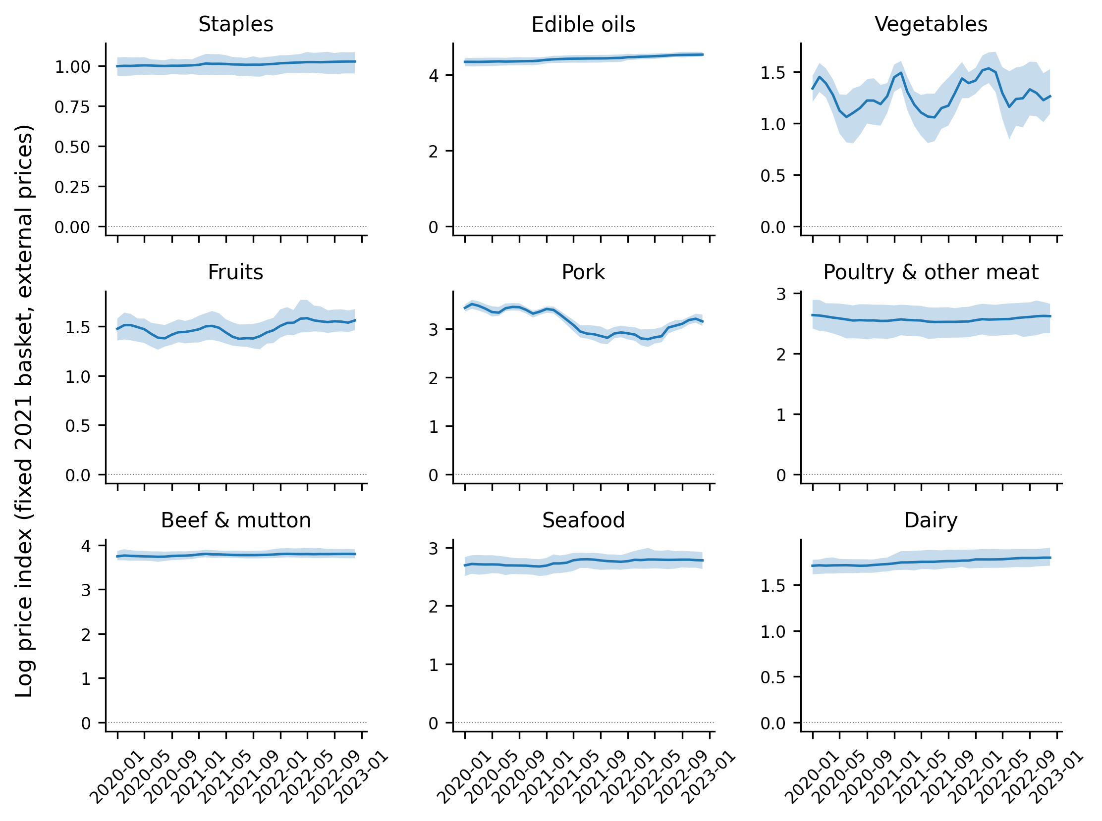
Figure 1. External fixed-basket group price indices, 2020–2022 (national mean, 10th–90th percentile province band).
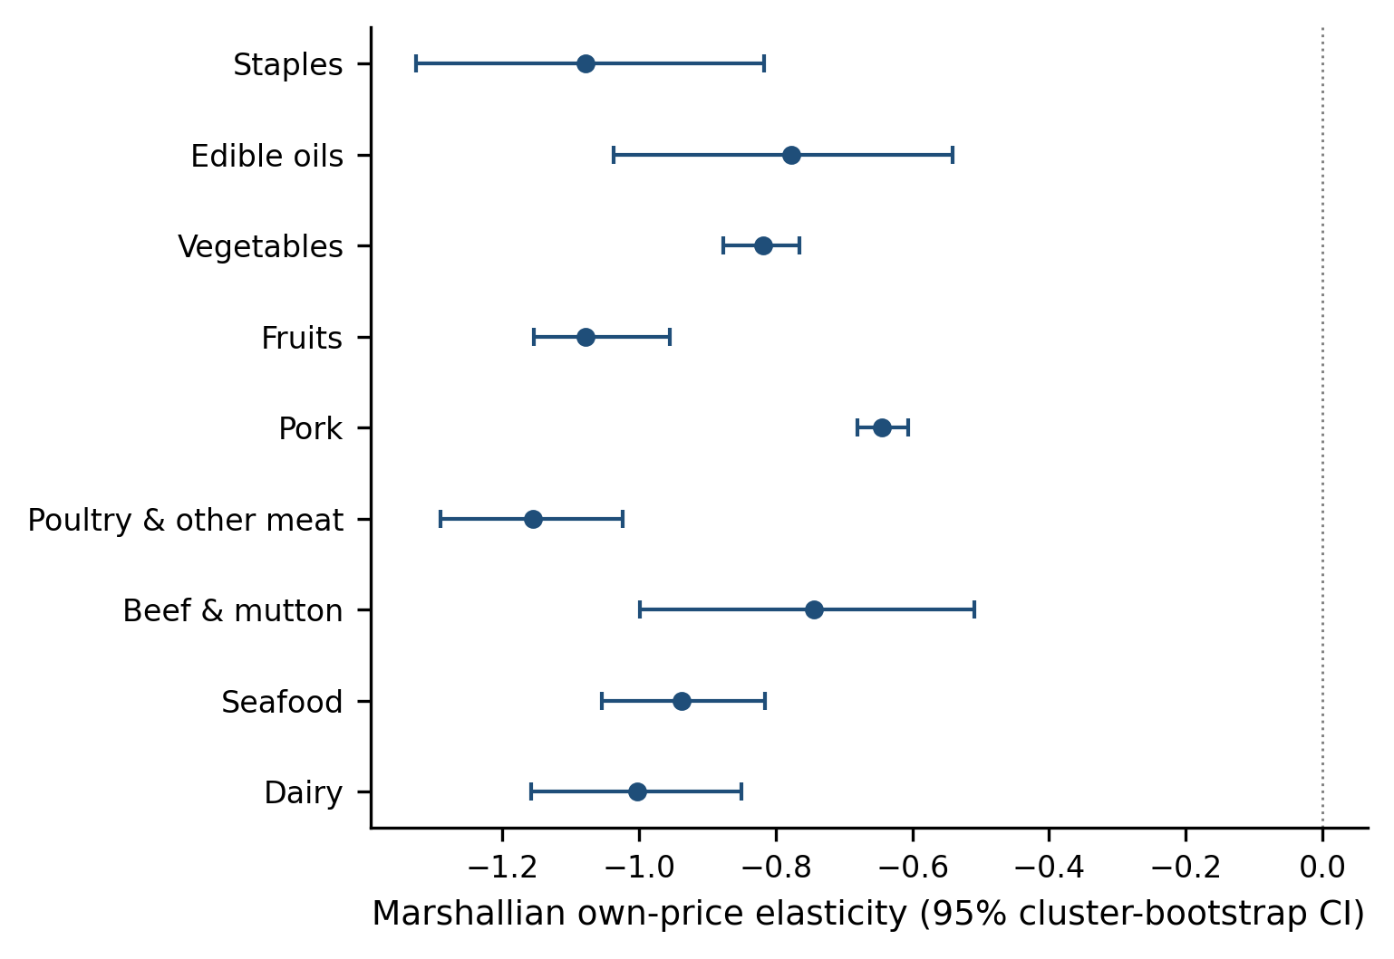
Figure 2. Marshallian own-price elasticities with 95% household-cluster bootstrap intervals.
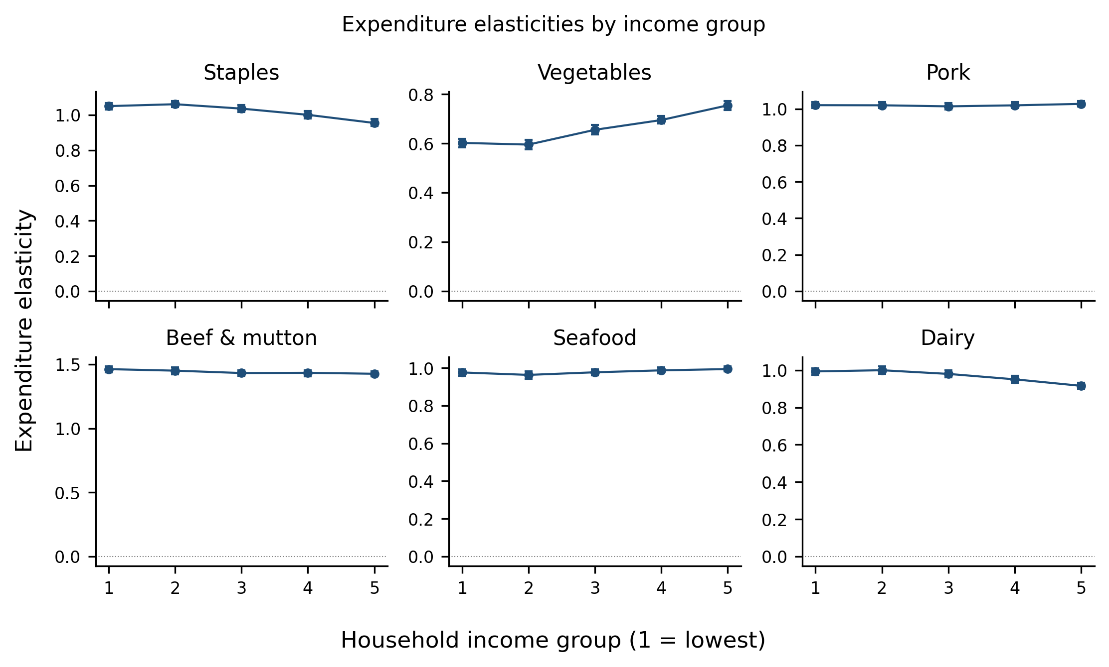
Figure 3a. Expenditure elasticities by income group, with 95% bootstrap intervals.
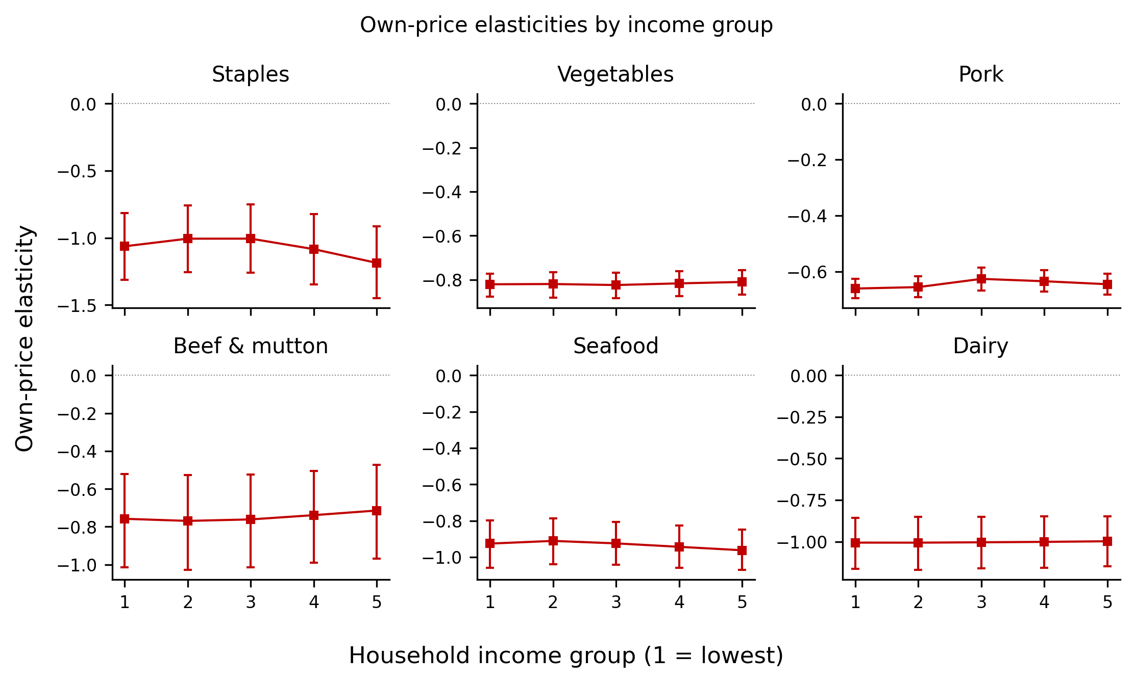
Figure 3b. Own-price elasticities by income group, with 95% bootstrap intervals.
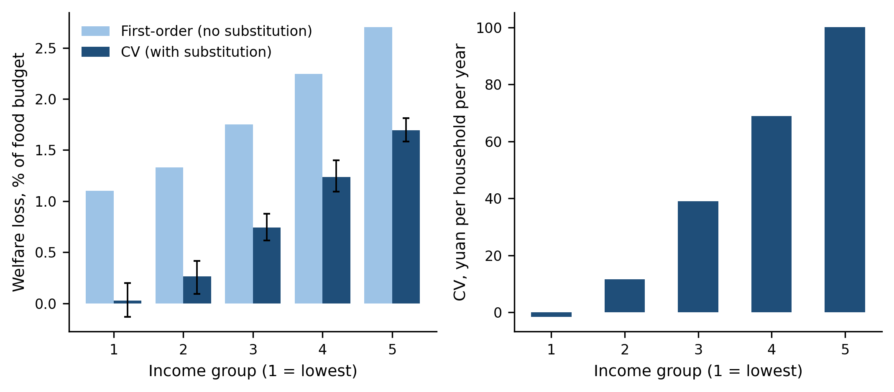
Figure 4. Compensating variation of 2020–2022 food price changes by income group. Net losses rise with income from roughly zero at the bottom; substitution (driven by the pork price reversal) offsets much of the first-order cost, most at the bottom of the distribution.
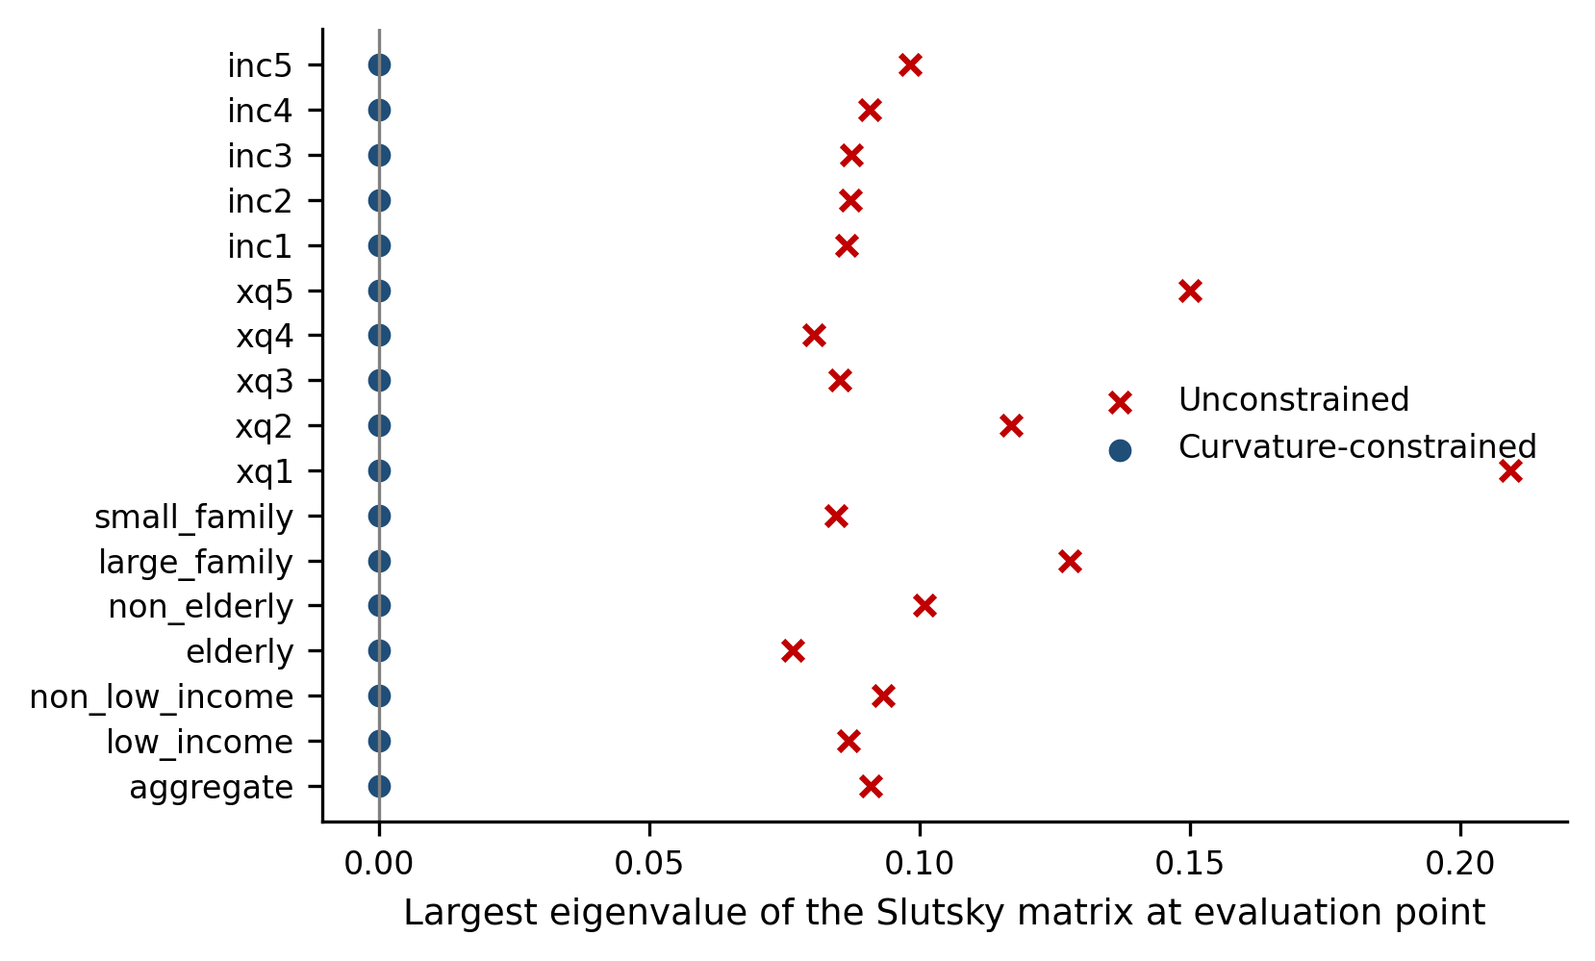
Figure 5. Curvature: largest Slutsky eigenvalue at each representative evaluation point, unconstrained versus constrained.

