San Diego Airbnb Market Intelligence Dashboard
A Neighborhood-Level Analysis for Short-Term Rental Investors
Group 11: Xin Cai, Boon Hun Joshua Gan, Yuhan Luan, Jose Mendoza, Xinru Tang
1. Project Statement
Our project analyzes the short-term rental market in San Diego, California, with a focus on Airbnb listings. The short-term rental industry sits at the intersection of tourism, real estate, and the gig economy. San Diego is an ideal market for this analysis because it is a major coastal tourism destination with Airbnb listings spread across many different neighborhoods, including high-demand coastal areas such as La Jolla, Pacific Beach, Mission Bay, and Ocean Beach, as well as inland neighborhoods. This creates meaningful variation in supply, nightly prices, review activity, and guest sentiment across the city.
The goal of this project is to build a Tableau dashboard that helps short-term rental investors evaluate neighborhood-level opportunities in San Diego. Instead of focusing only on citywide averages, the dashboard lets users compare neighborhoods based on listing supply, median nightly price, price premiums, review volume trends, room-type mix, Superhost pricing differences, and guest sentiment. The target audience is a potential Airbnb or short-term rental investor who wants to understand where demand appears strongest, where prices are highest, and which neighborhoods may offer the best balance between price, supply, and guest satisfaction.
Our main research questions are:
- How do Airbnb listing supply and pricing vary across San Diego neighborhoods?
- Which neighborhoods command the highest nightly prices and the largest price premiums relative to the city median?
- How has review volume, a proxy for booking demand, changed over time, and what does the forecast suggest about future demand?
- What do guest reviews reveal about customer sentiment by neighborhood?
- Do Superhosts appear to charge higher prices than non-Superhosts?
- Which neighborhoods appear most attractive when price, supply, and sentiment are viewed together?
2. Dataset Description
The analysis uses two linked Inside Airbnb datasets for San Diego: a listings dataset and a reviews dataset. The listings dataset contains approximately 13,000 Airbnb listings and includes variables such as listing ID, neighborhood, latitude, longitude, room type, price, minimum nights, Superhost status, review scores, and number of reviews. The reviews dataset contains approximately 900,000 reviews and includes listing ID, review date, reviewer ID, and written guest comments. Being common to both datasets, the listing ID is used to connect them.
The dataset covers more than 100 San Diego neighborhoods. The review dates span roughly 2008 through 2025, but the analysis focuses mainly on the more recent period from 2019 to 2025 to make the demand and sentiment analysis more relevant. The higher-level neighborhood group field is not populated in the San Diego Inside Airbnb file, so all geographic analysis is performed at the neighborhood level.
3. Data Cleaning and Preparation
The listings dataset was prepared for analysis using R with the following steps:
- Parse ‘price’ (stored as "$1,200.00") to numerical values
- Drop rows with missing, non-positive, or extreme (more than $10,000/night) prices
- Standardise ‘host_is_superhost’ and ‘instant_bookable’ to Booleans
- Parse date fields to year/month/date values
- Keep missing ‘review_scores_rating’ values as ‘NA’
- Select only the columns that are used in the analysis
The reviews dataset was prepared for analysis using R with the following steps:
- Drop reviews outside the analysis window of 2019 to 2025
- Drop empty or very short comments, i.e. less than 15 characters
- Drop auto-generated system messages such as cancellation notices
- Drop non-English reviews, to ensure syuzhet's English lexicon works correctly
- Drop reviews that are not of listing IDs from the listings dataset
- Add ‘neighborhood’ to the dataset through a left join to the listings dataset
- Score sentiment with syuzhet, with positive sentiment scores for positive tones and negative scores for negative tones
- Calculate average sentiment score per listing ID
4. Data Analysis and Findings
4.1 Chart 1: Listing Supply by Neighborhood
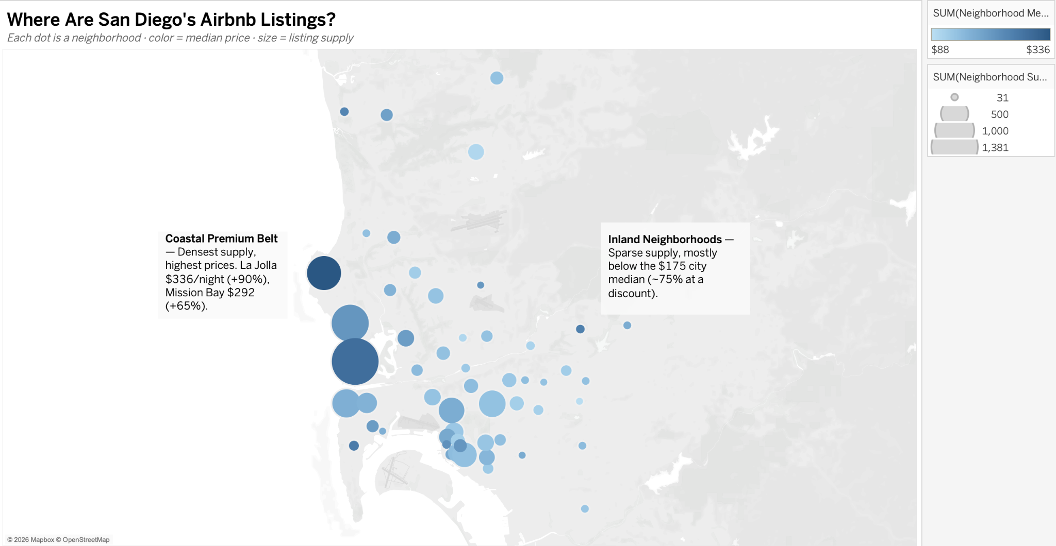
The San Diego listings map shows that Airbnb supply is not evenly distributed across the city. Larger bubbles represent neighborhoods with more listings, while color represents the median nightly price. The map shows stronger listing concentrations in coastal and central neighborhoods, which aligns with San Diego’s role as a tourism market. The map also shows that some neighborhoods have much higher median prices than others, suggesting that location plays a major role in short-term rental pricing.
4.2 Chart 2: Pricing by Neighborhood
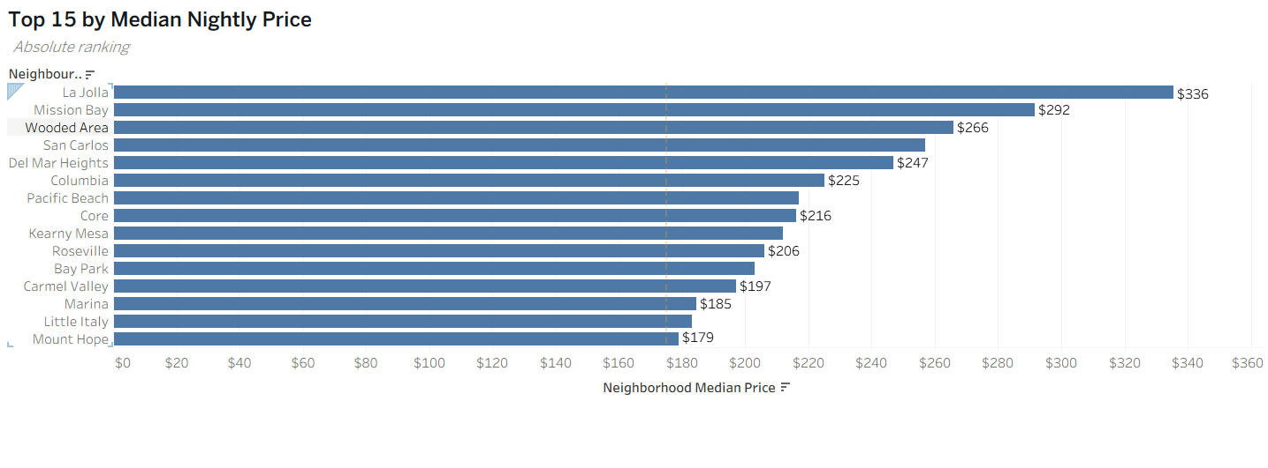
The median price chart shows the top 15 neighborhoods by median price in a bar chart format, with a comparison of the city median price of $175 per night. North City has the highest neighborhood median price at approximately $454 per night, followed by La Jolla at $336, Del Cerro at $322, Mission Bay at $292, and Torrey Pines at $273. These results show that premium and coastal or highly desirable neighborhoods command substantially higher nightly prices than the citywide benchmark.
4.3 Chart 3: Neighborhood Price Premiums
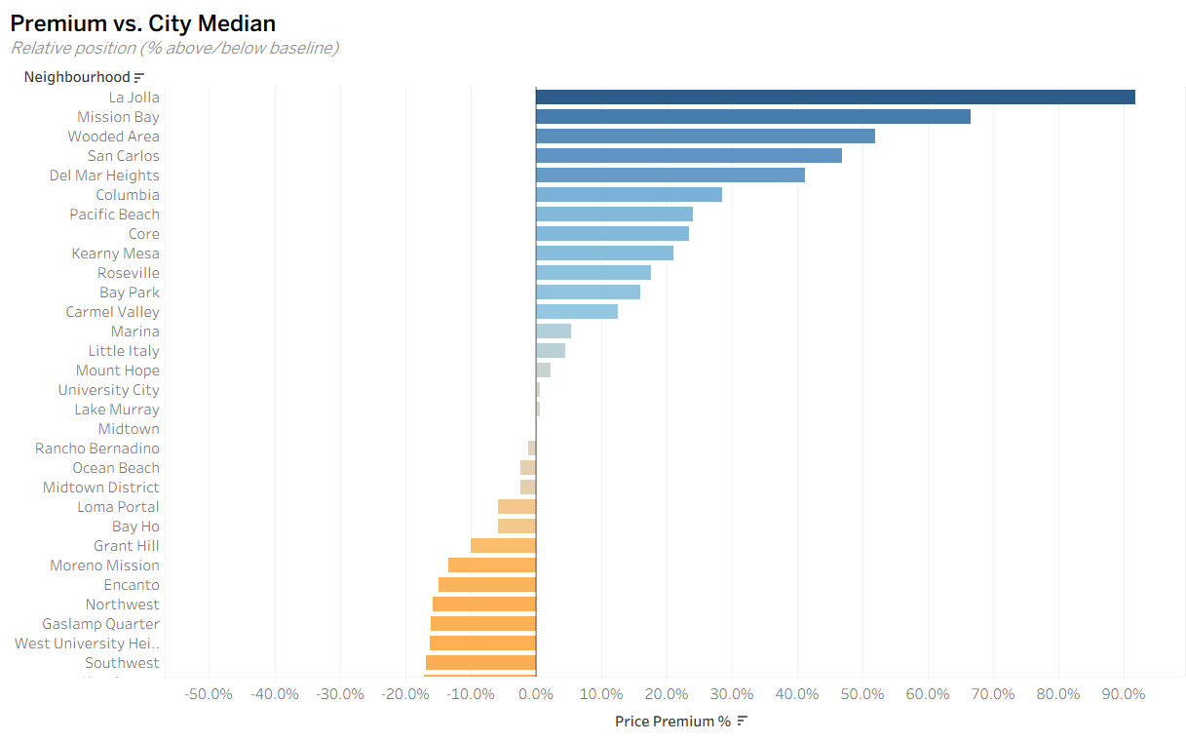
The neighborhood price premium chart compares each neighborhood’s median price to the citywide median. This helps identify which neighborhoods are priced above or below the San Diego Airbnb market baseline. La Jolla shows the highest price premium, followed by Mission Bay, Wooded Area, San Carlos, Del Mar Heights, Columbia, and Pacific Beach. On the lower end, neighborhoods such as Darnall, Otay Ranch, Mira Mesa, and Bird Land show large negative premiums. The chart ranges from approximately -49.7% to 91.7%, showing a wide gap between the most expensive and least expensive neighborhoods.
This finding is important for investors because high-priced neighborhoods may offer stronger revenue potential, but may also require higher acquisition costs and face more competition. Lower-price neighborhoods may represent value opportunities, especially if they also have strong sentiment or growing demand, or are slated for redevelopment.
4.4 Chart 4: Review Volume Forecast as a Demand Proxy
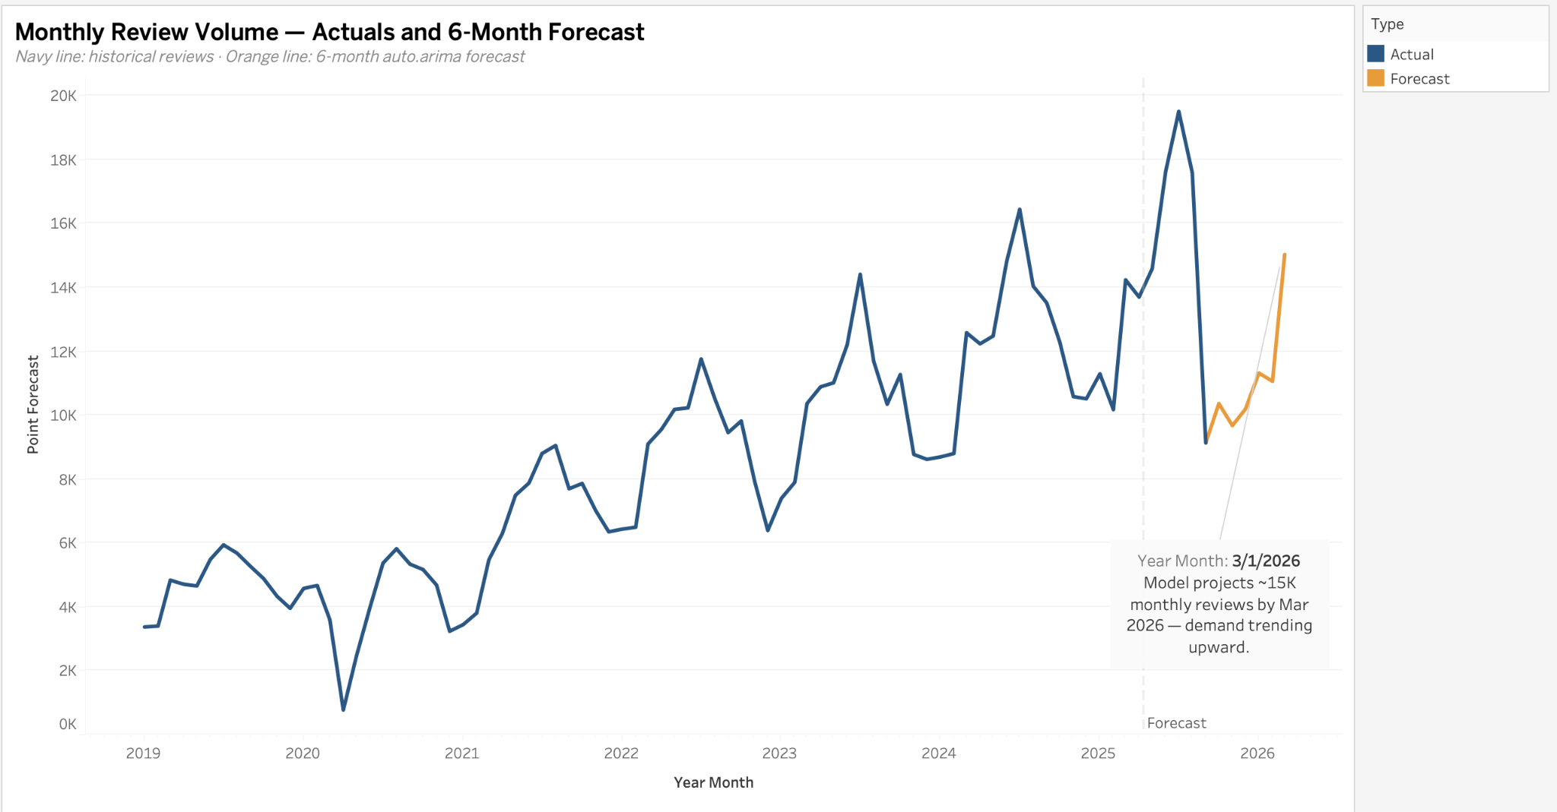
The review volume forecast shows monthly Airbnb review counts from 2019 through 2025 and projects review volume into 2026. Review volume showed a general upward trend, despite seasonal fluctuations, which once again confirms San Diego as a tourist destination. The forecast projects approximately 15,000 monthly reviews by March 2026, suggesting demand will continue to trend upward.
4.5 Chart 5: Guest Sentiment by Neighborhood
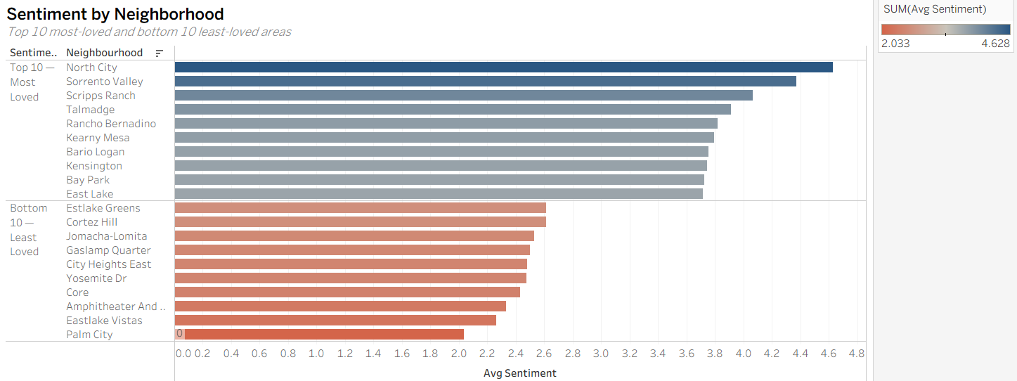
The sentiment analysis chart compares the neighborhoods with the highest and lowest average guest sentiment scores. North City, Sorrento Valley, Scripps Ranch, Talmadge, Rancho Bernadino, and Kearny Mesa are among the neighborhoods with the highest sentiment scores. On the lower end, neighborhoods such as Palm City, Eastlake Vistas, Amphitheater and Water Park, Core, Yosemite Drive, and City Heights East have lower average sentiment scores. The sentiment scores shown in the chart range from approximately 2.033 to 4.628.
This finding adds an important customer experience perspective to the analysis: a high-price neighborhood is not necessarily the best investment area, as lower guest satisfaction scores may result in higher customer acquisition costs. Likewise, a lower-priced neighborhood with high guest sentiment may indicate a possible opportunity for investors to place a premium price on the back of consistently high guest satisfaction scores. Another inference could be that guest expectations may increase with higher prices, and so guest experience must perhaps be even more carefully managed once the most desirable location is secured.
4.6 Chart 6: Sentiment vs. Price and Superhost Status
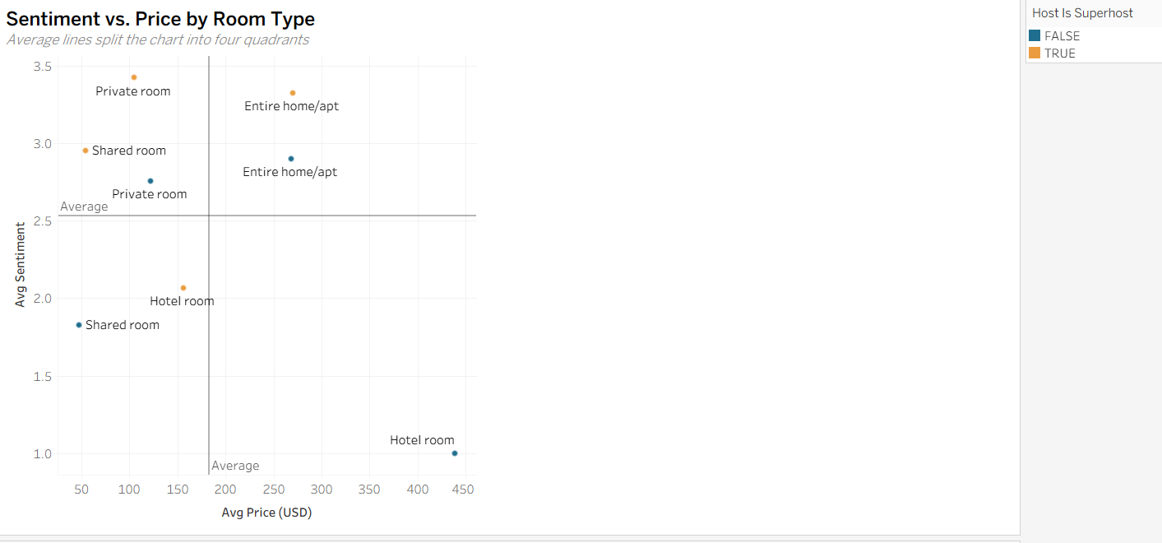
The sentiment-versus-price scatterplot compares average listing price with average sentiment, while also distinguishing Superhosts from non-Superhosts and room type. The x-axis is capped at $450 for readability, and luxury outliers are excluded.
The chart shows that both Superhosts and non-Superhosts appear throughout the price and sentiment range. However, sentiment is higher for Superhosts across all room types compared to non-Superhosts. For shared and private room types, sentiment is significantly higher for Superhosts, while the prices remain similar. It is possible that this difference could result in Superhosts experiencing more repeat business and higher occupancy rates, therefore a higher overall revenue and profitability.
The only room type that shows both Superhosts and non-Superhosts as above the average sentiment and price levels is that of the entire home/apartment. The higher average price may be explained by the higher number of guests per unit for entire homes/apartments. The higher average sentiment may be due to the type of traveler; there is a higher probability that travelers booking entire homes/apartments are traveling in groups, resulting in a better overall travel experience and therefore sentiment.
4.7 Chart 7: Room Type Mix
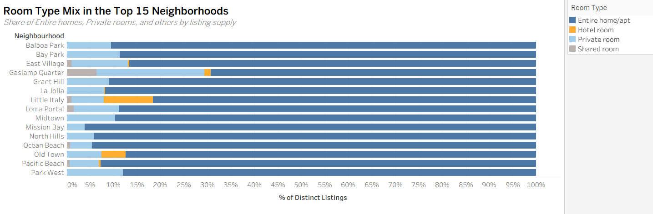
The room type mix chart shows that entire homes or apartments dominate the listing supply across the selected neighborhoods. Private rooms, hotel rooms, and shared rooms make up much smaller portions of the market. This supports the descriptive statistics from the project plan, which found that entire homes/apartments account for approximately 84% of listings.
For investors, this suggests that the San Diego Airbnb market is primarily driven by full-unit rentals rather than shared accommodations. This matters because entire homes/apartments usually have different pricing, regulations, operating costs, and guest expectations than private rooms or shared rooms.
4.8 Chart 8: Superhost Price Premium
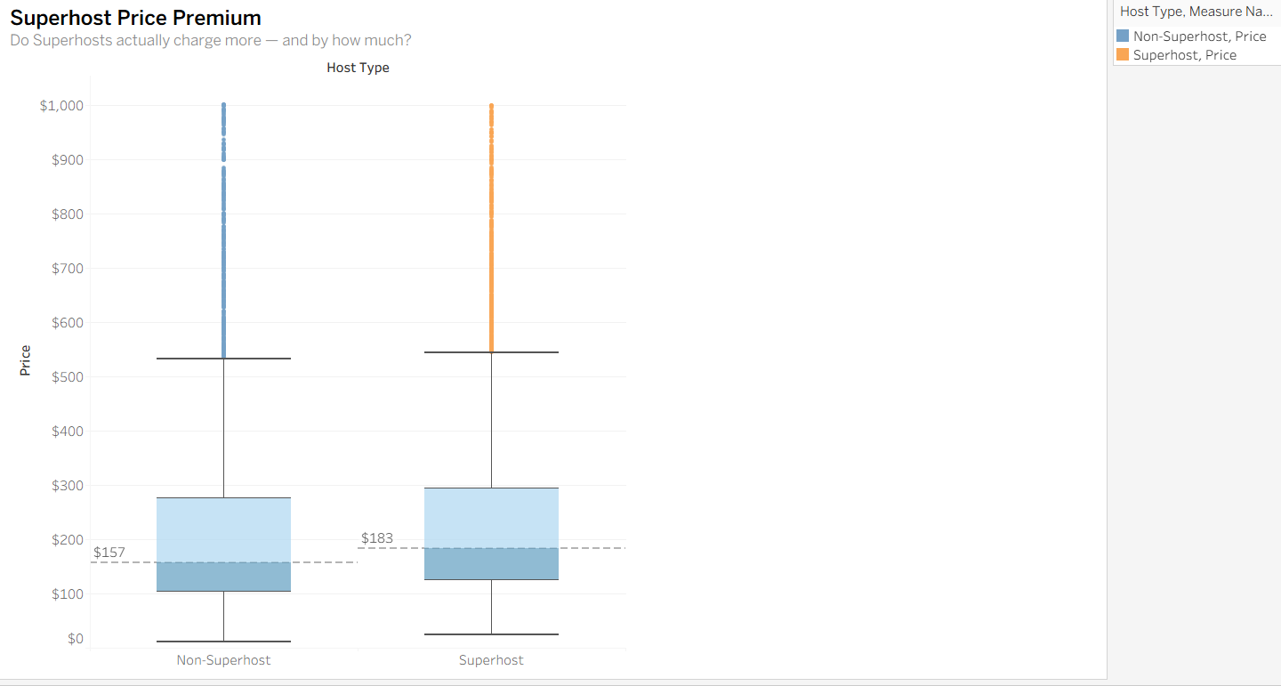
The Superhost price premium chart compares Superhost and non-Superhost prices. The box plot shows that Superhosts have a slightly higher median price than non-Superhosts, $183 and $157 a night, respectively. While this shows that there is a slight price premium for Superhosts, this difference may be offset by additional costs borne by Superhosts to create and maintain high levels of customer experience and satisfaction, e.g. complimentary bottles of wine, and the time taken by these Superhosts, e.g. the availability of 24/7 customer service and concierge services.
As such, the price premium exhibited in this chart may not be indicative of a profit premium per stay. However, as explained in section 4.6, the higher levels of customer satisfaction may lead to higher occupancy rates and therefore higher levels of revenue and profit.
4.9 Chart 9: Neighborhood Opportunity Map
The neighborhood opportunity map combines three important variables: median price, average sentiment, and listing supply. Each neighborhood is shown as a bubble. The x-axis represents median price, the y-axis represents average sentiment, and the bubble size represents supply. The chart uses median lines to divide neighborhoods into four quadrants: Value Play, Premium, Caution, and Overpriced.
This is the most useful synthesis chart for investors because it avoids creating a subjective weighted score. Instead, it allows users to interpret neighborhoods based on their own investment priorities. A “Premium” neighborhood has both high prices and high sentiment, which may appeal to investors seeking high-revenue markets. A “Value Play” neighborhood has lower prices but higher sentiment, which may appeal to investors looking for affordable entry points with positive guest experiences. A “Caution” neighborhood has both low price and low sentiment, while an “Overpriced” neighborhood has a high price but lower sentiment.
5. Limitations
This analysis has several limitations. Firstly, the data used for analysis is from Inside Airbnb, a snapshot of Airbnb listings and reviews rather than real-time transaction data. Secondly, the listed nightly price differs from the actual booked price because it does not fully account for discounts, seasonal adjustments, cleaning fees, or occupancy. Thirdly, review volume is only a proxy for demand because not every booking results in a review. Fourthly, the listed prices do not indicate occupancy rates and, therefore, overall revenue and profitability.
For our audience, potential Airbnb or short-term rental investors, to make a holistic analysis of the market for their investment decisions, additional analysis would need to be done on the cost side of the equation; while this analysis has identified specific neighborhoods that may be interesting from a revenue and demand perspective, a comprehensive cost analysis would also need to be done.
Additionally, this analysis is based on historical data. Qualitative information, such as plans for future development or redevelopment, is not considered in this analysis. This is particularly important as real estate investments are long-term in nature. There are examples globally of previously shunned neighborhoods that drastically increased in desirability and value upon the completion of revitalization projects.
6. Conclusion
The analysis shows that San Diego’s Airbnb market varies significantly by neighborhood in terms of supply pricing and sentiment. Coastal and premium neighborhoods such as La Jolla, Mission Bay, Pacific Beach, and nearby high-demand areas tend to command higher prices and stronger price premiums. Room type has a significant impact on pricing, with entire homes/apartments being the category for investors to focus on. While there is a clear relationship between Superhost status and sentiment levels, the impact of this status on pricing is not as evident. However, it can be inferred that it nonetheless influences repeat business and higher occupancy rates, and therefore higher overall revenue and profitability, with the latter also due to lower customer acquisition costs. As such, it would be important for short-term rental real estate investors to consider both the initial capital investment outlay and the running operational costs to achieve a Superhost status when calculating expected returns.
Ultimately, as stated in section 4.9, the choice of neighborhood to invest in depends on the investment thesis and expected returns. While it may be tempting to invest in neighborhoods with higher nightly Airbnb prices, there are many other factors to take into consideration for a holistic evaluation of long-term return. As such, we hope that this analysis provides a good starting point for short-term rental real estate investors to better understand the San Diego market.

