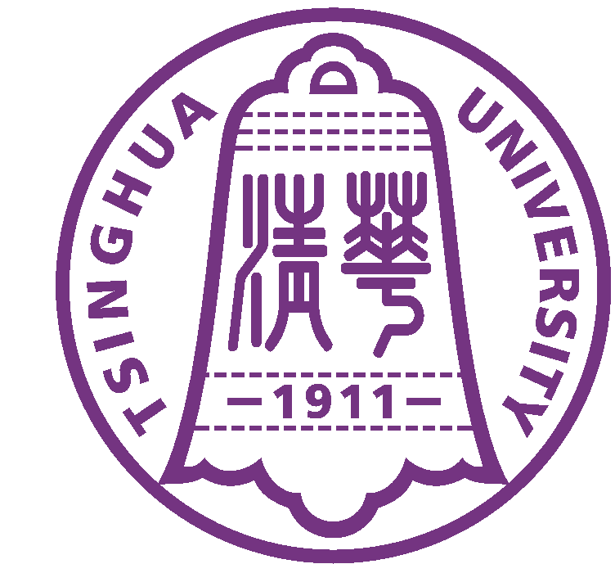
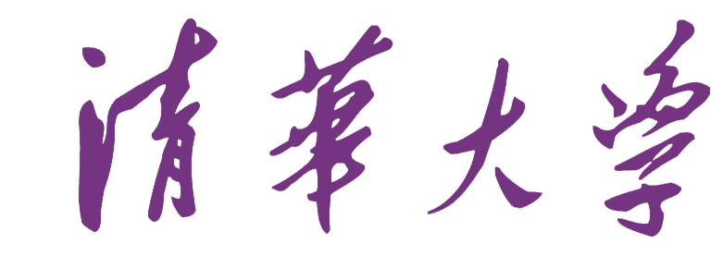 Tsinghua University
中 国 北 京100084 Beijing 100084, China

Certificate of Student Status

This is to certify that Miss Yingya Guo (born on November 20, 1990, passport number E28058228) has been admitted as a full-time doctoral candidate of Department of Computer Science and Technology, Tsinghua University in September 2013.

It is further to confirm that Miss Yingya Guo has been approved to have a twelve-month visit to New York University, USA, commencing from October 2017 and her student status will be maintained during the approval period.

Miss Yingya Guo has been granted a scholarship from China Scholarship Council that covers her international airfare, health insurance and living expenses while abroad.

Office of International Cooperation and Exchange
Tsinghua University
Beijing

Ms. LUO Shuping
Chief of Visiting Programs Abroad
Office of International Cooperation and Exchange
Tsinghua University
Beijing 100084, P.R.China
Tel: 62783741, 62785830, 62794714
Fax: 62771762

