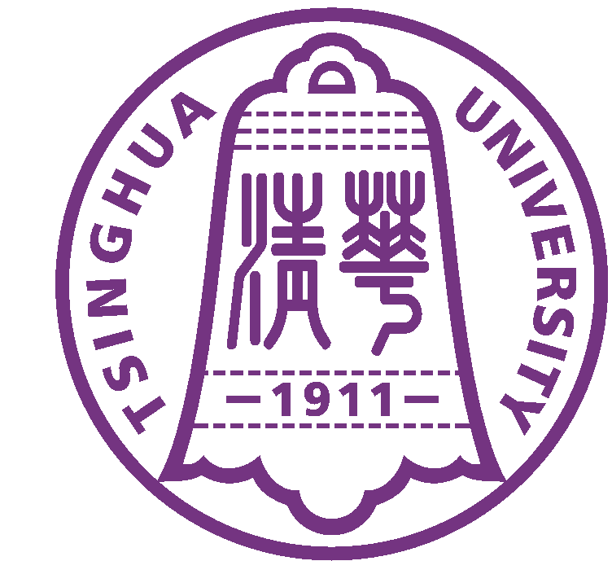
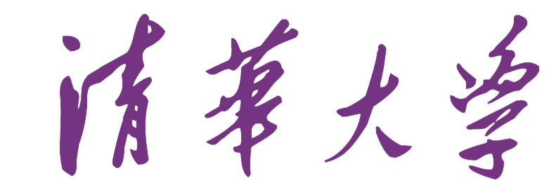 Tsinghua University
中 国 北 京100084 Beijing 100084, China

Verification

This is to certify that Miss Yingya Guo (born on 11-20-1990, passport number E28058228), PHD student of Department of Computer science and technology, Tsinghua University, has been approved to have a 6-day visit to Canada) from July 30 to August 4, 2017, attending an international conference: the 26th International Conference on Computer Communications and Networks (ICCCN 2017), which is to be held in Vancouver, Canada.
Tsinghua University will cover all her travel expenses, including the round-trip airfare, ground transportation, hotel accommodation and meals.
It is assured that Miss Yingya Guo will come back to resume her study in Tsinghua University after the visit and her student status will be maintained.

Office of International Cooperation and Exchange
Tsinghua University
Beijing

Ms. LUO Shuping
Chief of Visiting Programs Abroad
Office of International Cooperation and Exchange
Tsinghua University
Beijing 100084, P.R.China
Tel: 62783741, 62785830, 62794714
Fax: 62771762

