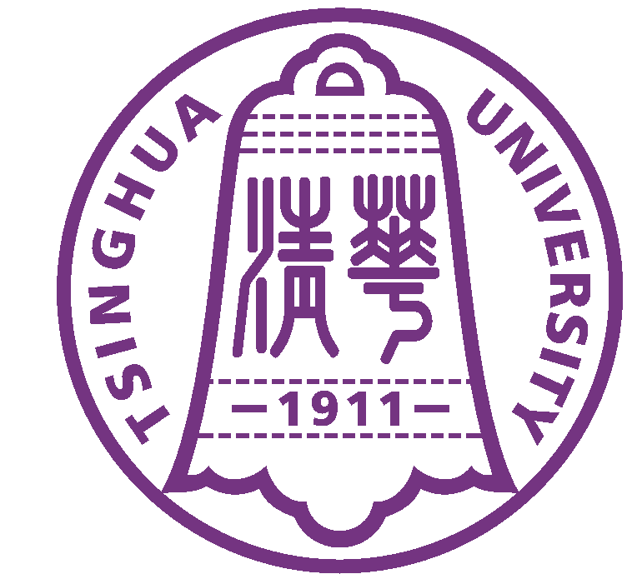
 Tsinghua University
中 国 北 京100084 Beijing 100084, China

Verification

This is to certify that Mr. Zhao Zongyi (born on Mar. 18th, 1990, passport number E35534665), Ph.D. student of Department of Computer Science and Technology, Tsinghua University, has been approved to have a 6-day visit to the United States of America from Jul. 6 to 11, 2019, attending an international conference, the 39th IEEE International Conference on Distributed Computing Systems (ICDCS 2019), to be held in the University of Texas at Dallas.
Tsinghua University will cover his travel expenses, including the round-trip airfare, ground transportation, hotel accommodation and meals.
It is assured that Mr. Zhao Zongyi will come back to resume his study in Tsinghua University after the visit and his student status will be maintained.

Office of International Cooperation and Exchange
Tsinghua University
Beijing

Mr. Guo Song
Director, Division of Outbound Visiting
Office of International Cooperation and Exchange
Tsinghua University
Beijing 100084, P.R.China
Tel: 62794714,62783741
Fax: 62771762

