## Instructions for the foraging decision making task

## by Xin Sui, last modified in January 2019

**Duration and Incentives**

This study will take place inside the **MRI scanner** and has two parts that fall on two separate days. Each part/session consists of 2.5 hours of scanning time and roughly 30 minutes outside of the scanner. You will be paid $20 per hour for your time, plus a performance-based bonus (up to $30 overall).

You will be playing a **two-patch** **foraging** video game, where you are represented by the archer warrior (see screenshot below) and your competitors by the spear warriors. You can move towards the left/right and up/down by using the number keys “1”/ “3” and “2”/ “4”, respectively, on the key pad we provide you. Your overall **objective** in this game is to approach the food rewards faster than all the competitors in the same patch as you and collect as many food rewards as possible. The number of food rewards you acquire determines the amount of monetary bonus you receive at the end of the experiment, on top of the hourly base pay. If the number of rewards you collect exceeds a certain **threshold** (that was pre-determined for all participants), you will take home the $30 bonus; if not, your bonus will be less than $30 and scaled proportionally to your collected amount.

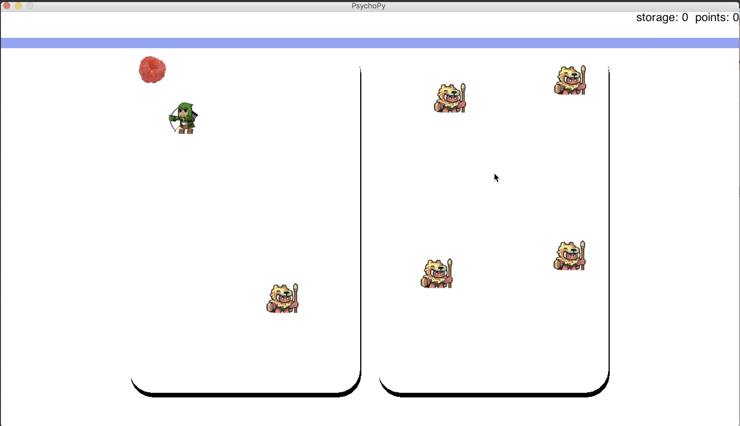

Your time inside the MRI scanner will be divided into two, (roughly) hour-long “**blocks**”. You will be able to, should you choose to, take a short break in between the blocks outside of the scanner. Each block consists of 144 (very short, 10-20 sec) “**trials**”, so it is a fast-moving game.

Before you go inside the MRI scanner for the actual game, you will have a chance to practice on a **demo** to get familiar with the game and ask any questions you may have.

**Flow of the Game**

At the beginning of each **trial**, you will have a “***sneak peek*”** (3 seconds) of the distribution of competitors in both left and right patch. You will then be asked (screenshots below) to choose the patch you would like to be placed in for the entire trial. The highlighted (i.e. **black,** as opposed to gray) options are the only available options you can choose from. You will be given 3 secondsto make your ***decision***, before all the available options change color to **blue**, indicating the time to ***input*** your choice by using the corresponding number keys “1”, “2”, “3”, or “4” on the key pad. After this, you will be placed in the patch of your choice and ***forage*** (for 7 seconds) until the end of the trial.

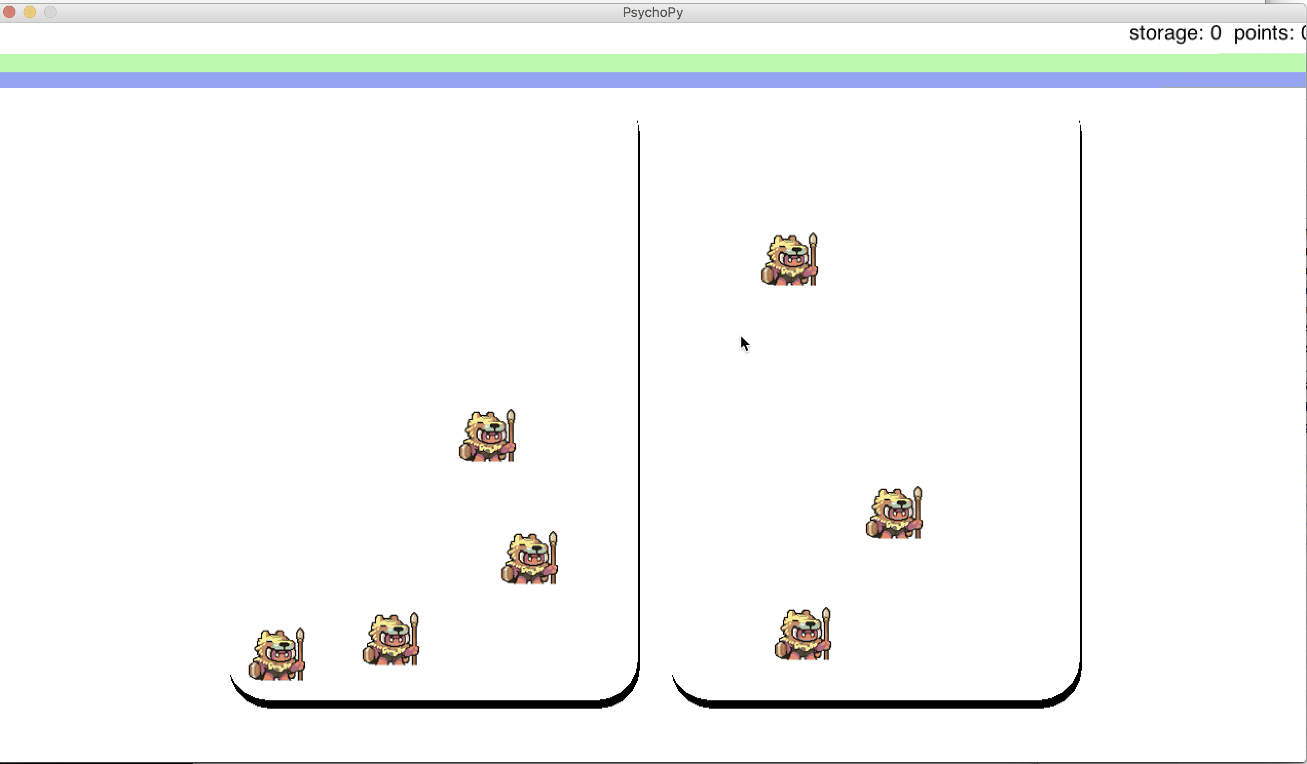

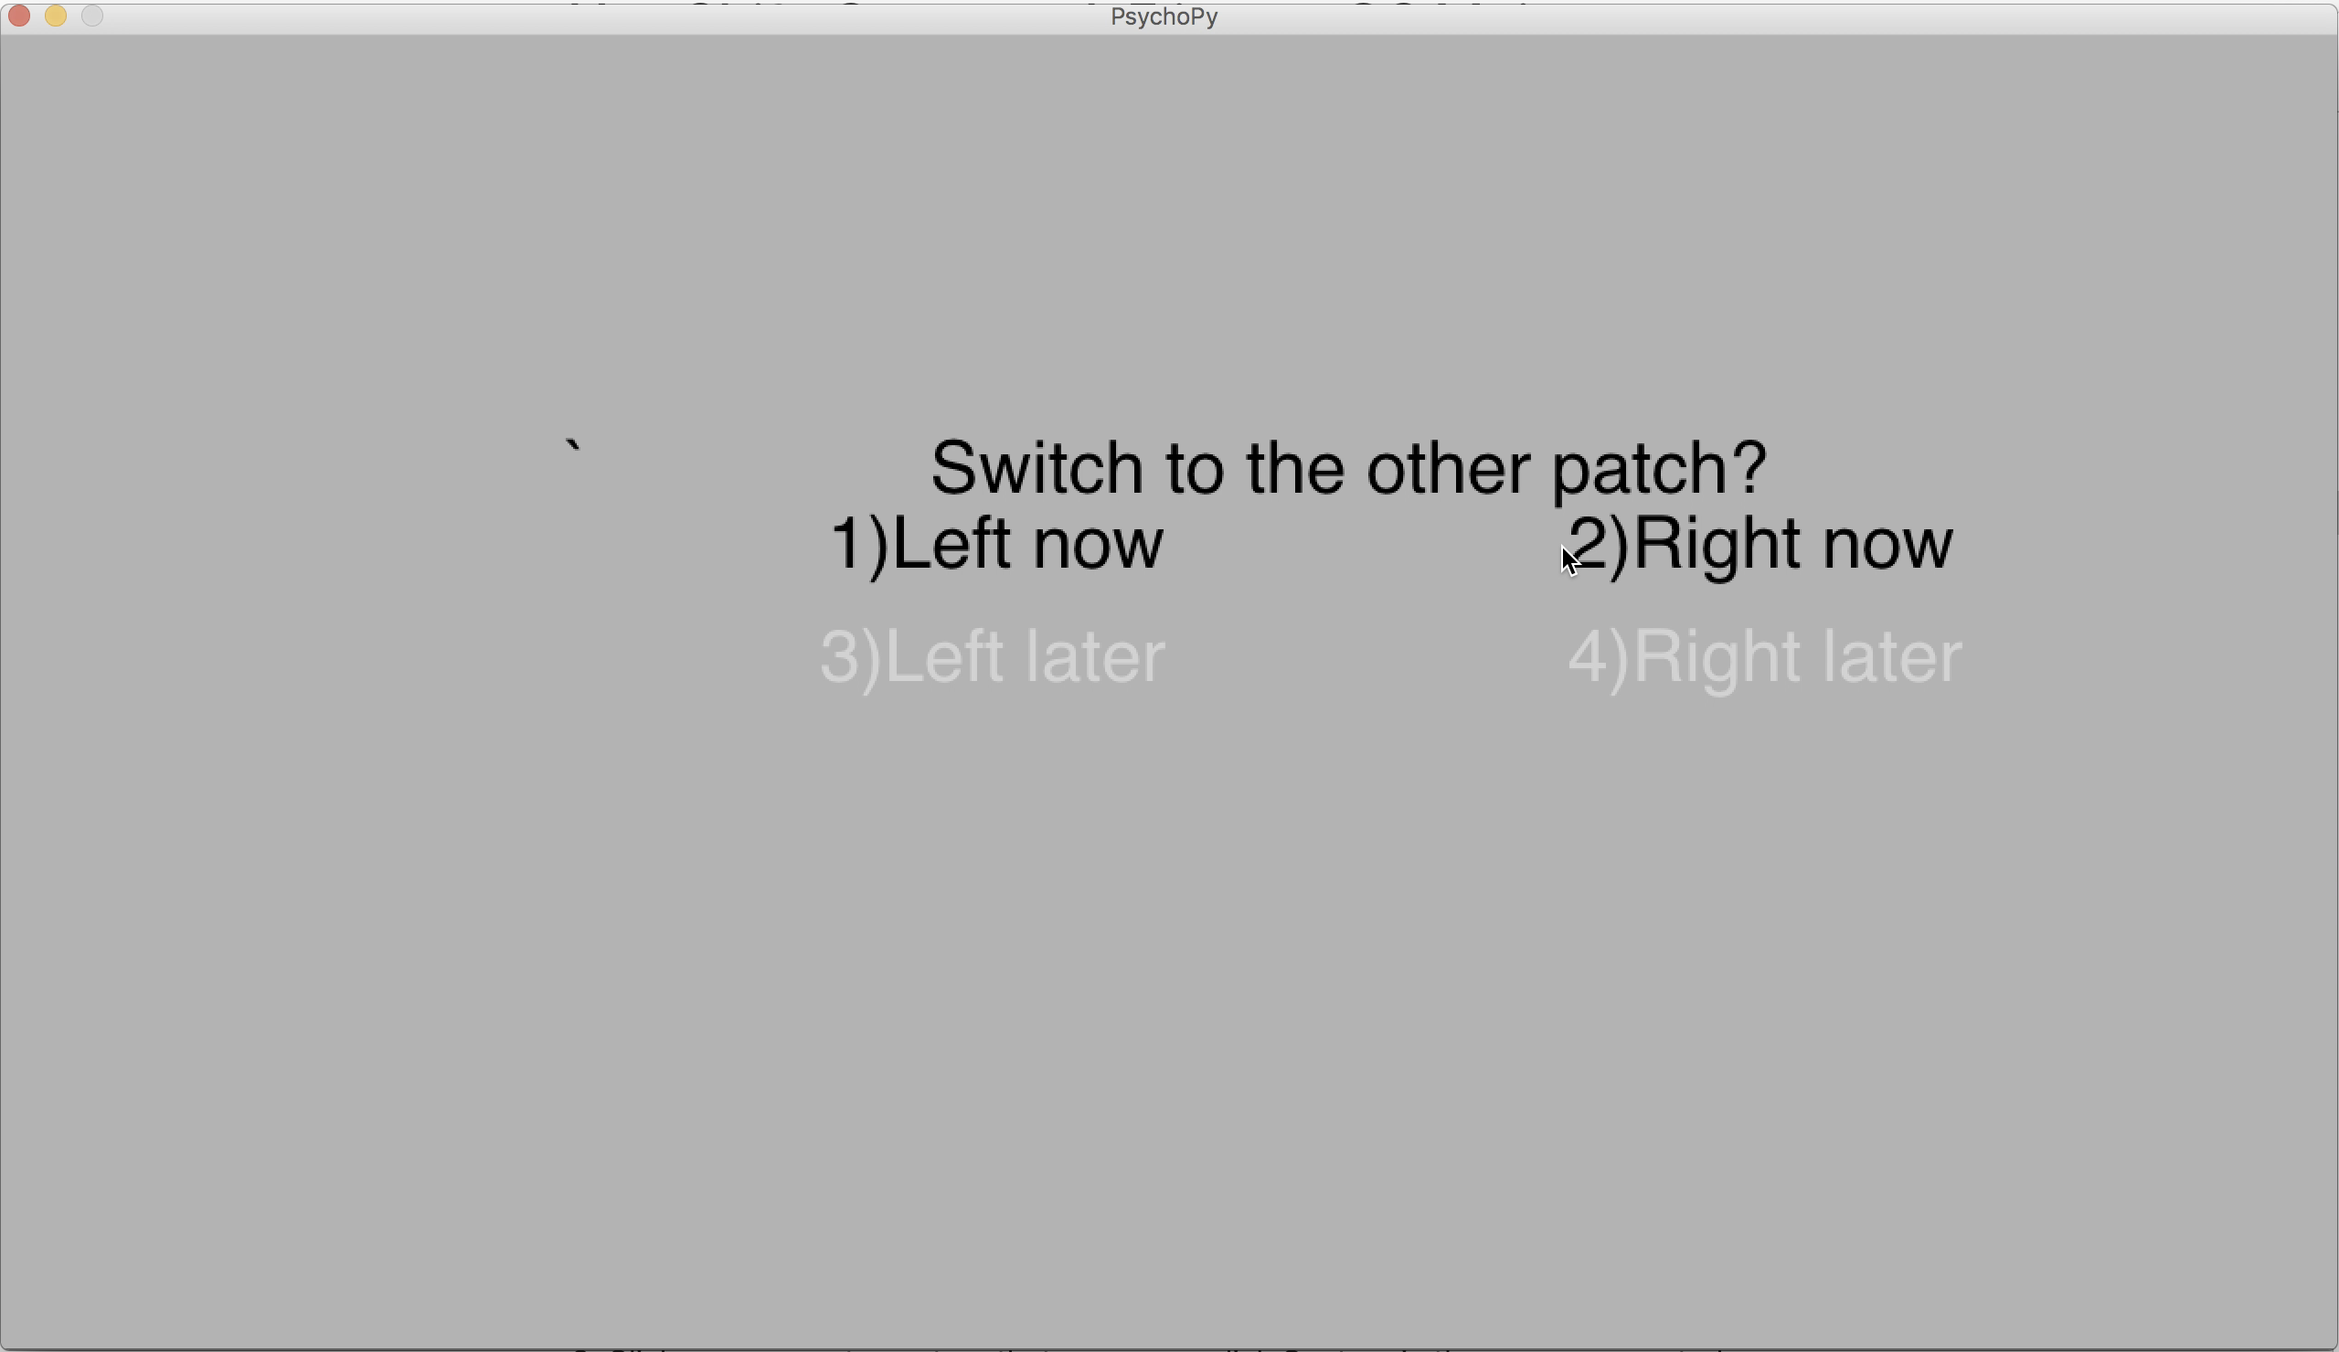

**Safe vs. Threat Conditions**

Each trial will be either of two conditions, as shown by the two screenshots below: **safe** (**white** background) and **threat** (**grey** background).



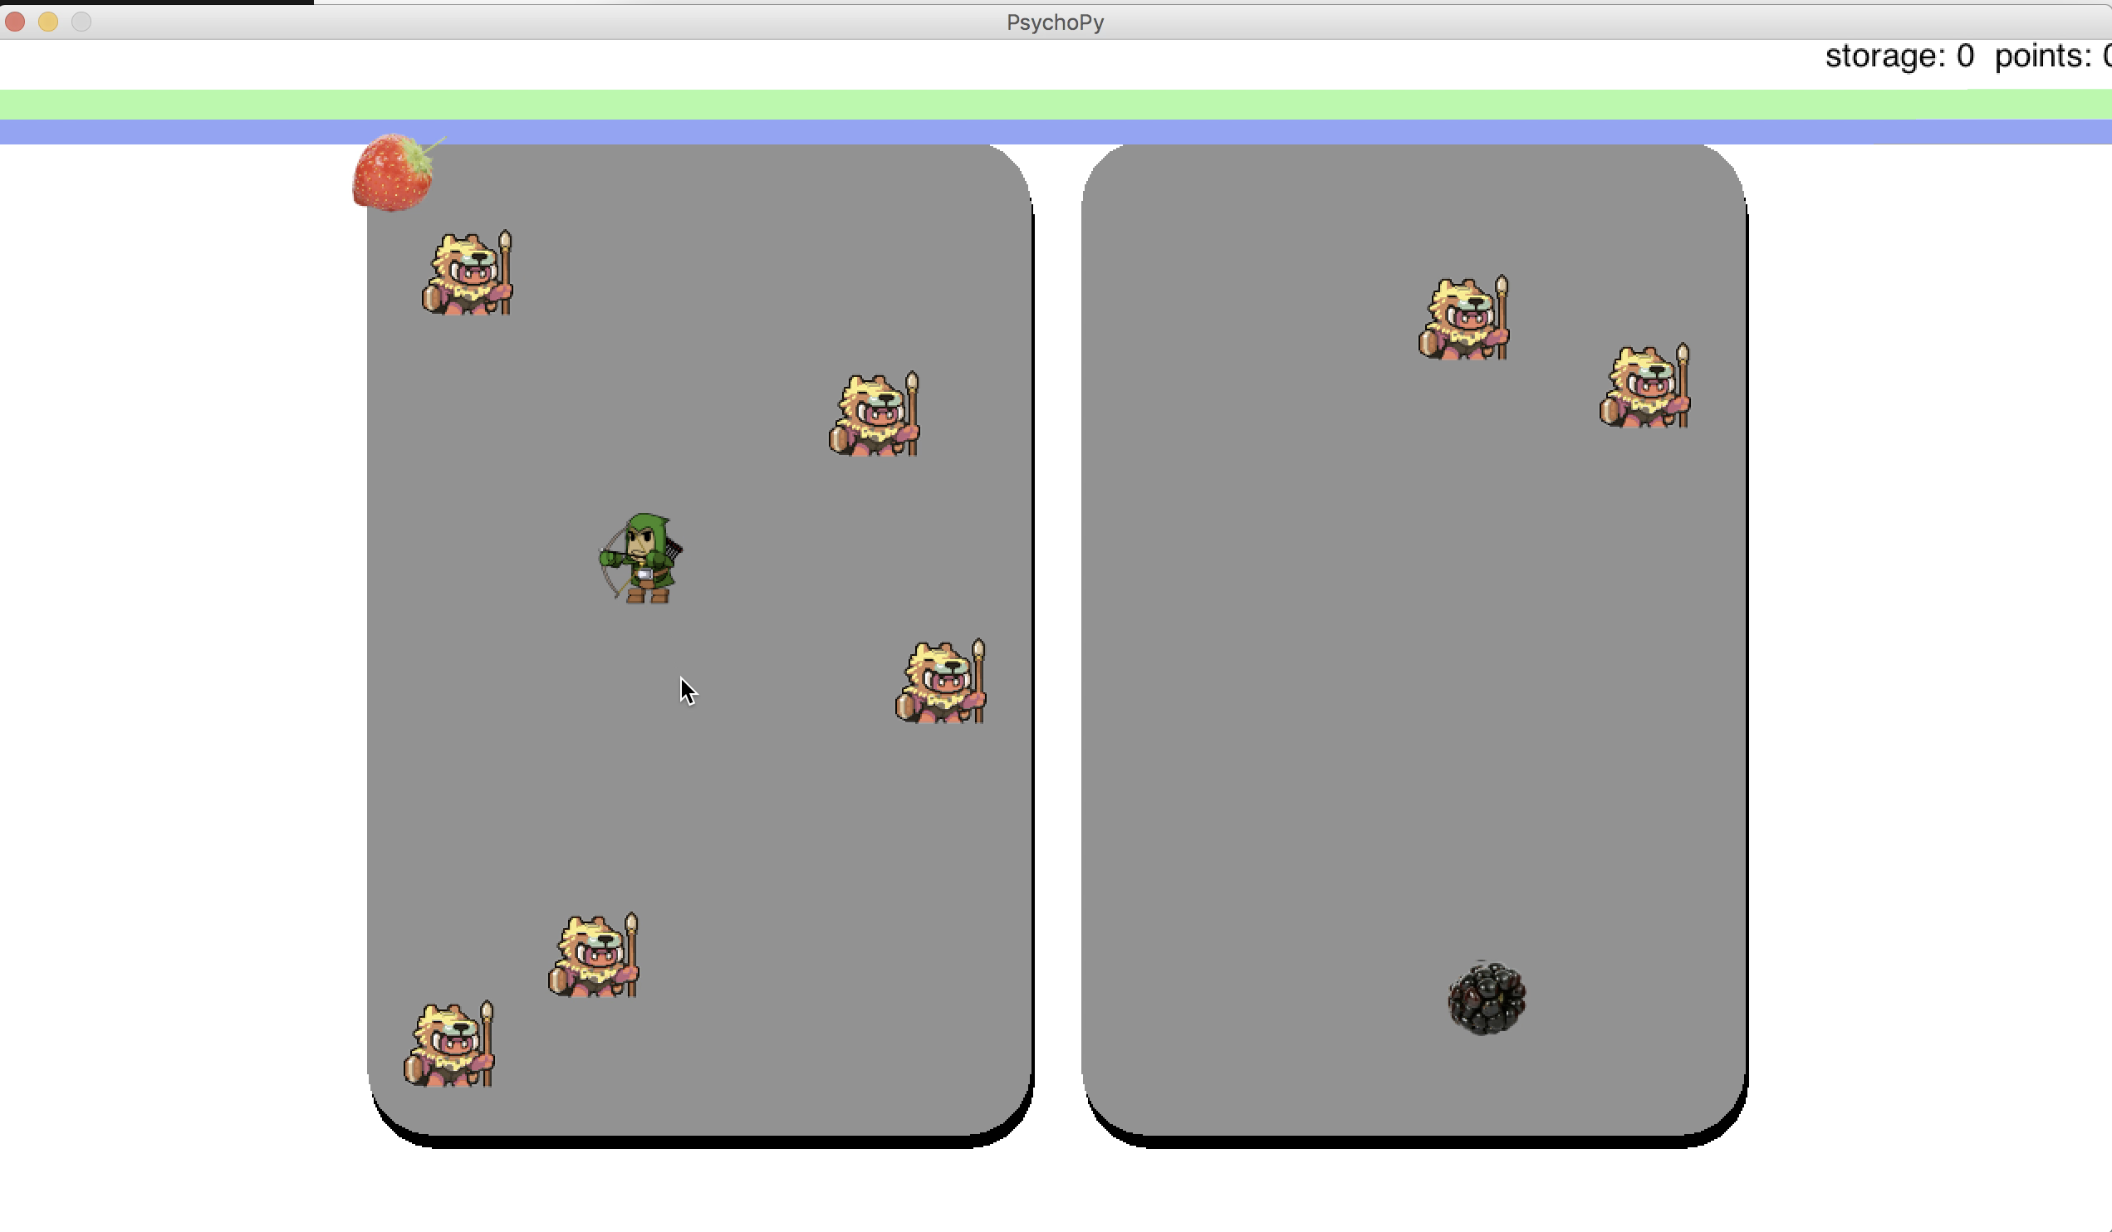

In **safe** trials, your only focus is to collect as many food objects as you can. To achieve this, you should strategically choose the patch with **least number of competitors**.

During the **threat** trials, however, a **predator** (the tiger in the screenshot below) will appear on screen at some point and randomly "attacks" one of the players in your patch. Once the predator shows up on the screen, everything freezes and there is nothing you can do for the rest of the trial (you cannot run away, or fight back, etc.). Each player in your patch, including you, has an equal chance of being attacked. If you are the unlucky chosen one, you will receive an **aversive, yet tolerable** shock to your wrist as well as **lose a portion of your winnings**. Since being in a low-competition patch results in increased likelihood of being attacked, in those situations you could choose to alter your strategy and opt for the patch with more competitors.

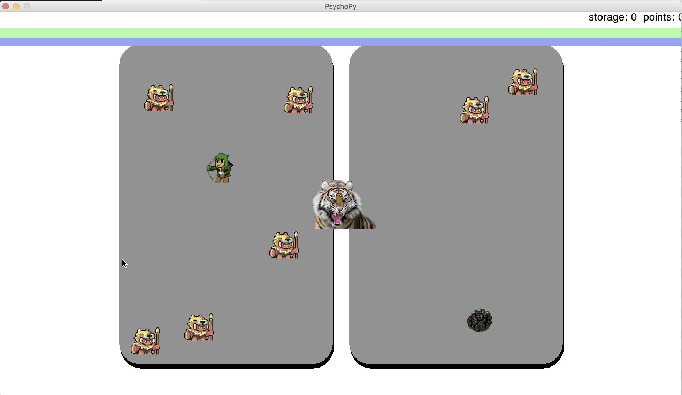

**NOTE**: the strength of electric shock will be carefully **calibrated** according to each participant’s tolerance before the game starts, to ensure that it is **aversive, yet very much tolerable**.

**Competitor Patterns**

Throughout each hour-long **block**, the number of competitors in both patches follow a consistent, underlying **pattern**. The pattern always has three **cycles**. Below is an example of what the pattern can look like:

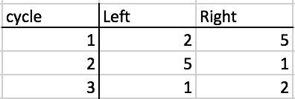

Note that the pattern is cyclical, so after 1 on the left and 2 on the right it will go back to 2 and 5, and so on. Before each block we will show you the pattern for that block for about 5 minutes. You will need to memorize the pattern and repeat it back to us correctly before we can start the block. The pattern offers crucial information as you make the decision on which patch you would like to be placed in. This is also where the **trial types** come into play.

**Three Types of Trials**

During your **sneak peek** at the beginning of each trial, pay attention to the **color bars** on top of the patches. There could be **one, two, or three** color bars, each corresponding to one of the three types of trials, as explained below:

**One color bar**

This is the most straightforward type of trials. The distribution of competitors you see during your **sneak peek** is exactly what you will deal with for that trial. In other words, what you see is what you get. Therefore, the only available options you can choose from are “1) Left now” and “2) Right now”. You will then be placed into the patch of your choice and forage for 7 seconds before reaching the end of the trial.

**Two color bar**

In this type of trials, you are allowed to choose from all four options: “1) Left now”, “2) Right now”, “3) Left later”, and “4) Right later”. If you choose either 3) or 4), you can **skip the current cycle** and jump right into the next cycle dictated by the **pattern** for that particular block. For example, if during the sneak peek you see 2 competitors on the left and 5 on the right, you will know, from recalling the pattern, that 5 on the left and 1 on the right will be the next cycle. If this is a safe trial, your best strategy will be to choose “4) Right later”, because 1 is the least number of competitors you can get out of all four available options (2, 5, 5, 1). If you do so, you will be placed into the right patch with 1 other competitor, and you will forage for 7 seconds before reaching the end of the trial. According to the way we designed the patterns, we expect to see participants choosing the “Later” options, i.e. either 3) or 4), about half of the time.

**Three color bar**

Trials of this type last about twice as long as the other two types, because they continue through **two cycles** instead of ending after one. During the decision stage, the only available options you can choose from are “1) Left now” and “2) Right now”. For example, if during the sneak peek you see 2 competitors on the left and 5 on the right, you will get what you see plus the immediate next cycle, i.e. 5 on the left and 1 on the right. If you choose “2) Right now”, you will be placed into the right patch with 5 other competitors, and you will forage for 7 seconds before the competitor distribution changes into the next cycle, which has 5 competitors on the left and 1 on the right. You will continue to stay in the right patch, with 1 other competitor, and you will forage for another 7 seconds before reaching the end of the trial. Note that in this type of trials, your decision has a more **long-term** effect in that you will be “stuck” in the patch of your choice for two consecutive cycles. Therefore, in this particular example, if the trial is a safe trial, your best strategy will be to choose “2) Right now” because (5 now, 1 later) is overall a less competitive patch than (2 now, 5 later).

**If you have any questions about the experiment, please ask the experimenter.**