CSE6242 Spring 2017 - OMS

HW1: R Programming

GT account name: xtao41

1. Get familiar with R.

Observation about programming in R, with sample code snippet and output

**Types of subscripts in R.**

1. Positive integer index

Unlike other programming language like C/C++, vector subscripts starts from 1. If subscript is out of range, it outputs ‘NA’ for vectors, but gives error for arrays.

|  |  |
| --- | --- |
| #vector  > x=c(1,2,3,4,5)  > x[1]  [1] 1  > x[6]  [1] NA  # array   |  | | --- | | > z=array(data=x,dim=c(2,3))  > z[1,]  [1] 1 3 5  > z[3,]  Error in z[3, ] : subscript out of bounds | |

1. Negative integer index

For vectors, x[-1] refers to all elements but the 1st one.

|  |  |
| --- | --- |
| #vector   |  | | --- | | > x=c(1,2,3,4,5)  > x[-1]  [1] 2 3 4 5  > x[-(2:4)]  [1] 1 5  # array  > z=array(data=x,dim=c(2,3))  > z[,-2]  [,1] [,2]  [1,] 1 5  [2,] 2 1 | |

1. Zero

It produces nothing, not even an error (get ignored). This can potentially generate design flaws (hard to debug without error).

|  |  |
| --- | --- |
| |  | | --- | | > x=c(1,2,3,4,5)  > x[0]  numeric(0)  > x[c(1,0,3,0)]  [1] 1 3  > x[7]=7  > x  [1] 1 2 3 4 5 NA 7 | |

1. Boolean index

It is very handy to select element, compare elements and make assignments.

|  |
| --- |
| > x=c(1,2,3,4,5)  > x[x>2]  [1] 3 4 5  > x>2  [1] FALSE FALSE TRUE TRUE TRUE  > x[x>2]=3.5  > x  [1] 1.0 2.0 3.5 3.5 3.5 |

1. Nothing

For vector, missing subscript returns the vector itself. For array, missing subscript in one coordinate means returning all element of that coordinate.

|  |
| --- |
| #vector  > x=c(1,2,3,4,5,6)  > x[]  [1] 1 2 3 4 5 6  # array  z=array(data=x,dim=c(2,3))  > z[,2]  [1] 3 4 |

1. Mixed indexes

Mixing positive and negative is not allowed. Mixing zero and integer results in zero being ignored.

|  |
| --- |
| > x=c(1,2,3,4,5,6)  > x[c(-1,2)]  Error in x[c(-1, 2)] : only 0's may be mixed with negative subscripts  > x[c(0,-1)]  [1] 2 3 4 5 6  > x[c(0,2)]  [1] 2 |

1. Compare Results to Built-In R Function-Report.
2. Comparison of the execution times:

The table below shows the run time (in second) of three different methods

* The recursive method is the slowest implementation. The running time of the loop method is between the recursive and the one implemented based on the built-in R function. The implementation based on the built-in lgamma(n) is the fastest method. For example, when n=3400, the recursive method is 4.3 times slower than the loop method, and the one with builtin method still has running time close to 0 sec.
* Timing of recursive implementation: sum_log_gamma_recursive(n) starts to see overflow when n equals to some number between 3500-3600.

|  |  |  |  |
| --- | --- | --- | --- |
| **n** | **runtime_loop** | **runtime_recursive** | **runtime_buitin** |
| 200 | 0.03 | 0.1 | 0 |
| 400 | 0.12 | 0.39 | 0 |
| 600 | 0.25 | 0.87 | 0 |
| 800 | 0.44 | 1.55 | 0 |
| 1000 | 0.72 | 2.5 | 0 |
| 1200 | 1.01 | 3.59 | 0 |
| 1400 | 1.45 | 5.11 | 0 |
| 1600 | 1.84 | 6.99 | 0 |
| 1800 | 2.29 | 9.11 | 0 |
| 2000 | 2.88 | 11.41 | 0 |
| 2200 | 3.43 | 13.98 | 0 |
| 2400 | 4.13 | 17.23 | 0 |
| 2600 | 4.85 | 20.28 | 0 |
| 2800 | 5.47 | 23.82 | 0 |
| 3000 | 6.5 | 27.8 | 0 |
| 3200 | 7.4 | 32.05 | 0 |
| 3400 | 8.42 | 36.19 | 0 |

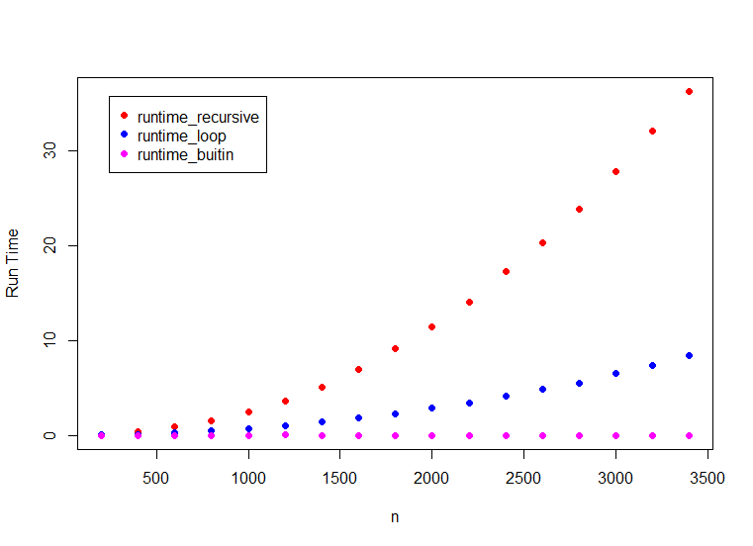

1. Growth Rate: Use the simple formula to calculate Growth Rate.

Growth Rate=ΔRun_Time/Δn

* Growth Rate of recursive method: I calculated the growth rate before it went overflow (n<3600). The growth rate increases almost linearly as n increases.

|  |  |  |
| --- | --- | --- |
| **n** | **runtime_recursive** | Growth_Rate_Recursive |
| 200 | 0.1 | 0.00135 |
| 400 | 0.37 | 0.00230 |
| 600 | 0.83 | 0.00350 |
| 800 | 1.53 | 0.00465 |
| 1000 | 2.46 | 0.00595 |
| 1200 | 3.65 | 0.00655 |
| 1400 | 4.96 | 0.00870 |
| 1600 | 6.7 | 0.00960 |
| 1800 | 8.62 | 0.01245 |
| 2000 | 11.11 | 0.01255 |
| 2200 | 13.62 | 0.01305 |
| 2400 | 16.23 | 0.01635 |
| 2600 | 19.5 | 0.01710 |
| 2800 | 22.92 | 0.02025 |
| 3000 | 26.97 | 0.01645 |
| 3200 | 30.26 | 0.02480 |
| 3400 | 35.22 | *NA* |

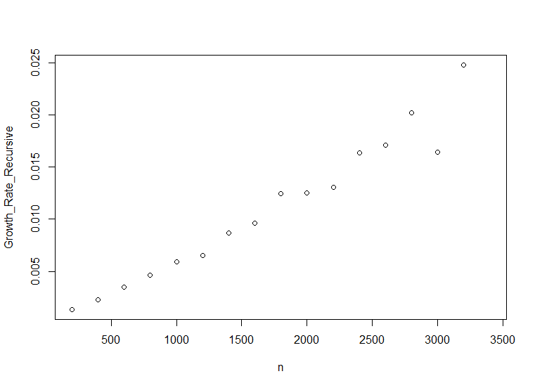

* Growth Rate of loop method: I calculated the growth rate with n<6000, when it slows down significantly. The growth rate increases almost linearly as n increases, but increases slower than recursive model.

|  |  |  |
| --- | --- | --- |
| **n_l** | **runtime_loop2** | **Growth_Rate_loop** |
| 200 | 0.01 | 0.000550 |
| 600 | 0.23 | 0.001250 |
| 1000 | 0.73 | 0.001750 |
| 1400 | 1.43 | 0.002250 |
| 1800 | 2.33 | 0.003100 |
| 2200 | 3.57 | 0.003175 |
| 2600 | 4.84 | 0.004200 |
| 3000 | 6.52 | 0.004400 |
| 3400 | 8.28 | 0.005500 |
| 3800 | 10.48 | 0.005650 |
| 4200 | 12.74 | 0.006150 |
| 4600 | 15.2 | 0.006600 |
| 5000 | 17.84 | 0.007625 |
| 5400 | 20.89 | 0.007775 |
| 5800 | 24 | *NA* |

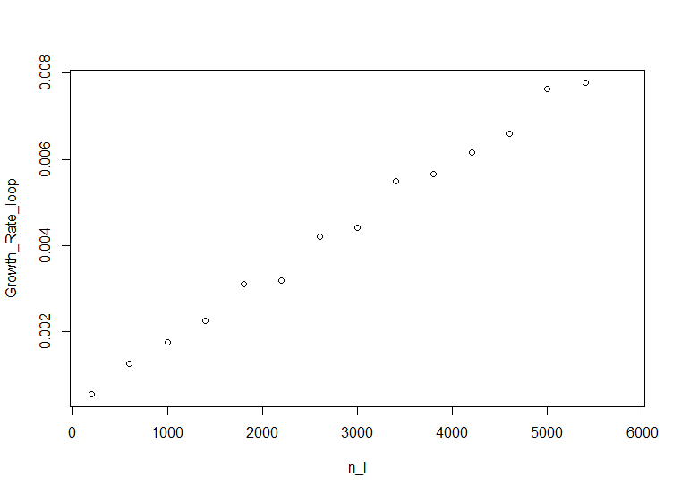

* Growth Rate of implementation based on built-in function: the execution time is very small for n<100000 (less than 0.1s). The growth rate is almost constant as n increases(n>100000, calculation not very reliable when n<100000). In fact, it is almost zero when n<10000.

|  |  |  |
| --- | --- | --- |
| **n_b** | **runtime_lgamma** | **Growth_Rate_lgamma** |
| 30000 | 0.03 | 1.00E-06 |
| 60000 | 0.06 | 2.00E-06 |
| 80000 | 0.07 | 2.00E-06 |
| 90000 | 0.09 | 2.00E-06 |
| 100000 | 0.11 | 1.10E-06 |
| 200000 | 0.22 | 9.00E-07 |
| 300000 | 0.31 | 1.30E-06 |
| 400000 | 0.44 | 9.00E-07 |
| 500000 | 0.53 | 1.00E-06 |
| 600000 | 0.63 | 1.00E-06 |
| 700000 | 0.73 | 1.10E-06 |
| 800000 | 0.84 | 1.00E-06 |
| 900000 | 0.94 | 1.30E-06 |
| 1000000 | 1.07 | 7.00E-07 |
| 1100000 | 1.14 | 1.10E-06 |
| 1200000 | 1.25 | 2.20E-06 |
| 1300000 | 1.47 | -1.00E-07 |
| 1400000 | 1.46 | 1.20E-06 |
| 1500000 | 1.58 | 1.90E-06 |
| 1600000 | 1.77 | 2.84E-19 |
| 1700000 | 1.77 | 1.20E-06 |
| 1800000 | 1.89 | 1.10E-06 |
| 1900000 | 2 | 8.00E-07 |
| 2000000 | 2.08 | *NA* |

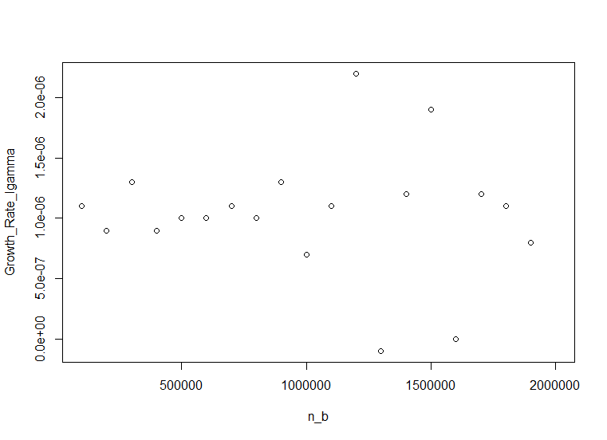

* Comparison of growth rates of run time: For both Loop and recursive method, the growth rate increases as n increases. But the recursive method increases faster than loop method. For example, when n=1000, recursive model grows 3.4 time faster than loop method and when n=3000, recursive model grows 3.7 time faster than loop method. In contrast, the growth rate of the implementation based on the built-in function is almost constant and very small as n increases. In fact, it is almost zero when n<10000, even for n on the order of 106, the growth rate is neglectable (~1.0E-06).

1. Why we see specific growth rates for the various functions?

* For the examples above, when using loops in R, because it is an interpreted language, every operation carries a lot of extra baggage/user-defined functions, as well creates environments for execution, assigns arguments to the environment, etc. Also loops can’t easily be vectorised because each iteration depends on the previous. Thus, it shows a strong slowing down as dataset becomes bigger.
* Recursion is even more slower than Loops in this case. One reason is that the recursion function always calls itself. A function call involves saving current stack frame and starting with a new stack frame (additional push and pop instructions), and thus takes more time. As the data set becomes large, the recursion can become too deep and easy to get stack overflow.
* Unlike the functions written in R code, which is interpreted when they are run, the built-in function “lgamma” and “gamma” is based on C translations of Fortran subroutines. and is pre-compiled. Therefore, it runs much faster than the two user-defined R functions based on R.