**CS7646: MC2_P2 Report**

Chunqing Yuan

**Part 1: Bollinger Band Strategy:**

**1. Bollinger Band Strategy Chart:**

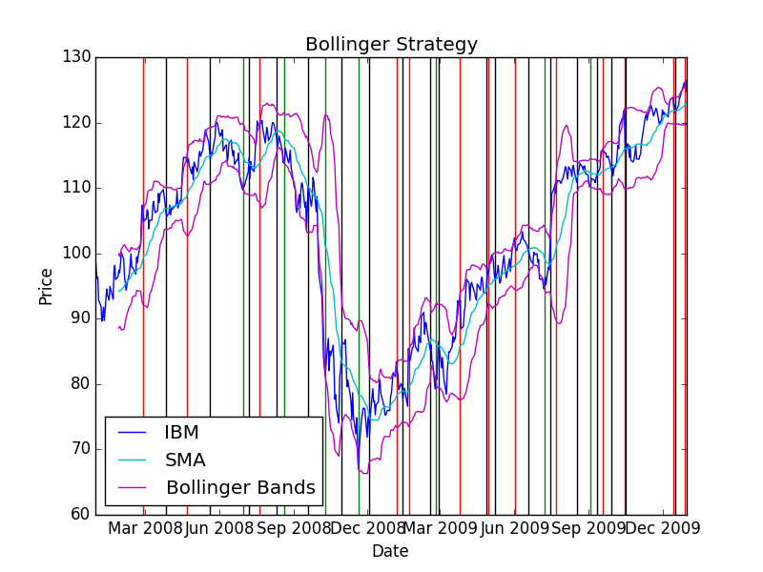

**2. Bollinger Band Strategy Backtest Chart:**

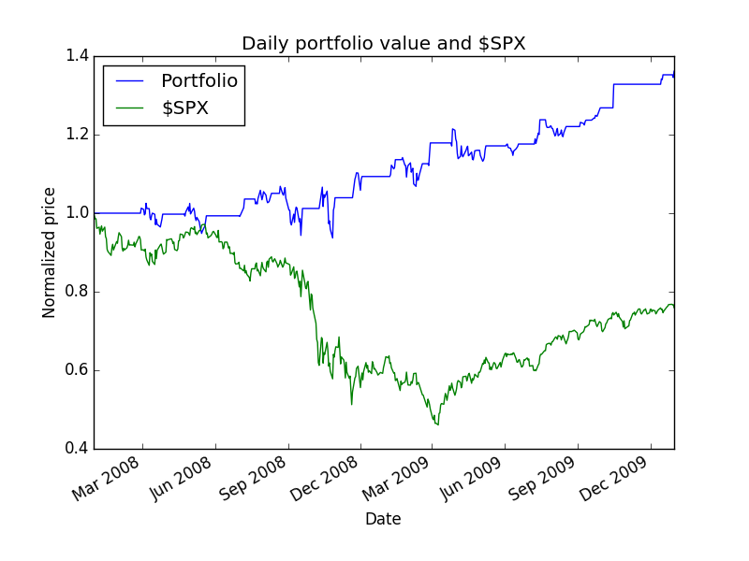

**3. Summary of Bollinger Band backtest performance metrics:**

Data Range: 2007-12-31 to 2009-12-31

Sharpe Ratio of Fund: 0.97745615082

Sharpe Ratio of $SPX: -0.21996865409

Cumulative Return of Fund: 0.3614

Cumulative Return of $SPX: -0.240581328829

Standard Deviation of Fund: 0.0108802922269

Standard Deviation of $SPX: 0.0219524869863

Average Daily Return of Fund: 0.000669942567631

Average Daily Return of $SPX: -0.000304189525556

Final Portfolio Value: 13614.0

**Part 2: My Strategy:**

1. **Introduction**

In my 10 years trading experience, “Bollinger Bands” is one of my favorite indicators. However, in contrast to the method shown in class, I use it in a different way with different parameters, and focus more on the “trend”. I find it is quite effective in determining the trend of price movement and trading opportunities of stocks. The basic idea is described as below:

1. The average window of SMA is **99**, means it is a 99-day moving average.
2. The standard deviation multiply factor is **1**, instead of 2. So the distance between upper and lower Bollinger bands is narrower.
3. The whole graph is divided into 4 regions:
   1. When stock price cross up SMA, it is considered that the stock has a “strong” moving trend (S).
   2. When stock price cross down SMA, it is considered that the stock has a “weak” moving trend (W).
   3. When stock price cross up Upper Band (UB), it is considered that the stock has a “very strong” moving trend (VS).
   4. When stock price cross down Lower Band (LB), it is considered that the stock has a “very weak” moving trend (VW).

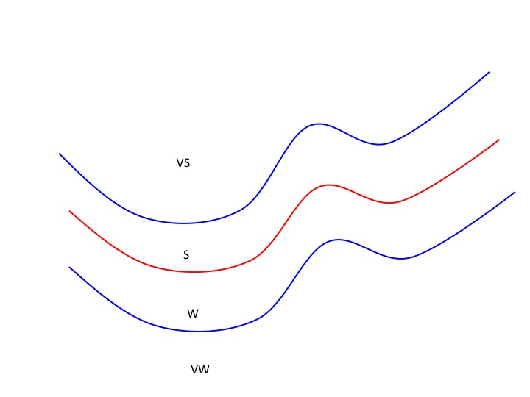

1. The main trading strategy is:
   1. When stock price is in between Upper Band and Lower Band, although it may have a strong or weak trend, it usually does not have a clear direction and it can swing back and forth. Therefore, it usually not worth to trade in this region.
   2. When stock price is above Upper Band, it usually has very strong trend of moving up. So at this point, we start to buy the stock as much as possible (up to leverage 2).
   3. When stock price comes back and cross down Upper Band, we believe the “very strong” trend is over so we sell all stocks.
   4. When stock price is below Lower Band, it usually has a trend of moving down. So at this point, we start to short the stock as much as possible (up to leverage 2). If price drops excessively that causes leverage become below 1, we further short more to keep leverage 2.
   5. When stock price comes back and cross up Lower Band, we believe the “very weak” trend is over so we cover all short positions.
2. The fine tuning:
   1. For high volatility stocks, its price is easily to cross Upper or Lower Bands without a strong moving trend. This is a misleading signal. Therefore, we use another indicator: RM_SMA, which is 5-day moving average of SMA. If SMA is significantly moving up (higher than RM_SMA), it may indicate that the stock has a trend of going up. If the SMA is significantly moving down (lower than RM_SMA), it may indicate that the stock has a trend of going down.
   2. Sometimes the stock price will occasionally fall below Upper Band during a “very strong” trend, or go above Lower Band during a “very weak” trend. If we were misled by those signals, we may lose a potential opportunity to further follow the trend. The RM_SMA is a good indicator to check if the trend is over. If the SMA is moving down comparing to RM_SMA, it may indicate that the stock’s “VS” trend is over. If the SMA is moving up comparing to RM_SMA, it may indicate that the stock’s “VW” trend is over.
   3. Another widely used indicator is the moving average (MA). Simply, two MAs with different window can indicate the stock price trend. For example, I use 10-day MA and 20-day MA here. If 10-MA is above 20-MA, the stock may have a going up trend. If 10-MA is below 20-MA, the stock may have a going down trend. Because the main strategy described here is a Bollinger band strategy, I only use the double MA strategy as an indicator of EXIT point. If the stock price is cross down Upper Band from “VS”, we check if the double MA also gives a downward trend, if so we sell it. If the stock price is cross up Lower Band from “VW”, we check if the double MA also gives an upward trend, if so we cover it.

F. There is a possibility that the “exit” indicator described above does not work at some particular point. For example, when the stock price crosses down Upper Band, the SMA or double MA do not show a downward trend. However after a while it start to move down further. Therefore we force to exit when the stock price crosses SMA. When it crosses down SMA and we have a long position, we sell all. When it crosses up SMA and we have a short position, we cover all.

**2. My strategy chart:**

The chart below illustrates the enter and exit points of my strategy. “Buy” points are green lines, followed by a black line at where we sell the long position. “Sell” points are red lines, followed by a black line at where we cover the short position. At each enter point, we buy (or sell) the maximum allowed number of shares (up to leverage 2). A table of generated orders is also listed below. 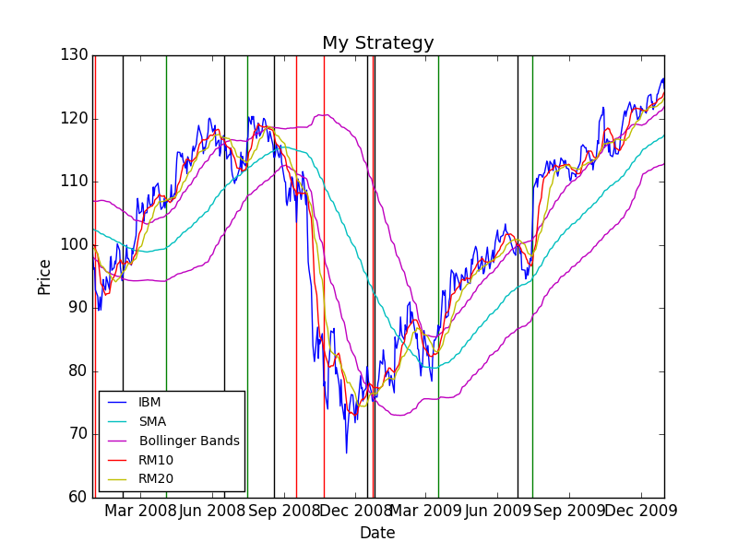

Orders:

|  |  |  |  |
| --- | --- | --- | --- |
| Date | Symbol | Order | Shares |
| 1/3/08 | IBM | SELL | 207 |
| 2/8/08 | IBM | BUY | 207 |
| 4/3/08 | IBM | BUY | 191 |
| 6/17/08 | IBM | SELL | 191 |
| 7/16/08 | IBM | BUY | 204 |
| 8/19/08 | IBM | SELL | 204 |
| 9/17/08 | IBM | SELL | 219 |
| 10/22/08 | IBM | SELL | 220 |
| 12/16/08 | IBM | BUY | 439 |
| 12/23/08 | IBM | SELL | 417 |
| 12/26/08 | IBM | BUY | 417 |
| 3/17/09 | IBM | BUY | 353 |
| 6/26/09 | IBM | SELL | 353 |
| 7/15/09 | IBM | BUY | 392 |

**3. Backtest chart of my strategy:**

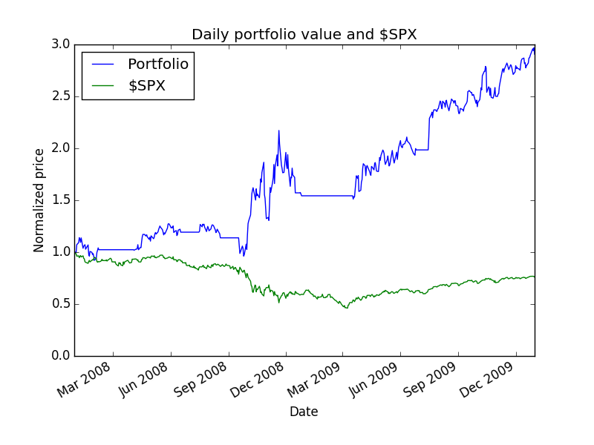

**4. Summary of my strategy backtest performance metrics:**

Data Range: 2007-12-31 to 2009-12-31

Sharpe Ratio of Fund: 1.33939299844

Sharpe Ratio of $SPX: -0.21996865409

Cumulative Return of Fund: 1.906076

Cumulative Return of $SPX: -0.240581328829

Standard Deviation of Fund: 0.0305756966303

Standard Deviation of $SPX: 0.0219524869863

Average Daily Return of Fund: 0.00257978857258

Average Daily Return of $SPX: -0.000304189525556

Final Portfolio Value: 29060.76

**5. Conclusion:**

The backtest result of my strategy has a cumulative return of 1.9, which strongly beat the Bollinger Band strategy. This performance is largely due to use of margin. If we do not use any margin, i.e. keep the leverage below 1, the total cumulative return is about 1.0, still quite competitive comparing to the Bollinger Band strategy and SPX. However, the high leverage may results high risk, and so that the sharpe ratio is not very high. For example, in a high volatile market without clear trend, the price may cross the UB or LB and come back quickly, this usually triggers non-profitable trades and it is easily to lose money if these trades occur frequently. To avoid this issue, I use other methods (like RM_SMA, double MAs) to determine the trend, and only trade when the trend becomes clear. This is a difficult work and requires fine tuning of the parameters. Finally, we force to exit any position when the price crosses the SMA, to prevent further loss in case all our exit indicators does not work.

This strategy is not a general strategy. Before apply it to other stocks, we should adjust the parameters, especially the width of Bollinger Bands (the multiply factor of rstd, may range from 0.5 – 2) based on the volatility of the stock. This value significantly affects the number of profitable trading opportunities. The trend evaluation parameters (RM_SMA, MAs) should also be tuned. Here these parameters seem to work well with IBM, and during 2008-2009. The strategy gives 0.36 return during 2006-2007, and 0.28 during 2010-2011, which are not as compelling as 2008-2009 period. In these years, large drawbacks are a significant issue due to incorrect signals. Again, it is risky to use margin because you could lose all your money after a few unsuccessful trades.

In real trading, I usually manually adjust the Bollinger band parameters to let it fit better with each stock, determine the support and resistance points, consider together with other indicators like KDJ, MACD, and also consider the market performance. It is overall an effective strategy but we need to be careful when using it. Machine learning could be a powerful tool to train the model and to find the best parameters. I’m eager to learn more from this course and apply them to my trading strategies!