# 创建批处理文件设置环境变量及启动tomcat

@rem @for /F "delims=" %%I in ("%~dp0") do echo %%~fI

@echo off

chcp 936

rem @setlocal

set JAVA_HOME=e:\jdk1.8

set classpath=.;.\classes\;.\target\test-classes\;.\target\classes\;%JAVA_HOME%\jre\lib\rt.jar;%JAVA_HOME%\lib\tools.jar;

set LANG=zh_CN.UTF8

set path=.;%JAVA_HOME%\bin;C:\Windows\system32;C:\Windows;C:\Windows\System32\Wbem

set CATALINA_HOME=E:\myIDE\tomcat9

taskkill /F /IM "java.exe"

@call E:\myIDE\tomcat9\bin\startup.bat

# Eclipse中启动tomcat

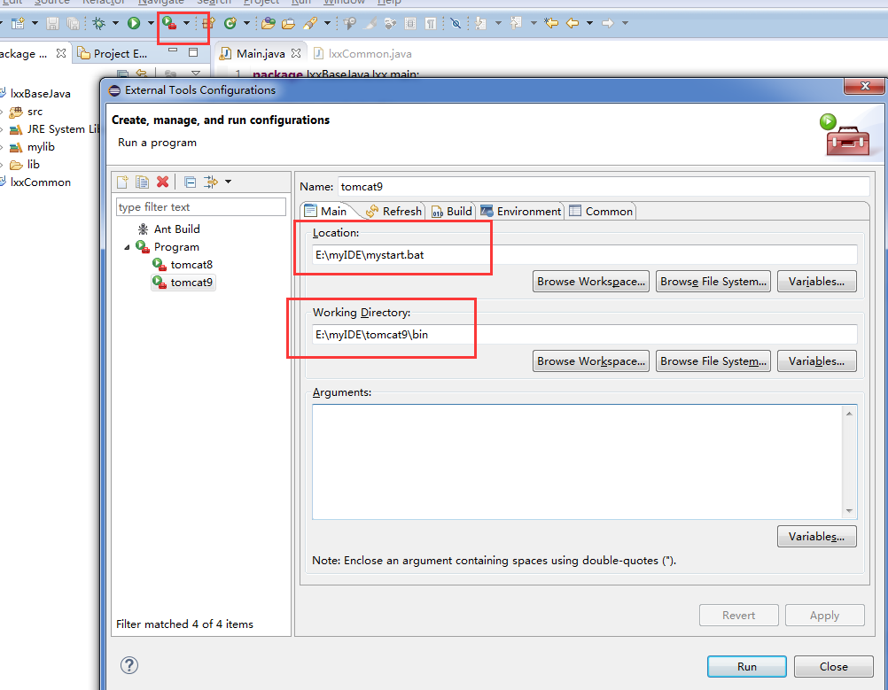

# 启动tomcat不在新窗口打开

启动catalina.bat时候加参数启动

Run:在同一窗口下启动服务器

Start:在新窗口启动服务器

Stop:关闭服务器

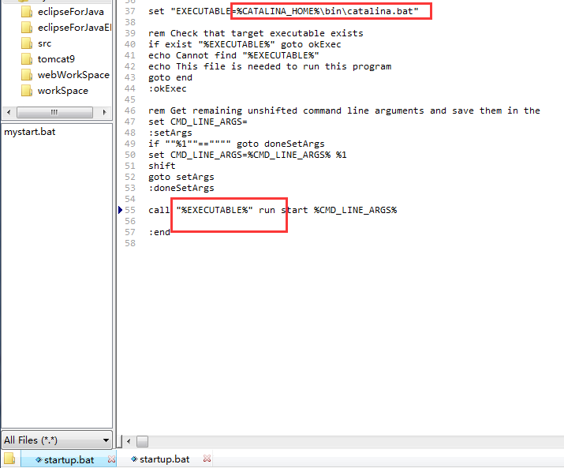

# Tomcat配置任意目录的web应用程序

