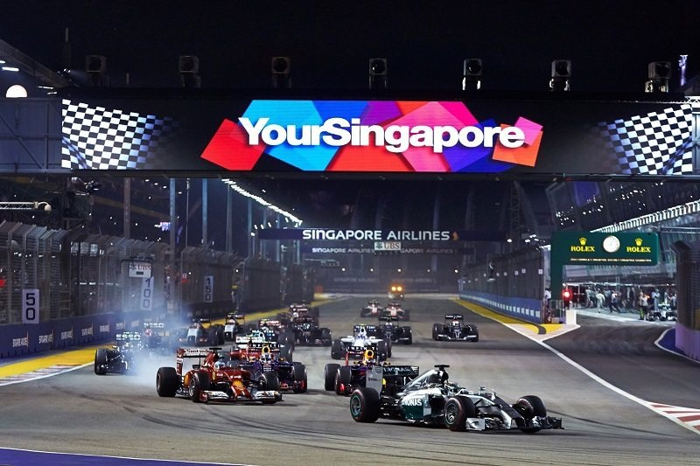

2016 FORMULA 1 SINGAPORE AIRLINES SINGAPORE GRAND PRIX

DATE \@ "d MMM, y" 16 Sep, 2016

Marina Bay Street Circuit

16 - 18 Sep, 2016

Zone B • Row 5 • Seat 23

[www.eventpresso.com.sg](http://www.eventpresso.com.sg)