To set up the system,

1. Download and Install Arduino IDE, and Processing IDE
2. Install the Arduino library “Adafruit_ADS1X15-master” and “CD74HC4067-1.0.0” into Arduino IDE. For tutorial, refer to <https://www.arduino.cc/en/guide/libraries>
3. Open Arduino IDE, open the file “control000”
4. adjust the user-defined variables:

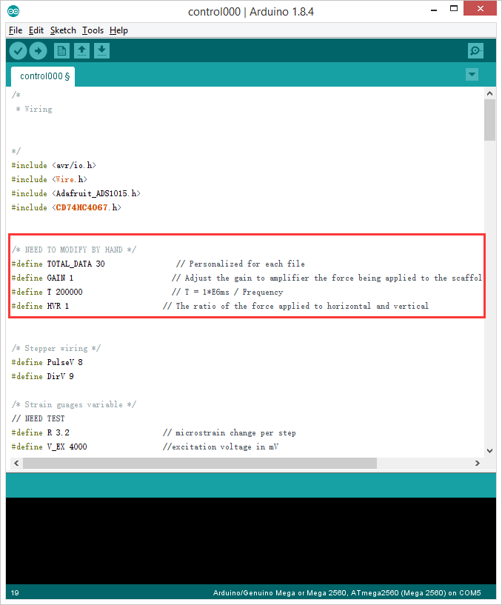

1. Upload the code on to mega2560
2. Open Processing IDE, open the program “ImportData”
3. Change the Path of the import Data file

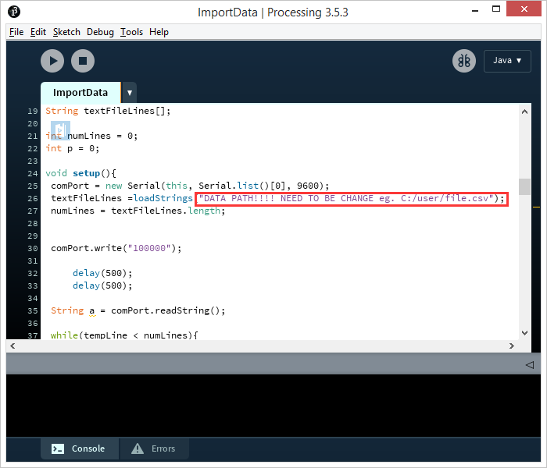

1. Run the program by click 
2. Connect the red wire between Reset and 5V on the board

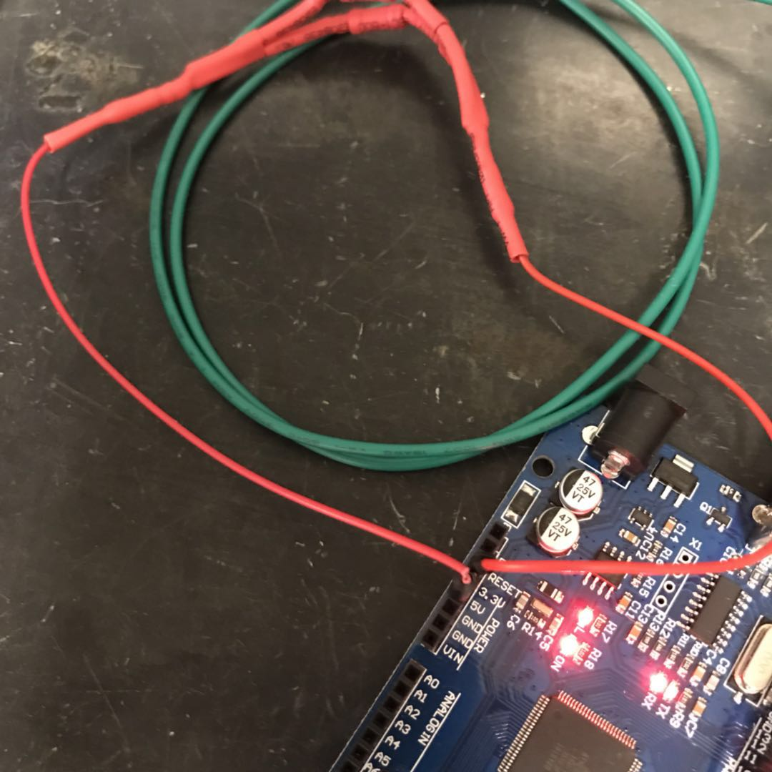

1. Open PXL_DAQ folder
2. Open PXL_DAQ Spreadsheet
3. Choose the available port and click connect

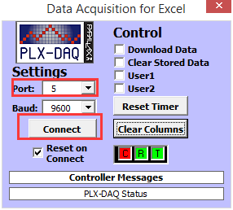

1. Plot real time measurements by excel tool