under the dome

Beijing PM 2.5 Pollution Analysis

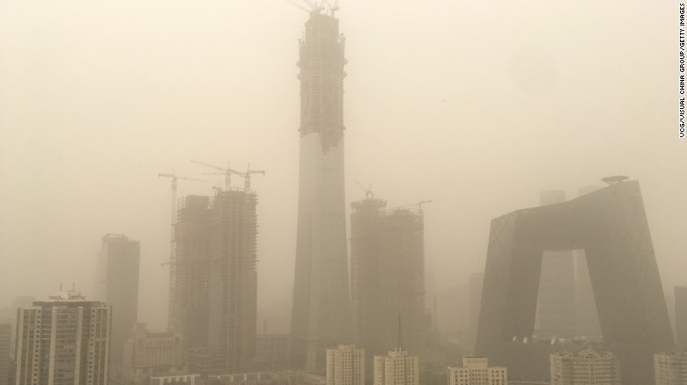

Xinge Jia: xj2221

Nikita Tourani: nrt2117

Xinyi Hu: xh2383