**1. Use a program design language to produce the design for the validation routines. Perform all validation as required for the design. Any assumptions you make about the design must be documented.**

**Answer:**

[**Structure Chart**](structure%20chart.docx)

**Membership Number (6 digits)**

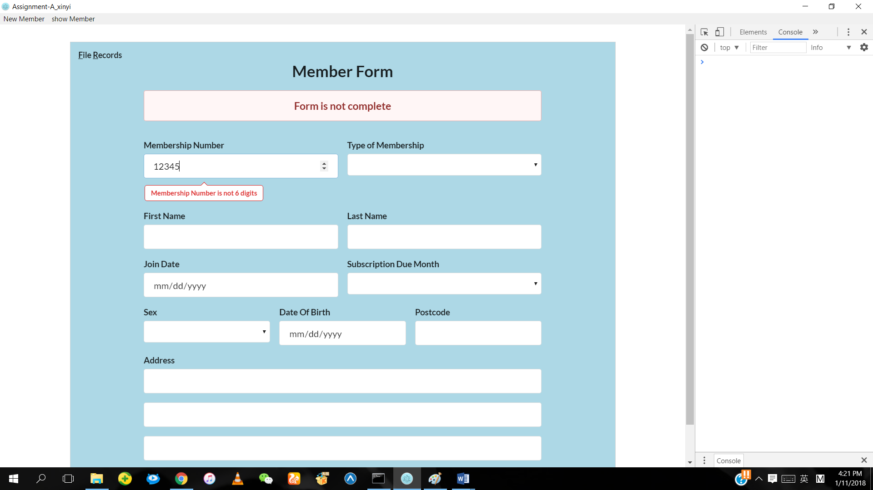

The Membership Number is less than 6 digits or more than 6 digits, the error message will be displayed.

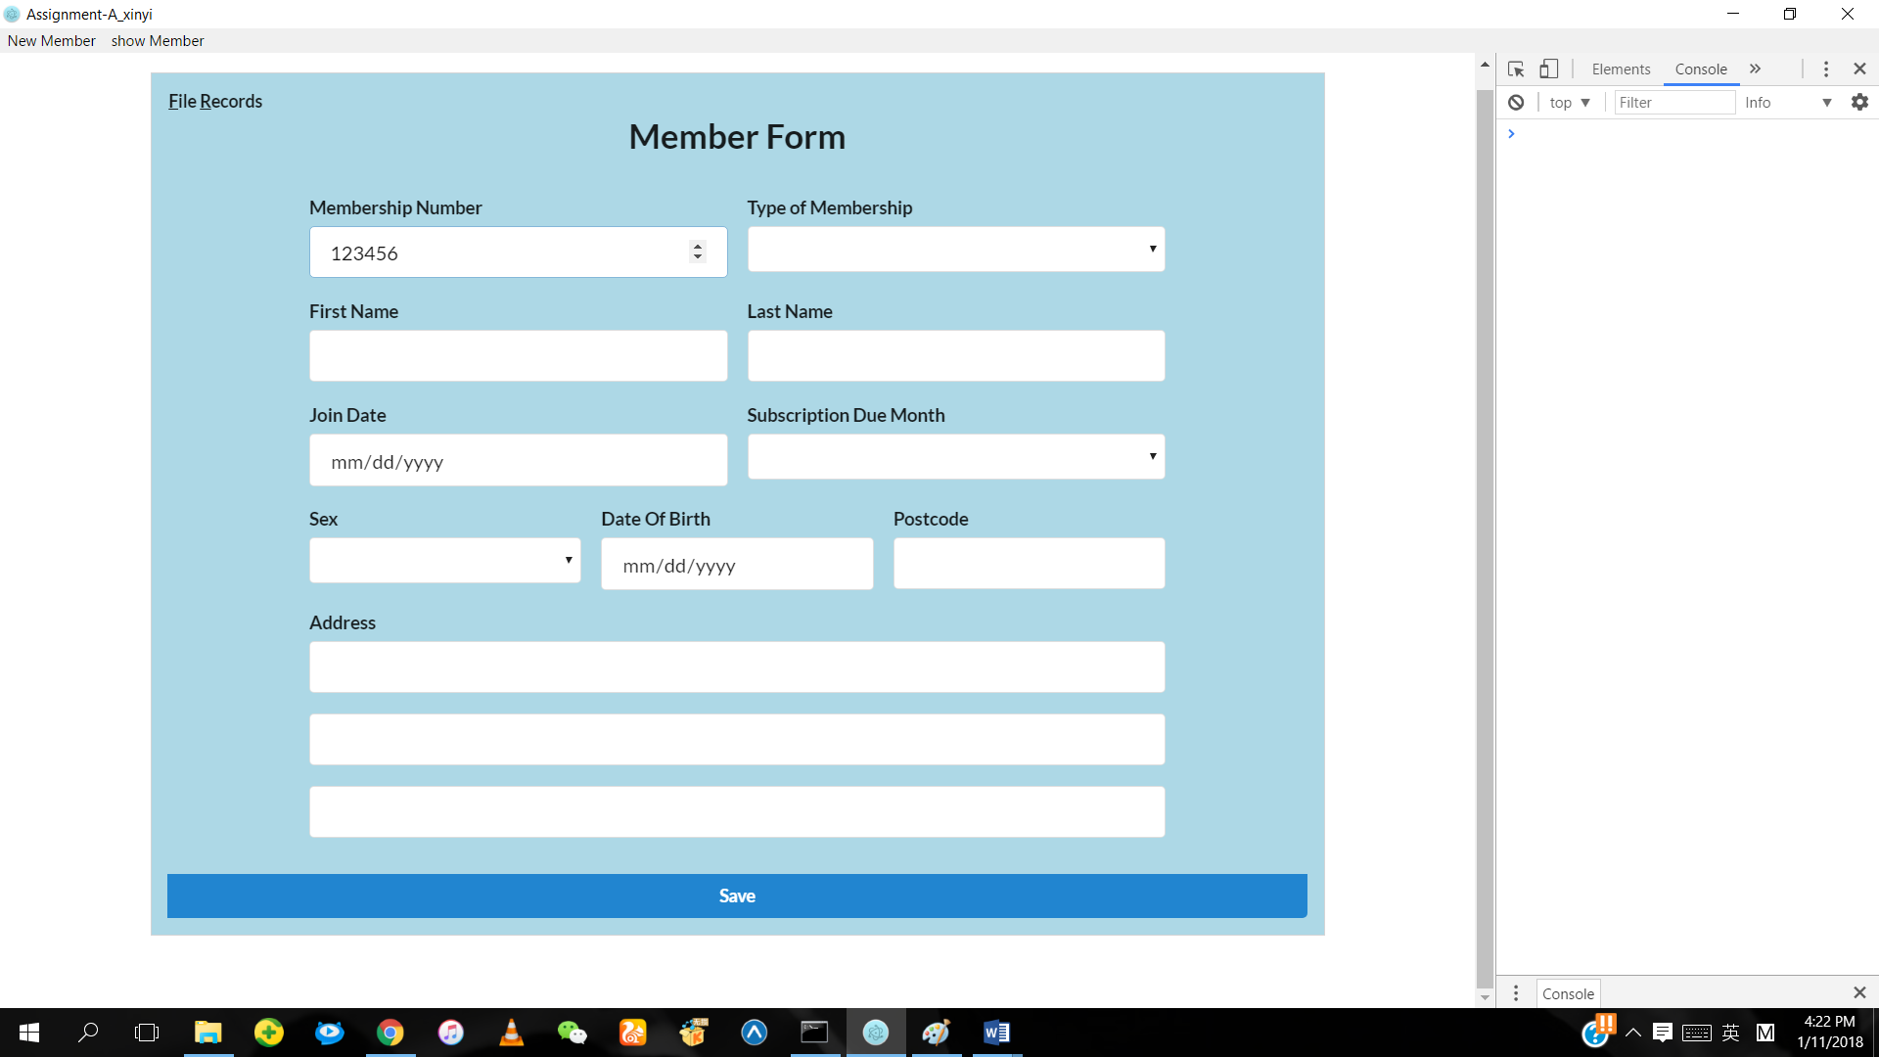

If the number entered is 6 digits, no error message is displayed.

**Membership Number (Modules 11)**

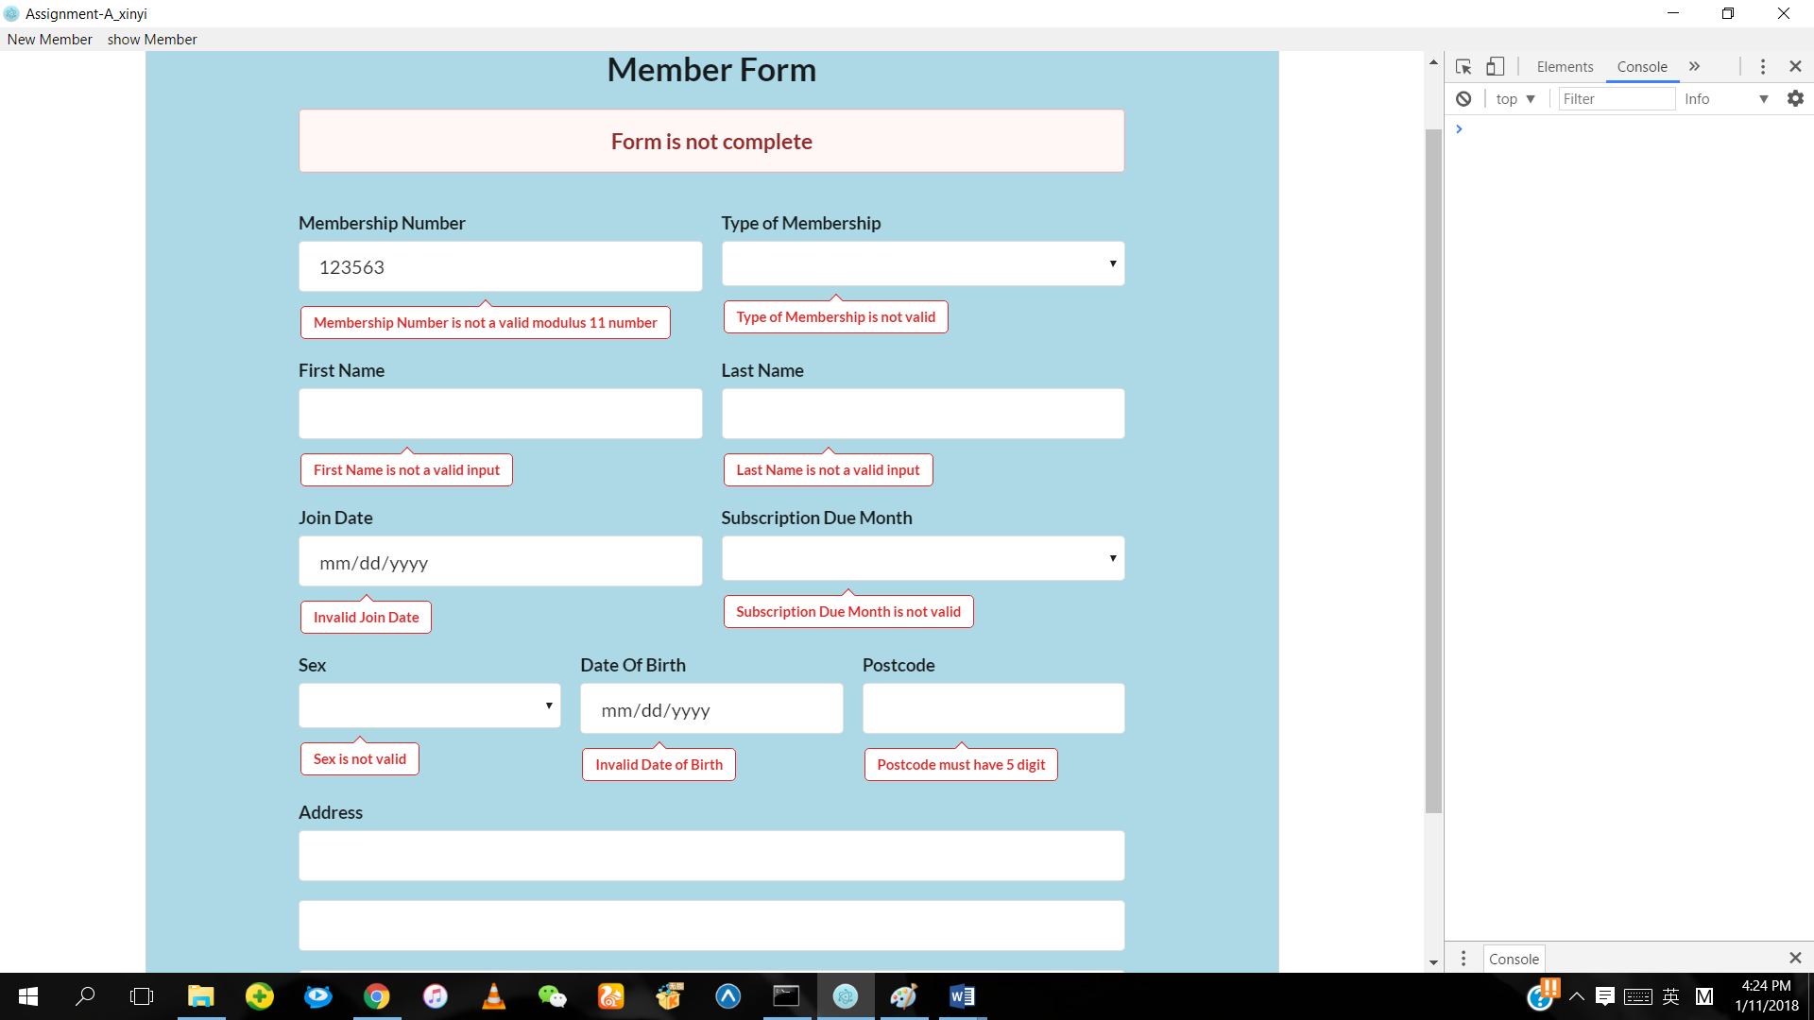

If the number entered is not modulus 11, the error message will be displayed.

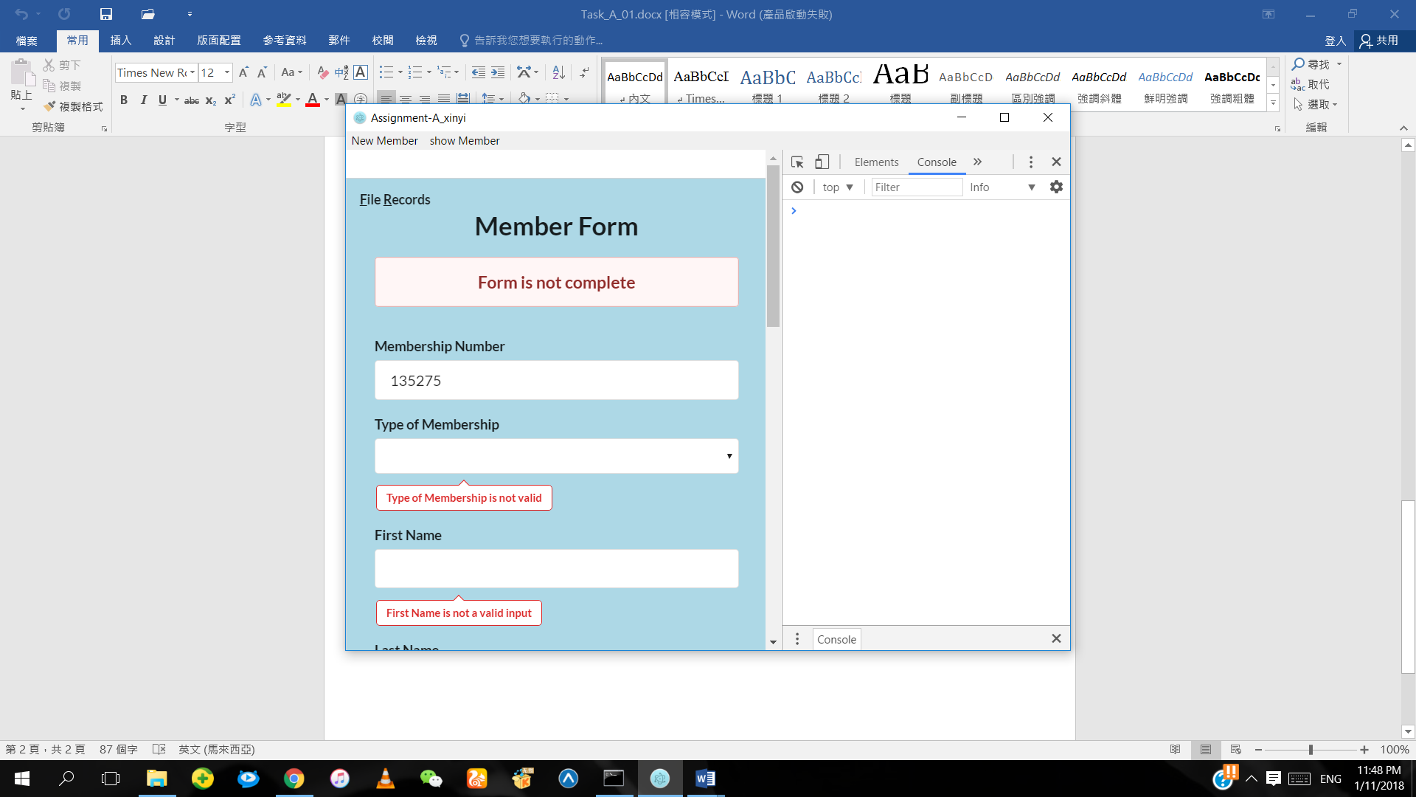

If the number entered is modulus 11, the error message will not be displayed.

**Sex (F or M)**

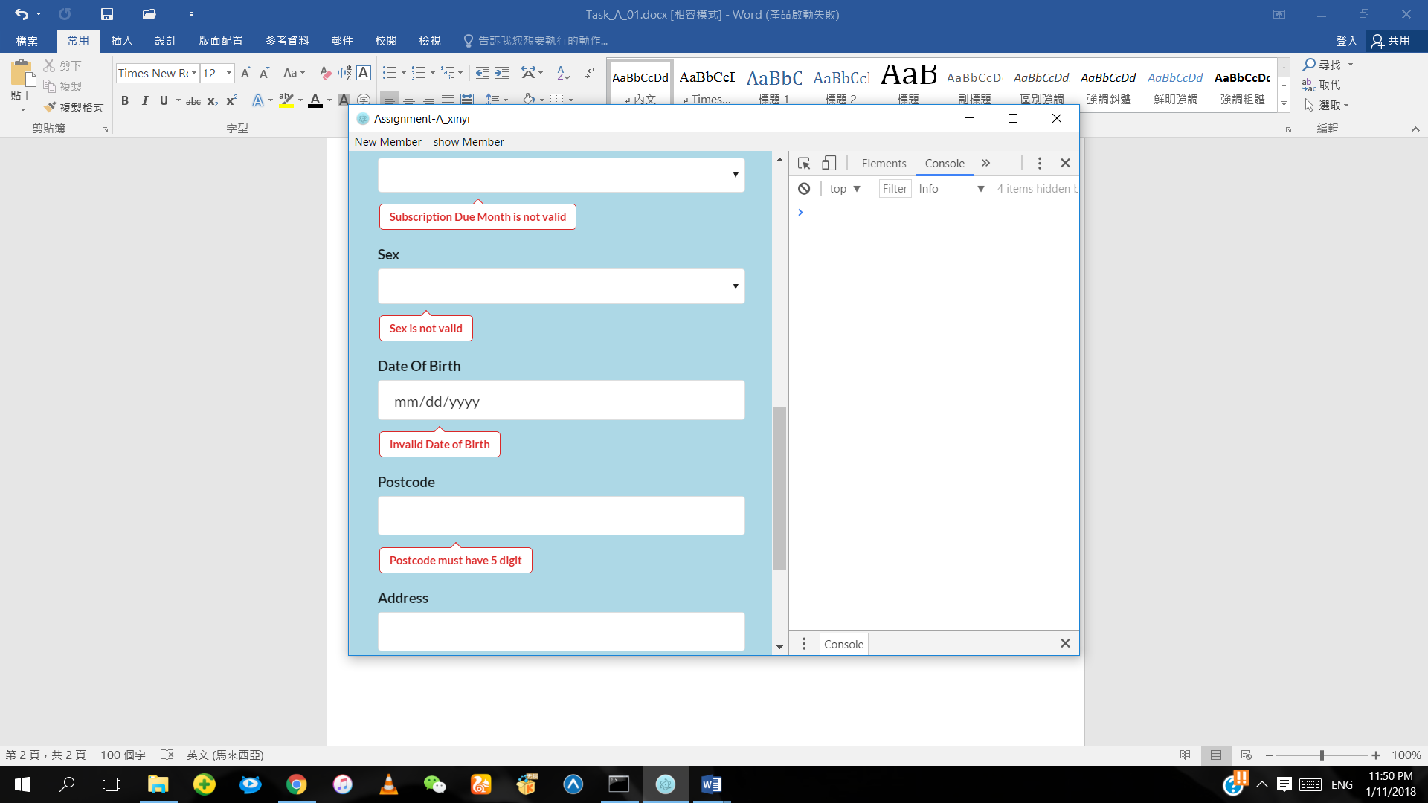

If the Sex entered is not F or M, the error message will be displayed.

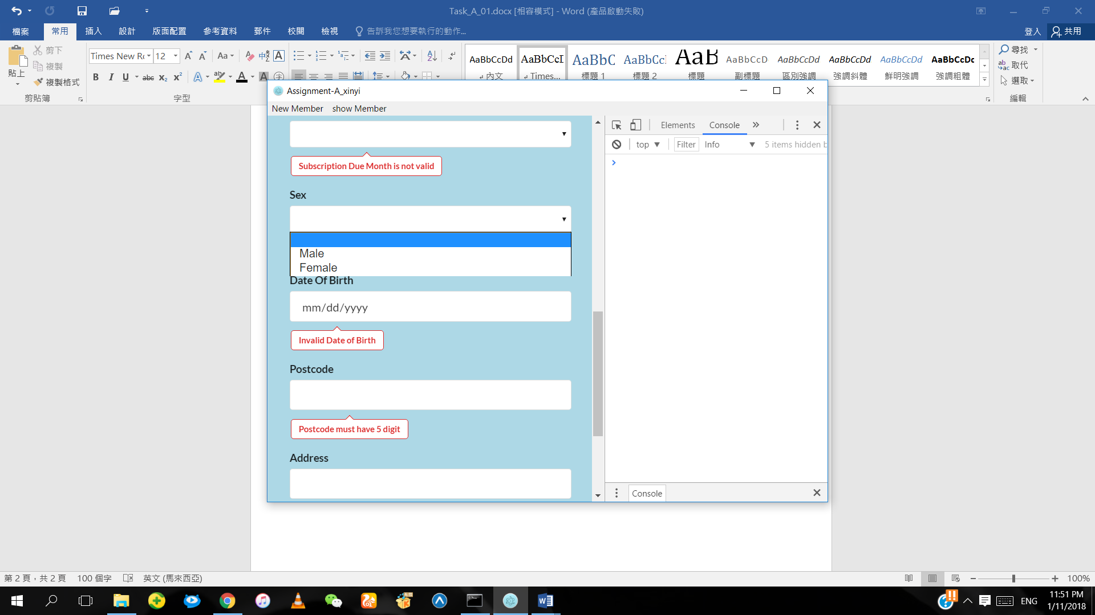

If the Sex entered is F or M, the error message will not be displayed.

**Membership type (F, S, T or B)**

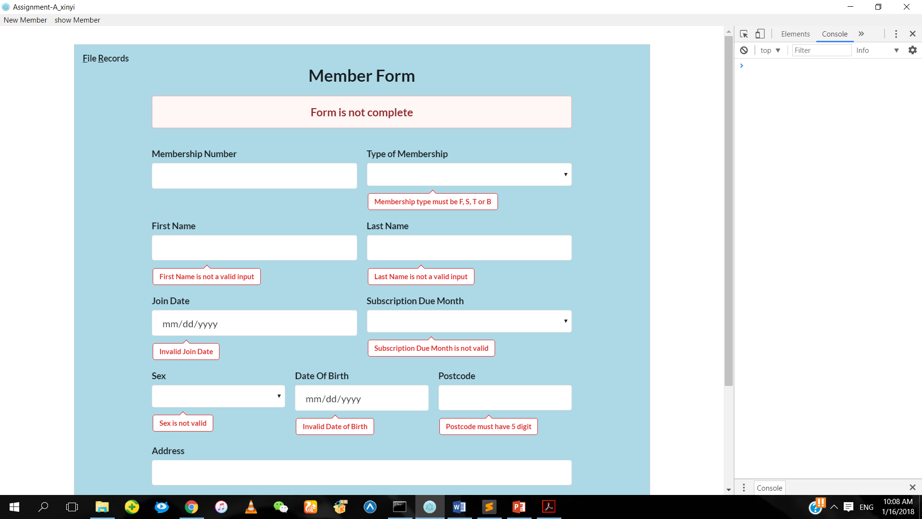

If the Membership type entered is not F, S, T or B, the error message will be displayed.

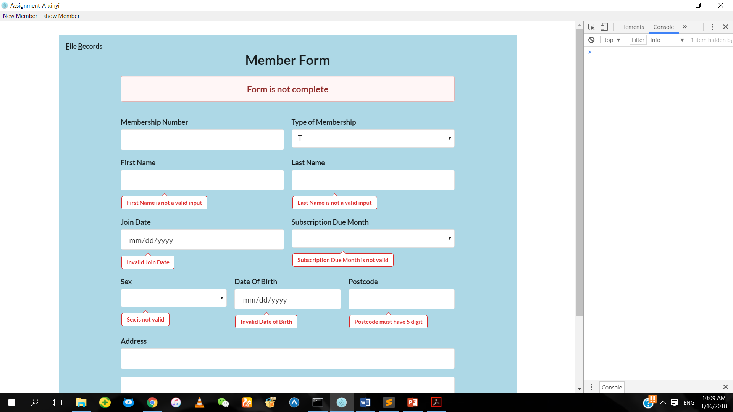

If the Membership type entered is F, S, T or B, the error message will not be displayed.

**Date of Birth**

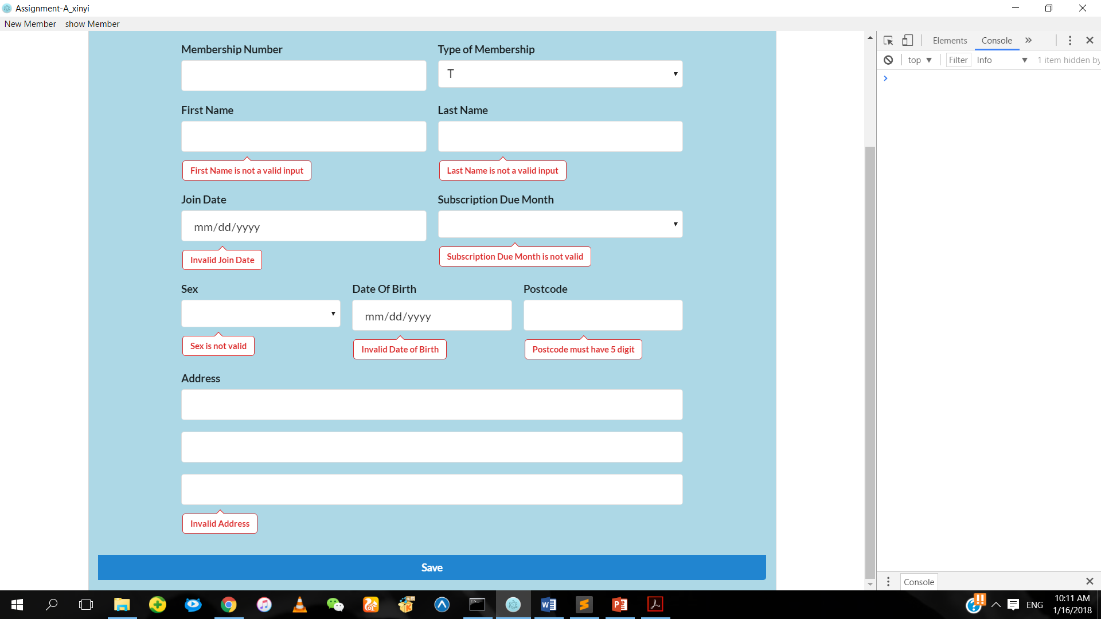

If the Date of Birth entered is not valid, the error message will be displayed.

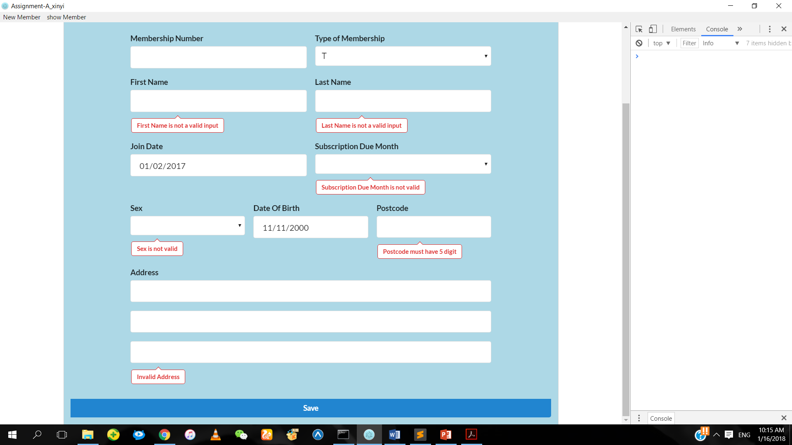

If the Date of Birth entered is valid, the error message will not be displayed.

**Join Date**



If the Join Date entered is not valid, the error message will be displayed.



If the Join Date entered is valid, the error message will not be displayed.

**Subscription Due Month**

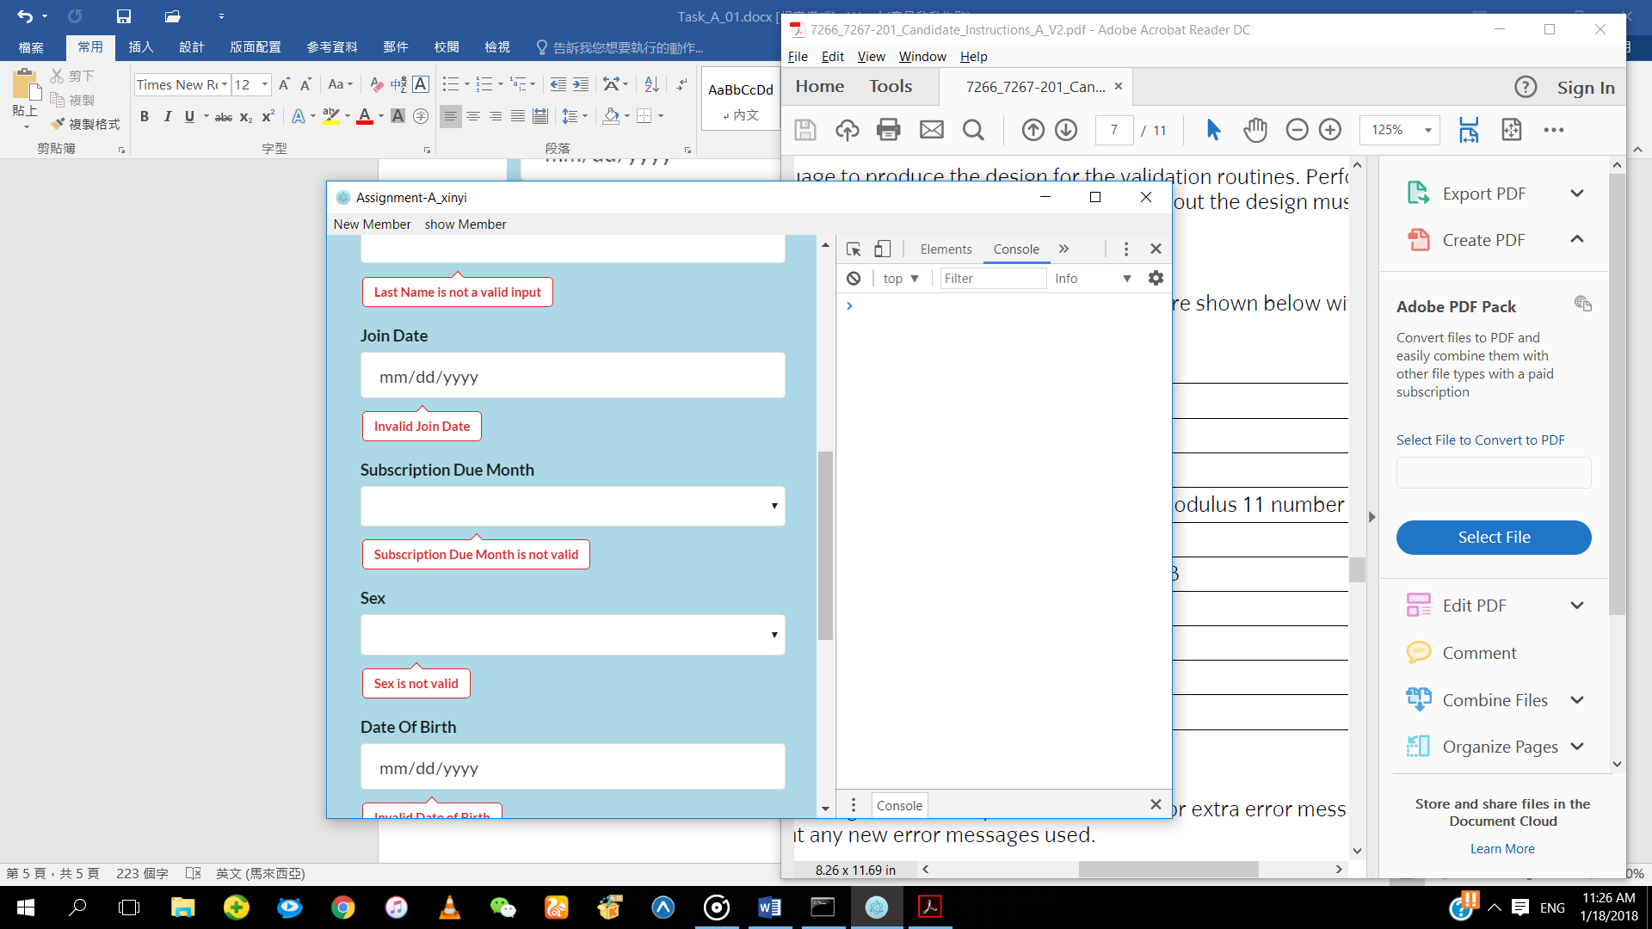

If the Subscription Due Month entered is not valid, the error message will be displayed.

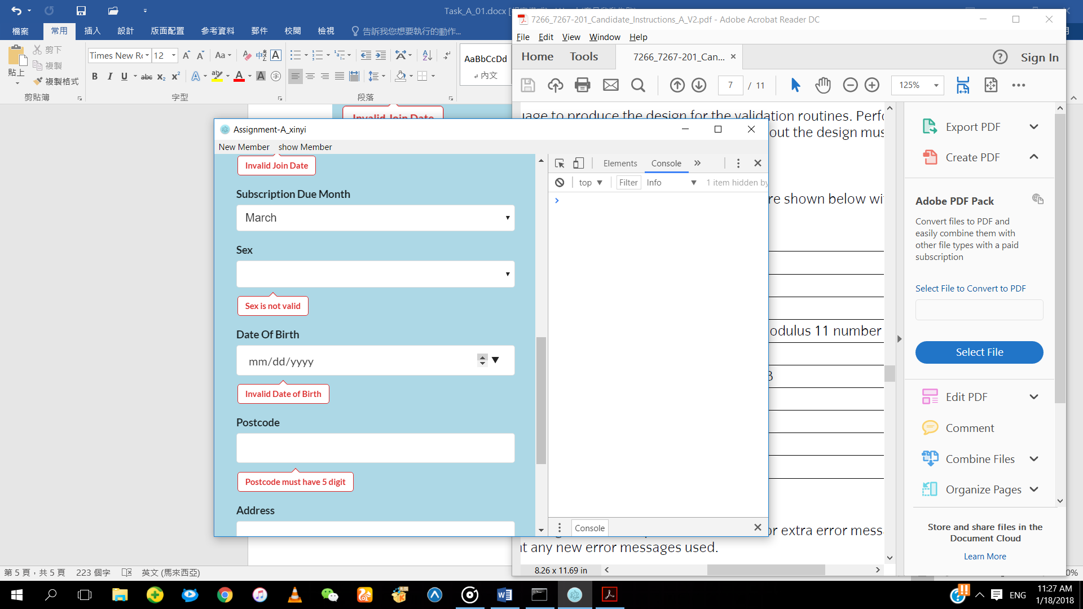

If the Subscription Due Month entered is valid, the error message will not be displayed.