**2. Some error codes have already been defined for the software and are shown below with their associated message.**

**Answer:**

|  |  |
| --- | --- |
| **Error Number** | **Error Message** |
| 1 | 1:Membership Number is not numeric |
| 2 | 2:Membership Number is not 6 digits |
| 3 | 3:Membership Number is not valid modules 11 number |
| 4 | 4:Sex must be F or M |
| 5 | 5:Membership Number is not a valid modules 11 number |
| 6 | 6:Invalid Date of Birth |
| 7 | 7:Invalid Join Date |
| 8 | 8:File not open |
| 9 | 9:Subscription month invalid |

**The error codes 10-14 are unassigned and if required can be used for extra error messages for your routines. Document any new error messages used.**

**If the Membership Number is empty, no error message is to be displayed and any other data entered is not to be saved when the Save Record button is clicked.**

**Membership Number (6 digits)**

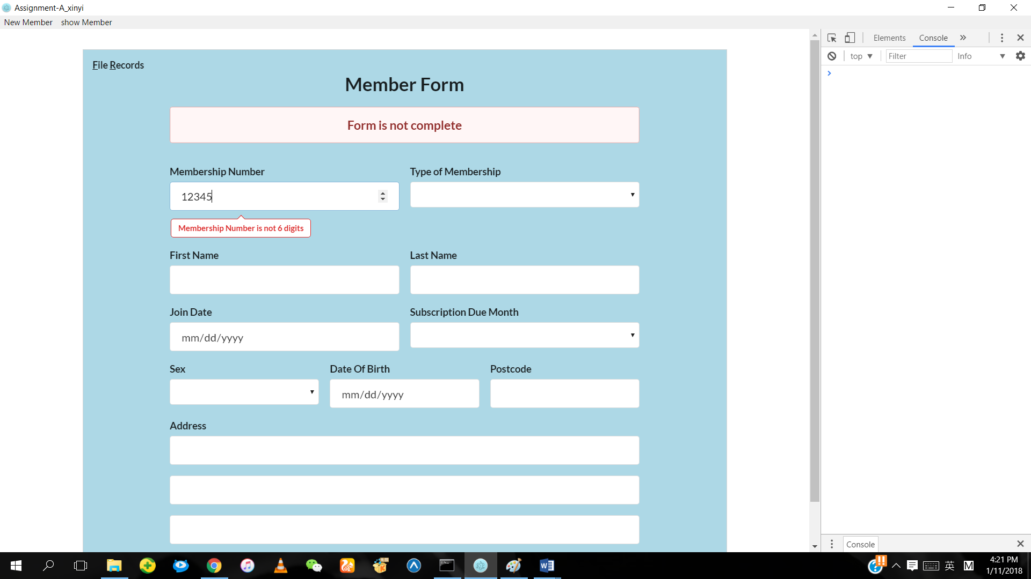

The Membership Number is less than 6 digits or more than 6 digits, the error message will be displayed.

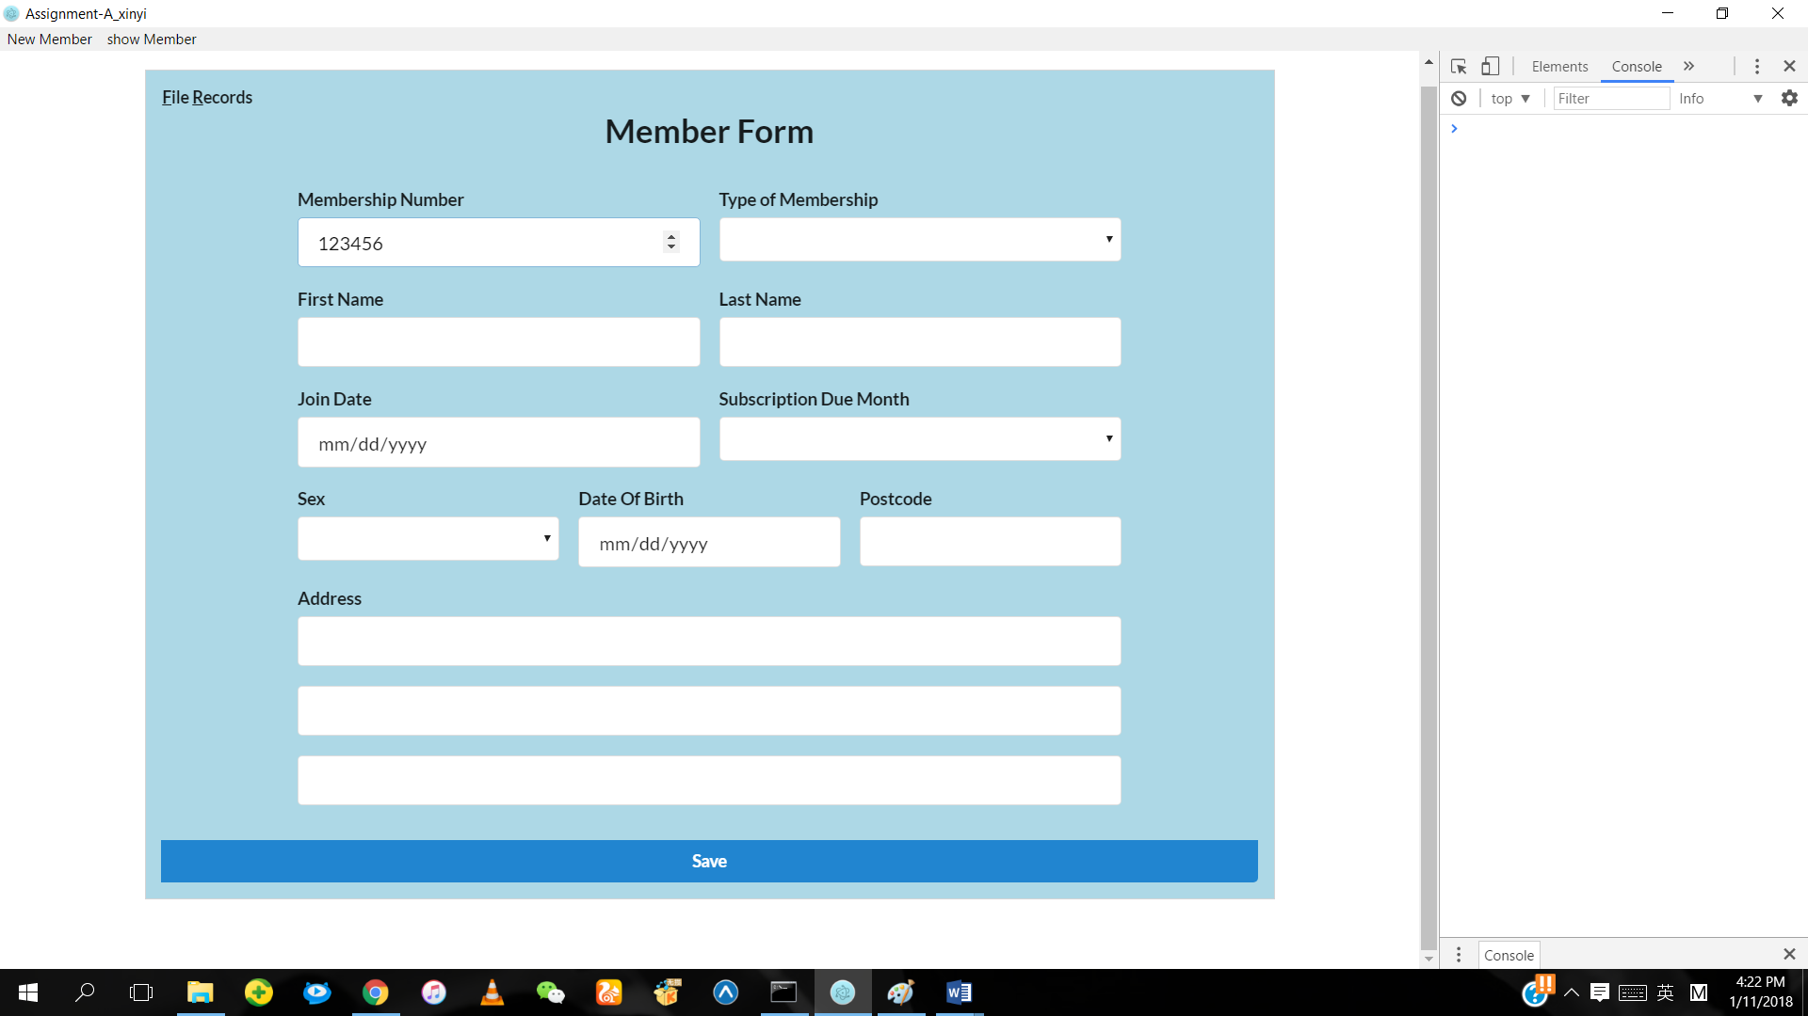

If the number entered is 6 digits, no error message is displayed.

**Membership Number (Modules 11)**

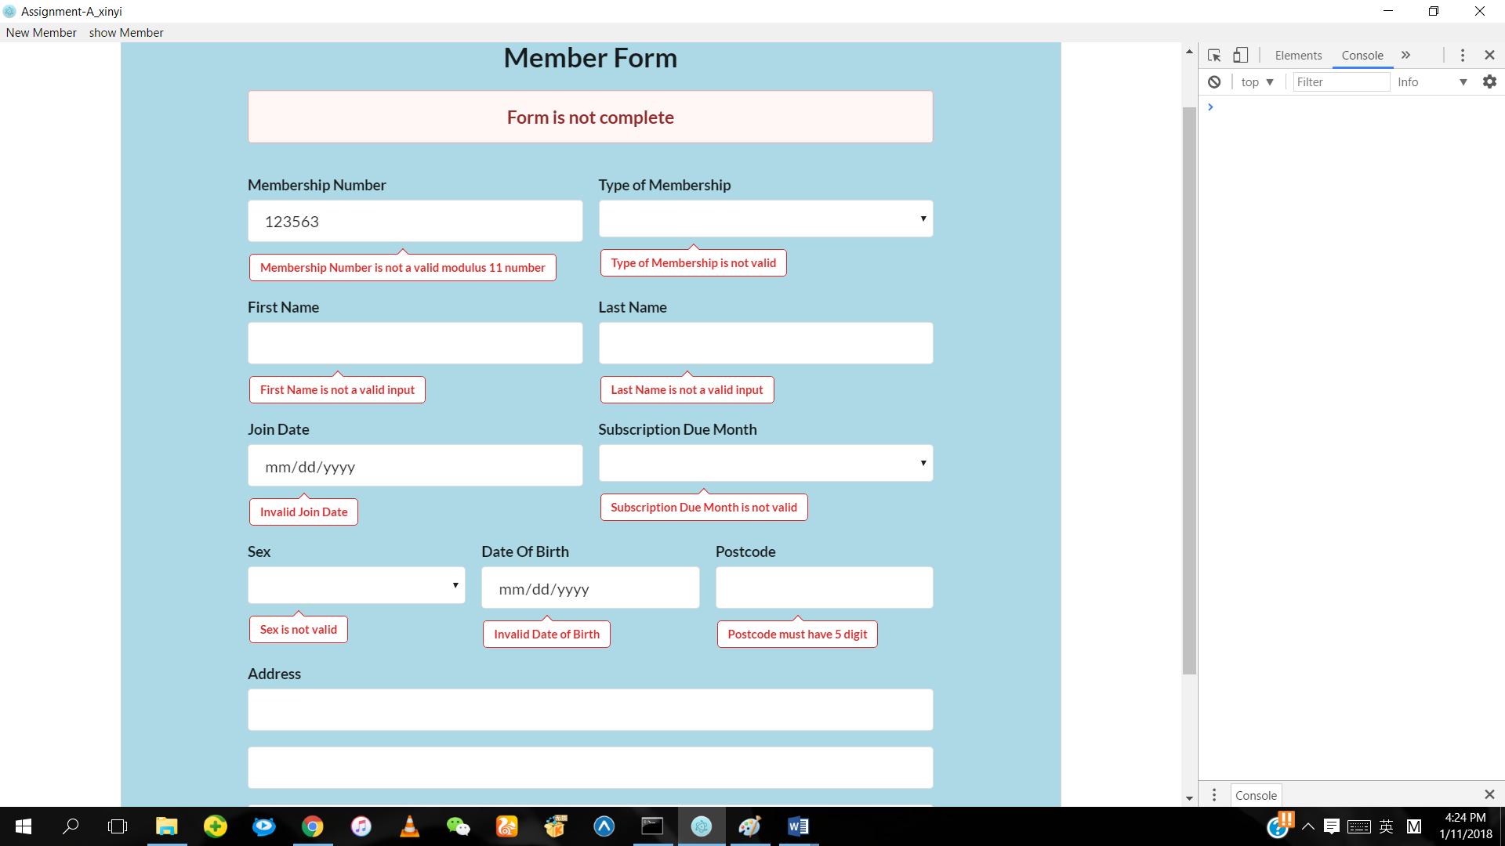

If the number entered is not modulus 11, the error message will be displayed.

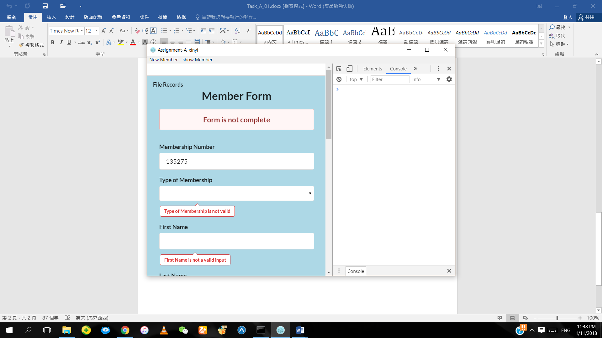

If the number entered is modulus 11, the error message will not be displayed.

**Sex (F or M)**

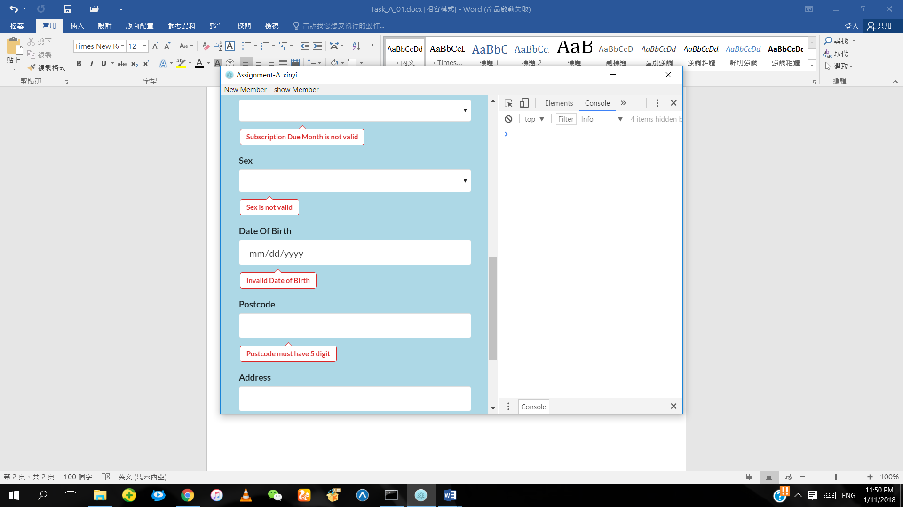

If the Sex entered is not F or M, the error message will be displayed.

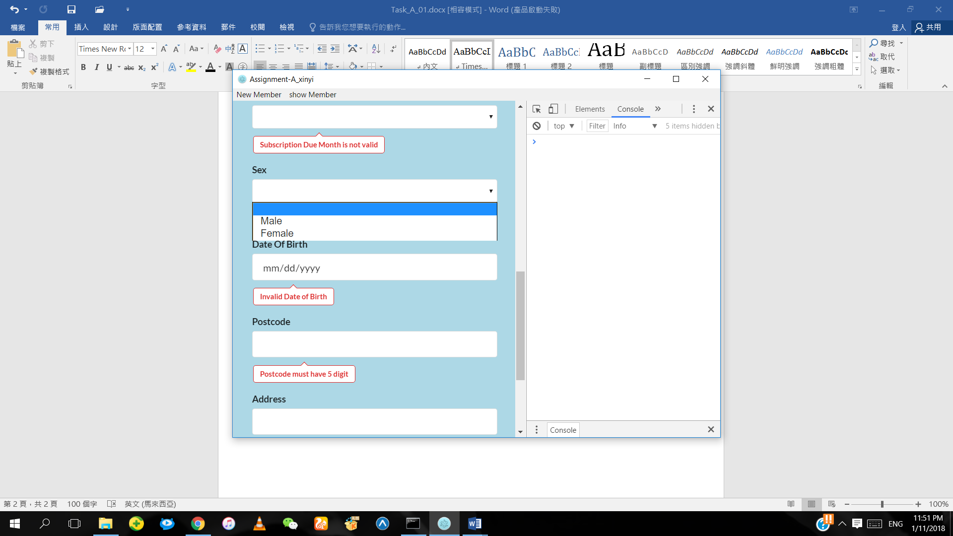

If the Sex entered is F or M, the error message will not be displayed.

**Membership type (F, S, T or B)**

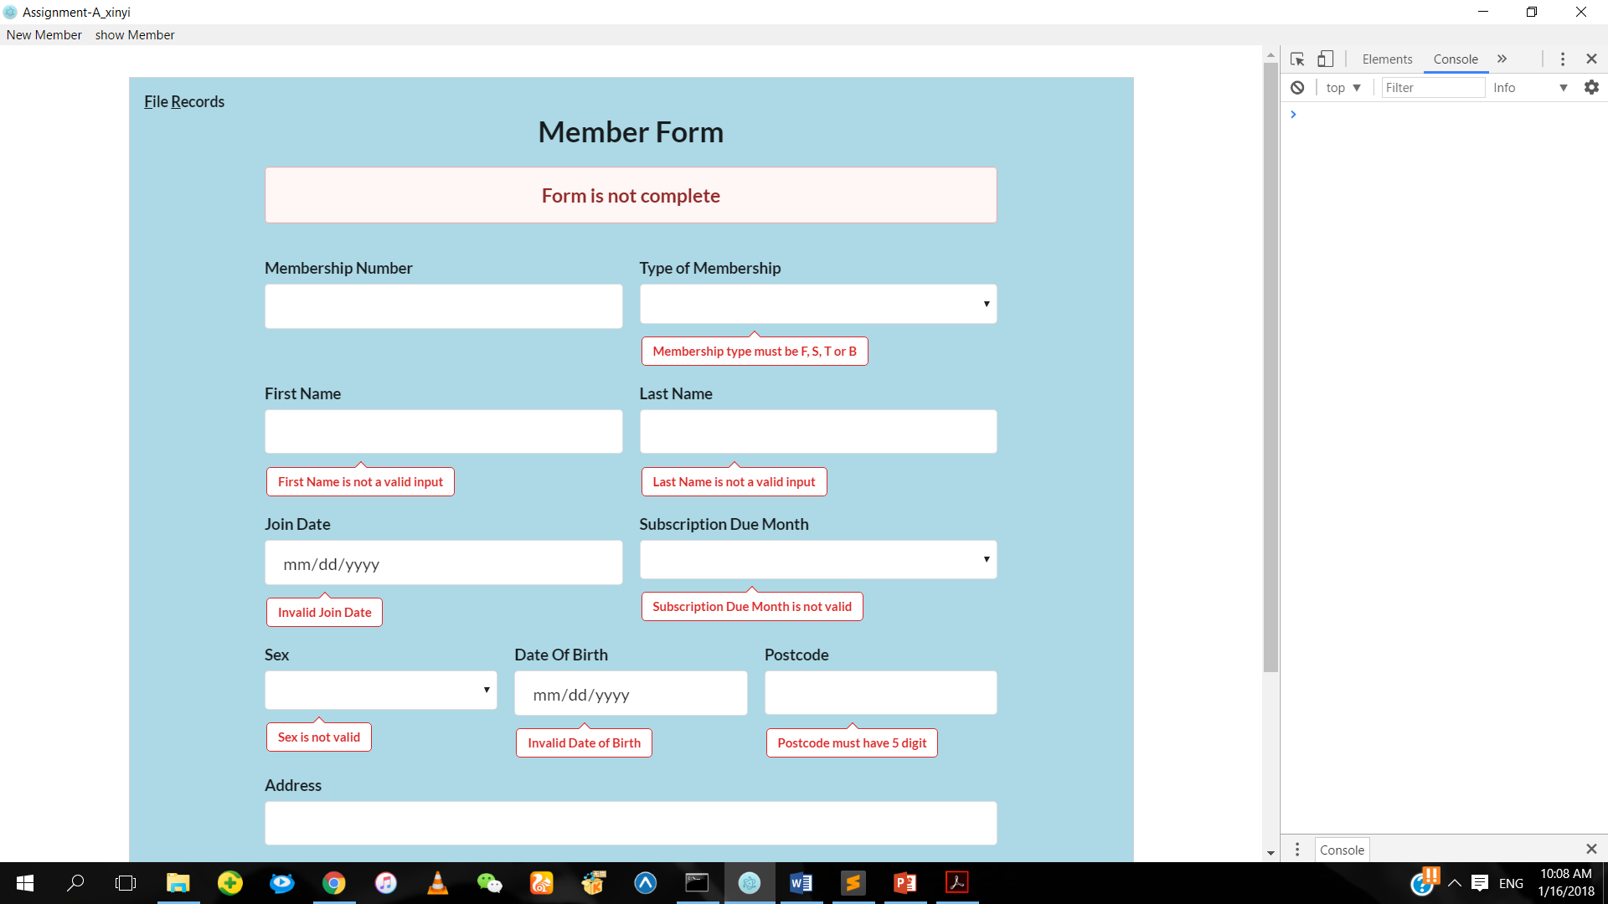

If the Membership type entered is not F, S, T or B, the error message will be displayed.

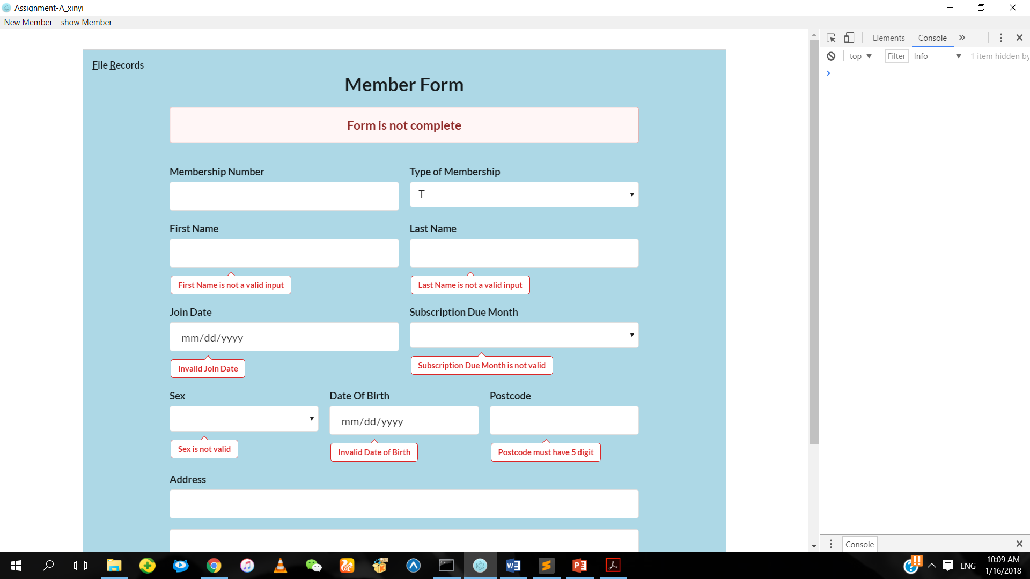

If the Membership type entered is F, S, T or B, the error message will not be displayed.

**Date of Birth**

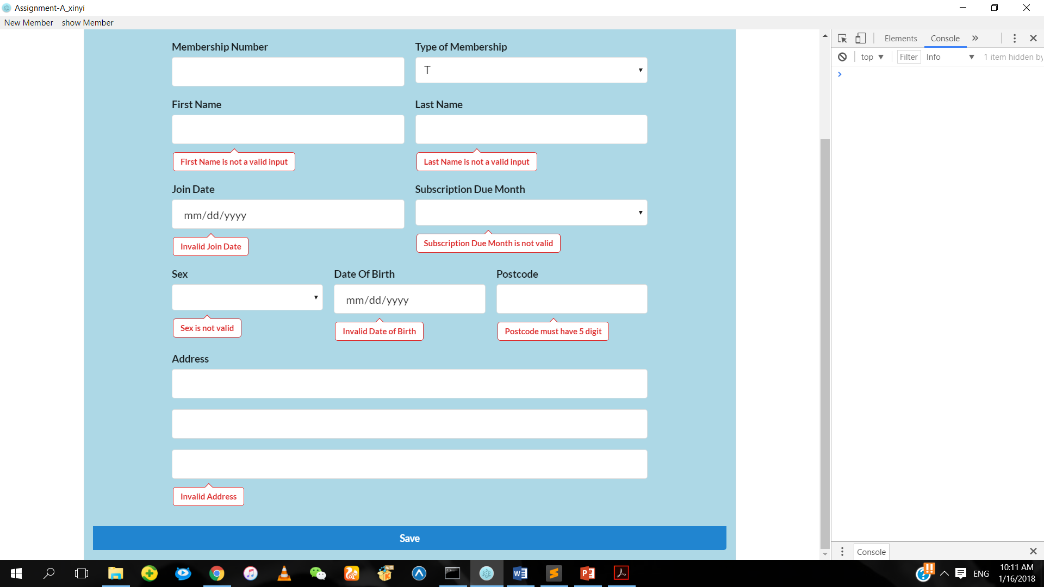

If the Date of Birth entered is not valid, the error message will be displayed.

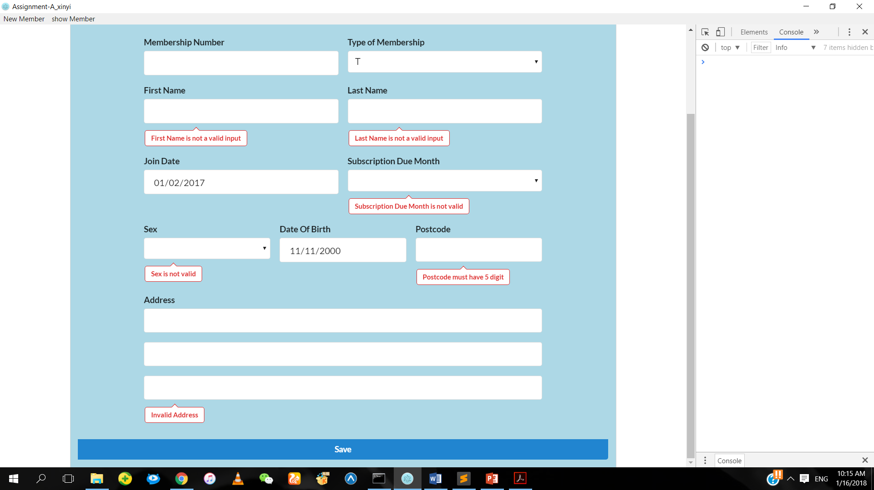

If the Date of Birth entered is valid, the error message will not be displayed.

**Join Date**



If the Join Date entered is not valid, the error message will be displayed.



If the Join Date entered is valid, the error message will not be displayed.

**Subscription Due Month**

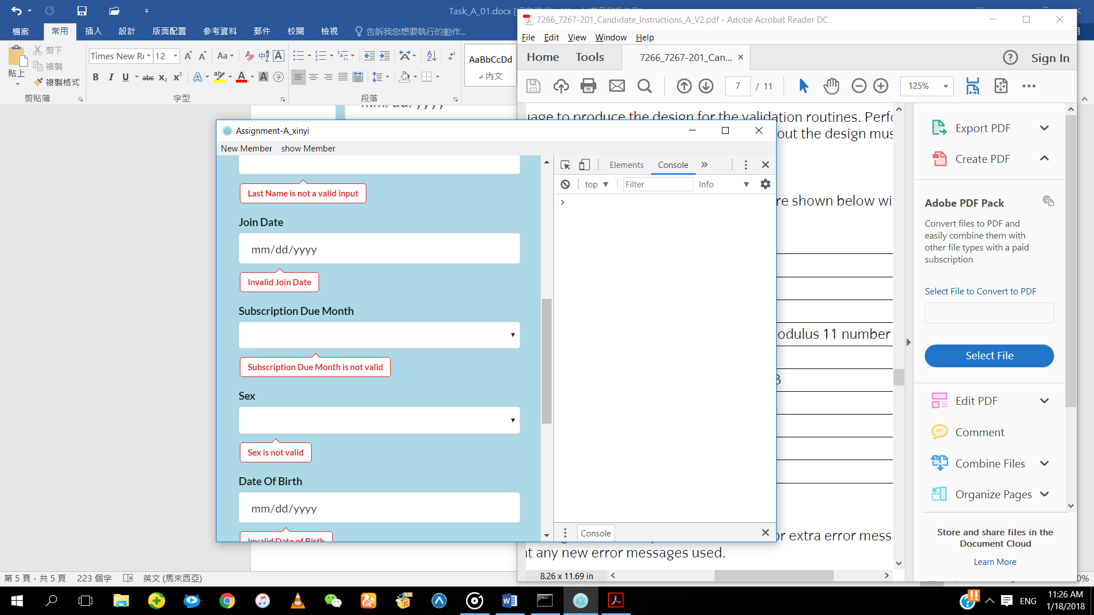

If the Subscription Due Month entered is not valid, the error message will be displayed.

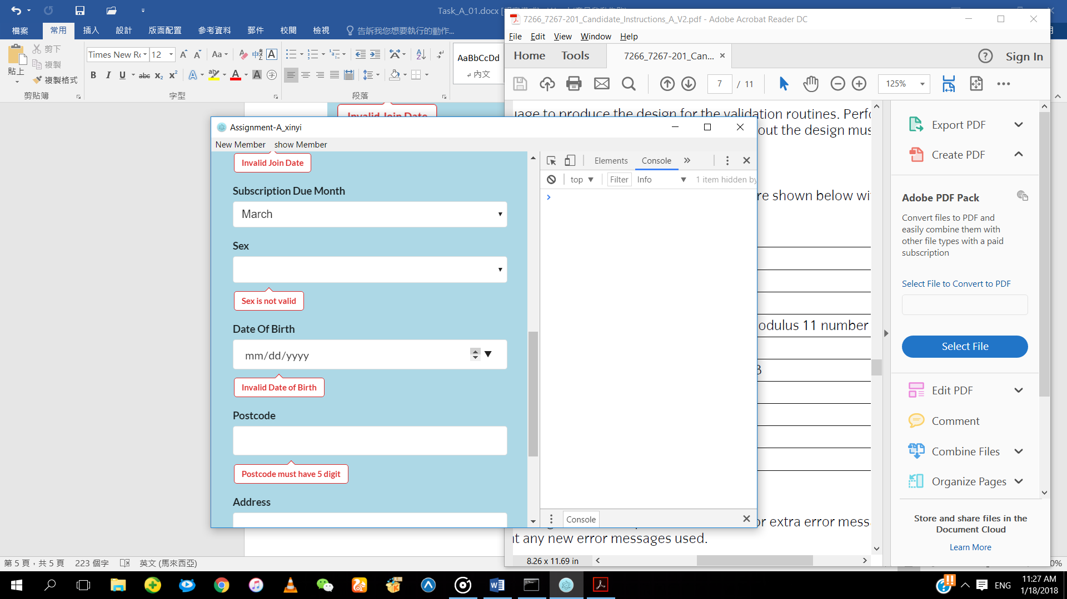

If the Subscription Due Month entered is valid, the error message will not be displayed.

**Postcode (5 digits)**

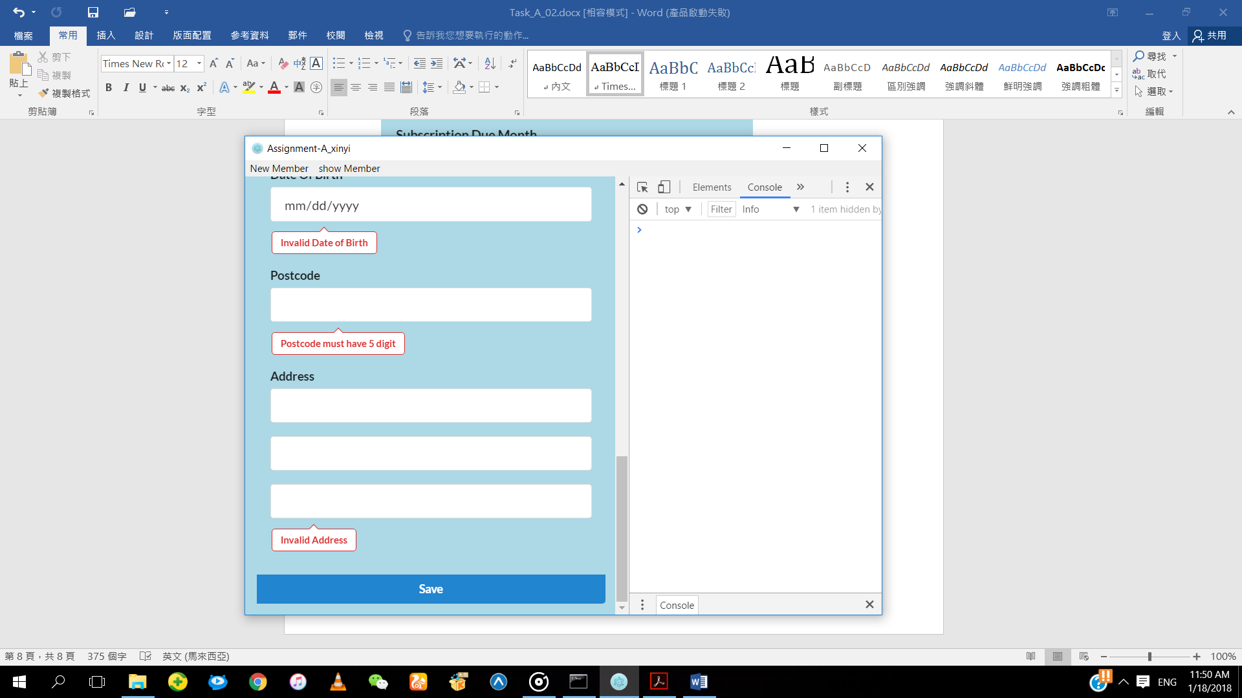

If the postcode entered is less than 5 digits, the error message will be displayed.

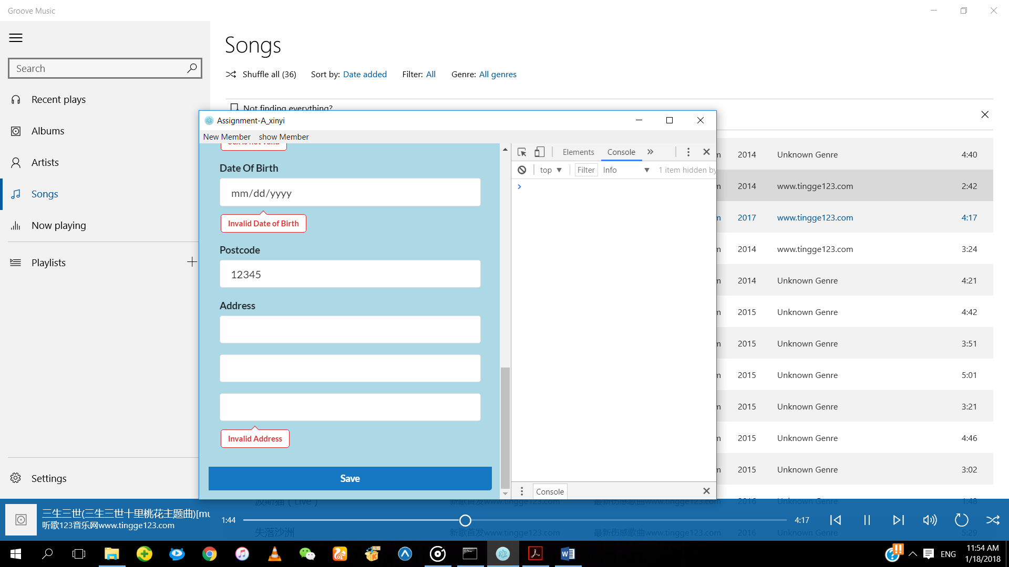

If the postcode entered is 5 digits, the error message will not be displayed.

**Address**



If the address entered is not valid, the error message will be displayed.

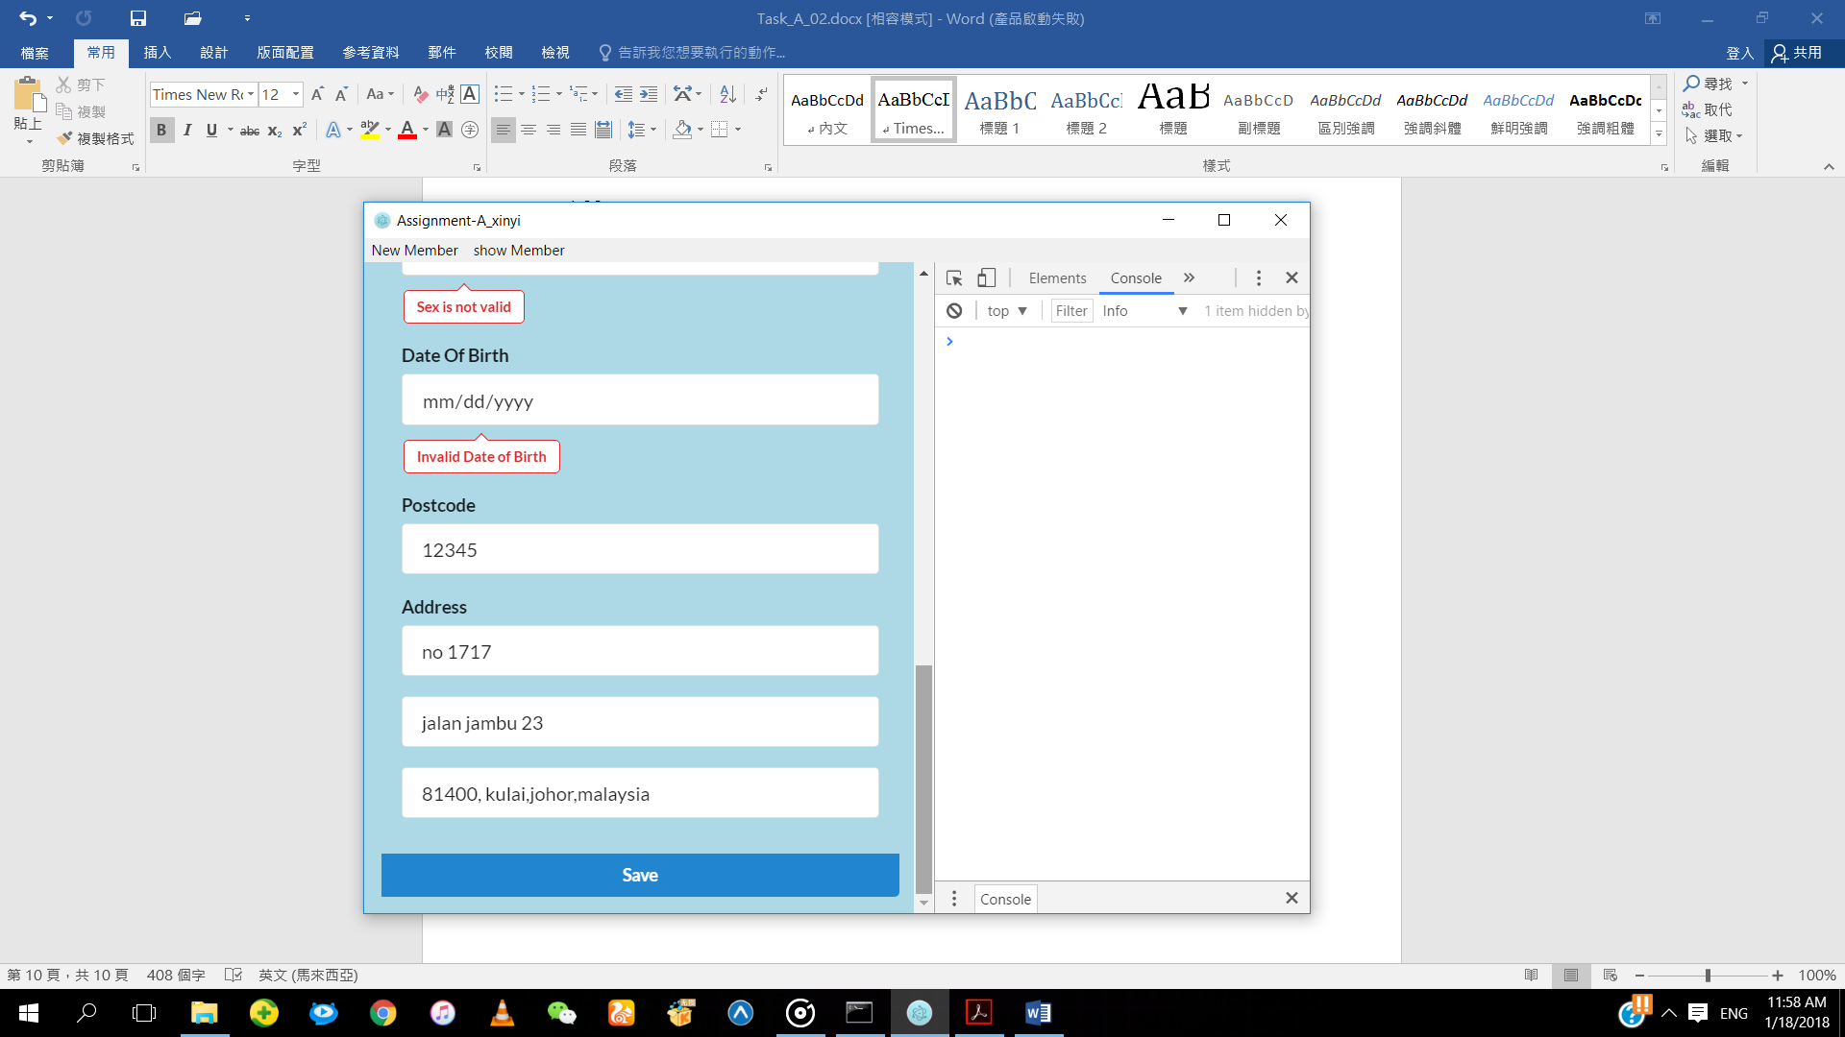

If the address entered is valid, the error message will not be displayed.