## Project Scope

To enrich the students' knowledge base, the college provided many elective courses.

The courses are grouped into different categories. A Lecturer can provide multiple courses

for more than one category.

A student can choose more than one courses based on his or her interests.

There are a few classrooms. One classroom can hold many elective courses.

The Lecturer of the course gives mark for each student and store it into the database.

The database on the back end should have the following entities:

* Course
* Category
* Student
* Lecturer
* Classroom
* Grade

## Entities and ERD

### Course

Role: represents elective course

Attributes:

* id: unique number of the course
* title: the name of the course
* category: according to the content of the course
* provider: the lecturer who teaches it
* classroom: where the course is held
* timetable: when the course begins and ends

### Category

Role:

Attributes:

* id: unique number of a category
* name: display string

### Student

Role: represents student who registers the course

Attributes:

* id: student ID
* name: student name
* email: student’s college email

### Lecturer

Role: teacher

Attributes:

* id: teacher ID
* name: teacher name

### Classroom

Role: place where lecturer teaches students

Attributes:

* id: unique number of a classroom
* location: which level of which building
* capacity: maximum number of students

### Grade

Role: final marks for students

* student: id for a specific student
* course: id for a specific course
* score: final number of points

### ERD

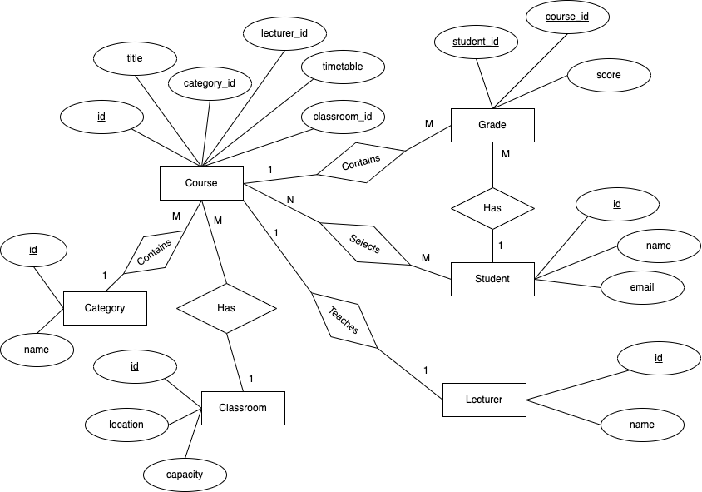

## Table Design

Basically, there are 6 tables for each entity. The relationship between Course and Student is many to many. Therefore, an additional table is needed to map the relationship, where it contains two columns, one is course_id, another is student_id.

In conclusion, the total number of tables is 7.