CS 3626 Spring 2026

Assignment 3

03/25/2026

4 Questions, 100 points

Question 1 AES (25 points):
- Explain why the last round of AES only contains 3 transformations. (5 points)
- Given the round key in Round 5 is

Table 1 Round 5 Key
1E | 18 | 47 | 9F
CA | 0E | 52 | 73
8D | 17 | 61 | A6
27 | DE | 2E | 58
w₂₀ | w₂₁ | w₂₂ | w₂₃
What is the first word w₂₄ of the round key for Round 6? (20 points)
Hint: Please find s-box, and RC table from the slides.
(Show intermediate steps clearly. You do not receive any credit for just writing down the answer)

Question 2 Random Number Generator (30 points):
- Given the 4-bit linear feedback shift register (LFSR), please generate the output sequence. The first two iterations are given. Based on these, please continue the calculation, and find out the cycle. (15 points)

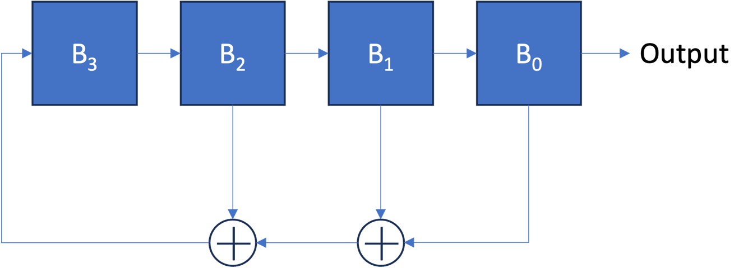

Table 2 Output Results
B₃ | B₂ | B₁ | B₀ | B₀$⨁$B₁$⨁$B₂ | Output
1 | 0 | 0 | 0 | 0 | 0
0 | 1 | 0 | 0 | 1 | 0

- Blum, Blum, Shub (BBS) generator is a cryptographically secure pseudorandom bit generator. We assume that the seed of a BBS generator is 17 and n is 221. Try to generate 10 random bits. (15 points)

Question 3 Meet in the middle attack (25 points):

Please apply the meet-in-the-middle attack on the 3DES. Please also discuss how many operations of encryptions and decryptions are required and the number of storage locations needed for the attack. (25 points)

Question 4 Block cipher modes (20 points):

- Consider the storage of data in encrypted form in a large database using AES. One record has a size of 16 bytes. Assume that the records are not related to one another. Which mode would be best suited and why? (10 points)
- Describe how the OFB mode can be attacked if the IV is not different for each execution of the encryption operation. (10 points)

Note: You need to show procedures of the solutions. No procedures, no points.
Submission deadline: Friday 4/3/2026 11:59pm.

