Animal Rescue Hub
CS 310 — Scalable Software Architectures | Winter 2026 | Xinyue Zhang

1. Project Overview
Animal Rescue Hub is a cloud-native web service designed to help small animal rescue organizations increase visibility and connect adoptable animals with potential adopters. The project was inspired by Paws and Claws Cat Rescue in Evanston, Illinois.
The application supports two user roles:
- Rescue staff — upload animal photos and create listings
- Visitors — browse animals, subscribe to alerts, and submit adoption applications

2. System Architecture
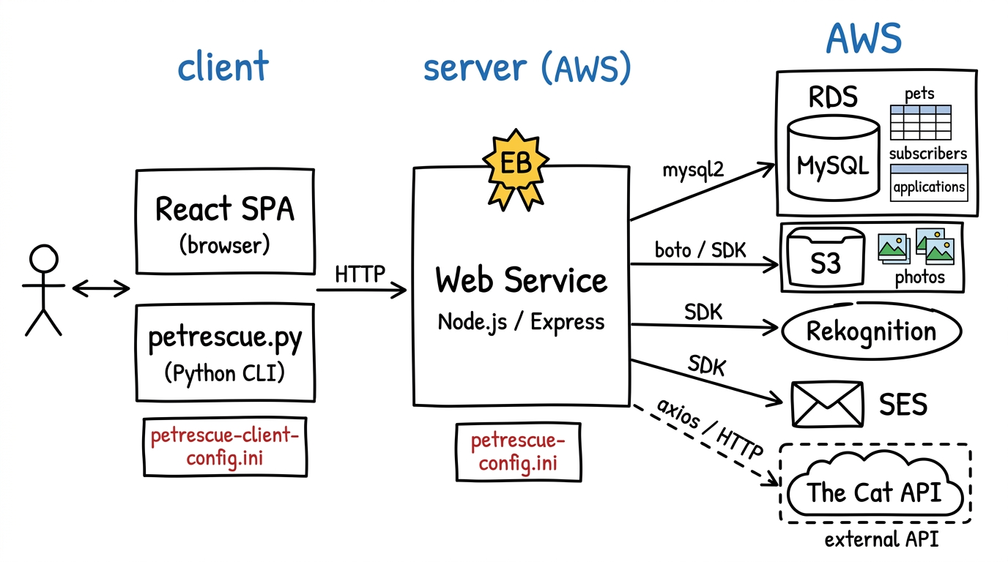
Figure 1 — Animal Rescue Hub Architecture
The application follows a multi-tier architecture consisting of a client tier, a server tier, and a backend services tier.
Client tier (left): There are two clients. The primary client is a React single-page application (SPA) served by the Express web service, accessed at http://localhost:8080. A secondary Python command-line client (petrescue.py) is provided for scripted testing. Both clients communicate via HTTP/JSON. Configuration is stored in petrescue-client-config.ini.
Server tier (center): The web service is built with Node.js and Express, deployed on AWS Elastic Beanstalk. It is the single entry point for all client requests and handles all business logic. AWS credentials and API keys are stored in petrescue-config.ini on the server. Each API endpoint is implemented in its own JavaScript file for modularity.
Backend services tier (right): The server connects to four AWS services and one external API:
- Amazon RDS (MySQL) — stores all persistent data across three tables: pets, subscribers, and applications. Uses mysql2/promise with p-retry for resilient access.
- Amazon S3 — stores pet photos. Each photo is assigned a UUID-based S3 key and retrieved as a base64-encoded string.
- AWS Rekognition — called via DetectLabels whenever a photo is uploaded. Returns ranked labels (e.g., "Cat: 97.5%") to auto-populate the species field.
- Amazon SES — sends new-pet alert emails to all subscribers when a listing is created, and confirmation emails to applicants.
- The Cat API (external) — a free third-party REST API at thecatapi.com. Called via axios to fetch live cat breed data. No data is stored in our database.

3. Three Non-Trivial Operations
Non-Trivial #1: GET /external_pets — External API Integration
The server makes a live HTTP call to The Cat API, transforms the breed data (name, description, temperament, traits), and returns it to the client. No data is stored in our database.
Non-Trivial #2: POST /listing — Rekognition Species Detection + SES Subscriber Alert
When rescue staff uploads a pet photo: (1) photo is uploaded to S3, (2) Rekognition DetectLabels auto-identifies the species, (3) record is inserted into MySQL, (4) all subscribers are emailed via SES.
Non-Trivial #3: POST /apply/:petid — Adoption Application + SES Confirmation
When a visitor submits an adoption application: (1) application is saved to MySQL, (2) a personalized SES confirmation email is sent to the applicant listing the pet details.

4. API Reference
Base URL: http://localhost:8080 | All requests/responses use JSON.
GET /ping
Health check — returns S3 photo count (M) and database pet count (N).
Parameters: None
200 { "message": "success", "M": 12, "N": 6 }
500 { "message": "error", "M": -1, "N": -1 }

GET /external_pets — Non-Trivial #1
Fetches live cat breed data from The Cat API.
Parameters: limit (optional, default 10, max 25) — number of breeds to return
200 { "message": "success", "count": 10, "pets": [ { "external_id", "image_url", "name", "breed", "description", "life_span", "temperament", "intelligence", "affection_level", "energy_level" } ] }
500 { "message": "error", "pets": [] }

GET /pets
Returns all rescue-added pets from the database, newest first.
Parameters: None
200 { "message": "success", "count": N, "pets": [ { "petid", "name", "species", "breed", "age_years", "description", "photo_key", "created_at" } ] }

POST /listing — Non-Trivial #2
Adds a rescue pet. Uploads photo to S3, runs Rekognition, saves to DB, emails subscribers.
Request body: { "name": "Buddy", "breed": "Golden Retriever", "age_years": 4.0, "description": "...", "data": "<base64 JPEG>" }
200 { "message": "success", "petid": 7, "species": "dog", "rekognition_labels": [...], "subscribers_emailed": 2 }
400 { "message": "name and data are required" }
500 { "message": "error" }

GET /image/:petid
Downloads a pet photo from S3 as a base64-encoded string.
Parameters: petid (URL param) — pet's database ID
200 { "message": "success", "petid": 7, "data": "<base64>" }
400 { "message": "no such petid" }

POST /subscribe
Adds an email to the subscribers table for new-pet alert emails.
Request body: { "email": "you@example.com" }
200 { "message": "success", "subid": 3 }
200 { "message": "already subscribed", "subid": -1 }

POST /apply/:petid — Non-Trivial #3
Submits adoption application, saves to DB, sends SES confirmation email.
Parameters: petid (URL param) — pet's database ID
Request body: { "applicant_name": "Jane Doe", "applicant_email": "jane@example.com", "message": "..." }
200 { "message": "success", "appid": 5, "petid": 7, "email_sent": true }
400 { "message": "no such petid" }
500 { "message": "error" }

5. Database Schema
Database: petrescue on Amazon RDS (MySQL)

Table: pets
Column | Type | Notes
petid | INT, AUTO_INCREMENT, PK | Unique pet identifier
name | VARCHAR(100), NOT NULL | Pet's name
species | VARCHAR(50) | Auto-filled by Rekognition (cat, dog, bird…)
breed | VARCHAR(100) | Entered by staff (optional)
age_years | FLOAT | Age in years (optional)
description | TEXT | Free-text description
photo_key | VARCHAR(255) | S3 object key for the photo
source | VARCHAR(20) | Always "rescue" for staff-uploaded pets
created_at | TIMESTAMP | Auto-set on insert

Table: subscribers
Column | Type | Notes
subid | INT, AUTO_INCREMENT, PK | Unique subscriber ID
email | VARCHAR(200), UNIQUE | Subscriber's email address
created_at | TIMESTAMP | Auto-set on insert

Table: applications
Column | Type | Notes
appid | INT, AUTO_INCREMENT, PK | Unique application ID
petid | INT, FK → pets.petid | Which pet was applied for
applicant_name | VARCHAR(200) | Applicant's full name
applicant_email | VARCHAR(200) | Applicant's email
message | TEXT | Applicant's personal message (optional)
created_at | TIMESTAMP | Auto-set on insert

