**The influence of Renaissance grottoes and cabinets on modern museums**

**Introduction**

Grottoes and cabinets of curiosity were the main form of Renaissance art collection and the ancestor of the modern museum. These grottoes and curiosity cabinets have shaped modern museums and exhibitions in four ways: Firstly, regarding the contents of the displays, the grottoes and curiosity cabinets of the Renaissance period provide modern museums with a large number of antiquities and objects for exhibitions. Second, in terms of exhibition methods, the art of displaying grottoes and cabinets of curiosity provides an aesthetic basis and reference for museum exhibition planning. Thirdly, the grottoes and curiosity cabinets covered a wide range with collections from several fields, and this idea of interdisciplinary collecting has influenced the categorisation and display concepts of modern museums. Fourthly, the concept of the Renaissance grottos and studios, which gradually evolved from private exhibitions to places of communication between aristocrats and artists, has been carried over into modern museums. Modern museums function as centres of cultural exchange, combining the functions of viewing, research and education.

**1. Collection concept and supply of collections**

Grottoes and cabinets of curiosity have brought together a range of collections, providing content and topics that can be displayed in modern museum exhibitions. And, the Renaissance concept of collecting has been continued by modern museums and exhibitions, guiding the development of modern exhibitions.

Isabella d'Este was an Italian marquess and collector of Renaissance art.[1] She has designed special private spaces for her collections, known as the Grotto. As a sponsor, Isabella was keen to commission artists to create works for her, such as funding artists to paint prescribed content, including scenes and colours at Isabella's discretion. These works have been passed down to this day and have become an important part of art history. Not only did they encourage artists of the time to exchange their creations, but also created the conditions for modern museums to appreciate these works of art.[2] On the other hand, Isabella doesn't just activities as a collector, she also buys various types of pieces as a customer. These pieces included several types, specimens of animals and natural curiosities such as rhinoceros horns and fish bones. This was also a very popular type of collection during the Renaissance. In addition, Isabella has a great interest in art, especially ancient art.[3] Isabella's grotto, for example, contains many small decorative objects, and the majority of the collection is made up of bronzes, stone carvings, vases and medallions.[4] Isabella would have visited Rome several times in order to purchase these antiquities, once residing there for two years between 1525 and 1524 to purchase more than thirty antique medals from various sources.[5] Stivini's list recorded the details of Isabella's various collections of information, including as many as one thousand one hundred and ninety-nine medals and coins, most in silver, in eight hundred and sixty-six pieces, and the remaining twenty-nine in gold.[6] In addition to this, the Cabinet of Curiosities has provided the Modern Museum with many of the extraordinary collections that have laid the foundation of the Modern Museum. For instance, in the 15th century the Medici family supported many artisans to produce artworks, and the Grand Duke of Cosimo I collected many paintings, sculptures, coins and weapons. This was followed by Francesco I's collection of precious stones and sculptural artefacts. Subsequent rulers reconstructed museums for these collections, based on which the present largest centre of scientific activity in Italy was built.[7] More importantly, when these museums and public exhibitions were established, private collectors provided the exhibits. The public institutions encouraged the owners of the collections to contribute generously and were supported by many of the middle class. They sent specimens, handcrafts from their private collections to the museums for public exhibitions.[8] In the 16th and 17th centuries, natural specimens and manufactured products were meaningful objects that collectors arranged to build their own miniature worlds, and arranging objects became a way of creating and exchanging knowledge.[9] The idea of collecting these curiosity cabinets was to categorise and to record them, and they grew to become encyclopaedias of the era. In this sense, the curiosity cabinets and studios were not just about storing artefacts.[10]

Overall, Isabella Esther's many collecting practices during the Renaissance are significant; her grotto has a rich variety of collections that highlight her unique collecting tastes, and the works she commissioned continue to have a cultural value worth spreading in contemporary times. Renaissance grottoes and curiosity cabinets have also provided modern museums with a large number of objects available for exhibition, thanks to the collection preservation and generous contributions of Renaissance collectors. More importantly, modern encyclopaedic museums have also continued the idea of collecting from the Cabinet of Curiosities.

**2. Interdisciplinary Collections and the Concept of Museum Classification**

The Renaissance cabinets of curiosity were the model for the encyclopaedic museum, and also provided an important revelation for modern museums as a reference, and provided the principles of museum classification for modern museums.

Early collectors would collect various types of rare and unique items. Some of these were souvenirs from other countries and regions, symbolising exotic cultural trends. Some were products from nature, such as specimens, while others were the product of a combination of humans and nature. These objects were gathered together in private cabinets of curiosities to show the owner's unique taste and knowledge, so that collections from different disciplines were often placed together to create diversity.[11] In the records of art museum inventories from 1607 to 1611, Rudolf II's Kunsthalle serves as an example of an encyclopaedic museum of the period, hosting collections in several disciplines, which were arranged together in a systematic manner and designed with a system of classification. For instance, all the collections can be divided into two categories, artificial and natural, and in addition, all the collections are catalogued according to material and size, being inventoried in their entirety. Similarly to the collection of Francesco I de Medici in Florence, there was an attempt to build a microcosm through the collection of objects, and to construct a microcosmos through the collection of specimens from nature.[12] By the 1820s, the British Museum had become an example of a more professional approach to the encyclopaedic museum. As the richness of the collections increased, which covered a wider range of collecting categories, there was a gradual move towards specialisation, and modern exhibitions have become more comprehensive in form and content.[13]

In short, these examples of interdisciplinary collections, covering artworks in the fields of painting, sculpture, and the natural sciences, are categorised by the content of the displays. The Renaissance grottoes and curiosity cabinets have guided the development of the modern encyclopaedic museum well.

**3. Exhibition formats and display art**

The Renaissance grottoes and curiosity cabinets reflect the aesthetic styles of that period, especially in terms of exhibition methods and display arrangements, which also provide an aesthetic basis and reference for modern museum curation.

From Isabella's correspondence with friends, she relocated and furnished her residence after her husband's death, and that an important part of it was the Grotto Apartment, which included a studio, grotto, and garden.[14] Although a few artworks are also stored in the studio, the grotto is the main space in which she displays her artworks, and thus her grotto has become the object of constant attention. Isabella's grotto included a wide range of collections, including many decorative objects in addition to artworks painted by commissioned artists. The collections were detailed in Stiverne's inventory and systematically arranged and placed, with each type of collection having an exclusive place, (Fig. 1) being discharged in various cabinets, shelves, niche and window sills.[15]

*Figure1 south-east wall of the Isabella d'Este grotto at Punta Vecchia*

*C. Brown 1985 reconstruction from O. Stivini's inventory*

This list summarises the localised distribution of the collection in a form that has similarities with modern museums. In addition to this, the layout and display of the Rudolf II Art Gallery provides a more comprehensive view of the exhibition methods and display art of the Holy Roman Empire. Rudolf II's art collection was an important form of displaying the culture and wealth of the Holy Roman Empire. Its presence was notable for its role in diplomacy and continues to be important in present. The collection is well organised and the arrangement and furnishings are professional. -1 Many of the imperial exhibitions and public ceremonies of Rudolf's reign had a symbolic function and were therefore also very elaborately designed. For example, the most famous gallery, the Spanish Room (Spanischer Saal), and the New Room (Neu Saalj) next to it. Both rooms were decorated with paintings from the ceiling by Pauwel and Jan Vredeman de Vries. The hall of the room displays bronze statues, the work by sculptor Adriaen De Vries. There are also statues placed in niches. The next building has a row of vaulted rooms with artwork featuring small decorative objects, such as small sculptures, rare natural specimens and jewellery. Connected to the rooms is a long gallery displaying many paintings. It is a two-storey building and the first floor of the building is also a gallery, housing many paintings. -21

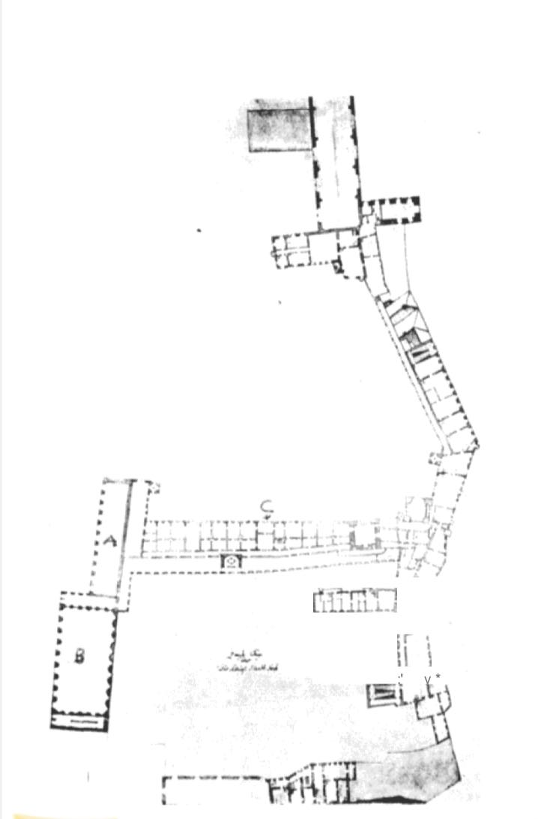

*Figure 2. A plan of the ground floor of the 18th-century Prague Castle*

*showing (A) the Spanischer Saal, (B) the Neu Saalj, and (C) the adjoining wing*

Rudolf II's Kunsthalle demonstrated the professionalism of the museum collection by allocating areas for display, and the aesthetic principles of the building provided a reference for modern specialised museums. The principle of display in Rudolf II's Kunsthalle, which separated between nature and aesthetics, was also continued in the 19th century.

**4. The concept of the museum as a cultural centre**

During the fifteenth and sixteenth centuries, the private studio gradually developed into a public place, becoming a special place for the display of exhibits and for cultural education. Private collections have also been put on public display in modern times, a trend that has been further developed in modern museums and exhibitions. Modern museum exhibitions fulfil the need for knowledge dissemination and have the functions of both viewing and communication and research.

During the Renaissance, nobles and scholars often established their social status by collecting arts. Therefore, collectibles not only have artistic meaning, but are also a symbol of social status. Considering Isabella's role as Marquise, she often commissioned artworks through her correspondence, the content of which highlighted her position in society, no longer an ordinary woman focused on domestic issues, but someone who was favoured by the art world and who had built her social network through these collecting practices.[16] Artists and scholars and nobles conducted salons in her grottoes, which in a small way became cultural centres for artistic exchange and creation. In the 15th and 16th centuries, curiosity cabinets and private studios also grew to become public places, where nobles entertained guests in their studios and flaunted their wealth and taste by way of art exhibitions. Subsequently, in seventeenth-century Germany, Italy, and England, cabinets of curiosity achieved a transition from private appreciation to public research. In addition to natural artefacts, a remarkably popular category of curiosity cabinet collections was that of artificial curiosities. Collections of manufactured objects constituted the first great science museums. These collections were carriers of knowledge and promoted the use of intelligence to create new inventions. Unlike antique collections, which symbolised wealth and status, such objects symbolised the superiority of intelligence. They attracted the curiosity of many philosophers and nobles, who initiated studies and discussions in private houses of curiosity, which gradually developed into public centres of learning.

In general, from the 15th to the 17th centuries, museums realised the transition from private studios to public service facilities. In the 18th century, with the further specialisation of the classification system, a complete collection structure was established. By the 19th century, the change in class made art appreciation no longer the privilege of the elite class; the lower class in the cities also became museum visitors, and museum collections were no longer symbols of status, but teaching instruments for cultural education.[17] On this basis, modern museums not only continue to collect and protect artworks, but also as a cultural centre to undertake the duties of cultural exchange and public education.

# **Conclusion**

Isabella Esther's Grotto and the Renaissance Cabinet of Curiosities both represent the collecting and display culture of the period, and have had a profound impact on modern museums and exhibition methods. The concepts of the Grotto and the Cabinet of Curiosities in terms of collecting philosophy, classification, display art, and the concept of the exhibition as a cultural centre inform and guide the modern museum in four ways. Modern museums have become more than just places for the display of art and history, but also platforms for the exchange of culture and knowledge.

# **Bibliography**

Bedini, Silvio A. “The Evolution of Science Museums.” *Technology and Culture* 6, no. 1 (1965): 1. <https://doi.org/10.2307/3100949>.

Cellauro, Louis. “Venice and the Origins of the Art-Historical Tradition of Display of the Modern Museum.” *Konsthistorisk Tidskrift/Journal of Art History* 81, no. 2 (June 2012): 94–122. <https://doi.org/10.1080/00233609.2011.644865>.

DaCosta Kaufmann, Thomas. “Remarks on the Collections of Rudolf II: TheKunstkammeras a Form OfRepresentatio.” *Art Journal* 38, no. 1 (September 1978): 22–28. <https://doi.org/10.1080/00043249.1978.10793465>.

Günay, Burcu. “Museum Concept from Past to Present and Importance of Museums as Centers of Art Education.” *Procedia - Social and Behavioral Sciences* 55 (October 2012): 1250–58. <https://doi.org/10.1016/j.sbspro.2012.09.622>.

Kolsky, S. “An Unnoticed Description of Isabella d’Este’s Grotta.” *Journal of the Warburg and Courtauld Institutes* 52 (1989): 232–35. <https://doi.org/10.2307/751550>.

Makho, Olga. “Original Items and Imitations of Classical Antiquity in Isabella d’Este’s Grotta.” *Actual Problems of Theory and History of Art* 5 (2015): 459–66. <https://doi.org/10.18688/aa155-5-50>.

Padgett, Joel, Madi Parks, and Gabe Zeigler. “The Patronage of Isabella d’Este: An Examination of Isabella d’Este’s Motivations as a Patroness in Renaissance Italy.” *2019 Festscrift: Claudio Monteverdi’s Orfeo*, October 1, 2019. <https://digitalcommons.augustana.edu/muscfest2019/2>.

San Juan, Rose Marie. “The Court Lady’s Dilemma: Isabella d’Este and Art Collecting in the Renaissance.” *Oxford Art Journal*14, no. 1 (1991): 67–78. <https://www.jstor.org/stable/1360278>.

Thomas, Sophie. “Collection, Exhibition and Evolution: The Romantic Museum.” *Literature Compass* 13, no. 10 (October 2016): 681–90. <https://doi.org/10.1111/lic3.12345>.

Vlasity, Sarah. “The Cabinet of Curiosities: Recreating the Renaissance Experience,” May 1, 2016.

Yaya, Isabel. “Wonders of America: The Curiosity Cabinet as a Site of Representation and Knowledge.” *Journal of the History of Collections* 20, no. 2 (November 1, 2008): 173–88. <https://doi.org/10.1093/jhc/fhm038>.

1. Rose Marie San Juan, “The Court Lady’s Dilemma: Isabella d’Este and Art Collecting in the Renaissance,” *Oxford Art Journal* 14, no. 1 (1991): 67, <https://www.jstor.org/stable/1360278>.
2. Joel Padgett, Madi Parks, and Gabe Zeigler, “The Patronage of Isabella d’Este: An Examination of Isabella d’Este’s Motivations as a Patroness in Renaissance Italy,” *2019 Festscrift: Claudio Monteverdi’s Orfeo*, (October 2019):13, <https://digitalcommons.augustana.edu/muscfest2019/2>.
3. Olga Makho, “Original Items and Imitations of Classical Antiquity in Isabella d’Este’s Grotta,” Actual Problems of Theory and History of Art 5 (2015): 463, <https://doi.org/10.18688/aa155-5-50>.
4. Rose Marie San Juan, “The Court Lady’s Dilemma: Isabella d’Este and Art Collecting in the Renaissance,” 67.
5. Olga Makho, “Original Items and Imitations of Classical Antiquity in Isabella d’Este’s Grotta,”461.
6. Olga Makho, “Original Items and Imitations of Classical Antiquity in Isabella d’Este’s Grotta,”463.
7. Silvio A. Bedini, “The Evolution of Science Museums,” Technology and Culture 6, no. 1 (1965): 12, <https://doi.org/10.2307/3100949>.
8. Sarah Vlasity, “The Cabinet of Curiosities: Recreating the Renaissance Experience,” (May 2016):19.
9. Sarah Vlasity, “The Cabinet of Curiosities: Recreating the Renaissance Experience,” (May 2016):1.
10. Burcu Günay, “Museum Concept from Past to Present and Importance of Museums as Centers of Art Education,” Procedia - Social and Behavioral Sciences 55 (October 2012): 1250, <https://doi.org/10.1016/j.sbspro.2012.09.622>.
11. Sophie Thomas, “Collection, Exhibition and Evolution: The Romantic Museum,” Literature Compass 13, no. 10 (October 2016): 683, <https://doi.org/10.1111/lic3.12345>.
12. Thomas DaCosta Kaufmann, “Remarks on the Collections of Rudolf II: TheKunstkammeras a Form OfRepresentatio,” Art Journal 38, no. 1 (September 1978): 24, <https://doi.org/10.1080/00043249.1978.10793465>.
13. Sophie Thomas, “Collection, Exhibition and Evolution: The Romantic Museum,” 684.
14. Olga Makho, “Original Items and Imitations of Classical Antiquity in Isabella d’Este’s Grotta,”461.
15. Olga Makho, “Original Items and Imitations of Classical Antiquity in Isabella d’Este’s Grotta,”463.
16. Rose Marie San Juan, “The Court Lady’s Dilemma: Isabella d’Este and Art Collecting in the Renaissance,” 75.
17. Burcu Günay, “Museum Concept from Past to Present and Importance of Museums as Centers of Art Education,” 1250.