Renaissance and Contemporary Art

**Introduction**

Renaissance works have deeply influenced contemporary art. By exploring SPECULUM ***[Figure 1]*** and The Garden of Earthly Delights ***[Figure 2]***,the artist team SMACK used digital technology to create a special treatment and re-creation of Bosch's most famous work, Earthly Paradise.[1] SPECULUM not only reflects the inspiration of Renaissance works for contemporary creativity but also promotes communication between old and new cultures. Meanwhile, this paper will explore the contemporary assessment of the value of Renaissance works.

**The inspiration of Renaissance works for contemporary creativity**

Firstly, the works of the Renaissance had a significant impact on contemporary artistic creation in terms of visual presentation. The styles, creative techniques and forms of ancient paintings provide direction and inspiration for new artworks. For example, these two paintings are both triptychs, and both contain three scenes: the Garden of Eden, Paradise, and Hell. SPECULUM uses the same layout as the originals. It replicates a lot of details in the scene, such as the landscape and towers. Moreover, to match the perspective view of the original painting, the SMACK team specifically used a camera with parallel perspective and individually modelled each element ***[Figure 3]***.[2] These perspective views and the portrayal of the scenery were inspired by the original.

In addition, inspiration in the expression of the theme is also important. Renaissance had a variety of themes, including religious beliefs, historical events, social morality, etc. Many contemporary artworks are based on the same themes. For instance, The Garden of Earthly Delights has been widely interpreted as a warning and judgment against indulgent sexuality.[3] In SPECULUM, the artist is also criticizing the indulgence of desire in the 21st century. This includes excessive sexuality, indulgent consumer desires, the spread of electronic technology and environmental issues.[4] In addition, some of the meaningful images and symbols created by Renaissance artists are still widely discussed and used in contemporary.[5] In Bosch's painting of the erotic garden, springs and berries serve as the typical symbols of sexuality ***[Figure 4]***.[6]These details also have a new presentation in SMACK's description of the garden of the 21st-century superego. The visual elements of the Renaissance have also become the basis for modern artists to study and borrow ideas.

Lastly, the Renaissance emphasized the spirit of humanism, inspiring the artists of that period to explore and express human nature, and arousing the artists' concern for the spiritual world of human beings in contemporary times. Humanist thought emphasizes the dignity of humans and the characteristics of human nature. The Garden of Earthly Delights focuses on human desires, and SPECULUM reinterprets desires, combining them with the characteristics of the new era and exploring the indulgent behaviour that exists in contemporary society. This means that humanist thought still plays an important role in modern creativity.[7]

**Conversation between Contemporary and Renaissance Works**

Historical works are reinterpreted and reused in the creation of contemporary art, which establishes a deep connection between historical and contemporary works. In that case, it has produced many appreciated innovations, like Venice and Milan, both recognize the achievements of contemporary art and have contributed to the cultural growth of the city.[8] However, there are still cities that hold on to ancient art within the historical context of the Renaissance, even resisting exhibiting contemporary art in historical spaces. Florence as a key city of the Renaissance, still has challenges in organizing contemporary art exhibitions.[9] Even contemporary art in the Florence showroom was once attacked.

But there are still positive aspects. For instance, Urs Fischer organized an exhibition in the Piazza della Signoria. He opened the exhibition by placing two wax figures in the middle of the Renaissance classic. ***[Figure 5]*** The wax figures will melt, creating an echo of the other two sculptures.[10] Fischer's attempt was a big step toward the fusion of modern and Renaissance art, and he wanted to bring more modern aesthetics into the city, which had grown up due to the Renaissance but was thus trapped by it.

**Evaluating the Value of Renaissance Works in Contemporary**

The value of Renaissance works in contemporary terms depends on the understanding of contemporary people. Therefore, value assessment needs to be discussed in the context of the current social environment. Looking back at the historical development of the Renaissance, changes in genre and form were not entirely innovative. they often achieved transformation by remixing extant content. Many of the innovative creations of the Renaissance originated in the Middle Ages.[11]Many contemporary innovations in aesthetic concepts and shifts in creative forms do not appear suddenly, and thus the value of Renaissance works in contemporary aesthetic concepts is continuously evolving.

Student: Xinyue Kang （1468524）

Tutor: Dr. Alice Helme

Coordinator: Professor Anne Dunlop

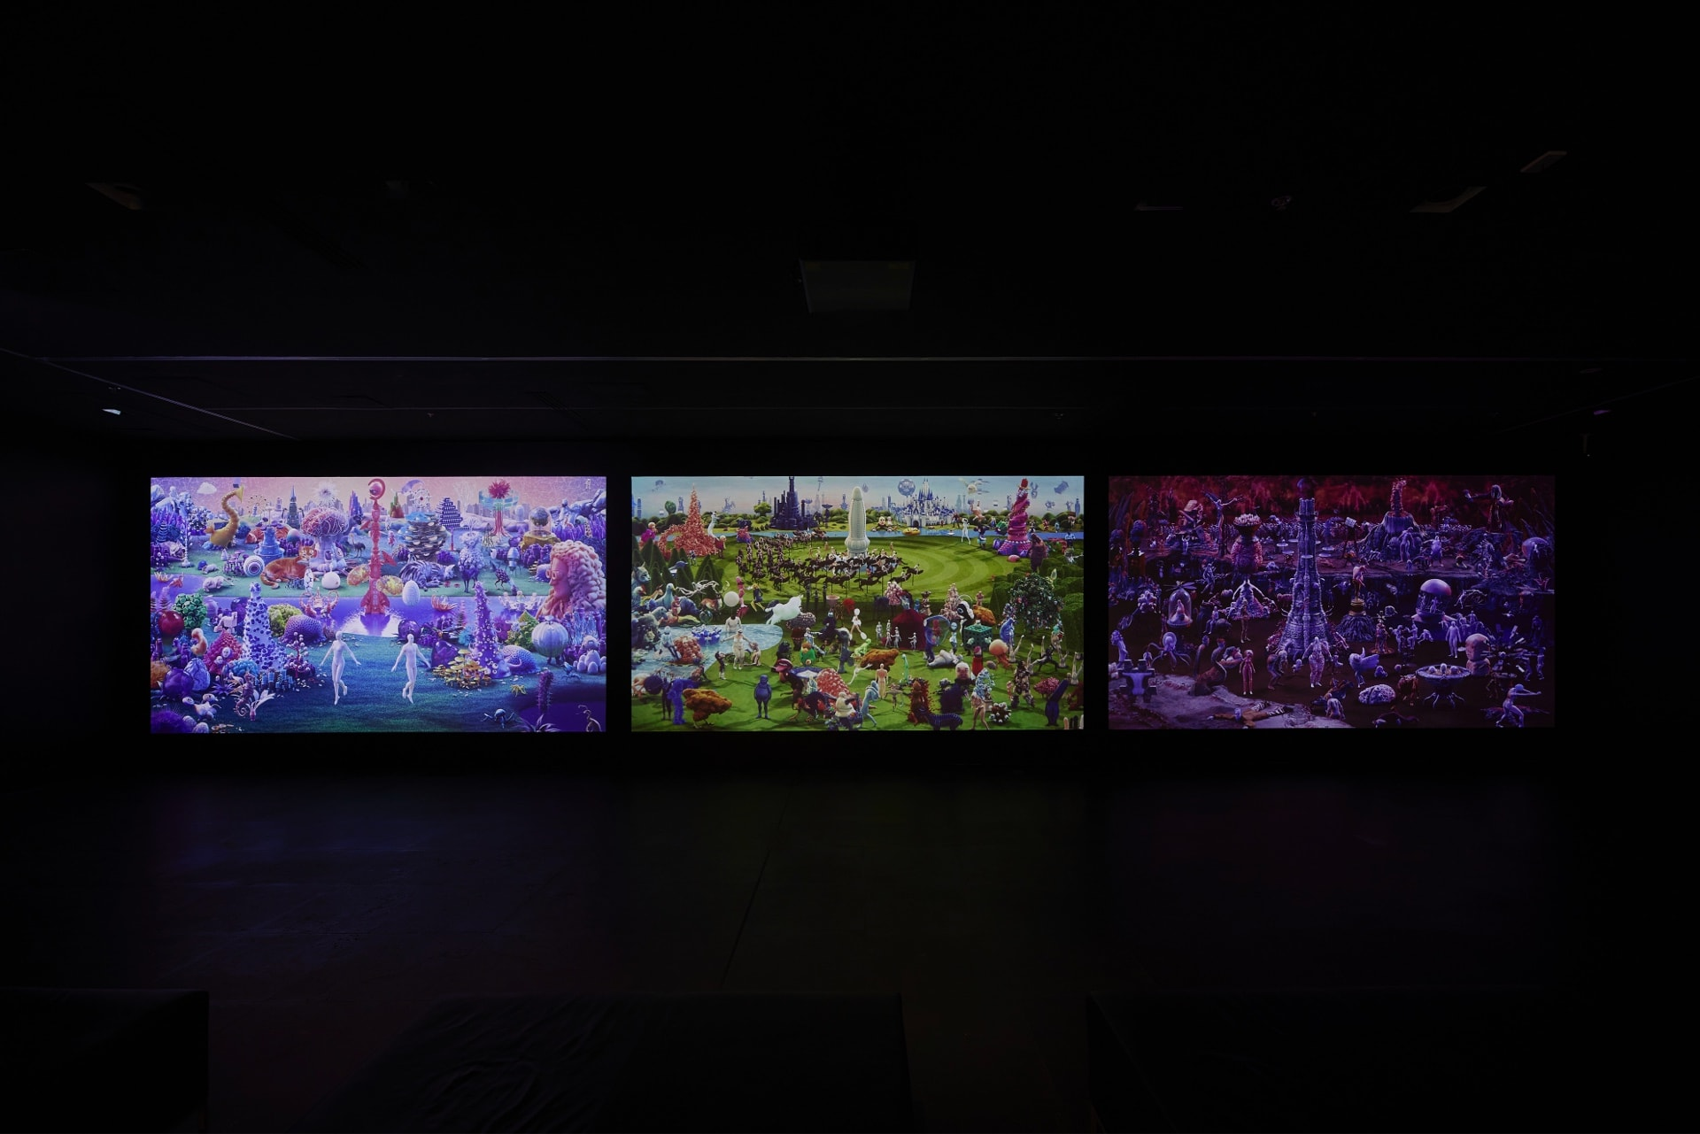

Figure 1

SMACK, *SPECULUM,* digital triptych (2019)

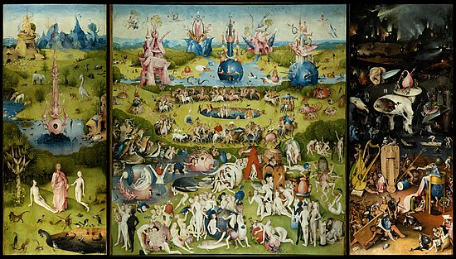

Figure 2

Hieronymus Bosch, The Garden of Earthly Delights, oil on oak panels (1490-1510)

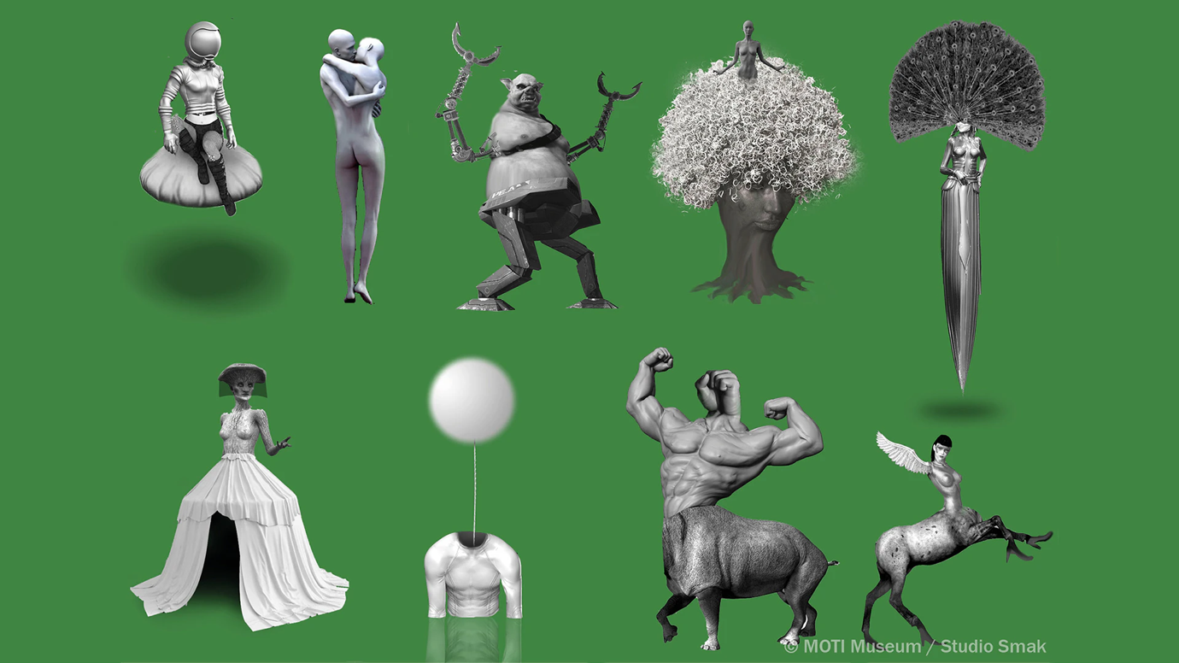

Figure 3

SMACK*,* digital characters

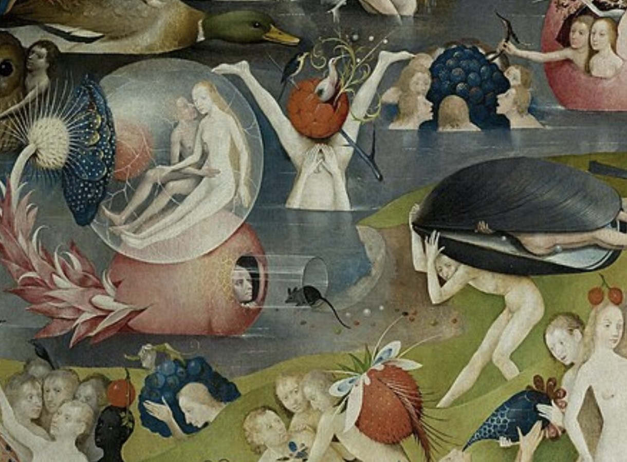

Figure 4

Hieronymus Bosch, The Garden of Earthly Delights, berries and spring

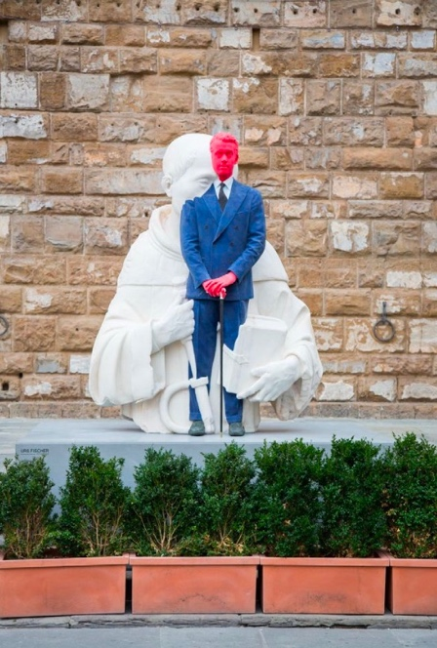

Figure 5

Urs Fischer, “Big Clay #4 and 2 Tuscan Men,” (2017)

**Bibliography**

Cohen, Simona. 2014. “Animal Imagery in Renaissance Art.” *Renaissance Quarterly* 67 (1): 164–80. <https://doi.org/10.1086/676155>.

Ferguson, Wallace K. 1939. “Humanist Views of the Renaissance.” *The American Historical Review* 45 (1): 1. <https://doi.org/10.2307/1905046>.

Fowler, Alastair. 2003. “The Formation of Genres in the Renaissance and After.” *New Literary History* 34 (2): 185–200. <http://www.jstor.org/stable/20057775>.

Gibson, Walter S. 1973. “The Garden of Earthly Delights by Hieronymus Bosch: The Iconography of the Central Panel.” *Nederlands Kunsthistorisch Jaarboek (NKJ) / Netherlands Yearbook for History of Art* 24: 1–26. <http://www.jstor.org/stable/24706821>.

Glum, Peter. 1976. “Divine Judgment in Bosch’sGarden of Earthly Delights.” *The Art Bulletin* 58 (1): 45–54. <https://doi.org/10.1080/00043079.1976.10787241>.

Guest. 2016. “Paradise by Studio Smack | Looping Hieronymus Bosch Animation.” Directors Notes. December 19, 2016. <https://directorsnotes.com/2016/12/19/studio-smack-paradise/>.

Hryniuk, Natalia. 2020. “Modern Attitudes toward Art in Florence: An Exploration of the Renaissance Capital’s Struggle to Accept Contemporary Art.” *Soar.suny.edu*. <http://hdl.handle.net/20.500.12648/13152>.

“SMACK | Triennial | NGV.” n.d. Www.ngv.vic.gov.au. <https://www.ngv.vic.gov.au/triennial/artists-designers/smack/>.

1. “SMACK,” National Gallery of Victoria, published 2024, <https://www.ngv.vic.gov.au/triennial/artists-designers/smack/>.
2. “Paradise,” Directors Notes, published 2016, <https://directorsnotes.com/2016/12/19/studio-smack-paradise/>.
3. “The Garden of Earthly Delights,” Wikipedia, published March 2024, <https://en.wikipedia.org/wiki/The_Garden_of_Earthly_Delights>.
4. “SMACK,” National Gallery of Victoria.
5. Gibson, Walter S. “The Garden of Earthly Delights by Hieronymus Bosch: The Iconography of the Central Panel.” Nederlands Kunsthistorisch Jaarboek (NKJ) / Netherlands Yearbook for History of Art 24 (1973): 10. http://www.jstor.org/stable/24706821.
6. Gibson, Walter S. “The Garden of Earthly Delights by Hieronymus Bosch: The Iconography of the Central Panel.” 9.
7. Ferguson, Wallace K. “Humanist Views of the Renaissance.” The American Historical Review 45, no. 1 (1939): 2. https://doi.org/10.2307/1905046.
8. Hryniuk, Natalia. “Modern Attitudes toward Art in Florence: An Exploration of the Renaissance Capital’s Struggle to Accept Contemporary Art.” Soar.suny.edu., (2020):25. http://hdl.handle.net/20.500.12648/13152.
9. Hryniuk, Natalia. “Modern Attitudes toward Art in Florence: An Exploration of the Renaissance Capital’s Struggle to Accept Contemporary Art.” 23.
10. Hryniuk, Natalia. “Modern Attitudes toward Art in Florence: An Exploration of the Renaissance Capital’s Struggle to Accept Contemporary Art.” 32.
11. Fowler, Alastair. “The Formation of Genres in the Renaissance and After.” New Literary History 34, no. 2 (2003): 186. <http://www.jstor.org/stable/20057775>.