**Analysis of the Embroidered Chinese Jacket**

The artwork is a traditional Chinese costume [Fig.1], which is a blue robe decorated with intricate embroidery patterns. This dress may be the top worn by women in the Qing Dynasty or the early Republic of China, and is usually called "mandarin jacket". The following is a comprehensive description of this work of art from three aspects: material craftsmanship, symbolic significance and value.

The main body of the dress is based on blue silk, the fabric is smooth, with patterns, showing its high-quality material choice. The embroidery patterns are mainly concentrated in the collar, cuff and front part, which are some butterfly and flower patterns [Fig.2]. In traditional Chinese culture, butterflies often symbolize longevity, love and happiness, while flowers symbolize prosperity and beauty.

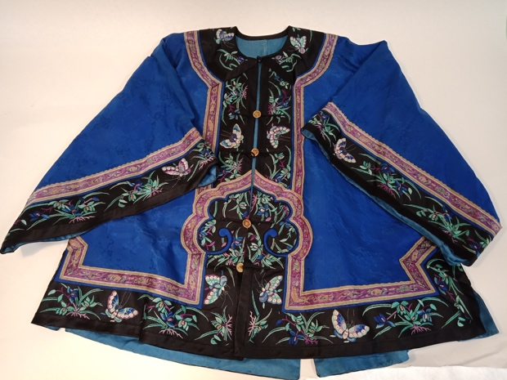 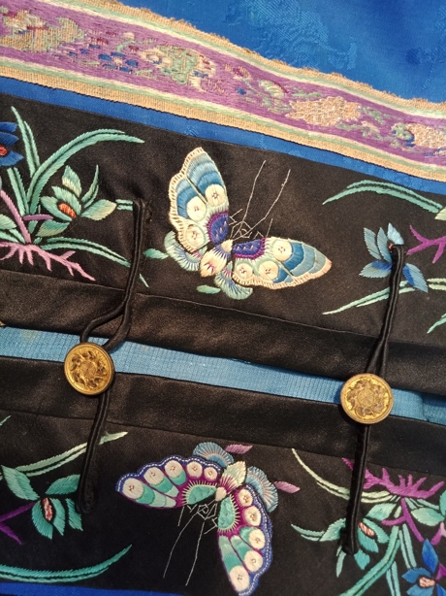

Fig.1. (Left) The Embroidered Chinese Jacket

Fig.2. (Right) The Embroidered Chinese Jacket (Part)

It can be seen from the simplified button design [Fig.3] that this kind of clothing usually appeared in China during the Qing Dynasty or the early Republic of China, especially among royal women or women from wealthy families. The dress uses traditional Chinese embroidery techniques to show the exquisite level of craftsmanship. From the selection of materials to the embroidery process, it takes a lot of time and effort, so the embroidered close is usually made by a workshop, involving cooperation between multiple trades and artisans. Workshops usually include designers, tailors, embroiderers, dyers and other support staff. This clear pattern of cooperation ensures the professionalism of each process, thus improving the quality of the final product. The workshop mode not only enables the realization of complex crafts, but also ensures the continuation of artistic traditions and cultural values. Thus, the value of art is not only the ultimate aesthetic effect, but also in the spirit of collaboration and the whole creative process of art. It can be seen that art is not the embodiment of individual artist's talent, but a social and collective product.

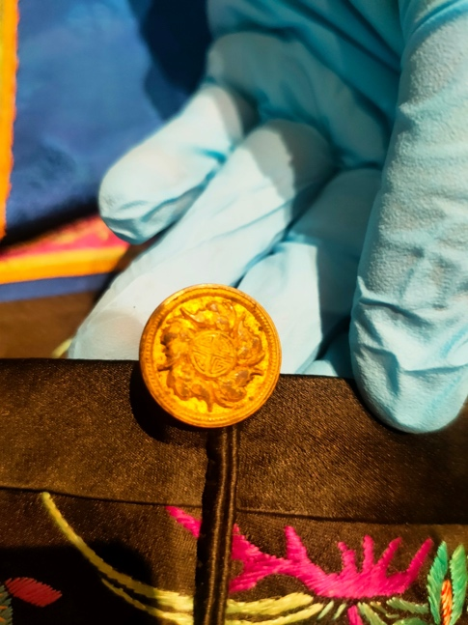

Fig.3. The button of the jacket.

In terms of value evaluation, the silk material and embroidery technique used in this dress enhance its visual effect and affect the interpretation of its cultural value by the viewer. Expensive silk fabrics add a sense of nobility, while delicate patterns of embroidery reflect the attention to detail and professional craftsmanship of the makers. The material and the choice of techniques make this dress is of high value. On the one hand, it is the aesthetic value of clothing, and on the other hand, it is also the identity symbol of its owner.

Put this dress in a wider range of historical and social background, it is not only a reflection of personal aesthetic taste, but also the development of Chinese social culture and history of the witness. During the Qing Dynasty and its later period, there were many changes in dress style, but embroidery as a noble art form always maintained its important position. The appearance of such clothing also marked the society's respect for and inheritance of traditional culture at that time. Even in the period of increasing influence of foreign cultures, elements of traditional Chinese culture still occupy an important position in daily life.