# **Explore the Taoxi River Cultural Community Project**

As the origin of ceramic culture, Jingdezhen is an example for creative cities in China, and was selected as the City of Crafts and Folk Art by the UNESCO Creative Cities Network in 2014. In 2017, a museum in Jingdezhen's Taoxi River cultural community was awarded the annual UNESCO Asia-Pacific Prize for Innovation in Cultural Heritage Preservation. The transformation from an industrial wasteland of a national porcelain factory in the 1990s to the internationally famous cultural neighbourhood of Taoxi River is due to the ‘Taoxi River - China Square’ project in 2012, it is the Taoxi River cultural community which was invested by the local government and state-owned companies, with the goal of creating an urban cultural community that includes both cultural industries and tourism services. (Yongjian Wang, 2021) This paper explores the transformation of the Taoxi River project in Jingdezhen from an abandoned industrial site into an internationally renowned cultural community. Subsequently, it will be discussed the advantages of this urban planning project in terms of innovation in the cultural sector, economic development, and international identity, and the limitations and shortcomings of the project will be critically analysed. Overall, the benefits of the Taoxi River Cultural Neighbourhood project for Jingdezhen greatly outweigh the negatives.

# **Taoxi River Cultural Community Project**

Taoxi River Cultural Community is built on the industrial wasteland of Cosmos Porcelain Factory, one of the formerly state-run‘Ten Major Porcelain Factories’ in Jingdezhen, and is planned and constructed by a state-owned company under the Jingdezhen Culture and Tourism Group. It aims to protect the cultural heritage of the local ceramic industry, promote local economic development, and build cultural and creative industries as well as tourism services. The project covers an area of more than 270 acres with a total building area of 180,000 square metres [Figure 1]. The main construction of the project is to transform the factory buildings built in the 1950s and 1990s into a museum and art gallery [Figure 2].

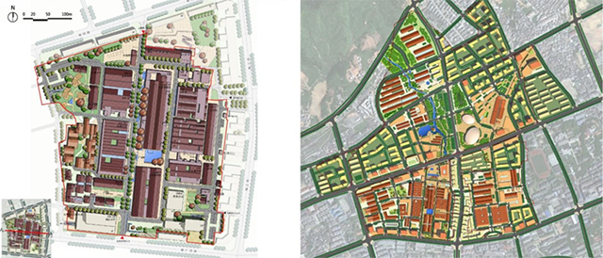

Figure 1. Jingdezhen Taoxi River Area and Phase I Demonstration Area Plan

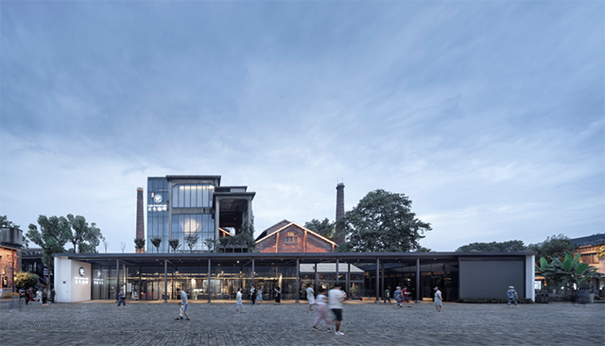

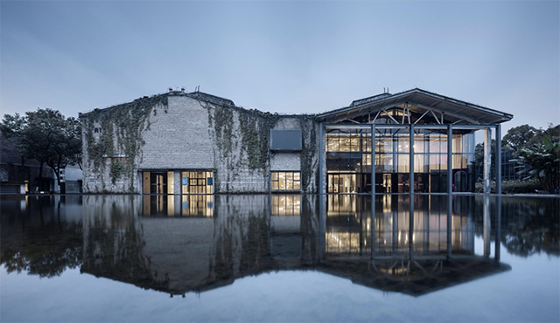

Figure 2. Cosmos Porcelain Factory Ceramic Industry Museum (top)

and Art Museum (bottom)

In order to complete this project efficiently, the local government has provided both policy and financial support. In terms of policy, the city government has set up a special working group to co-ordinate support from various departments in terms of planning and land use, environmental assessment and taxation. In terms of funding, the total investment in the East Side Stilt Reform Project is about 2.5 billion yuan, with the State Development Bank providing nearly 2 billion yuan and the State Land Development Fund providing 300 million yuan. In addition , it has also obtained the national service industry development guidance funds, special funds for the development of cultural industry, special protection funds for intangible cultural heritage within the central budget and financial subsidies, with a total investment of up to 6.5 billion yuan. (Institute of Cultural Industry, Renmin University of China, 2020)

Over three years of construction, the first phase of the Taoxi River project was completed and opened [Figure 3], with a floor area of nearly 90,000 square metres, with 22 old factory buildings of the former Cosmos Porcelain Factory as the core. (Yongjian Wang, 2021) Zhiyi Zhou(2019) states that based on the principle of least intervention in heritage conservation, the newly constructed buildings retain the brickwork of the old buildings, reflecting the dynamic process of renewal of these buildings as they evolve through history.

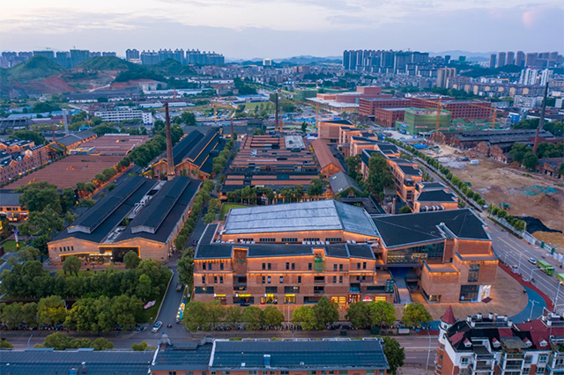

Figure 3. Taoxi River Community

**Ceramic cultural heritage and industrial innovation**

Taoxi River project promotes the protection and inheritance of Jingdezhen ceramic culture, and industrial innovation based on this inherited culture, enriching the local ceramic industry industry ecology and attracting more creators of ceramic art.

There are several historical and cultural preservation buildings and districts in the central urban area of Taoxi River, such as 1 national protection unit, 55 important historical buildings, 6 old ceramic kiln sites, and 40 traditional residential areas. The project plan is based on cultural heritage Protecting the historical and cultural heritage while introducing innovative platforms and creative organisations has enriched the sectoral ecology of the local ceramic industry. These multiple organisations are all based on the development of Jingdezhen ceramic culture. After continuous adjustment of the industry, the building area used for the cultural industry has reached 73,000 square metres, accounting for 80 per cent of all buildings; nearly 150 cultural enterprises have been introduced, accounting for more than 80 per cent of the total number of all branded enterprises. The business scope of these cultural enterprises includes cultural communication, creative design, art exhibition, non-heritage protection, and handicraft education. Creative and design projects account for 42% of the total, introducing more than 10 overseas art organisations and more than 50 ceramic artists, including the Door County Gallery of the United States, the Korea Celadon Research Institute, the Icheon Ceramic Association of South Korea, and the famous potter Yasuda Mang. (Yongjian Wang, 2021) Exhibition and exchange projects accounts for 4%, such as Tao Xi River Art Museum, Jingdezhen Ceramic Industrial Heritage Museum, Ceramic Art Research Institute of the Central Academy of Fine Arts, China Academy of Fine Arts Dunpin Design Centre, People's Daily Ceramic Art Museum, and Li Li Fang Seeking Knowledge Academy. Cultural enterprises in Taoxi River absorb about 4,200 employees, accounting for more than 80% of the total number of employees in the overall creative neighbourhood. (Institute of Cultural Industry, Renmin University of China, 2020) In addition to providing jobs, Taoxicuan Eup Space has created a platform for entrepreneurship, combining a creative bazaar, an offline shopping mall and an online shop. Bazaar stalls are provided and weekly night market events are held, attracting 7,000 university students and entrepreneurs in the first year Taoxicuan was open. Of these, 19 per cent were from China's eight renowned art schools, 35 per cent were from Jingdezhen Ceramic University and other local institutions, and 9 per cent were from overseas. The platform has become an important channel for university students to start their own business and co-operate with enterprises. (Li Qiu & Yafen Wu, 2017) The influx of youth groups has brought new trends to the ceramic art of Jingdezhen, and the creation of young artists can be supported by local art organisations and enterprises, which together create a good atmosphere for innovation.

Overall, the Taoxi River project not only promotes the historic ceramic culture, but also allows more arts organisations and businesses to join in to promote innovation in the industry, attracting young artist groups and providing artistic talent for long-term innovative development.

# **Cultural tourism for economic development and employment**

The project has led to the development of tourism industry in Jingdezhen, and its contribution to the local financial income is gradually increasing. Corresponding to this is the increase of jobs, in addition to art practitioners, tourism has also led to the development of the local service industry, and the number of employees and resident population is also increasing.

With the opening of the Taoxi River Cultural Zone, the number of people travelling to Jingdezhen City has continued to grow, from just 16,046,000 in 2011 to 39,813,000 in 2017, and the revenue brought in by the tourism industry has grown from 8.38 billion yuan to 35.926 billion yuan. (Yongjian Wang, 2021) In order to attract tourists, it has strongly developed malls and markets, with more than 170 well-known brands, including restaurants and fine hotels, a chain of music pubs and cafes, and well-known ceramic training institutions. All these companies and brands have made huge profits from it, and in 2016 the neighbourhood's business revenue was nearly 600 million yuan, and attracted 5,200 people in the workforce, with a total tax payment of 34.8 million yuan. According to 2023 statistics, Jingdezhen has absorbed 100,000 people working in the ceramics industry, of which 30,000 are ceramic craftsmen starting their businesses here, and 5,000 international travellers from overseas are learning ceramics making here. In addition, Linlin Liu(2023) said that Jingdezhen has the only ceramic university in the world, all of which support the Jingdezhen Ceramic Culture Study Tour activities. Many youth groups travel to Jingdezhen for the purpose of studying ceramic art. Such cultural study tours are not only trendy among youth groups, but are also widely promoted in primary and secondary school study tour programmes. For example, in 2018, Jingdezhen Ceramics City Pottery Museum, together with the remaining eight units, won the title of ‘the city's primary and secondary school students study and practice quality education training base’. There are also four units selected as provincial research bases, including the Jingdezhen Chinese Ceramic Museum, which has also been selected as a national primary and secondary school students' research and practice education base. (Linlin Liu, 2023) The Jingdezhen Education Bureau and the Culture and Tourism Bureau have published relevant policies to regulate and manage study tour service organisations. For instance, in order to ensure that the contractors are of sufficiently high quality, the relevant departments have issued documents such as the Circular Concerning the Selection of Organisations to Undertake Study Tours for Primary and Secondary School Students in the City of Jingdezhen Porcelain, and have screened qualified organisations by means of qualification examination, expert evaluation and field visits.

In summary, the construction of Taoxi River Cultural Community has attracted tourists through commercial means on the one hand, and youth groups and primary and secondary school students learning ceramic handicrafts through the unique cultural study service on the other. The local government regulates and manages the related enterprises by improving the legislation, so that the tourism industry develops stably and the income increases year by year. On the other hand, the tourism industry also influences the development of the service industry, the number of local employment and resident population is also increasing, and the tax revenue also contributes to the local finance.

**Enhancement of the city's international identity**

The Taoxi River Cultural Community Project has provided a platform for ceramic cultural exchanges at home and abroad, and has held many world exhibitions, enhancing the world influence of Jingdezhen ceramics and the international image of Jingdezhen as a city.

The planning of the project includes international studios, international art centres and Nordic art centres and other worldwide exchange platforms, and more than ten overseas ceramic institutions and galleries have been introduced, including the Korean Celadon Graduate School, the Icheon Ceramics Association, and the Door County Gallery in the United States. It has attracted dozens of international ceramic masters, such as Yasuda Mang and members of the IAC organisation. In the first year of the Taoxi River Cultural Community, the First Jingdezhen International Ceramic Art Biennale was held in order to raise its profile around the world. In 2019, the preliminary evaluation of the ‘New Image of the Times’ China-Jingdezhen Public Sculpture International Exhibition was also held at the Taoxicuan Museum of Art in Jingdezhen, in addition to the successful organisation of the National Design Masters Award, the Nordic Art Festival, the China-Japan-Korea Pottery Artists' Works Exchange Exhibition, and other international cultural exchange activities. (Yaojie Chen, 2022) Art critic Zhenhua Sun describes Jingdezhen as a small but cosmopolitan city. Pinchang Lv is‘The chief curator of the First Jingdezhen International Ceramic Art Biennale, who is also the vice president of Jingdezhen Ceramic University, Pinchang LV(2023)said that quality exhibitions are important for international reputation. For example, in the United States there is the NCECA Annual Education Conference, in Japan there is the Mino International Ceramics Exhibition, and in South Korea there is the Gyeonggi-do World Ceramics Biennale, etc. These exhibitions not only allow local practitioners and students to see works from their own countries, but also allow them to see works from around the world, and, more importantly, they also promote the exchange and development of the ceramic arts around the world.

In short, the Taoxi River Cultural Neighbourhood enabled Jingdezhen to be selected as a UNESCO Creative City in 2014 and, in 2017, to win the annual UNESCO Asia-Pacific Award for Innovation in Cultural Heritage Preservation. All these results show that Taoxi River has had a positive effect on Jingdezhen's international image.

# **Negative effects of an extremely rapid transformation**

The development of the Taoxi River cultural neighbourhood is a relative success case in practice in China, but there are still two limitations. The first is the negative impact of the extremely rapid development of tourism on the local community. The second is that the arts ecology is not yet sound.

Firstly, the boom in tourism has led to a change in the traditional way of life of the local community. In particular, tourists travelling to the region to learn pottery have led to an increasing demand for short-term rentals, which has led to an increase in local housing rents. As a result, the original residential communities have been overrun by foreign tourists, and many local indigenous people have been forced to move away due to the rising cost of living and the declining stability of their communities. Secondly, the youth groups attracted by this project have enriched Jingdezhen's artistic creation, but still do not constitute a complete artistic ecology. For instance, there is still a gap between young artists and local artists, who tend to use traditional methods of creation and are more conservative in their expression, repeating what has already been expressed in the past.(Jie Zhang, 2023)On the contrary, young artists are more inclined to use new material processes to express contemporary cultural connotations. The communication between these two important creative groups is not close enough. There is also a lack of professional art dealers and local art media in the industry.

In conclusion, the Taoxi River Creative Neighbourhood Project has improved Jingdezhen's tourism industry and artistic and cultural atmosphere, but it has also negatively impacted the local indigenous people to varying degrees. Moreover, the project is in the early stage of construction, and there are still many cultural and ecological deficiencies that need to be further improved in the future.

# **Conclusion**

Considering the historical development of Jingdezhen and the characteristics of a post-industrial society, the Taoxi River Cultural Community Project has rationally reused industrial heritage resources, planned in line with the needs of the local cultural heritage, and ultimately facilitated the revival of both the tourism industry and the ceramic culture industry. And it has achieved world-class results. However, there are still many aspects that need to be built and optimised, such as exploring ways to protect the local Aboriginal community, reducing the impact of tourism on the Aboriginal people, and bringing in more brokerage organisations and media to further improve the local arts ecology. Therefore, the Taoxi River Cultural Community project has brought new opportunities and created some challenges for the ancient city of Jingdezhen. The local government should not only focus on economic benefits and ceramic craft heritage, but also give some consideration to the social impact and human environment.

# **References**

Institute of Cultural Industry, Renmin University of China. (2020, April 26). *Jiangxi Cultural Industrial Park Case 1: Jingdezhen Taoxichuan Cultural and Creative District*. F.qianzhan.com. <https://f.qianzhan.com/yuanqu/detail/200416-d8da3e59.html>

*National Cultural Industry Demonstration Park: Jingdezhen Taoxiche River Cultural and Creative District*. (2017, December 20). Www.daixinming.com. <https://www.daixinming.com/index.php?m=Article&a=show&id=10099>

onewedesign. (2024, March 29). *Taoxicuan, How China’s Most Successful Cultural and Creative Park Was Built?*M.onewedesign.com. <https://m.onewedesign.com/shangyekongjiansecaisheji.html/56-3115.html>

Qian, L. (2023, October 2). *Jingdezhen trend, thousands of artists live by Taoxiche River*. Www.sohu.com. <https://www.sohu.com/a/725292365_377096>

Qiu, L., & Wu, Y. (2017, November 23). *Tao Xi River: The Spiritual Home and Dreaming Space of a Thousand-Year-Old Porcelain City*. M.xinhuanet.com. <http://m.xinhuanet.com/jx/2017-11/23/c_1121997470_4.htm>

Wang, Y. (2019). *Landscape production of urban art districts in post-industrial societies: The case of taoxichuan, jingdezhen|fieldwork-art anthropology*. Www.artanthropology.com. <http://www.artanthropology.com/show.aspx?id=2173&cid=8>

Zhang, J. (2023, November 14). *Heritage preservation and inheritance leads to urban regeneration*. Www.planning.org.cn. <https://www.planning.org.cn/report/view?id=619>

Zhao, X. (2023, May 29). *Industrial Heritage: From sleep to new life*. Paper.people.com.cn. <http://paper.people.com.cn/rmrbhwb/html/2023-05/29/content_25989114.htm>

Zhou, Z. (2019, April 24). *Protection and renewal design of “Taoxichuan” industrial heritage exhibition area in jingdezhen, jiangxi province*. Www.landscape.cn. <http://www.landscape.cn/architecture/10424.html>