**LixSiON**

Li+-containing oxynitride amorphous thin films are promising materials for electrochemical applications as solid electrolytes due to their high ionic conductivity, mechanical stability and chemical durability. Most studies focus on LiPON thin films, while only a few reports discuss lithium boron oxynitrides LiBON (10-8 S/cm), lithium sulfur oxynitride LiSON (10-6-10-5 S/cm) and lithium vanadium oxynitride LiVON (10-5-10-4 S/cm at 330 °C). A number of research groups have explored MSiON (M = Li, Na) glass-ceramics by melt mixing Li2O or Na2O, SiO2 and Si3N4 at 1400-1500 °C/1-3 h in BN crucibles under N2, and the ambient conductivities of M-Si-O-N glasses are only 10-8-10-7 S/cm.

On the other hand, Li4SiO4, similar to Li3PO4, belong to the LISICON-type SSE family, where Li+ are tetrahedrally coordinated in XO4 based (X = Si or P) units. Li4SiO4 by itself, shows negligible ionic conductivity at room temperature (RT). By mixing Li4SiO4 and Li3PO4, when they have equivalent content, optimum ionic conductivity can be achieved. Such improvement is caused by solid solution induced structural distortion, where short-range disorder creates 3D interconnected conduction pathways for Li+, resulting in increased Li+ mobility. In addition, as discussed in the **Intro** and **LixPON and LixSiPON** pages, nitridation also improves ionic conductivity, hence the studies on N-doped Li3PO4 (LiPON glass) and N-doped Li3PO4-Li4SiO4 mixture (LiSiPON glass), which also begs the question, what about N-doped Li4SiO4, or LiSiON?

Reference1,2

(1) Deng, Y.; Eames, C.; Chotard, J. N.; Laleìre, F.; Seznec, V.; Emge, S.; Pecher, O.; Grey, C. P.; Masquelier, C.; Islam, M. S. Structural and Mechanistic Insights into Fast Lithium-Ion Conduction in Li4SiO4-Li3PO4 Solid Electrolytes. *J. Am. Chem. Soc.* **2015**, *137* (28), 9136–9145. https://doi.org/10.1021/jacs.5b04444.

(2) Famprikis, T.; Galipaud, J.; Clemens, O.; Pecquenard, B.; Le Cras, F. Composition Dependence of Ionic Conductivity in LiSiPO(N) Thin-Film Electrolytes for Solid-State Batteries. *ACS Appl. Energy Mater.* **2019**, *2* (7), 4782–4791. https://doi.org/10.1021/acsaem.9b00415.

(3) Zhang, X.; Temeche, E.; Laine, R. M. Design, Synthesis, and Characterization of Polymer Precursors to Li XPON and Li XSiPON Glasses: Materials That Enable All-Solid-State Batteries (ASBs). *Macromolecules* **2020**, *53*, 2702–2712. https://doi.org/10.1021/acs.macromol.0c00254.

(4) Temeche, E.; Zhang, X.; Laine, R. M. Solid Electrolytes for Li–S Batteries: Solid Solutions of Poly(Ethylene Oxide) with LixPON- and LixSiPON-Based Polymers. *ACS Appl. Mater. Interfaces* **2020**, *12* (27), 30353–30364. https://doi.org/10.1021/acsami.0c06196.

(5) Temeche, E.; Zhang, X.; Laine, R. M. Polymer Precursor Derived LixPON Electrolytes: Toward Li–S Batteries. *ACS Appl. Mater. Interfaces* **2020**, *12* (18), 20548–20562. https://doi.org/10.1021/acsami.0c03341.

However, to the best of our knowledge, there have been no reports on LiSiON as solid electrolytes. Given our previous success in developing polymer precursor derived LixPON-like electrolytes, we continued to explore the possibility of LixSiON oligomer/polymer precursors.

Unlike LixPON-like polymer precursors using hazardous chemical (Me3Si)2NH as the Si source, agricultural waste rice hull ash (RHA, combustion product of rice husk, produced world-wide in millions of tons/year) is used here for LixSiON precursors. As shown in the schematic below, silica (SiO2), ~90 wt. % in RHA, can be catalytically (alkali base) dissolved (20-40 wt. %) in hexylene glycol (HG) and distilled directly from the reaction mixture as the spirosiloxane [(C6H14O2)2Si, SP] at 200 °C. SP can then be lithiated simply by using controlled amounts of LiNH2 to produce LixSiON (Li/Si, x = 2, 4, and 6) oligomers/polymers.

It is noteworthy that the other product for the dissolution of SiO­2, silica depleted RHA (SDRHA, ≈ 65 wt.% SiO2, 35 wt.% C), which is a carbon/silica nanocomposite, can be used as hybrid Li+ capacitors (LICs) electrodes. As a result, such a synthetic approach provides environmental advantages including green source, low-cost, low temperature, low energy consumption, emission-free, and scalable features.

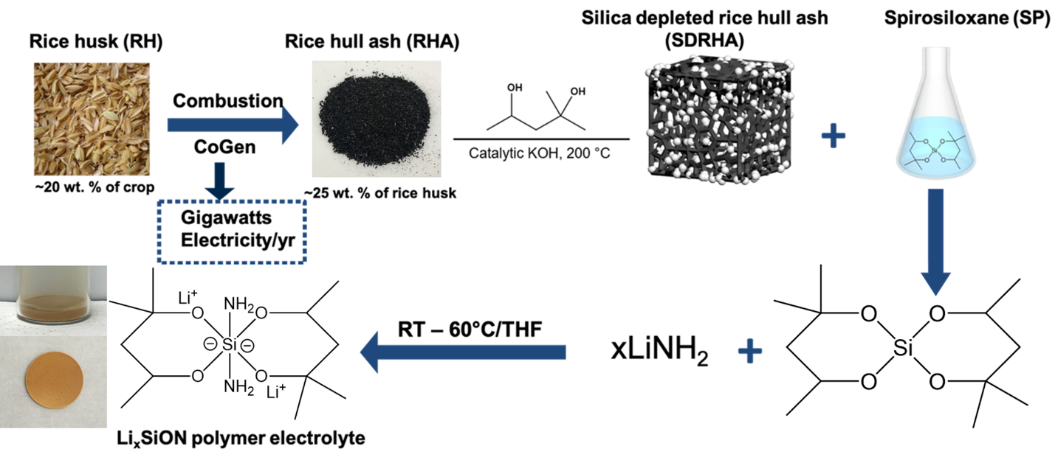

Structures and chemical compositions of LixSiON precursors were analyzed using MALDI-ToF, FTIR, multi-nuclear NMR, TGA-DTA, XRD, XPS, SEM and EDX, followed by EIS for ionic conductivity measurements.

Analyzed by MALDI-ToF combined with MALDI-Calculation, molecular weights (MWs) of LixSiON precursors seem to increase with Li content. It’s possible that Li+ containing species exist as clusters in addition to those that interact with O from SP, or there may be ring-opening and formation of more Si-NH bonds and Li-O-HG bonds, resulting in polymerization.

7Li NMR suggests that Li+ ions are well solvated and dissociated, and excess Li+ may exist in clusters, correlating to MALDI studies, which is beneficial for electrochemical performances.

XPS studies (done under vacuum, 10-9-10-7 Torr) on precursors dried at different temperatures (RT-100 °C) show that the Li content increases with LiNH2 amounts. However, when x = 6, the Li content seems to reach a saturation level. On the other hand, all precursors show low N content (0.7-0.9 at.%), suggesting N is not stable. This is also confirmed by EDX studies for precursors heated to different temperature between 100-400 °C, which show that N at.% decreases with the heating temperature.

Ionic conductivities of the precursors generally correlate with Li and N content. Li6SiON heated to 200 °C/2 h/N2 shows the highest conductivity of 8.5 × 10-6 S/cm, owing to relatively high Li and N contents, as well as dense microstructure suggested by SEM.

Selected representative data are given below.

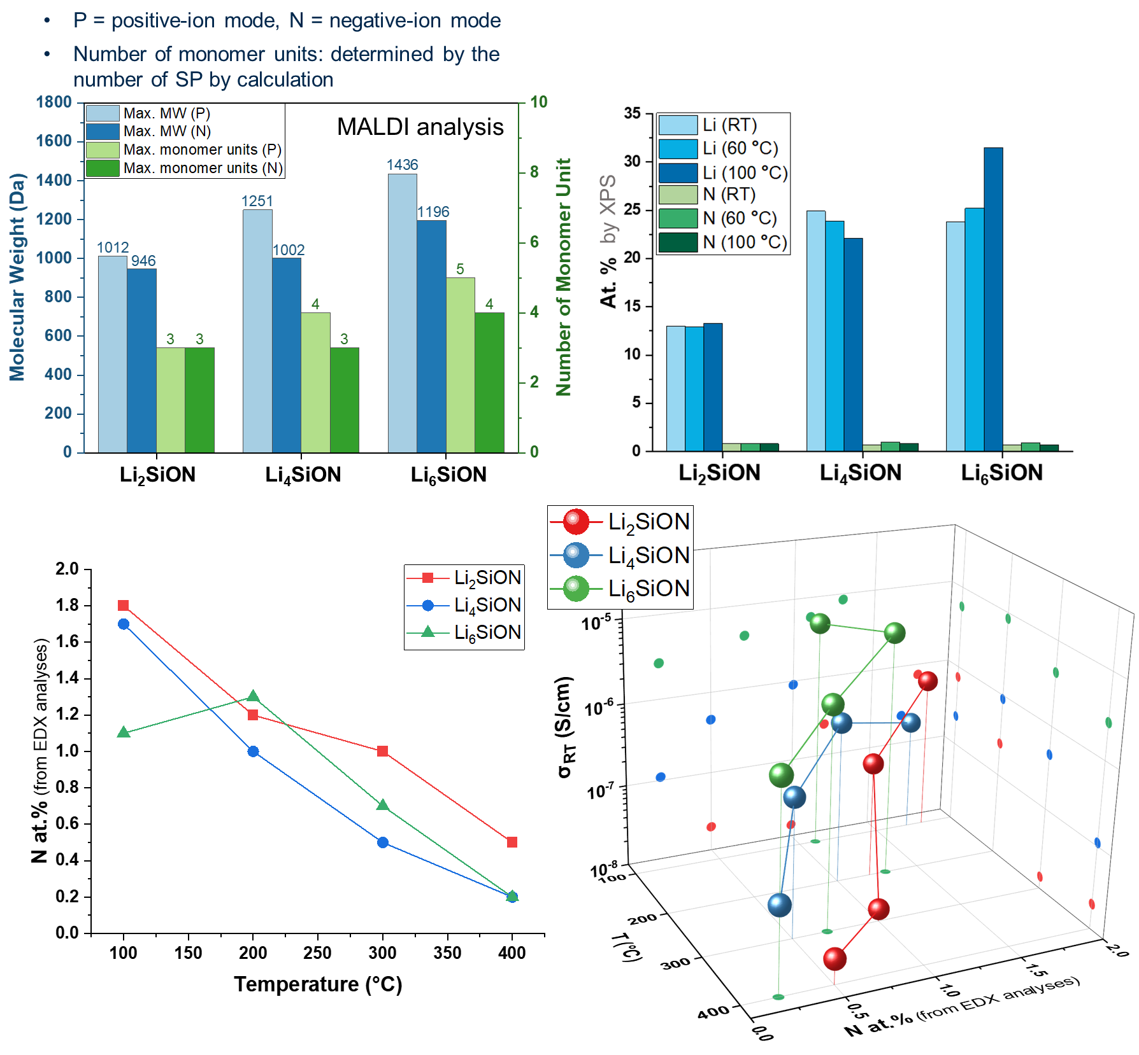

To further study electrochemical properties, Celgard separators were impregnated with LixSiON polymer precursors forming polymer electrolytes (PEs) for electrochemical studies. The PEs show an optimal conductivity for Celgard/Li6SiON (~6.5 × 10-6 S/cm) at ambient and low *Ea* (0.28 eV), which can be ascribed to the high Li content and nitridation of the Li6SiON precursor. Celgard/LixSiON PEs also exhibit high *tLi+* of ~0.7-1 attributed to the polymer framework with low anion mobility. Furthermore, the Celgard/Li6SiON PE enables the assembly of Li symmetric cells with high critical current density of 3.75 mAh/cm, making it desirable for fast charging applications.

A half-cell was also assemble using a sulfur-based cathode (SPAN), Celgard/Li6SiON PE and Li metal anode, which delivers a reversible capacity of ~725 mAh/g at 0.5 C over 50 cycles.

In a separate set of studies, we show that a facile liquid-feed flame spray pyrolysis (LF-FSP) method enables the synthesis of high surface area (∼38 m2/g), phase pure Li4Ti5O12 (LTO) nanopowders. Pristine LTO (theoretical capacity ∼175 mAh/g) was mixed with selected amounts (5 and 10 wt.%) of LiAlO2 and Li6SiON electrolytes forming LTO-composite anodes, aiming to improve the ionic and electronic conductivities by simple ball-milling and ultrasonication methods. The microstructure studies show that the composite powders are homogeneous with APSs <60 nm.

Overall, LTO-composite show improved electrochemical performance, especially for LTO + Li6SiON (10 wt.%) with reversible capacity of 230 and 190 mAh/g at 0.5 and 10 C, and LTO + LiAlO2 (5 wt.%) + Li6SiON (10 wt.%), which shows reversible capacity of 260 and 140 mAh/g at 0.5 and 10 C.

Compared to **LixPON-like polymer precursors**, although LixSiON precursors show lower ionic conductivities (10-6-10-5 vs. 10-5-10-4 S/cm), LixSiON syntheses utilize the green source RHA as starting material and avoids toxic compounds [OPCl3 and (Me3Si)2NH]. There is also no byproduct produced, making it waste-free with better impurity control.

***Detailed description, analyses and discussions are reported in the following papers:***