**M-HMDS**

Metal nitrides are intensely investigated because they can offer high melting points, excellent corrosion resistance, high hardness, electronic and magnetic properties superior to the corresponding metals/metal oxides. Thus, they are used in multiple diverse applications including refractory materials, semiconductors, electronic devices and energy storage/conversion systems.

Common metal nitride syntheses use gas phase deposition or chemical routes. As mentioned for **Novel SSEs** studies, gas phase depositions methods generally require specialized and expensive equipment with relatively low production rates (generally <100 nm/min), limiting the ability to scale for industrial applications. In contrast, chemical routes are more versatile and allow production of a broader range of metal nitrides. However, it is difficult to achieve impurity-free products with optimal morphology control, and toxic precursors are often used.

Traditional chemical syntheses for metal nitrides involve high-temperature reactions (800-2000 °C) of parent metals, metal oxides, or other metal precursors with selected N sources, typically N2/NH3.

Here, simple, novel and scalable reactions of metal chlorides (MClx) with hexamethyldisilazane [HMDS, (Me3Si)2NH] in THF or ACN at low temperatures (ambient to 60 °C/N2) to produce metal nitride precursors, M(NHSiMe3)x (denoted as M-HMDS for convenience) were explored. For example, the synthesis of Al-HMDS precursor towards AlN is as follows.



The byproduct Me3SiCl (boiling point = 57 °C) can be removed easily along with THF/ACN and excess HMDS by drying at 80 °C/1 h/vacuum (vac). The dried Al-HMDS precursor can be further heated to 1600 °C/4 h/N2 in a tube furnace to produce AlN.

This work focuses primarily on the Al-HMDS precursor as well as produced AlN. It was further extended via proof of principle studies to other metal chloride systems, including Zn-HMDS, Cu-HMDS, Fe-HMDS and Bi-HMDS. These formed precursors are volatile, offering the potential utility as gas-phase deposition precursors for their corresponding metal nitrides.

**Al-HMDS**

Structures and molecular weights (MWs) of the synthesized the Al-HMDS precursor were analyzed by MALDI-ToF and **MALDI-calculation**. Overall, structures of the Al-HMDS precursor contain 2-4 units with Al-N bonds, suggesting oligomers and/or cyclomers with Al-N backbones. Some peaks also indicate -Cl inclusion and complexes with THF, consistent with NMR and EDX studies. Examples of predicted structures are as follows.

The synthesized Al-HMDS precursor was heated to different temperatures (800-1600 °C/4 h/N2). BET analyses show that Al-HMDS heated to 800° or 1200 °C show similar high specific surface areas (SSAs) >200 m2/g. On heating to 1600 °C, the resulting powders exhibit a much-reduced SSA of 28 m2/g coincident with grain growth. The high SSAs at 800° and 1200 °C indicate small pore sizes (4-5 nm) and average particle sizes (APSs) of ~20 nm.

XRD data for lower temperatures show primarily amorphous materials and only at 1600 °C are clear crystalline peaks for AlN observed, see below. When heated to 1600 °C/2 h/N2, a mixture of *α*-Al2O3 and wurtzite AlN phases are exhibited, and the AlN phase intensity increases with prolonged heating (1600 °C/4 h/N2). The presence of Al2O3 is likely due to moisture uptake as Al-HMDS shows high SSAs, making it highly susceptible to oxidation.

27Al MAS NMR spectra show that after drying at 80 °C/1 h/vac, Al is primarily present in [AlO6] units with a small amount of [AlO5] units. The [AlO5] peak intensity increased after heating to 800 °C/4 h/N2. After heating to 1600 °C/4 h/N2, a large peak at 114 ppm occurs, indicating AlN. Another peak at 14 ppm suggests [AlO6] units, but with different [AlO6] peak positions and narrower characteristics, indicating that the Al environment is more symmetrical for Al-HMDS heated to 1600 °C, likely a result of increased crystallinity, corresponding to XRD.

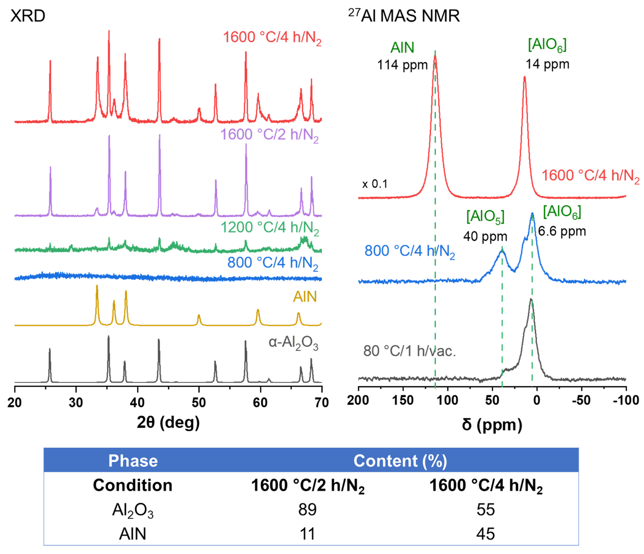

Overall, process optimization needs further attention to eliminate Al2O3; however, this approach is proven valid to produce high surface area AlN powder and should offer the potential for making coatings. The high surface areas are indicative of nanoscale particles. As a result, the heated Al-HMDS powders can also be used as additives to polymer matrices to modify their thermal stabilities, offering another potential application.

**Polymer Matrix + Al-HMDS**

Previously studied polymers, DGEBA-TMDS and DEO-OHS, were used as matrices, see the **Oxysilylation** page. Selected amounts (5, 10, and 25 wt.%) of Al-HMDS powders heated to 800 °C/4 h/N2 were added to the matrices.

DGEBA-TMDS + 0-25 wt.% Al-HMDS composites are all viscous liquids. In general, with Al-HMDS addition, decomposition temperatures (Td5%) increases slightly (increments of ~5 °C), except for 25 wt.% Al-HMDS, and ceramic yield (CY) increases with the Al-HMDS amount.

DEO-OHS + 0-25 wt.% Al-HMDS composites form black, flexible films. With 10 wt.% Al-HMDS, Td5% shows an ~100 °C increment, suggesting significant improvement in the polymer’s thermal stability. However, when the Al-HMDS content is further increased to 25 wt.%, both Td5% and CY decrease, lower than the pristine DEO-OHS. It is likely that the large amount of Al-HMDS impedes reaction between DEO and OHS as the catalyst likely binds preferentially to nitrogen, leaving considerable amounts of unreacted Si-H groups, resulting in less rigid structures with poorer thermal stabilities. This also explains the slight Td5% decrease for DGEBA-TMDS + 25 wt.% Al-HMDS.

In conclusion, flexible solid films with Al-HMDS (800 °C/4 h/N2) powders added to DEO-OHS were successfully cast, effectively modifying the thermal stabilities of polymer matrices with controlled loadings.

**Other M-HMDS**

Other metal chloride systems were also briefly explored including Zn-HMDS, Cu-HMDS, Fe-HMDS and Bi-HMDS, as potential precursors to corresponding metal nitrides. MALDI study indicates oligomers/cyclomers with M-N bonds, similar to Al-HMDS. TGA-DTA suggests that these M-HMDS precursors are volatile when heated (typically 500-700 °C), providing the potential to be used as gas-phase deposition precursors for their corresponding metal nitrides.

Examples of predicted structures of M-HMDS precursors:

Example thermal decomposition pathways for M-HMDS precursors:

**For comprehensive analyses and discussions, please see the published paper:**

**Continue reading:**