**Oxysilylation**

**Traditional Epoxy Resin Syntheses**

Epoxy resins are widely used for applications ranging from fibre-reinforced composites for aircraft components, to paints, to dental restoratives, to flip-chip underfill, to bonding glues for household use. The typical epoxy resin is a two-component mixture where one component contains two or more epoxy groups and a hardener that is most often a diamine. In some instances, accelerating catalysts can be added to promote curing at low temperatures.



Many properties rely on the chemical structure of the epoxy, the hardener used, and the ratio of one to the other though this is typically 2:1. One of the troubling issues with epoxy resins is their susceptibility to moisture uptake leading to mass and volume changes coincident with changes in multiple physical properties.

**Oxysilylation of Diepoxides – A Novel Approach to Epoxy Resins**

Our approach employs two components and a catalyst. One component is a traditional diepoxide. However, the “hardener” consists of compounds containing two or more Si-H groups, and the reaction is affected using catalytic amounts of B(C6F5)3. The curing reaction adds Si-H across one epoxide C-O bond to form new Si-O and C-H bonds coincident with ring-opening. We term this reaction oxysilylation.



Oxysilylation is also known as Piers-Rubinsztajn reaction:

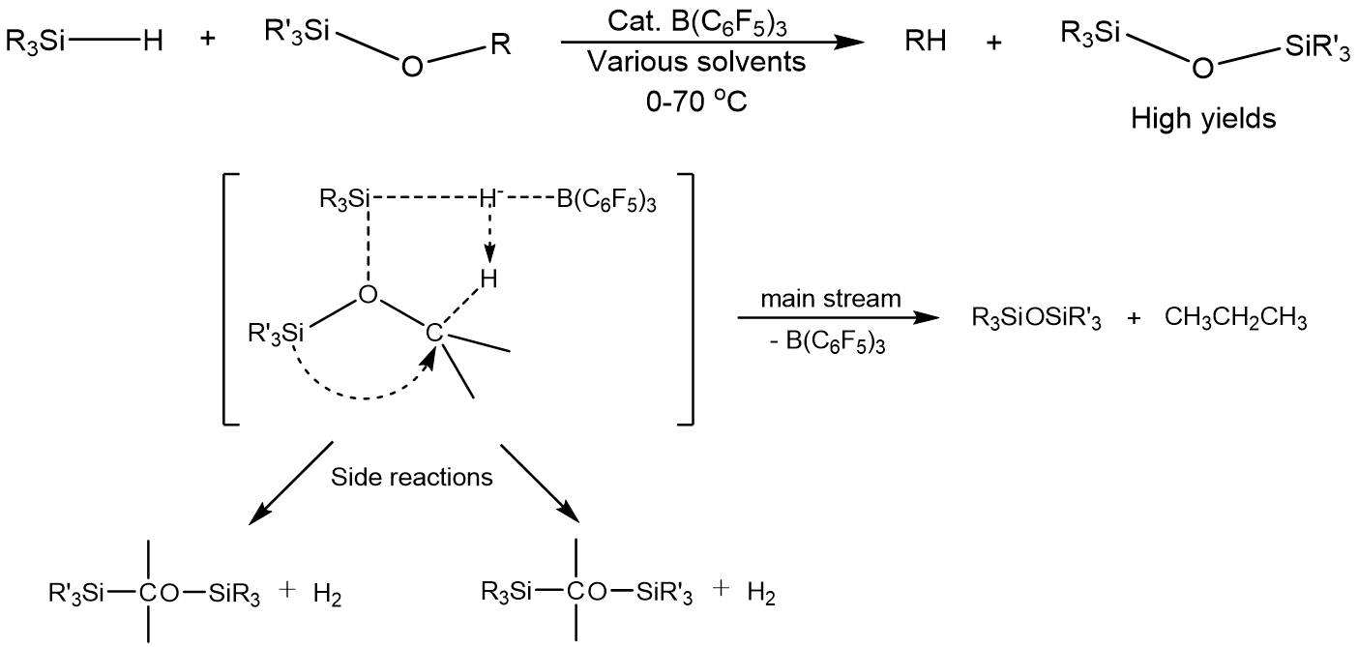

In this work, linear, 2D to 3D structured epoxy resins are synthesized by oxysilylation:

Relationships between properties of these epoxy resins, starting materials, reaction rate and different reaction conditions including various solvent volumes [in 1:1 vol. mixture of CH2Cl2 (DCM) and hexane] and catalyst concentrations are studied.

In summary, reactions of diepoxides with TMDS give linear polymers. These reactions are quite rapid and may be useful in the development of novel self-curing systems. With low solvent volume (1 mL), diepoxide oxysilylations with TMDS give gels/solids that are stable in boiling water up to 5 h suggesting good water stability.

For diepoxides with D4H/D5H, the D5H products show much higher molecular weights compared to D4H products, and can form gels/solids more easily with good water stability.

Highly ordered networks can be made through oxysilylation of diepoxides with a cubic symmetry Q-cage (OHS). Due to high crosslink density, gels/solids form from reactions of diepoxides with OHS and show good water stability, solvent affinities, and solvent uptake. The DEO-OHS system in particular, can be cast as transparent and flexible thin films, see below.

For comprehensive analyses and discussions, please see the published paper: