Name Wang, Yuqin, Guo, Xinyu Date: 11/23/2022

(last name, first name)

NYU ID: yw3875, xg693

Course Section Number: DS-GA 2433-001

Project 2

Total in points (100 points total): ___________________

Professor’s Comments:

Project 2 Report

Uploaded disease data to google cloud. 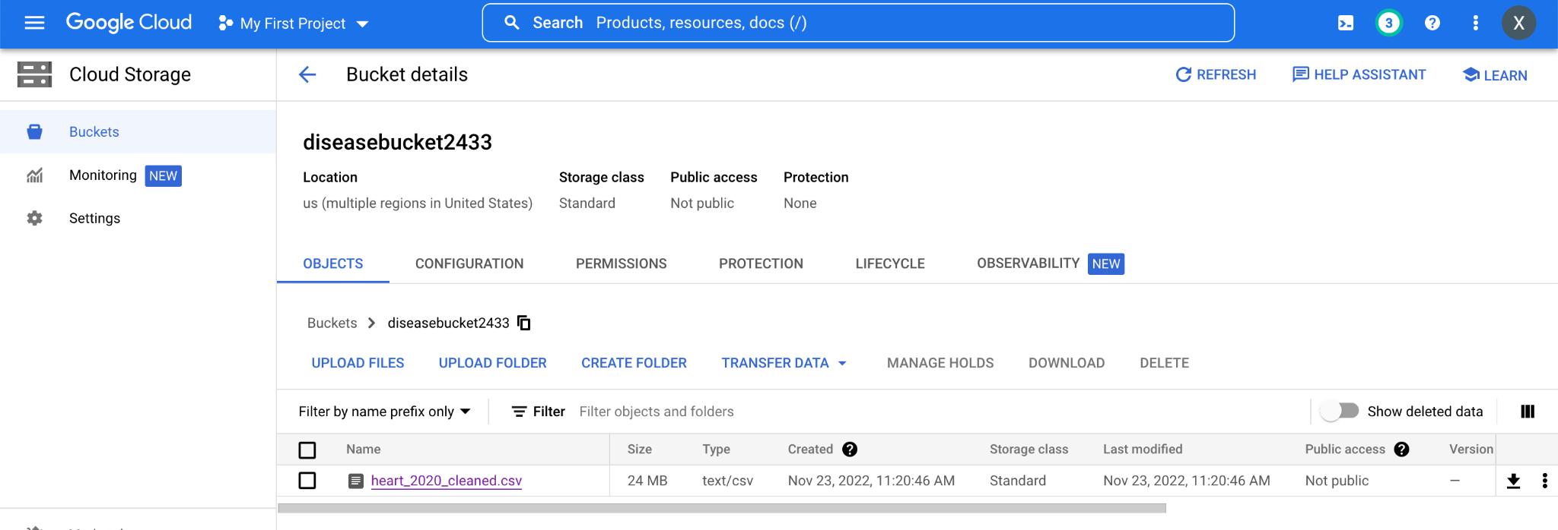

Generate a logical database for the insurance company

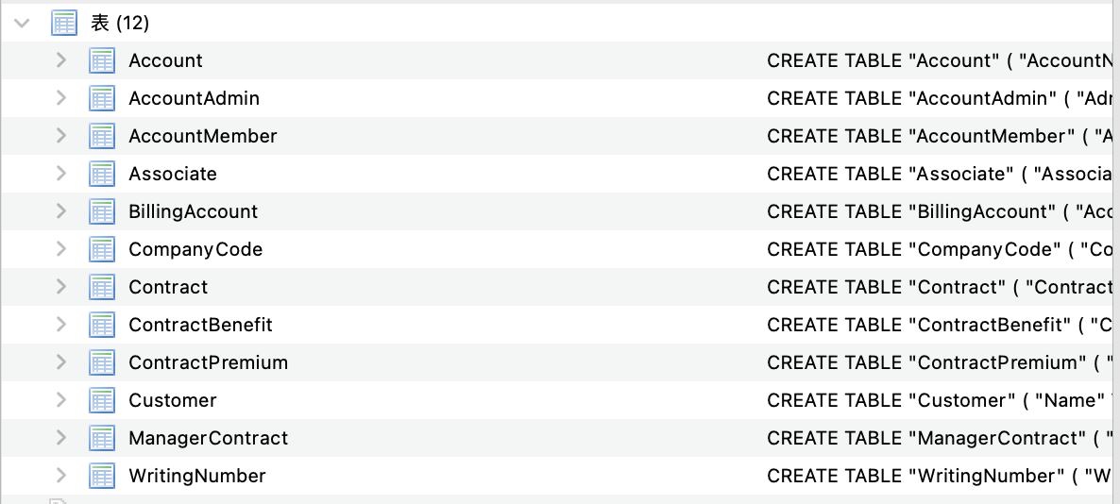

Insert data to the logical database for the insurance company.

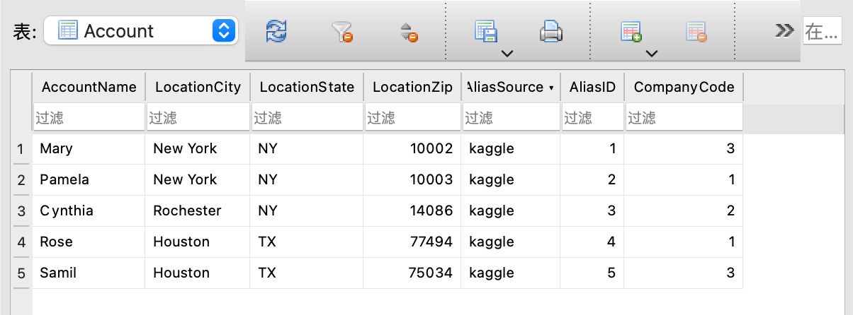

Upload insurance database to Cloud Platform.

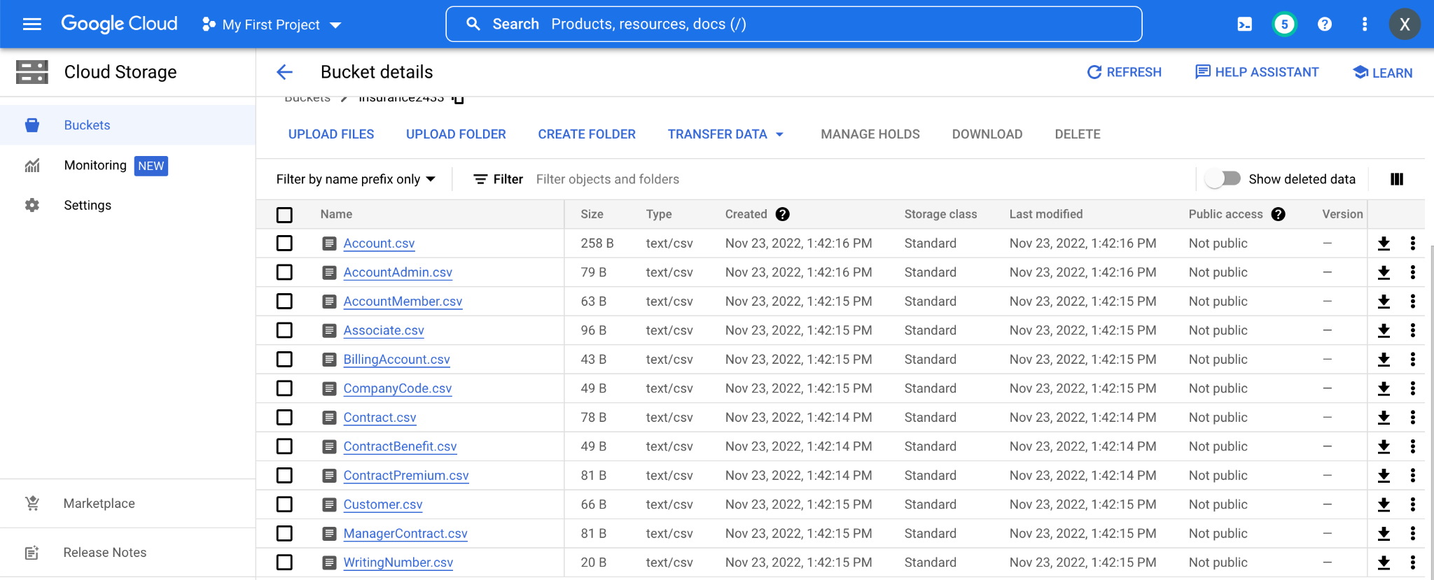

Draw a diagram for the insurance database.

