**Introduction**

**intended audience**

The theme of the website I made is a travel website, so the range of audience groups is very wide and probably divided into the following categories：

1、**Adolescents**

High school students and college students already have a certain degree of self-care, every holiday they will choose the strategy to travel, travel websites are a good choice for them.

**Age**: 18-25 years old.

2、**Middle age**

For travel, people who have entered the workforce are its loyal fans, they usually choose to travel on holidays to reduce stress and enjoy life, so they tend to browse travel websites to develop strategies.

**Age**: 25-50 years old.

3、**The elderly**

After retirement, old age is the best time to enjoy life, the elderly often like to travel to enjoy life, so they are also a popular group of travel sites.

**Age**: 50 years old and above.

**Gender**：There is no clear limit to the gender of the audience, probably slightly more women than men, because women are more important in the development of travel plans and tips.

**Education**：There is no clear line of educational attainment, but more educated people tend to choose to travel.

**socio-economic**：The theme of our website is a website for travel services, which promotes the development of the tourism industry by providing a wide variety of travel options for the masses, thus enhancing.

**Purpose and accomplishment**

Our website is a travel-themed website, and our aim is to be able to offer the viewer, through the design and creation of this website, a number of options for getting out and about.

1. Cost-effective all-around travel packages

2、Some suitable attractions

3、Some cost effective hotels

What we want to achieve.

We want to provide visitors with the most suitable travel style and travel options through our designed website, which can reduce their time and effort in making travel tips, and provide some suitable travel packages at the right price to help visitors as much as possible.

**Opportunity and problem to solve**

We were able to solve some of the tough questions for some of the tourists who chose to travel

1、Be able to help them develop a strategy and travel plan that suits them

2、Provide them with cheap group ticket prices and transportation costs

3、We can make travel packages to make them enjoy the process more comfortably.

**Similar sites**

[中国国家地理网 (dili360.com)](http://www.dili360.com/)

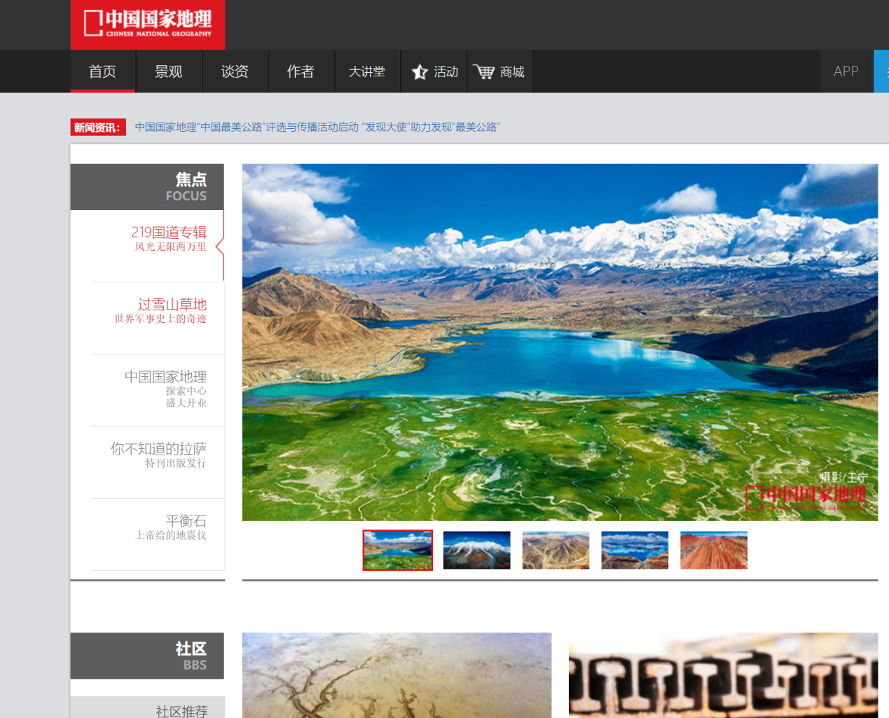

[旅游攻略,自由行,自助游攻略,旅游社交分享网站 - 马蜂窝 (mafengwo.cn)](https://www.mafengwo.cn/)

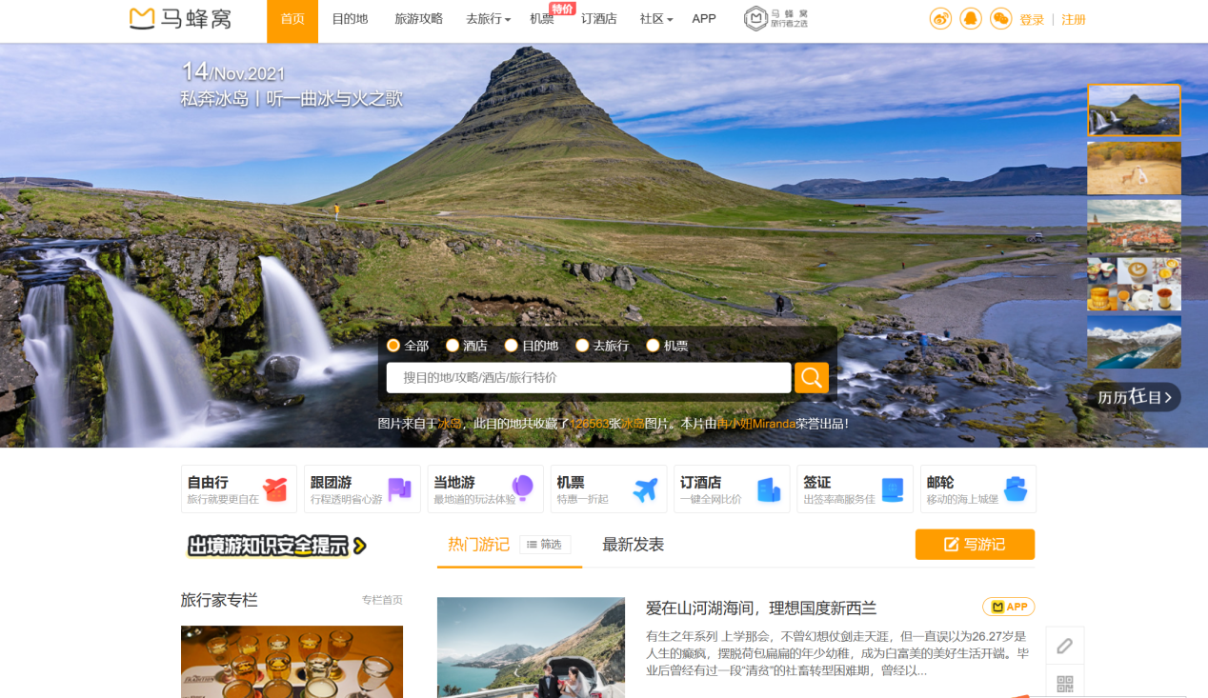

**Why?**

I chose them because they are two very typical and very famous Chinese travel websites

The first one is the National Geographic of China website, which mainly introduces the country's geography and customs, which is rich in content and profound in meaning, from which I borrowed some pictures of the layout and frame, and more importantly, I carefully browsed the content that is expressed on it.

The second one is a very famous travel guide website in China, which has detailed content, comprehensive functions and a neat and beautiful structure. I borrowed from it the modules and the main content and functional categories that the site contains.

**Analysis**

**Web Site Goal**

Our goal: to be able to provide travelers with the most sensible tips and the most informative travel advice to help make their trip comfortable and fun.

**What information do I need?**

During the design process, I used a wealth of images that would help me enrich my pages. Also, I have used some videos, graphics to enrich my pages.

**How will your project use a form?**

I use forms to solicit feedback from some visitors, including their name, email, phone number, subject and what they want to feedback, etc., to solicit their comments and suggestions to better improve the composition of the site.

**A Site Map**

I used a map to clearly show the location of the company so that visitors can easily understand the relevant information.

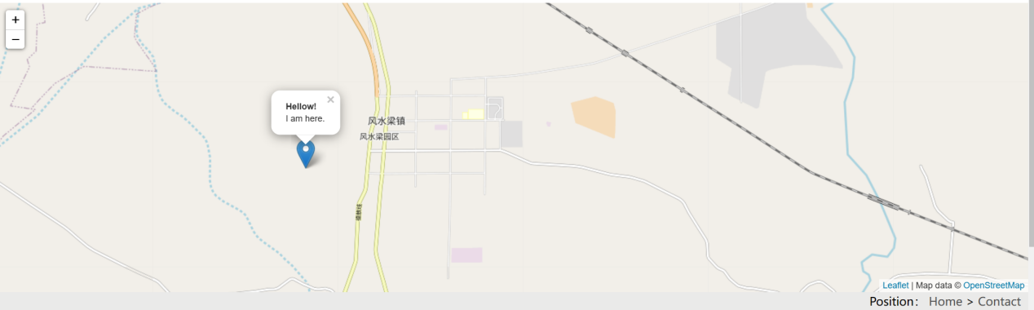

**A Page Wireframe**

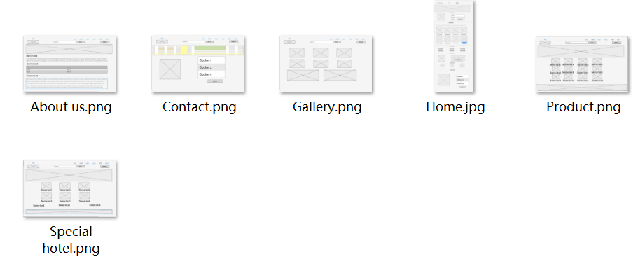

**A critique of the site:**   
 **what do you think is good?**

The website I designed is complete and contains six areas: home page, products, featured hotels, photo album, about us introduction, and contact us. Using light colors as the theme color, as well as with some beautiful videos and pictures, the whole page fits the theme of travel, the picture is light and natural, can give the best visual experience to the viewer  
 **given more time, what would you improve?**

If I had more time, I would like to further enrich my website with more features, such as the introduction of travel options, etc., to give the viewer more choices.

**Appendix**

<!-- 快捷导航模块 -->

<div class="shortcut">

    <div class="W">

        <div class="fl">

            <div class="tubiao">

                <h3>

                    <a href="index.html" title='Tourism'>20008023@qq.com</a>

                </h3>

            </div>

        </div>

        <div class="fr">

            <ul>

                <li class="active_a">

                    <a href="index.html" class="active">

                        <span>Home</span>

                    </a>

                </li>

                <li>

                    <a href="Product.html">

                        <span>Product</span>

                    </a>

                </li>

                <li>

                    <a href="Special.html">

                        <span>Special Hotel</span>

                    </a>

                </li>

                <li>

                    <a href="About.html">

                        <span>About us</span>

                    </a>

                </li>

                <li>

                    <a href="Gallery.html">

                        <span>Gallery</span>

                    </a>

                </li>

                <li>

                    <a href="Connection.html">

                        <span>Contact us</span>

                    </a>

                </li>

            </ul>

        </div>

    </div>

</div>

<!-- 快捷导航模块2 -->

<header class="header W">

    <div class="logo">

        <h1>

            <a href="index.html" title='Tourism'>Tourism</a>

        </h1>

    </div>

    <!-- 搜索模块 -->

    <div class="search">

        <input type="search" name="" id="" placeholder="New sencery">

        <button>Search</button>

    </div>

    <!-- login模块 -->

    <div class="login">

        <form method="get" action="Connection.html">

            <button>

                Login!

            </button>

        </form>

    </div>

</header>

**This is the code for my navigation bar, designed for almost every page**

<script>

    var mymap = L.map('mapid').setView([39.129498, 117.251038], 15);

    L.tileLayer('https://{s}.tile.openstreetmap.org/{z}/{x}/{y}.png',

    {

        maxZoom: 18,

        subdomains: ['a', 'b', 'c'],

        attribution: 'Map data &copy; <a href="http://www.openstreetmap.org/copyright">OpenStreetMap</a>'

    }).addTo(mymap);

    //Adding marker

    L.marker([40.129498, 110.251038]).addTo(mymap)

        .bindPopup("<b>Hellow!</b><br />I am here.").openPopup();

    var popup = L.popup();

    //Adding clicking to map

    function onMapClick(e) {

        popup

            .setLatLng(e.latlng)

            .setContent("You clicked the map at " + e.latlng.toString())

            .openOn(mymap);

    }

    mymap.on('click', onMapClick);

</script>

**This is the js section with the map**