1.映射动画

2.去掉动画映射然后导出模型

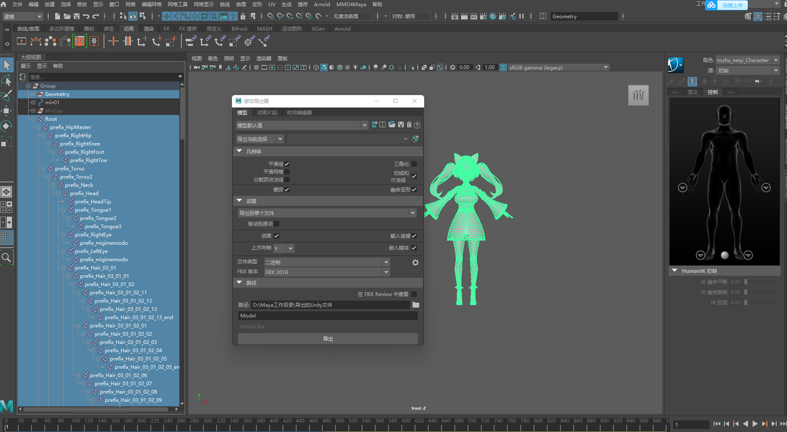

4.导出动画，注意：导出动画时要选中全部骨骼

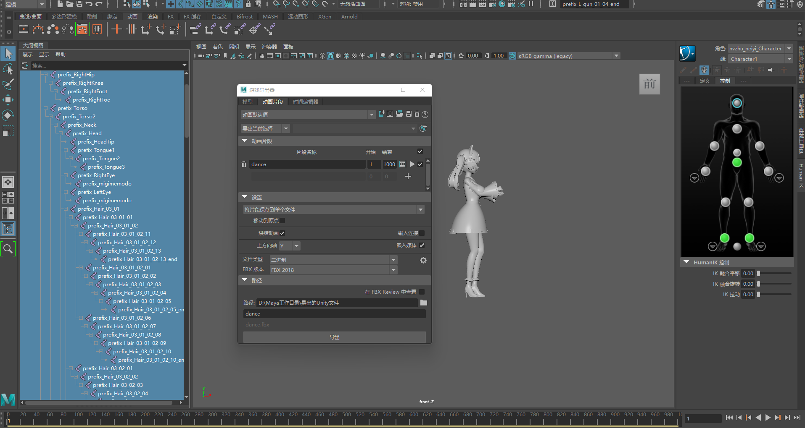

5.导出之后Unity里动画循环不要勾选Loop Pose，否则动画会不正确的（暂时不清楚原因）

6.注意：用Maya导出BlendShapes必须用Binary和FBX2021才行，否则BlendShapes的参数前会有前缀

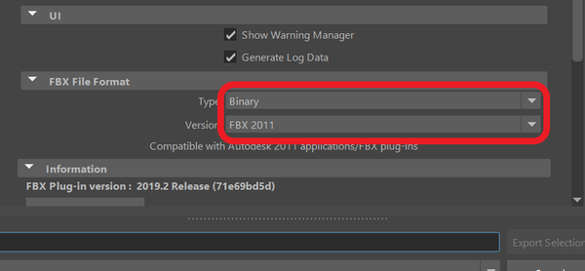

7.BlendShape的名称和顺序如下：

BrowDownLeft,  
BrowDownRight,  
BrowInnerUp,  
BrowOuterUpLeft,  
BrowOuterUpRight,  
CheekPuff,  
CheekSquintLeft,  
CheekSquintRight,  
EyeBlinkLeft,  
EyeBlinkRight,  
EyeLookDownLeft,  
EyeLookDownRight,  
EyeLookInLeft,  
EyeLookInRight,  
EyeLookOutLeft,  
EyeLookOutRight,  
EyeLookUpLeft,  
EyeLookUpRight,  
EyeSquintLeft,  
EyeSquintRight,  
EyeWideLeft,  
EyeWideRight,  
JawForward,  
JawLeft,  
JawOpen,  
JawRight,  
MouthClose,  
MouthDimpleLeft,  
MouthDimpleRight,  
MouthFrownLeft,  
MouthFrownRight,  
MouthFunnel,  
MouthLeft,  
MouthLowerDownLeft,  
MouthLowerDownRight,  
MouthPressLeft,  
MouthPressRight,  
MouthPucker,  
MouthRight,  
MouthRollLower,  
MouthRollUpper,  
MouthShrugLower,  
MouthShrugUpper,  
MouthSmileLeft,  
MouthSmileRight,  
MouthStretchLeft,  
MouthStretchRight,  
MouthUpperUpLeft,  
MouthUpperUpRight,  
NoseSneerLeft,  
NoseSneerRight,  
TongueOut,

8.命名规范（暂定没有换装的情况）

模型名：角色名_服装名_Pose名，比如：Xiaolan_Lifu_APose（Pose要区分APose还是TPose）

动作名：角色名_动作名_Anim，比如：Xiaolan_Walk_Anim