Dan Xiong

WDD 130

Welcome to Hmongworld.org

The history of the Hmong people dates back 8000 years ago with the last know Hmong King Chi Yu.

King Chi Yu was one of 3 Legendary founding fathers of China. His efforts on uniting the Hmong people failed as the other two Kings formed an alliance and defeated him. Hmong people were scattered across Asia with many fleeing to the southeast.

This website is to pay homage to King Chi Yu and finally unite the Hmong people across all lands.

Currently there’s 4 to 5 million Hmong around the world. Most of the population is in Asia with about 5% Hmong in the United States.

The first step for unification is with the use of Hmoob Coin. Hmoob Coin can be used exclusively with Hmongworld.org and the Hmong world ecosystem.

On this website you can buy, sell or trade with other Hmong people across the globe.

The spirit of King Chi Yu, invites all Hmong across the world to unite and get your free Hmoob coin today right here at Hmongworld.org.

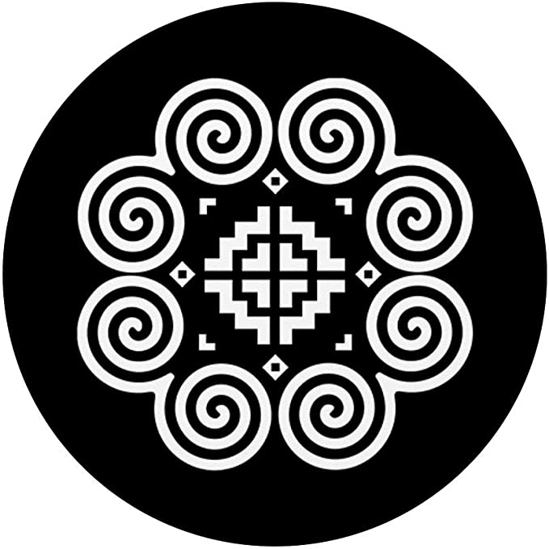

HMOOB COIN (Bring back the Hmong Empire by uniting with one currency, Hmoob coin)

The spirit of Emperor Chi You, Txiv Yawg invites every Hmong across the globe to participate

Signup and receive your free Hmoob coin now

Free 100 hmoob coin

Refer get 100 hmoob coin

Please write “hello” in Hmong and get an additional 1,000 free Hmoob coin.

Inside Back office

DONATIONS to uniting the Hmong people accepted

Contributor .01 ETH = 1,000

Star Contributor .10 ETH = 10,000 limited time bonus gift 10,000

VIP Contributor 1 ETH = 100,000 limited time bonus gift 100,000

Please only Contribute up to 1 ETH. We don’t want any whales getting all the coin.

Listed on Uniswap Exchange

Partnering with Hmong Vendors across the world soon.

Hmong Market place coming soon

Buy, Sell, Trade globally with your family in the New Hmong Empire.

First Round Token Distribution: bonuses given 11,000,000 Total Hmoob Coin

Second Round token Distribution: No bonus 11,000,000 Total Hmoob Coin

Membership site: include token amount in account

Plus referral bonus coin amount

Option to transfer to Metamask wallet, ERC20 wallet

Countdown clock before bonus expires

Hmong people have always dreamed of having a country they can call their own. Now you can have the whole Earth as your country in the digital world. Lets face the facts, if you are using the same currency to trade and you can trade with any Hmong person around the world, what difference does it make that you have to live on one land. Its already as if you live on one land because you can communicate and trade with one another. You can call the Earth as Hmong Land if you want, we are all connected now with Hmoob coin.

NOTE: Create Virtual Real estate (Hmoob Land)

In a world where governments are controlled by corporations and greed runs rampant in every country, is there any hope that the Hmong will have their own country someday. We think not, all the major lands and real estate has already been bought and owned. We find it somewhat ludicrous to say that the Hmong will have their own country someday like what some of the old Hmong generation wishes. We are however very respectful of the older Hmong generation. We do understand that it has always been a dream of the Elders to have a country called home, and to keep that dream alive there needs to be HOPE. For this reason, we have created Hmong Land.

Hmong Land will keep that Hope alive. Hmong Land is the virtual land of the Hmong and anyone can access it through any VR headset. In Hmong Land, you can experience what it was like to live in the old traditional Hmong way. See the bamboo trees and witness the sun setting over beautiful green mountain tops. You can hike along a dirt path going up the hill and then as you look down, you eyes will swell with joy as you witness the beautiful green rice fields slightly bending against the gently blowing wind. Welcome to Hmong Land.