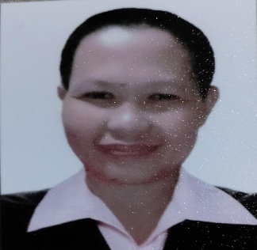

# Education

#### Housekeeping NC2

#### Dr. Cabuco College of arts and Science Inc.

2025

#### Bachelor of Science in Office Administration - Undergrad

Eulogio “Amang” Rodriguez Institute of Science and Technology (EARIST)

Three Years Specialized Secretarial

2002

#### Secondary Education

Rizal Highschool

1998

**Primary Education**

Tigbao Elementary School

1992

# Skills

* Housekeeping
* Sewer
* Steno Typing
* Communication
* Teamwork
* Critical thinking
* Time management
* Adaptability

# Achievements

#### Best in Battler Award: Housekeeping Specialized Secretary

Dr. Cabuco College of Arts and Science Inc.

2025

**Certificate of Completion**

UERMMMC

2001

**Certificate of Completion**

Office of the Ombudsman for the military

2002

# Profile

Reliable and dedicated professional with a strong ability to multitask efficiently under pressure. Known for excellent communication, time management, and a positive, team-oriented mindset. Passionate about learning new skills and contributing to company success through hard work and genuine enthusiasm. Eager to grow in dynamic work environments and make a lasting impact.



# CONTACT

09666708283

gildabrazilhonrado@example.com

Block 9 Lot 28 Phase 1 Section 1 Pabahay 2000 CSJDM Bulacan Barangay Muzon

Honrado gilda b.

# Work Experience

SSS Marikina Branch – Medical Department

2000

* Assisted in administrative tasks supporting medical records management.
* Coordinated with staff to ensure timely processing of health-related documentation.

UERMMMC (University of the East Ramon Magsaysay Memorial Medical Center) - Record Department

2001

* Maintained and organized hospital records ensuring confidentiality and accuracy.
* Supported daily documentation operations in compliance with institutional standards.

Office of the Ombudsman for the Military – Director’s Office

2002

* Provided clerical and administrative support to the office.
* Handled official correspondence and filing of sensitive documents.

Freelance Sewing

2008 – present

* Operated sewing equipment and ensured high-quality stitching and finishing
* Operate high speed and edging machine

# person references

#### Janet P. Herrera

**Trainor**

DR. CABUCO COLLEGE OF ARTS ANG SCIENCES INC

09234245980

Carlo Lirazan

System Engineer

EEI Corporation