**VIAHALE: TRANSPORT NETWORK VEHICLE SERVICE ADMINISTRATIVE WITH QR CODE-BASED VISITOR REGISTRATION AND FACIAL RECOGNITION**

**POWERED BY OPENCV**

A Capstone

Presented to the Faculty of

The College of Computer Studies

Bestlink College of the Philippines

In Partial Fulfilment

Of the Requirements for the Degree of

Bachelor of Science in Information Technology

**GLEN B. HONRADO**

**DANICA C. LUMBAO**

**ERICA MAE S. MADRIGAL**

**LANCE STEVEN A. RAMOS**

**CARL JUSTINE R. SOLIS**

July 2025

# APPROVAL SHEET

This thesis entitled **VIAHALE: TRANSPORT NETWORK VEHICLE SERVICE ADMINISTRATIVE WITH QR CODE-BASED VISITOR REGISTRATION AND FACIAL RECOGNITION POWERED BY OPENCV,** prepared and submitted by **Glen B. Honrado, Danica C. Lumbao, Erica Mae S. Madrigal, Lance Steven A. Ramos and Carl Justine R. Solis** in partial fulfillment of the requirements for the degree of Bachelor of in Information Technology, has been examined and is recommended for acceptance and approval for Pre Oral Defense.

**RICHELYN VILLASOR**

Adviser

**__________________________________________________________**

**THESIS REVIEW PANEL**

    Approved by the Committee on Oral Examination with a grade of____.

Member                                                     Member

   Chairperson

Accepted and approved in partial fulfillment of the requirements for the degree of Bachelor of Science in Information Technology.

Dean, College of Computer Studies

 Date of Final Defense:

# ACKNOWLEDGEMENT

The researchers would like to express their heartfelt thanks and gratitude to the following persons who, in one way or another, has contributed much, and extended willingness and support needed to make this research possible:

**Dr. Maria M. Vicente,** President/CEO, Bestlink College of the Philippines, for her generosity and kind heart in establishing this institution and giving opportunities to those less fortunate students to continue their studies and pursue their dreams;

**Ms. Edith M. Vicente,** Executive Vice President, for providing the needed information to complete this research;

**Dr. Charlie I. Cariño,** Vice President for Academic Affairs, for his support and encouragement to make this thesis writing possible;

**Engr. Diosdado T. Lleno**, Vice President for Administration and

Finance, for his words of encouragement and motivation;

**Dr. Joy Evelyn A. Ignacio,** College Associate Research Head, for her good heart to extend her help needed by the researchers.

**Dr. Rosicar E. Escober,** Dean, College of Computer Studies of Bestlink College of the Philippines, for providing guideline documentation in capstone projects.

**Mr. Rommel J. Constantino,** Program Head, Bachelor of Science in Information Technology, for the constant supervision as well as providing necessary information regarding the project and also for his support in completing this project

**Ms Richelyn A. Villasor,** Research Coordinator, for helping us in improving our research and guiding us in completing this project.

Ms Richelyn A. Villasor, Capstone Adviser, for giving us suggestions and ideas to improve our research and guiding us in completing this project.

Panelists, Mr.Vincent Carlo T. Garados, Engr. Reynante B. Ponay, and  Mr. Rommel J. Constantino, who extended their effort and time to be able to constructively criticize this thesis and share their knowledge with them to deepen and widen their needed information.

**Families and Friends,** for all the financial and moral support that have enabled the researchers to triumph all the challenges, especially during the lowest time that served as their inspiration to complete this study; and

**Above all**, to the Almighty God, for the strength and knowledge that were used for the accomplishment of this research journey.

**THE RESEARCHERS**

# DEDICATION

This business research study is wholeheartedly dedicated first and foremost to ourselves as researchers, for executing dedication, time, effort, motivation, sacrifice, and courage to make this conducting study a fruitful and successful piece of work.

To our beloved parents who have been our inspiration and gave us strength when we thought of giving up, which continually provide their moral, spiritual, emotional and financial support.

To the research advisers and professors, for extending help by giving guidance, supervision, time and wisdom to the researchers in conducting this business research study.

And lastly, above all, to our Almighty God, for giving guidance, strength, power of mind, protection, skills and for giving us a healthy life. All of these we offer to you.

**THE RESEARCHERS**

# 

# ABSTRACT

Title: **VIAHALE: TRANSPORT NETWORK VEHICLE SERVICE ADMINISTRATIVE WITH QR CODE-BASED VISITOR REGISTRATION AND FACIAL RECOGNITION POWERED BY OPENCV**

Authors: **GLEN B. HONRADO**

**DANICA C. LUMBAO**

**ERICA MAE S. MADRIGAL**

**LANCE STEVEN A. RAMOS**

**CARL JUSTINE R. SOLIS**

Degree: **Bachelor of Science in Information Technology**

Major: Information Management, Information Security & Network Administrative

Date of Completion: August 2025

The TNVS industry continues to expand rapidly in the Philippines through platforms like Grab and Angkas, administrative areas face increasing issues in terms of managing visitors while relying on inefficient manual logbook systems that compromise security and operational efficiency. This study addressed critical challenges in TNVS administrative operations, including manual check-in inefficiencies, security and operational identity verification, limited real-time oversight capabilities, and fragmented systems that result in operational delays and miscommunication. The study employed an Agile Scrum methodology combined with microservices architecture and DevOps practices to ensure iterative development, scalability and seamless integration across system modules.

The proposed project contains four administrative modules: Facilities Reservation for digital booking and scheduling with pre-defined rules to automate approval decision and support scheduling issues, Visitor Management with online pre-registration using Qr-code based registration and facial recognition for visitor access control, Legal Management for tracking contracts and compliance requirements, and Document Management for centralized file storage and retrieval. The system design utilizes PHP for backend logic, MySQL for data management, and OpenCV for facial recognition capabilities, hosted on IndevFinite cloud infrastructure with continuous integration and deployment pipelines. The system architecture aims to eliminate scheduling conflicts through centralized reservation management and provide real time monitoring capabilities through comprehensive dashboards.

The study contributes to the growing body of knowledge in smart administrative systems by providing a tailored solution specifically designed for TNVS operational requirements. The integrated approach combining multiple administrative functions into a unified platform offers a scalable model for similar service-oriented organizations seeking digital transformation. The research demonstrates how emerging technologies can be effectively integrated to address sector specific administrative challenges while maintaining data security and operational continuity. This research demonstrates the significant potential for technology-driven solutions in modernizing administrative processes within the transportation service sector, ultimately improving operational efficiency, security, and user experience in TNVS facilities.

# TABLE OF CONTENTS

APPROVAL SHEET ⅰ

ACKNOWLEDGEMENT ⅱ

DEDICATION ⅴ

ABSTRACT ⅵ

TABLE OF CONTENTS ⅸ

LIST OF TABLES ⅺ

LIST OF FIGURES ⅻ

CHAPTER Ⅰ 1

INTRODUCTION 1

1.1 BACKGROUND OF THE CAPSTONE PROJECT 1

1.2 CONTEXT AND SCOPE 3

1.3 PROBLEM STATEMENT 5

1.4 GOALS AND OBJECTIVES 6

1.5 SIGNIFICANCE OF THE STUDY 9

1.6 DOCUMENT STRUCTURE 10

CHAPTER Ⅱ 11

LITERATURE REVIEW 11

2.1 OVERVIEW OF THE AGILE SCRUM METHODOLOGY 11

2.2 CONCEPTS OF ENTERPRISE ARCHITECTURE (EA) 15

2.3 MICROSERVICES ARCHITECTURE 20

2.4 DEVOPS AND CI/CD 22

2.5 RELEVANT STUDIES AND RESEARCH 24

2.6 INTEGRATION OF INFORMATION SYSTEMS 27

CHAPTER Ⅲ 34

METHODOLOGY 34

3.1 SCRUM METHODOLOGY IN THE PROJECT 34

3.2 ROLES 35

3.3 SPRINT CYCLES 37

3.4 SCRUM ARTIFACTS 38

3.5 MICROSERVICES ARCHITECTURE 41

3.6 DEVOPS IMPLEMENTATION 44

3.7 INTEGRATION APPROACH FOR INFORMATION SYSTEM 47

3.8 INTRODUCTION TO TOGAF AND THE FOUR ARCHITECTURAL DOMAINS 50

# 

# 

# LIST OF TABLES

***Table 1:*** *Project Team Roles and Responsibilities* 36

***Table 2:*** *Product Backlog with Sprint Planning and Task Prioritization* 39

***Table 3:*** *Sprint Modules and ViaHale Use Cases* 40

***Table 4:*** *Development Pipeline Stages with Corresponding Tools and Descriptions* 45

# LIST OF FIGURES

***Figure 1:*** *System Development Life Cycle Diagram of Transport Network Vehicle Service Administrative System* **47**

***Figure 2:*** *Sprint Backlog: A planning document used in Agile project management to track tasks across different sprints* **49**

***Figure 3:****Proposed Microservices Architecture showing decomposition of core system functions into independently* **51**

***Figure 4:*** *Communication Patterns within Administrative Module* **52**

***Figure 5:*** *System Data Flow Diagram* **53**

***Figure 6:*** *DevOps CI/CD Pipeline Workflow and Tool Integration* **54**

***Figure 7:*** *Infrastructure as Code (IaC) Implementation Workflow* **56**

***Figure 8:*** *Monitoring and Alerting System Architecture* **57**

***Figure 9:*** *Information System Integration Approach* **58**

***Figure 10:*** *API Gateway Architecture* **59**

# CHAPTER Ⅰ

# INTRODUCTION

## BACKGROUND OF THE CAPSTONE PROJECT

In the past few years, Transport Network Vehicle Service has rapidly grown in the Philippines, and a lot of commuters rely on ride-hailing platforms like Grab, Uber, and Angkas for convenience and accessibility. These services reduce dependencies on traditional taxis and public utility vehicles. In this transformation the administrative areas of TNVS operations have grown increasingly complex such as Facility Reservation, Visitor Management, and Data monitoring.

Administrative areas of TNVS companies are frequented by a diverse mix of visitors: drivers, applicants, delivery personnel, clients, and business partners. Managing this growth securely and efficiently is vital not only for facility protection but also for maintaining a smooth human resource and compliance workflows. Many of these offices still rely on manual logbooks and basic id checks. The traditional manual logbooks for physical management systems used in TNVS offices have shown limitations, from delays in check in, inaccurate tracking, unauthorized access to inefficient record keeping. With the increased demand for security, accountability, and real-time data in administrative areas, there's a drawing need for smart solutions.

In contrast, institutions such as local government units and corporate buildings have already adopted modern visitor tracking systems integrating QR code scanners and Facial Recognition. These technologies offer fast, contactless, and verifiable ways of managing people entering and exiting a facility. However, these advancements remaina noticeable gap in customized specifically for the administrative operations of TNVS providers where real-time monitoring, mobility, and data integration are essential.

This capstone project, titled ViaHale: Transport Network Vehicle Service Administrative with QR Code-Based Visitor Registration and Facial Recognition Powered by OpenCV, aims to address these gaps. It proposes a smart, centralized, and automated platform tailored to TNVS administrative functions. By integrating QR code check in, facial recognition, and real time visitor monitoring, the system will modernize the visitor entry process while improving data accuracy, operational visibility, and overall security for TNVS facilities.

## CONTEXT AND SCOPE

This project is set in the context of the growing Transport Network Vehicle Services (TNVS) industry in the Philippines. As more people rely on apps like Grab and Angkas for daily transport, the internal operations of TNVS companies especially in handling visitors are also getting more demanding. Offices often receive walk-ins from drivers, job applicants, partners, and other guests, making visitor tracking an essential part of day-to-day operations.

At present, many companies still use manual logbooks for visitor entry. This method can be slow, disorganized, and prone to errors, especially during busy hours. It's hard to keep track of who's coming in and out, and this can affect both security and efficiency in the workplace.

This project aims to develop ViaHale, a smart administrative system that encompasses multiple operational modules to streamline TNVS office management. The main goal is to make administrative processes faster and more organized through the use of modern technology such as Facial Recognition and QR codes. Instead of relying on manual methods, staff and visitors can interact with the system using efficient, contactless approaches. The system will also let admins monitor operations in real time and access comprehensive logs whenever needed, all in one place.

The ViaHale system includes four core submodules:

* Visitor Management: Contactless check-in process using Facial Recognition and QR codes, with real-time visitor flow monitoring and access logging
* Facilities Reservation: Digital booking system for meeting rooms and office spaces with centralized scheduling and conflict prevention
* Document Management: Centralized storage and retrieval of company documents with version control and secure access features
* Legal Management: Management of legal documents, contracts, and compliance requirements with deadline tracking and secure storage

The system focuses on these four administrative modules and does not cover ride-booking, driver or fleet tracking, customer services, or mobile app functions. The focus is on improving the internal administrative processes in TNVS offices through a smart, efficient, and easy-to-use integrated system.

## PROBLEM STATEMENT

The current administrative processes in Transport Network Vehicle Services (TNVS) suffer from inefficient manual check-ins, unsecured identity verification, and disconnected booking and visitor data systems resulting in security vulnerabilities, delayed operations, and poor coordination that affect staff, drivers, and clients alike.

**Why This Problem Matters:**

* Manual check-in inefficiency slows down daily operations, especially during peak hours, causing frustration among visitors and administrative staff.
* Security gaps in identity verification, due to lack of biometric or digital validation, allow risks such as unauthorized access and identity fraud a serious concern for safety and compliance.
* Limited real-time oversight makes it difficult for administrators to monitor visitor flow, facility usage, and legal documentation accurately.
* Disjointed systems for bookings and visitor management result in miscommunication between departments, scheduling conflicts, and delays in coordination.

According  Entrust and DocuSign (2025) to recent studies, over 70% of administrative departments in service industries report significant inefficiencies due to fragmented data systems, while security breaches linked to poor identity verification cost organizations millions annually in operational and reputational damage.

This project seeks to resolve these challenges by creating an AI-powered TNVS administrative system that integrates smart visitor monitoring using Facial Recognition and QR check-in, streamlines document and legal management, enables facility reservation automation, and provides administrators with a real-time dashboard to optimize oversight and decision-making across operations.

## GOALS AND OBJECTIVES

**General Objective**

  The main goal of this project is to design and develop an integrated    Administrative System for Transport Network Vehicle Services (TNVS), branded as ViaHale, with built-in QR Code-based Visitor Registration and Facial Recognition powered by OpenCV. In an environment where visitor flow, facility usage, legal documentation, and daily administrative tasks intersect, having a streamlined and secure digital system is not just an improvement, it is a necessity. The proposed system aims to eliminate inefficiencies caused by manual processes and disconnected modules while reinforcing organizational security, improving coordination, and supporting real-time administrative decision-making.

This system is not a generic off-the-shelf solution. It is tailored specifically to address the operational challenges faced by the TNVS administrative department including delayed check-ins, identity security gaps, fragmented document tracking, and scheduling conflicts. By integrating smart technologies such as facial recognition and QR-based entry, ViaHale aims to modernize administrative workflows, strengthen visitor identity verification, and centralize oversight, ultimately improving productivity, safety, and responsiveness for staff, drivers, and clients.

**Specific Objectives**

* To develop a QR code-based visitor registration system that accelerates the check-in process while ensuring secure and verifiable visitor access.
* To implement a facial recognition module using OpenCV to enhance identity verification and prevent unauthorized access within TNVS administrative facilities.
* To design a centralized Document Management module that enables easy storage, retrieval, and monitoring of critical legal and operational files.
* To create an automated Facilities Reservation system that prevents scheduling conflicts and allows for efficient coordination of shared spaces.
* To provide a real-time administrative dashboard that consolidates visitor logs, facility usage, and document status for improved monitoring and decision-making.
* To build a Legal Management module that tracks contracts, incident reports, and compliance documents essential for regulatory oversight.
* To ensure interoperability between all administrative modules so that data flows seamlessly, promoting better coordination and reducing communication breakdowns across departments.
* To incorporate robust data protection mechanisms that secure biometric and personal data in compliance with relevant privacy standards.
* To test and evaluate the system’s effectiveness based on usability, accuracy, security, and overall impact on administrative efficiency.

## SIGNIFICANCE OF THE STUDY

With Transport Network Vehicle Service (TNVS) such as Grab and Angkas booming in the Philippines, administrative offices are facing increased visitor traffic drivers, applicants, partners, and more while still relying on manual logbooks that slow down operations and pose security risks. This project is important because it modernizes this administrative process by using Facial Recognition, QR codes, and real-time monitoring, resulting in faster check-ins, safer access control, and more accurate records. This transformation aligns with industry-wide shifts toward contactless, automated solutions. For instance, a 2022 McKinsey study found that organizations integrating automation into workflows can boost productivity by up to 30%. Moreover, robust identity verification measures like multifactor authentication (MFA) can reduce unauthorized access by over 99%, enhancing security for admin systems. By addressing real-world concerns from operational efficiency to facility security, This project benefits administrative staff, companies, visitors, security personnel, and future researchers.

Who benefits from the project:

1. Admin Staff – Less paperwork and faster check-in process
2. Visitors – A quicker and smoother experience
3. Companies – Better security and accurate visitor logs
4. Security Teams – Easier monitoring of who enters and leaves
5. Future Researchers – A helpful reference for building smart admin systems

In today’s world, where digital and contactless systems are becoming the norm, this project is relevant and timely.

## DOCUMENT STRUCTURE

This document is organized into several key sections that guide the reader through the development of the ViaHale: Transport Network Vehicle Service Administrative System with Qr-Based Visitor Registration and Facial Recognition. It begins with the introduction and background of the study, followed by a review of related literature and research that supports the project. The methodology section explains the development process and tools used. The design and implementation section showcases the system’s features, including QR code-based visitor registration and facial recognition. Finally, the document concludes with findings, evaluation, and recommendations. Together, these sections provide a complete understanding of the system's purpose, development, and potential impact on administrative operations.

# CHAPTER Ⅱ

# LITERATURE REVIEW

## OVERVIEW OF THE AGILE SCRUM METHODOLOGY

Agile Scrum is a framework within the Agile methodology that is widely used in software development projects. It emphasizes iterative and incremental development, allowing teams to deliver high-quality software while adapting to changing requirements. Scrum promotes collaboration, flexibility, and customer involvement throughout the development process.

**Principles of Agile Scrum**

Delivering valuable software to customers early and continuously is a primary goal of agile methodology, as emphasized by Schwaber and Sutherland (2020) in *The Scrum Guide*. This principle is particularly relevant for VIAHALE: Transport Network Vehicle Service Administrative system, which aims to enhance transportation network services in administrative areas through innovative technology. Daily collaboration between business stakeholders and developers is essential; for system development, this means engaging with transportation authorities, users, and technical teams to ensure that the QR code-based visitor registration and facial recognition features meet real-world needs. The most effective communication is face-to-face conversation, which can facilitate quick feedback and adjustments to the system.

Agile Scrum welcomes changing requirements, even late in development, allowing VIAHALE:  VIAHALE: Transport Network Vehicle Service Administrative system to adapt to new regulations or user feedback regarding visitor registration processes. This flexibility provides a competitive advantage in the rapidly evolving transportation sector. As noted in *The Scrum Guide*, agile processes promote sustainable development, maintaining a constant pace indefinitely, which is crucial for the ongoing updates and maintenance of the system.

Working software is delivered frequently, with a preference for shorter timescales; this approach allows development to roll out features incrementally, such as initial QR code functionalities followed by advanced facial recognition capabilities. Continuous attention to technical excellence and good design enhances agility, ensuring that the VIAHALE: Transport Network Vehicle Service Administrative system remains robust and user-friendly. The primary measure of progress is working software, which for VIAHALE translates to the successful deployment of its features that improve the efficiency and security of transportation services (Schwaber & Sutherland, 2020).

**Practices of Agile Scrum**

According to Haigh, A.J. (2025) Agile Scrum methodology development is structured around time-boxed iterations known as sprints, typically lasting 2-4 weeks. For the VIAHALE Transport Network Vehicle Service Administrative system, each sprint represents a critical opportunity to advance the development of its QR code-based visitor registration and facial recognition system. At the beginning of each sprint, the team collaborates to plan the specific features and enhancements to be completed, ensuring alignment with the project’s goals and user needs.

Short daily meetings, often referred to as stand-ups, are essential for maintaining momentum within the team. During these meetings, team members discuss their progress, outline plans for the day, and identify any obstacles they may be facing. This practice fosters open communication and quick problem-solving, which is vital for addressing challenges that may arise in the development of complex features like facial recognition technology.

At the end of each sprint, the team demonstrates the completed work to stakeholders and end-users, to gather valuable feedback. This iterative review process allows the team to ensure that the system is evolving in a way that meets real-world requirements and expectations, enabling timely adjustments based on user input.

The **Product Backlog** serves as a prioritized list of features, enhancements, and bug fixes that the team will work on. This dynamic list is continuously refined based on stakeholder feedback and changing requirements, ensuring that the most critical functionalities such as the QR code registration process and facial recognition capabilities are prioritized for development. By maintaining a clear and prioritized backlog, the team can effectively manage its resources and focus on delivering the most valuable features to enhance administrative areas.

**Iterative and Incremental Nature**

Agile Scrum is characterized by its iterative and incremental approach. Teams work in cycles (sprints) to refine and improve the product based on feedback and changing requirements. Each sprint results in a potentially shippable product increment, allowing for gradual enhancement of the software.

According to Magnussen, E. F., Havnelid, E., & Molléri, J. S. (2024) customer collaboration is a cornerstone of the Agile Scrum framework. The Product Owner plays a crucial role in representing stakeholders, defining the product vision, and prioritizing the backlog to ensure that the development team aligns with user needs. Regular feedback from customers is essential, as it allows the team to adjust priorities and refine features, such as the QR code registration and facial recognition functionalities, to better serve users. Additionally, Scrum's adaptability to changing requirements is particularly relevant in this project. The iterative nature of the framework enables the team to reassess priorities and make necessary adjustments based on stakeholder feedback, market dynamics, or new insights gained during development. This flexibility ensures that the project remains responsive to user needs and can effectively integrate advancements in technology, ultimately enhancing the overall user experience.

## CONCEPTS OF ENTERPRISE ARCHITECTURE (EA)

 In the context of the ViaHale administrative system, Enterprise Architecture (EA) plays a vital role in aligning the project's technological components with the operational goals of the TNVS platform. By applying EA principles, the system ensures that the four key administrative modules such as, Facilities Reservation, Document Management, Legal Management, and Visitor Management, are developed in a unified and scalable structure that supports overall service efficiency. This structured alignment supports digital transformation and efficient governance Ettinger, A. (2025).

**Enterprise Architecture’s Role in Aligning Business and Technology**

In developing the ViaHale TNVS administrative system, Enterprise Architecture ensures that the system's technological components are aligned with the platform's operational structure and workflows. Each administrative function has been designed to complement one another through well-coordinated architecture. The connection between the Document and Legal Management modules, for instance, enables streamlined access to case-related documents, minimizing manual handling, and ensuring proper documentation flow across departments. This structured alignment across modules supports greater efficiency, reduces duplication, and promotes a more responsive and organized administrative environment within the TVS system.

Moreover, EA supports long-term sustainability by creating a scalable and adaptable system structure. It defines how each component interacts through well-planned data flows, application design, and supporting technology infrastructure. According to  O’Higgins, D. (2023), effective business architecture significantly influences an organization's digital transformation by improving coordination, reducing complexity, and enabling strategic alignment between IT and operational goals. This directly applies to ViaHale, where every design decision from database schemas to user interface functionality contributes to broader institutional objectives. EA thus ensures that ViaHale’s administrative system is not only efficient in its current state but also future-ready, capable of integrating innovations such as biometric verification or AI-driven analytics without the need for major overhauls. Ultimately, EA ensures that technology serves as a driver of transparency, innovation, and operational excellence, reinforcing the TNVS system’s ability to evolve with emerging demands while maintaining structural integrity.

**Key Enterprise Architecture’s (EA) Frameworks and Standards**

The Key EA frameworks, such as TOGAF, offer standardized methodologies for developing and managing enterprise architectures. TOGAF's Architecture Development Method (ADM) provides a structured approach for designing, implementing, and maintaining enterprise systems that support both current and future business needs. These frameworks are highly relevant to project architecture as they ensure consistency, reduce redundancy, and support decision-making across the enterprise.

According to van de Wetering (2021), a critical advantage of using standardized Enterprise Architecture (EA) frameworks is their alignment with essential architectural elements governance, stakeholder engagement, and technology standardization. Van de Wetering’s quantitative study involving 299 CIOs, IT managers, and lead architects found that dynamic EA capabilities (realized through frameworks like TOGAF) significantly enhance business IT alignment and process innovation, delivering tangible organizational benefits. This supports the argument that adopting TOGAF in complex systems like ViaHale not only improves operational alignment but also positions the enterprise for sustainable growth and innovation.

**Areas of Architecture within Enterprise Architecture (EA)**

**Business Architecture** in the ViaHale system models operational flows such as Facility Reservation, Visitor Check-In, and Document Handling. These processes align with institutional policies and strategic goals, ensuring functional coordination across administrative modules Bernard, S. A. (2020).

**Application Architecture** includes the QR code scanning module, facial recognition system, and document tracking software. These applications function cohesively to streamline workflows and improve system usability. Rehman et al. (2023) note the growing importance of intelligent components within enterprise systems to support dynamic user needs.

**Data Architecture** supports structured data handling across the modules such as secure Visitor logs, audit trails for legal case documentation, and metadata tagging for digital files ensuring traceability and compliance Ettinger, A. (2025).

**Technology Architecture** integrates tools such as OpenCV for facial recognition, cloud-based storage for centralized access, secure APIs for inter-module communication, and responsive mobile/web platforms. Gartner Research (2021) emphasizes that such integrations reduce fragmentation, enhance scalability, and support enterprise-wide agility.

**Importance of Coherent Architecture**

A coherent Enterprise Architecture is essential in ensuring that the ViaHale TNVS administrative system functions as a fully integrated, scalable, and future-ready platform. Given the nature of ViaHale's operations which involve real-time facility bookings, secure handling of legal documents, and cross-module coordination among administrative departments, a unified architectural structure is critical Sararuch, S., Palaiahnakote, P., & Kim, K. (2023). This structure prevents the development of isolated modules and supports interoperability, future enhancements, and cost-efficiency.

This unified structure supports interoperability, allowing smooth data flow and consistent communication between system modules. For instance, legal documents stored in the Document Management module can be automatically referenced in the Legal Management module without duplication or manual transfer. Additionally, a coherent architecture positions ViaHale for future enhancements, such as the integration of biometric verification or Al-driven analytics, without requiring major system overhauls. By minimizing complexity, eliminating redundancies, and reducing maintenance costs, the system's coherent architecture directly contributes to operational efficiency and supports the organization's long-term digital transformation goals.

## MICROSERVICES ARCHITECTURE

Microservice is an innovative architectural style that is becoming more and more popular. Numerous scholars support microservices as a solution to the outdated methods for monolithic architecture style. However, there is no comprehensive research study on the shift from monolithic architecture to MSA. Micro Service Architecture has made it necessary to create software development processes and architecture design is the continuous development of MSA to meet the needs of autonomous deployment, scalability, and maintenance Razzaq et al. (2022).

A study by Bushon et al. (2021) Microservices Architecture enhances scalability, reusability, and independent deployment essential features for administrative systems where several workflows must run simultaneously and independently.

Calp and Karakose (2023) highlighted the growing popularity of AI-assisted service deconstruction and dynamic orchestration in a recent review on artificial intelligence based microservice architecture. This is particularly useful in complex administrative systems where processes such as legal compliance and document approval can be modularized and automated.

Microservices have also been found to be effective in edge computing environments, where real-time visitor data needs to be processed efficiently. Gharavi and Hu (2023) investigated this in the context of distributed this in the context of distributed microservices across cloud and edge, highlighting latency reduction and improved user responsiveness key factors in Visitor Management systems.

Zia et al. (2024) showed the benefits of Microservice Architecture in building responsive and scalable reservation systems. The framework allowed real-time analytics and predictive processing, improving both administrative planning and user experience, an ideal fit for the Facility Reservation module.

## DEVOPS AND CI/CD

DevOps is a modern approach that bridges development and operations by integrating people, processes, and technology to streamline the application lifecycle. It breaks down silos between development, IT operations, quality assurance, and security teams, fostering continuous collaboration and faster delivery cycles (Chintale, 2024). This is especially critical in administrative systems like TNVS, where rapid updates, consistent performance, and secure operations are paramount.

Continuous Integration (CI) and Continuous Delivery (CD) are core DevOps practices that automate testing and deployment workflows, enabling frequent, reliable releases. Soares et al. (2021) analyzed 101 empirical studies and found that CI enhances system integration, team collaboration, and code quality—benefits directly applicable to complex admin systems that integrate visitor management, driver profiling, reservation modules, and real-time access logs.

Rongali (2025) emphasized that CI/CD pipelines improve operational efficiency and scalability in AI workflows—principles that can be extended to TNVS systems that may later integrate predictive analytics (e.g., for driver performance or facility usage). Automation of critical tasks such as version control, database migrations, and security patching through CI/CD pipelines ensures that releases are not only faster but more reliable, minimizing downtime and manual errors.

As administrative systems scale, CI/CD pipelines play a key role in maintaining consistency across environments—development, staging, and production. These pipelines ensure that all updates to the TNVS system, whether a new module or a hotfix, are deployed uniformly using version-controlled rollouts that support traceability and rollback if needed. This stability is crucial for systems that deal with sensitive data such as visitor logs and driver profiles.

Moreover, successful DevOps implementation is not purely technical—it demands cultural and organizational readiness. Gwangwadza and Hanslo (2022) identified collaboration, toolchain integration, and continuous improvement as critical success factors. In line with this, Al-Debagy and Martinek (2023) outlined nearly 100 success metrics, reinforcing that effective DevOps adoption requires structured processes and team alignment—both of which are essential when building a TNVS admin platform with cross-functional development teams.

In the context of the TNVS administrative system, adopting DevOps practices ensures faster release cycles, better testing coverage, and the ability to respond rapidly to user feedback and operational requirements. Whether rolling out features like real-time check-in dashboards, QR/RFID-based access, or analytics reporting, CI/CD pipelines provide the foundation for scalable and resilient system deployment.

## RELEVANT STUDIES AND RESEARCH

This section presents a review of previous studies, scholarly articles, and research related to QR code-based systems, facial recognition, and administrative technologies. It aims to summarize key findings, methodologies, and conclusions that are relevant to the proposed capstone project. By analyzing these studies, this section highlights best practices, identifies existing gaps, and explores opportunities for innovation. The insights gathered provide a solid foundation for the project and ensure it builds upon validated research and real-world applications.

**RELATED STUDIES AND RESEARCH**

**Gallera (2023)** authored *"Designing and Evaluating a QR Code-Based Monitoring System for School Visitor Logs"*, where a school portal and mobile app allowed visitors to check in via QR codes, with positive usability, security, and maintainability results.

**Nguyen‑Tat et al. (2024)** authored *"Automating Attendance Management in Human Resources: A Design Science Approach Using Computer Vision and Facial Recognition"*, where facial recognition powered by OpenCV and Jetson Nano was used to automate attendance in workplace settings, resulting in high accuracy and cost-efficiency, particularly for organizations with limited infrastructure.

**Bugingo et al. (2025)** authored *"Enhancing Face Recognition Attendance System Utilizing Real-Time Face Tracking"*, where OpenCV-based facial tracking technology was implemented in an attendance system, significantly improving recognition speed and reliability in real-time environments such as schools and small offices.

**Bhat, Nithin & Pranav (2023)** authored *"Enhancing Room Security and Automating Class Attendance Using ID Cards"*, where the integration of facial recognition, Arduino, and IoT components improved automation in classrooms, demonstrating real-time monitoring and access control relevant to visitor check-ins.

**Face2QR Authors (2024)** authored *"Face2QR: A Unified Framework for Aesthetic, Face-Preserving, and Scannable QR Code Generation"*, where a novel approach was introduced to embed facial images into QR codes using Stable Diffusion, enabling visual recognition while preserving scannability, with implications for enhanced visitor identity verification systems.

**Touzene et al. (2024)** authored *“An Embedded Intelligent System for Attendance Monitoring,”* where a Raspberry Pi–based facial recognition module using a Pi camera was paired with a web application for attendance management. The system was optimized for low-resource environments and delivered reliable face detection under real-time conditions.

**Nguyen‑Tat et al. (2024)** authored *“Automating Attendance Management in Human Resources: A Design Science Approach Using Computer Vision and Facial Recognition,”* where OpenCV and Haar Cascade models were run on a Jetson Nano to automate attendance tracking. Results showed high accuracy and affordability in workplace real-time biometric systems.

**Nandhitha & Benisha (2024)** authored *“Facial Recognition Attendance System Using OpenCV Implemented in Python,”* where a real-time attendance solution was tested in educational and corporate settings. The system offered accurate detection, efficient logging, and an improved user experience through contactless verification.

**Nacaroğlu et al. (2024)** authored *“Cyber Security Based Visitor Control System Design,”* where a visitor control workflow was implemented using QR-coded entry cards and Raspberry Pi for participant identity verification. The system improved security in institutional event environments.

**ZKTeco Case (2025)** presented an *Access Control Management Solution* combining facial recognition and QR code reading at the Unitel Building in Laos. The system was integrated into centralized software for real-time access control and visitor logging in a corporate environment.

## INTEGRATION OF INFORMATION SYSTEMS

Integrating information systems into the business environment is a critical endeavor for administrative areas, which seeks to enhance its operational capabilities. This involves ensuring that various information systems, such as QR code-based visitor registration systems, facial recognition technology powered by OpenCV, and backend databases, work together seamlessly. This integration can improve efficiency, consistency, and decision-making, benefiting both transportation authorities and visitors. By combining these systems, VIAHALE: Transport Network Vehicle Service Administrative System with Qr-Code Based Visitor Registration and Facial Recognition for access control security powered by OpenCV can create a single platform that makes visitor registration easier and improves security. Challenges include data compatibility, tracking system updates, and security issues. However, successful integration can lead to real-time data sharing, accurate visitor identification, and improved reporting capabilities. Common integration tools like Application Programming Interfaces (APIs) and middleware solutions are essential for building a strong infrastructure that can handle changing transportation network needs. These integration efforts align with Enterprise Architecture (EA) ideas, ensuring that VIAHALE's information systems can adapt to future technology and rules changes. Kohansal, M. A. (2024).

**Challenges of Integrating Information System**

Complexity of Systems*:* VIAHALE Administrative system may need to operate with a mix of legacy systems and modern applications, which can lead to compatibility issues. McKinsey & Company. (2021). Integrating these diverse systems such as existing visitor management systems with the new QR code registration and facial recognition technologies can be technically challenging and resource-intensive. This complexity requires careful planning and execution to ensure a smooth integration process.   
*Data Silos:* Different departments within the transportation network may utilize separate systems that do not communicate with each other, resulting in data silos. For the VIAHALE Administrative system, this fragmentation can hinder collaboration among stakeholders, such as transportation authorities and security personnel, and lead to inconsistent data regarding visitor registrations and identifications. Breaking down these silos is essential for achieving a unified and efficient operational framework. Kusumawati, R. (2025).  
*Resistance to Change:* Employees and stakeholders may be accustomed to existing processes and systems, making them resistant to adopting new integrated solutions. Ramadhani, W., Khuzaini, K., & Shaddiq, S. (2024). For the VIAHALE Administrative system, effective change management strategies are crucial to address this resistance, ensuring that all users understand the benefits of the new QR code-based visitor registration and facial recognition system and are trained to use it effectively.

*Security Risks:* Integrating systems can expose vulnerabilities, especially when sensitive data, such as personal identification information, is involved. Herath, H. M. S. S., Herath, H. M. K. K. M. B., Madhusanka, B. G. D. A., & Guruge, L. G. P. K. (2024) The VIAHALE Administrative system must implement robust security measures to protect against data breaches and ensure compliance with privacy regulations. This includes securing data transmission between the QR code system and facial recognition software, as well as safeguarding stored data.   
*Interoperability Issues:* Different systems may use varying data formats and protocols, complicating the integration process. Sadeghi, M., Carenini, A., Corcho, O., Rossi, M., Santoro, R., & Vogelsang, A. (2024).  For the VIAHALE Administrative system, ensuring interoperability between the QR code registration system, facial recognition technology, and existing databases will require additional development work. This may involve creating APIs or middleware solutions to facilitate seamless communication between systems.

**Benefits of Integrating Information Systems** Integrating information systems offers numerous advantages that can significantly enhance operational efficiency and effectiveness. According to the Striped Giraffe Team (2025), these benefits include improved efficiency, data consistency, better decision-making, enhanced collaboration, and scalability. *Improved Efficiency:* Integration automates the data flow between systems, significantly reducing manual data entry and minimizing errors. For this project, this streamlining of processes means that visitor registrations can be processed more quickly and accurately, leading to faster operations and lower operational costs. The automation of tasks such as data capture from QR codes and facial recognition enhances overall service delivery in the transportation network.  *Data Consistency:* A unified information system ensures that all departments within VIAHALE Transport Network Vehicle Service access the same data, reducing discrepancies and improving the reliability of information. This consistency is crucial for accurate reporting and analysis, particularly when it comes to tracking visitor patterns and security metrics. Reliable data supports better decision-making and enhances the effectiveness of the transportation network.   
*Better Decision Making:* Integrated systems provide decision-makers with real-time access to comprehensive data and analytics. For the VIAHALE Administrative system, this means that transportation authorities can quickly assess visitor traffic, identify trends, and make informed decisions regarding resource allocation and operational adjustments. The ability to analyze data from both the QR code registration and facial recognition systems enables more effective management of transportation services. *Enhanced Collaboration:* Integration fosters collaboration among departments by providing a shared platform for communication and data sharing. This project leads to improved teamwork among security personnel, administrative staff, and transportation authorities, ultimately resulting in better project outcomes. A collaborative environment enhances the ability to respond to visitor needs and operational challenges effectively. *Scalability:* Integrated systems can be more easily scaled to accommodate growth, as they provide a cohesive framework for adding new functionalities or systems without disrupting existing operations. For this project, this means that as the transportation network expands or as new technologies emerge, the system can adapt and integrate these advancements seamlessly, ensuring continued efficiency and effectiveness.

**Integration Techniques and Technologies**

According to Haider K. (2025), data integration encompasses various techniques that facilitate the seamless exchange and management of data across different systems.Middleware Solutions: Middleware serves as a communication bridge between different components of the VIAHALE system. For example, it connects the visitor registration module with the facial recognition engine powered by OpenCV, ensuring real time data flow and responsiveness.  
API Integration: The use of Application Programming Interfaces (APIs) is crucial for allowing the QR code scanner, facial recognition software, and administrative dashboard to interact efficiently. APIs ensure that data captured from visitors such as check-in timestamps and identity matches can be shared instantly across the system modules. Data Warehousing: VIAHALE benefits from a centralized data repository where all administrative logs, visitor records, facial recognition matches, and system usage analytics are stored. This centralized structure ensures consistent and accessible reporting for security audits and administrative decision-making. ETL Processes: Extract, Transform, Load (ETL) procedures are implemented to gather data from facial recognition results, visitor logs, and QR scan events. These processes clean and standardize the data, making it reliable for further analysis and enhancing the accuracy of security monitoring.Cloud Integration: VIAHALE may leverage cloud integration to ensure that visitor data, facial recognition logs, and administrative reports are securely stored and accessible remotely. This setup allows the system to operate in a hybrid environment where real-time visitor verification can occur on-site while data management and analytics can be handled off-site through cloud services.

# CHAPTER Ⅲ

# METHODOLOGY

## SCRUM METHODOLOGY IN THE PROJECT

In line with the project's goals of flexibility, rapid adaptation, and stakeholder-driven development, researchers have chosen to implement the Agile Scrum methodology. Agile Scrum is a collaborative and iterative framework that emphasizes regular communication, teamwork, and responsiveness to change. This methodology is particularly well-suited for software development projects in higher education, which require close coordination between multiple functional modules and emerging technologies.

# 

## 

*Figure 1: System Development Life Cycle Diagram of Transport Network Vehicle Service Administrative System*

**Sprint Based Approach**: The project is structured into 3-week sprints, each focused on delivering a specific feature in an administrative module.

**Incremental Delivery**: At the end of each sprint it produces a usable piece of the system, tested and reviewed by stakeholders.

**Continuous Refinement:** ViaHale evolves through iteration. Backlog grooming, sprint retrospectives, and stakeholder reviews ensure that each cycle improves upon the last.

## ROLES

The project team is structured according to Scrum best practices:

|  |  |  |
| --- | --- | --- |
| **Name** | **Role** | **Responsibility** |
|  | Product Owner | Defines requirements, prioritizes features in the product backlog, and ensures the team delivers value. |
| Madrigal, Erica Mae | Scrum Master | Ensures Scrum process is followed, facilitates events, coaches team, and removes impediments. |
| Honrado, Glen  Ramos, Lance Steven | Development Team | Responsible for designing, coding, testing, and delivering product features collaboratively. |
| Solis, Carl Justine | Document Specialist | Creates, maintains, and manages project documentation, ensuring accuracy and accessibility for communication |
| Lumbao, Danica | Quality Assurance (QA) | Ensures product meets quality standards, develops and executes test plans, and verifies feature functionality. |

*Table 1: Project Team Roles and Responsibilities*

## SPRINT CYCLES

This outlines the Agile Scrum cycle used to develop the Viahale Transport Network Vehicle Service Administrative System, integrating biometric registration, QR-based visitor registration, and modular admin workflows.

1. **Sprint Planning**

Define the scope of the sprint, select backlog items, and align on goals.

* Review backlog items by module and priority.
* Select tasks for Sprint 1 to Sprint 4 based on story points and dependencies.
* Confirm team capacity and assign tasks.
* Clarify acceptance criteria and expected outputs.

1. **Daily Standup**

15-minute daily sync answering:

* What did I complete yesterday?
* What will I work on today?
* Are there any blockers?

1. **Sprint Execution**

Deliver working increments through focused development.

Approach:

* Developers update task status (To Do-> In Progress-> Done).
* Tasks are tracked by module and sprint.
* Mid sprint check-ins ensure alignment and allow for scope adjustments.

1. **Sprint Review**

Demonstrate completed work and gather feedback.

Activities:

* Present working features to stakeholders.
* Validate outputs against acceptance criteria.
* Capture feedback for backlog refinement.

1. **Sprint Retrospective**

Reflect and improve team processes.

Discussion Points:

* What went well?
* What could be improved?
* What will we try next time?

## SCRUM ARTIFACTS

The Scrum artifacts were crucial in directing the development process and guaranteeing alignment with stakeholder needs in the study of VIAHALE: Transport Network Vehicle Service Administrative with QR Code-Based Visitor Registration and Facial Recognition Powered by OpenCV. All necessary features, enhancements, and technical tasks to the project were documented in the Product Backlog, which functioned as a dynamic document. This backlog was updated and improved on a regular basis by the Product Owner in response to feedback from stakeholders and users. This allowed them to prioritize important tasks like integrating facial recognition and QR code registration. The team was able to stay focused on providing value and adjusting to any new needs 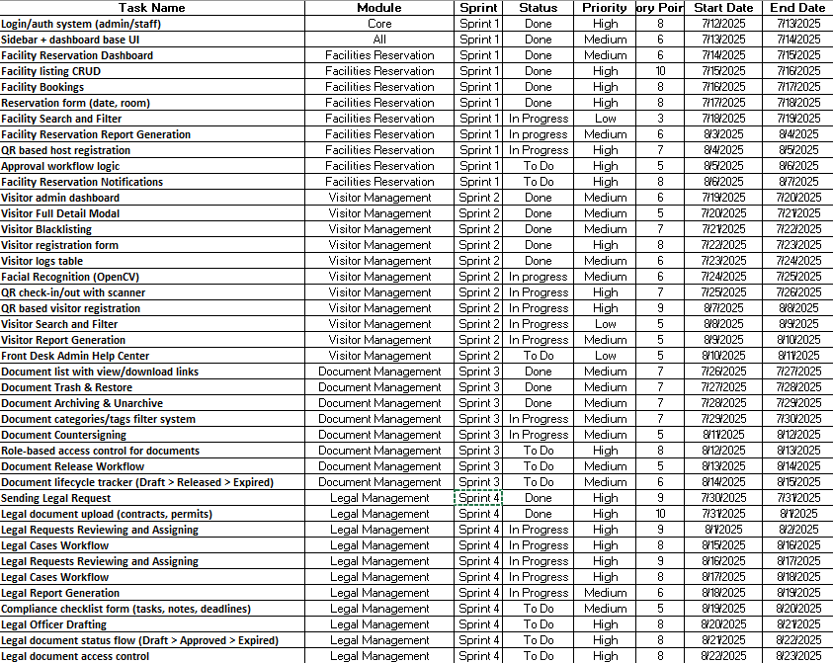or insights to this flexible strategy.

Additionally, the team's work was organized according to the Sprint Backlog for each sprint. By selecting specific items from the Product Backlog. The Development Team pledged to complete a set of user stories and tasks that were required to advance the project. Throughout the sprint, the team actively managed the Sprint Backlog, monitoring progress and making the required changes. This adaptability was important, particularly when new challenges emerged or stakeholder input suggested that adjustments to functionality were necessary. In terms of Scrum artifacts, the backlog duration is estimated to span between 2 to 4 weeks. This timeframe indicates that the team is prepared to work on the project over multiple sprints, allowing for flexibility and responsiveness to emerging stakeholder needs. By using these Scrum artifacts, the VIAHALE project was able to maintain a clear focus on offering a dependable and user-friendly service while also ensuring that the development process remained flexible and responsive to the evolving needs of its customers.

*Figure 2: Product Backlog with Sprint Planning and Task Prioritization*

|  |  |  |
| --- | --- | --- |
| **Sprint** | **Module** | **ViaHale Use Case** |
| Sprint 1 | Facilities Reservation | Other Department reserve facilities with approval workflow. |
| Sprint 2 | Visitor Management | Internal and external visitor register via Qr-based registration with facial recognition used for security access control. |
| Sprint 3 | Legal Management | Upload, review, process and approve legal requests with digital signatures and audit trail |
| Sprint 4 | Document Management | Archive, retrieve, and tag internal documents with role based access and versioning |

*Table 2: Sprint Modules and ViaHale Use Cases*

## MICROSERVICES ARCHITECTURE

To enhance scalability, modularity, and system resilience, the proposed system adopts a Microservices Architecture. Each core function of the system is broken down into independently deployable services, communicating via REST APIs. Below is a breakdown of each service, their purpose, key endpoints, and interactions.

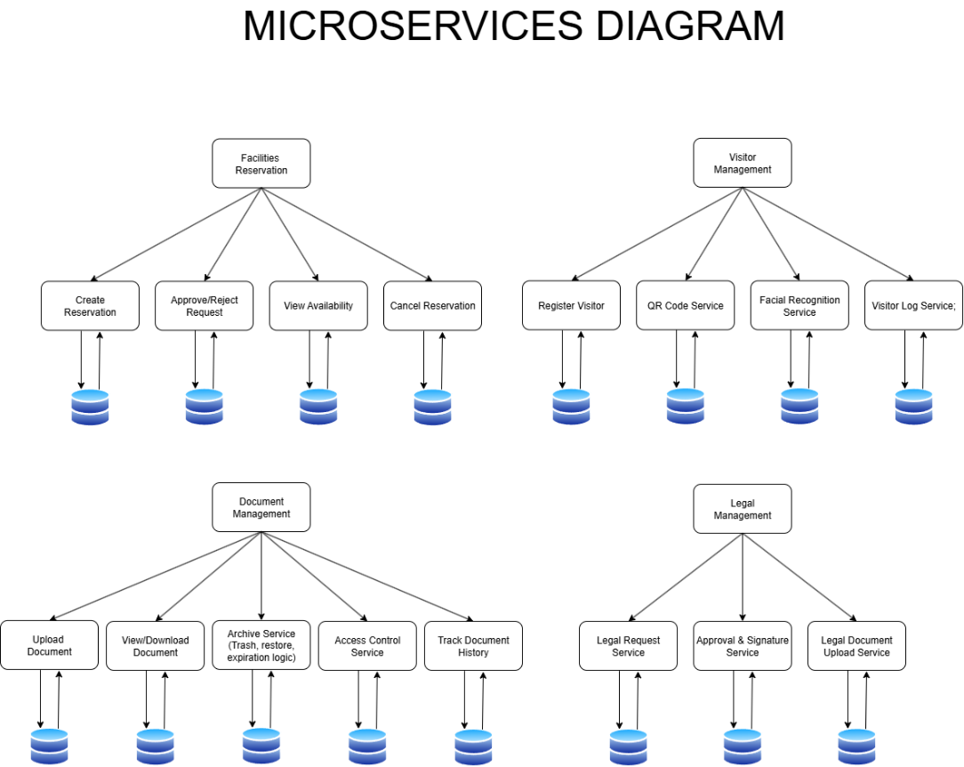

The communication structure and integration flow within the Administrative Module, composed of four core microservices: Facilities Reservation, Visitor Management, Document Management, and Legal Management. Each service communicates via well-defined protocols including REST for synchronous workflows. Shared components like API Gateway, Authentication Service, and Logging infrastructure support 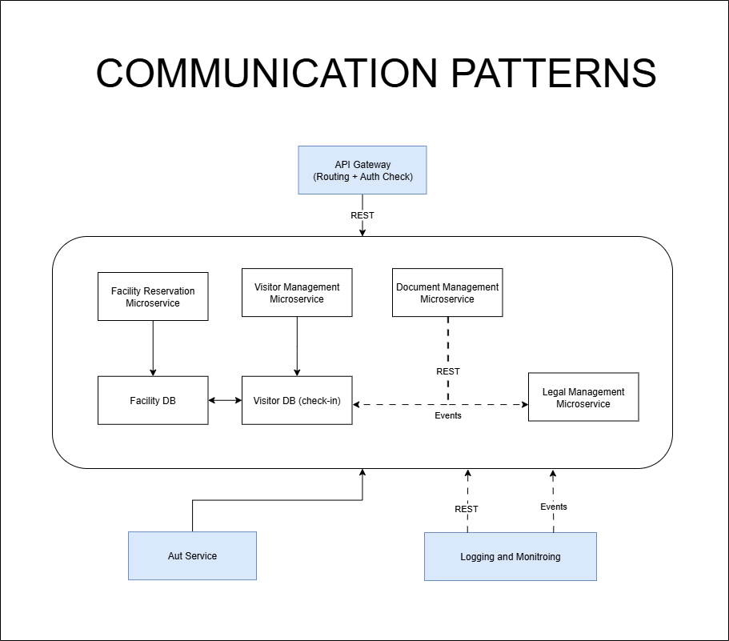seamless orchestration, security, and observability across the system.

*Figure 3:Proposed Microservices Architecture showing decomposition of core system functions into independently*

*deployable services*

*Figure 4: Communication Patterns within Administrative Module*

To visualize the flow of data between users, external systems and internal microservices, highlighting key inputs, outputs, and data stores. This diagram helps clarify how each module processes and exchanges information such as booking requests, visitor logs, legal records, and document managing ensuring transparency, traceability, and alignment with organizational workflows.

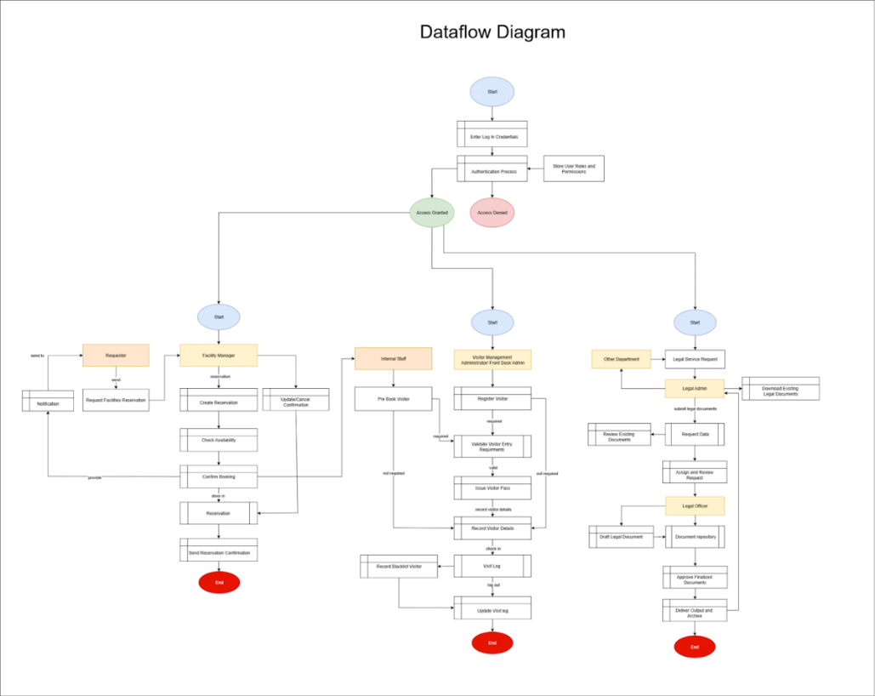 Users begin by entering their login credentials. The system then authenticates the user and checks stored roles and permissions. Based on this verification, access is either granted or denied, which then leads users into different system modules depending on their role.

## DEVOPS IMPLEMENTATION

*Figure 5: System Data Flow Diagram*

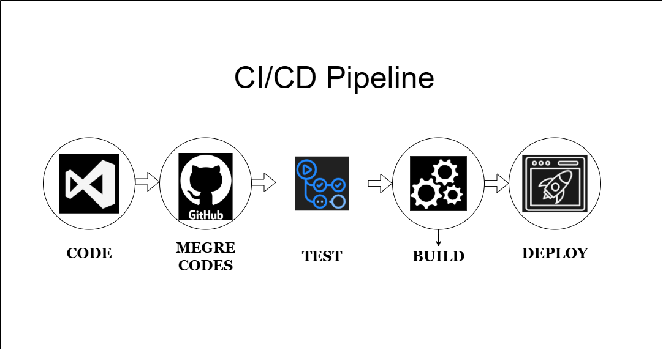This section outlines the tools and practices involved in each phase of the CI/CD pipeline for the system.

*Figure 6: DevOps CI/CD Pipeline Workflow and Tool Integration*

|  |  |  |
| --- | --- | --- |
| **Stage** | **Tools** | **Description** |
| Code | Virtual Studio Code | Developers write and edit codes. |
| Merge Codes | Git + GitHub | All code pushed and reviewed in branches via PRs. |
| Test | GitHub Actions | Run unit tests and syntax checks on code push/merge. |
| Build | GitHub Actions | The validated code is compiled into deployable artifacts using build tools and scripts |
| Deploy | IndevFinite | Final artifacts are deployed to staging or production environments. |
| Monitoring/Logging | Prometheus + Grafana | Monitor system health and logs. |

*Table 3: Development Pipeline Stages with Corresponding Tools and Descriptions*

Infrastructure code is processed by an Automation API, which interprets the configuration and initiates provisioning tasks. These tasks are executed on a Cloud Sever (IndevFinite), where networks and other resources are created or updated. The final infrastructure state is deployed and managed within the **IndevFinite** cloud platform, ensuring consistency, scalability, and traceability across environments.

This IaC approach eliminates manual setup, reduces configuration drift, and supports repeated deployments making it a foundational practice in modern DevOps and system architecture.

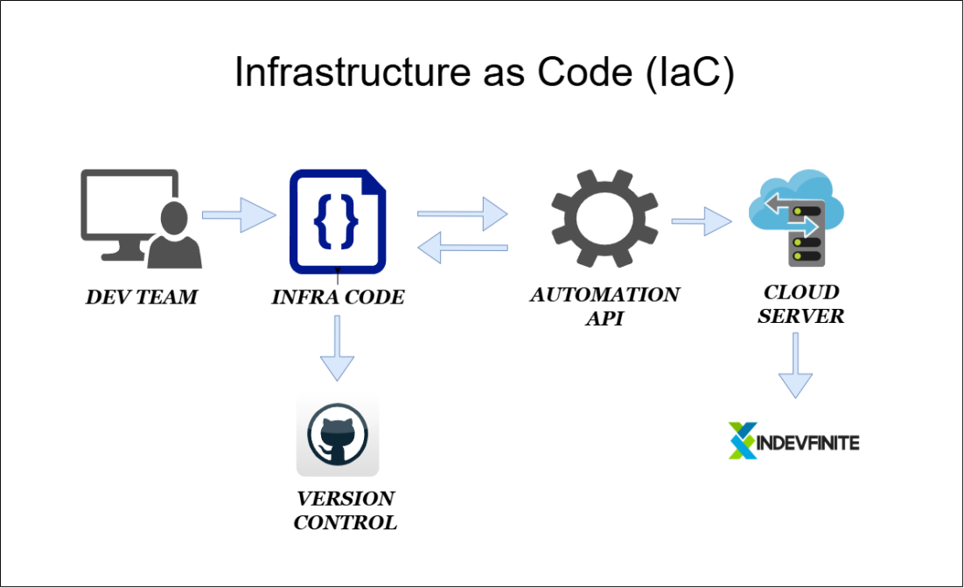

*Figure 7: Infrastructure as Code (IaC) Implementation Workflow*

Critical services are monitored proactively, and that stakeholders are notified immediately when issues aris supporting system reliability, performance tracking, and operational transparency. These alerts are routed to designated channels such as email notifications (via aEmail) and Visual Dashboards (via Grafana), enabling real-time visibility and rapid incident response.

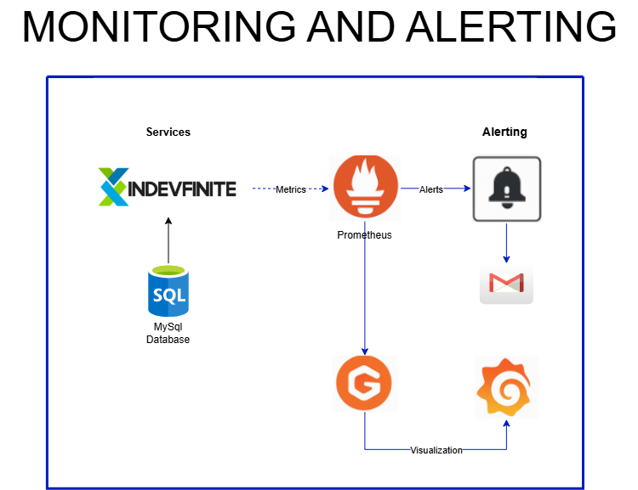

*Figure 8: Monitoring and Alerting System Architecture*

## INTEGRATION APPROACH FOR INFORMATION SYSTEM

The integration of ViaHale’s administrative modules such as Visitor Management, Facilities Reservation, Document Management, and Legal Management is achieved through a modular, API-driven approach. Each service communicates using RESTful APIs and standardized JSON formats to ensure smooth data exchange. Key integration techniques include data mapping for aligning fields like visitor ID and timestamps, and data transformation for formatting consistency. The system uses asynchronous communication protocols and a shared cloud database with role-based access control to maintain real-time synchronization and data integrity. This setup allows for seamless collaboration among microservices, improves operational visibility, and supports scalable deployment through CI/CD pipelines in a DevOps environment.

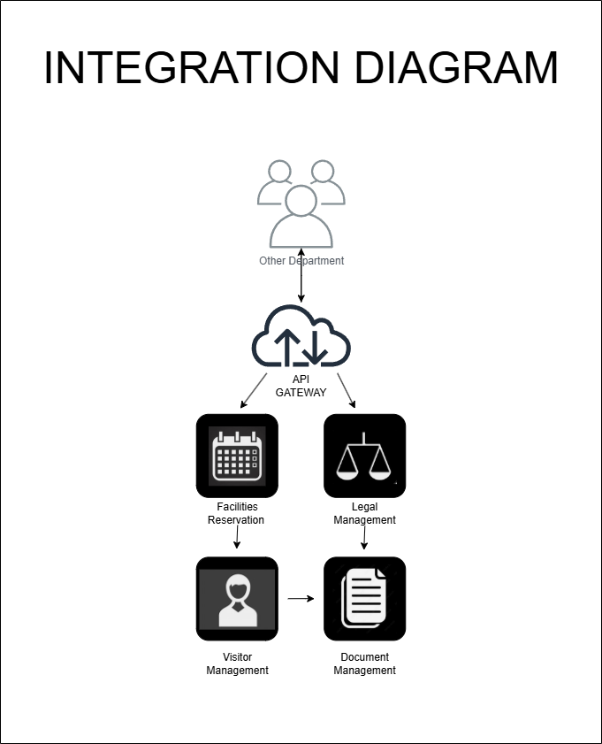

*Figure 9: Information System Integration Approach*

Acting as the central entry point, the API Gateway receives all incoming requests from the Client Web App and routes them to the appropriate backend microservices. It handles key responsibilities such as authentication, request validation, rate limiting, and protocol translation, ensuring secure and efficient communication across the system.

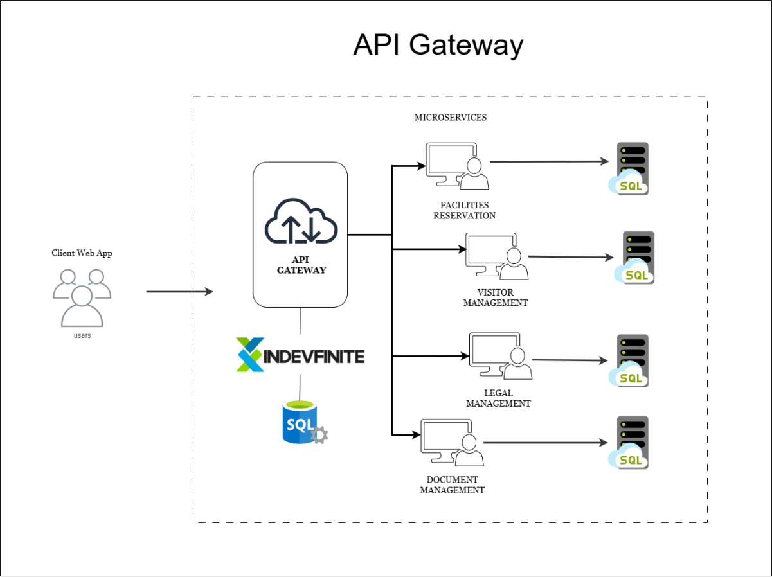

*Figure 10: API Gateway Architecture*

Each microservice operates with SQL database, allowing for modular scalability. By abstracting the complexity of backend services, the API Gateway simplifies client interactions and supports consistent, maintainable integration across the administrative module.

## INTRODUCTION TO TOGAF AND THE FOUR ARCHITECTURAL DOMAINS

As part of the enterprise architecture framework for the project, adherence to The Open Group Architecture Framework (TOGAF) is essential. TOGAF provides a comprehensive and widely adopted approach to enterprise architecture, emphasizing the four architectural domains. This structure ensures a unified architectural vision for ViaHale.

1. Business Process Architecture: The focus is on defining the operational workflows that support the ViaHale system. This includes visitor registration processes utilizing QR codes, vehicle tracking, service management procedures, and governance around biometric data capture. The aim is to ensure that these processes align with operational objectives such as efficiency, security, and user satisfaction.
2. Application Architecture:  outlines the software systems and service interfaces that support business operations. For ViaHale, this encompasses the applications for QR code issuance and scanning, the OpenCV-powered facial recognition engine, the administrative dashboard, and integrations with backend systems and vehicle tracking modules. This architecture ensures interoperability and alignment with business workflows
3. Data Architecture: The focus is on how data is structured, stored, integrated, and secured. This involves designing data schemas for visitor and vehicle information, managing QR-token logs, biometric facial embeddings, and implementing encryption mechanisms. The architecture also includes lifecycle policies for data retention and access control, ensuring data integrity, consistency, and regulatory compliance.
4. Technology Architecture: Specifies the infrastructure required to support applications and data processes. In the context of ViaHale, this includes the computing infrastructure necessary for running the OpenCV facial recognition system, QR code scanners, backend servers, and network topology. It also addresses deployment environments, high-availability configurations, and integration with access control systems, ensuring a robust and scalable technology foundation.

By integrating these four architectural domains, the ViaHale project ensures that business objectives, system functionality, data governance, and technology infrastructure are fully aligned. This integrated approach provides a strong foundation for scalability, adaptability, regulatory compliance, and operational effectiveness, while remaining compatible with Agile Scrum practices.