实验一报告

# 回答问题

请一边熟悉sakila数据库，一边回答以下问题：

1. sakila.mwb模型中，表结构里每个字段前面的小标记分别表示什么意思？

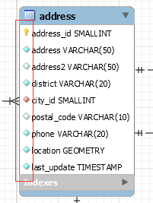

|  |  |
| --- | --- |
| 标记 | 意义 |
|  | 主键 |
|  | 非主属性(非空) |
|  | 默认空值 |
|  | 外键(非空) |

2. 图中哪部分体现影片-演员关系？换句话说，如果要找出演某个影片的演员名字，访问哪几张表可以获得信息？

需要访问 film, film_actor, actor这三张表

3. 如果已知某个顾客姓名，要找到他租借的所有影片名，需要访问哪几张表？

需要访问customer, rental, inventory, film这四张表

4. 为什么film和language表间会有2条线？

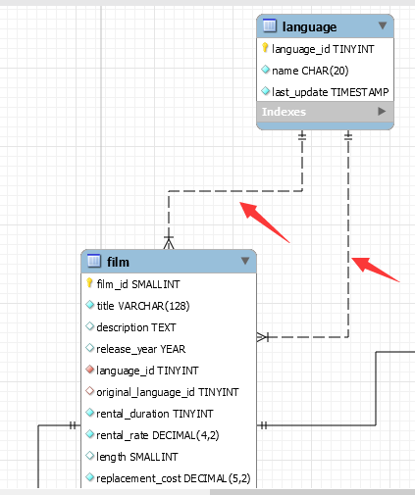

表示这两张表可以通过外键language_id, original_language这相连

# 实验截图

*注意截图清晰，截图时需要体现SQL语句（可复制粘贴）、执行结果、Output窗口*

1.请列出所有商店的详细地址，显示商店id，商店地址，所在区域，所在城市，所在国家；

select store_id,address,district,city,country

from address,city,country,store

where store.address_id = address.address_id and address.city_id=city.city_id and city.country_id=country.country_id





2.哪些演员出演过影片《WEST LION》？请列出他的姓名；

select first_name, last_name

from actor, film, film_actor

where actor.actor_id = film_actor.actor_id and film.film_id = film_actor.film_id and film.title = "WEST LION"



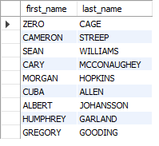

3.找出租DVD花费最高的前3名，请列出他们的first_name, last_name和每个人花费的金额；

select first_name, last_name, sum(amount)

from payment, customer

where payment.customer_id = customer.customer_id

group by customer.customer_id

order by sum(amount) DESC limit 3



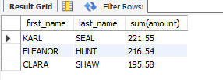

4.哪个影片获得了总体最高的租金？请列出影片id、影片名、总租金；

select film.film_id, title, sum(amount)

from film, inventory, rental, payment

where film.film_id = inventory.film_id and inventory.inventory_id = rental.inventory_id and rental.rental_id = payment.rental_id

group by film.film_id

order by sum(amount) DESC

limit 1



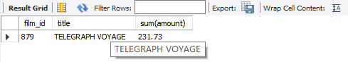

5.哪个演员出演的电影超过40部？ 请列出演员id、演员名、出演的电影数；

select actor.actor_id, first_name, last_name, count(film.film_id)

from film_actor, film, actor

where film_actor.film_id = film.film_id and film_actor.actor_id = actor.actor_id

group by film_actor.actor_id

having count(film.film_id) >= 40



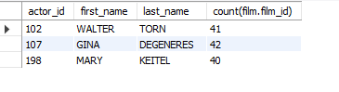

6.请找出没有租借过电影《WEST LION》的顾客姓名；

select first_name, last_name

from customer

where customer_id not in(

select distinct customer.customer_id

from customer,film, inventory, rental

where film.film_id = inventory.film_id and inventory.inventory_id = rental.inventory_id

and rental.customer_id = customer.customer_id and film.title = "WEST LION")



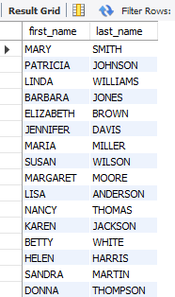

7.查询演过《FIRE WOLVES》和《JAWBREAKER BROOKLYN》这两部电影的演员，列出其姓名；

select actor.first_name, actor.last_name

from film f1, film f2, film_actor a1, film_actor a2, actor

where f1.film_id = a1.film_id and f2.film_id = a2.film_id and a1.actor_id = a2.actor_id and actor.actor_id = a1.actor_id

and f1.title = "FIRE WOLVES" and f2.title = "JAWBREAKER BROOKLYN"





8.统计每种类型的影片数，显示类型编号、类型名称、该类型影片数；

select category.category_id, category.name, count(film.film_id)

from category, film_category, film

where category.category_id = film_category.category_id and film.film_id = film_category.film_id

group by category.category_id

order by category.category_id



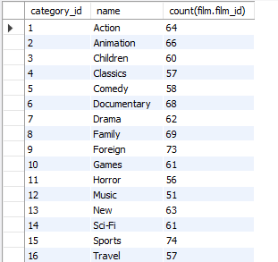

9.有哪些影片是2个商店都有库存的？

select distinct film.title

from film, inventory i1, inventory i2, store s1, store s2

where film.film_id = i1.film_id and film.film_id = i2.film_id and s1.store_id = i1.store_id

and s2.store_id = i2.store_id and s1.store_id <> s2.store_id



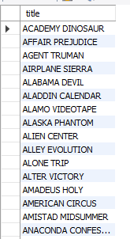

10.查询单次租借影片最长时间的3位客户，列出其first_name、last_name和当次租借时长；

select first_name, last_name,timestampdiff(microsecond,rental.rental_date,rental.return_date)

from rental, customer

where rental.customer_id = customer.customer_id

order by(timestampdiff(microsecond,rental.rental_date,rental.return_date)) DESC

limit 3



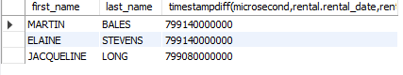

11.在customer表中新增一条数据，注意customer表与其他表的关系；

insert into address

values(606,'1329 Fukuyama Street',null,'Heilongjiang',537,27107,288241215399,st_geomfromtext('POINT (128.0449753 46.9804391)'),now());

insert into customer

values(600,1,"Luis","Sword",'Sword.Luis@sakilacustomer.org',606,1,now(),now());







12.修改刚才在customer表中新增的那条数据；

update customer

set email = 'Luis.Sword@sakilacustomer.org'

where customer_id = 600





13.删除第11步新增的那条数据。

delete from customer

where customer_id = 600;

delete from address

where address_id = 606;







# 思考题

1. 如果insert一条数据到actor表，但actor_id和已有数据重复，会发生什么？同学们请自己尝试一下。

会显示duplicate entry，插入错误，因为actor_id是主键，不能有重复值

insert into actor

values(1,'PENELOPE','GUINESS',now());

1. insert语句还用了一个函数NOW()，是做什么的呢？

NOW()函数获取当前的时间以datetime格式输出