Design solid-state lithium-ion batteries with high thermomechanical stability with supervised learning simply by chemical formula
Zhangjun Shiª, Hao Xiongª, Xiaozhen Chenª, Dongwei Xu^{*a}
ªState Key Laboratory of Coal Combustion, School of Energy and Power Engineering, Huazhong University of Science and Technology, Wuhan, Hubei 430074, China

Abstract

All-Solid-State Lithium-Ion Batteries (ASSLIBs) are critical for next-generation energy storage; however, material compatibility challenges persist, particularly in matching electrodes and electrolytes with compatible thermal expansion coefficients (TECs). Here, we introduce a machine learning approach for TEC prediction of lithium-containing compounds, requiring only chemical formulas as input. A baseline framework was developed using a Random Forest model trained on 428 experimental data points, further enhanced by a multi-level cascading algorithm and feature engineering. Validation through Density Functional Theory (DFT) calculations on LiF confirmed the model's reliability. The method was subsequently applied to screen ~100,000 materials in the Materials Project database, identifying candidates with TECs closely aligned with LiMn₂O₄ electrodes. This work bridges data-driven discovery and materials science, offering a scalable solution to accelerate the design of thermomechanically stable lithium-ion batteries (LIBs). By integrating computational efficiency with physical insights, our approach enables smarter and faster material selection for advanced energy systems.
Key words: Thermal expansion coefficient, Solid-state electrolyte, Machine learning
- Introduction
Solid-state batteries (SSBs) represent a promising solution for addressing the safety and stability issues associated with conventional lithium batteries¹. Unlike traditional liquid electrolytes, which are prone to combustion and expansion under extreme conditions, solid electrolytes are more stable. This advancement introduces critical challenges including poor solid-solid contact and thermal stress between the electrode and the electrolyte. The mismatch in TECs between the electrolyte and the electrode can result in two distinct failure modes: (1) excessive contraction reduces interfacial contact area, thereby increasing ionic transport resistance; or (2) excessive expansion generates interfacial cracks and thermal stresses, ultimately resulting in battery failure⁴. To address these questions, Bertrand et al. systematically investigated TECs of solid electrolytes and their compatibility with electrode materials, establishing a foundation for optimizing SSB performance through TEC alignment⁵.
Machine learning has become a transformative tool in materials discovery, overcoming limitations of conventional screening methods such as high costs and slow throughput^{6, 7}. Predictive models enable rapid identification of materials with targeted properties, significantly reducing development time and resources. For instance, Kumar et al. demonstrated the feasibility of predicting thermal expansion coefficients (TECs) using 271 structural features and features generated from Magpie data, though sometimes structural data acquisition remains a practical challenge⁸.
Chemical formula-based prediction has proven both effective and critical for accelerating material discovery. Zijing Wan et al. demonstrated that thermal stability can be predicted directly from chemical formulas, significantly reducing computational costs and enabling efficient preliminary screening^{9. Building} on this approach, we utilize chemical formulas to predict thermal expansion coefficients (TECs), further extending the applicability of formula-driven models in materials science
In this study, we propose an enhanced random forest framework by integrating a multi-level cascaded architecture with residual connections, effectively combining ensemble learning strategies. To address data sparsity, chemical formulas were subjected to Centered Log-Ratio (CLR) transformation, followed by the incorporation of thermodynamic average electronegativity and descriptors derived from Pymatgen's Magpie database. These steps collectively improved the model's predictive capability for thermal expansion coefficients (TECs). The optimized algorithm achieved a determination coefficient (R²) of 0.87, demonstrating robust accuracy in TEC prediction and validating the efficacy of formula-driven machine learning for materials screening.

- Method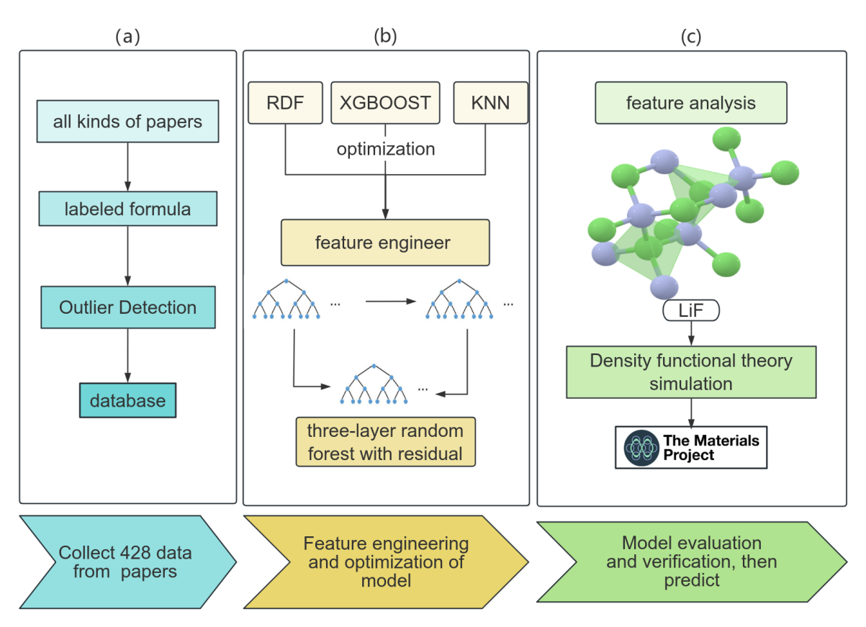
Figure 1 Research workflow (a) data collection process (b) model development including feature engineering and multi-layer cascaded structure (c) Validation & Application. The TEC screening process is outlined in Figure 1. First, data was collected from papers. Further, a model was selected and optimized via multi-layer architecture, residuals, and feature engineering. Finally, predictions were validated with DFT calculations to ensure reliability.

2.1 Database
A dataset of 428 compounds was compiled from experimental and simulated sources from all kinds of papers, as illustrated in Fig. 1 (a). To ensure model robustness, outliers were systematically addressed by restricting the TEC range to −20 K⁻¹ ≤ TEC ≤ 50 K⁻¹. Data points outside this range were excluded to mitigate bias from extreme values.
2.2 Model development

2.2.1 Model selection

Three machine learning models—Random Forest (RF), K-Nearest Neighbors (KNN), and eXtreme Gradient Boosting (XGBoost) were evaluated for TEC prediction with the elements' composition and quantities in chemical formulas serving as the feature matrix. Hyperparameter optimization was conducted via an exhaustive attack search, iteratively tuning individual parameters until convergence. This process identified parameter sets maximizing the coefficient of determination (R²) on the test dataset. The model with the lowest MSE and the best R² of the three models on the test dataset will be chosen as the best model.
2.2.2 Feature Engineering
Feature engineering plays a pivotal role in bridging raw compositional data and machine learning models, particularly for sparse and high-dimensional material datasets. To address the inherent sparsity of elemental composition matrices and improve the accuracy, we prioritized feature construction to embed physicochemical significance. A key innovation is the incorporation of thermodynamic electronegativity (TEN). Electronegativity is particularly worthy of attention. McGuinness et al. demonstrated a strong correlation between electronegativity and TECs, establishing electronegativity as a descriptor for TEC prediction¹⁰. TEN, Thermodynamic electronegativity (TEN), proposed by Tantardini and Oganov et al. is a dimensionless metric that quantifies elemental trends across the periodic table, explicitly capturing bond polarity and ionic character. Its link to bond strength makes it closely related to material thermal expansion coefficients¹¹.
The total TEN (EN_{sum}) of a compound is calculated as the weighted sum of atomic electronegativities:
Within this formula, EN_{Atom}: TEN of an atom; N_{Atoms}: Stoichiometric count of the atom in the compound.
This formulation normalizes the chemical formula to quantify the compound's overall TEN, serving as a key descriptor for predicting TEC.
To enhance feature diversity, the Python library pymatgen's Magpie was employed to generate descriptors, from which five critical features were selected based on their R²value⁸. However, matrices derived from elemental compositions inherently exhibit high sparsity, leading to redundant predictions. To address this, Centered Log-Ratio (CLR) transformation was applied, which not only mitigates sparsity but also reduces data closure and spurious correlations, thereby enhancing model stability. Additionally, although random forests are inherently robust to feature scale variations, significant disparities in feature magnitudes can distort importance assessments, leading to degraded model performance¹². To address this, feature scaling was implemented via an exhaustive search method, optimizing parameters based on R² maximization. This step ensures balanced contributions from heterogeneous features, enhancing both model stability¹³.

2.2.3 Ensemble Learning and Model Architecture
Ensemble learning enhances model accuracy and robustness, making it a cornerstone for practical applications. To further leverage these advantages, we implemented a multi-level cascaded random forest architecture inspired by Zhou et al's non-neural network deep learning framework with cascaded forest structure which is effective for small-scale datasets¹⁴. Each layer in the cascade iteratively refines predictions from the preceding layer, progressively improving performance with the upper layer's prediction as supplementary features. Hyperparameters, including the optimal number of layers, were systematically optimized through exhaustive search based on R² and confusion matrix. This approach enhances feature representation, particularly effective for small-scale datasets. This approach enhances feature representation and hierarchical learning, particularly effective for small-scale datasets. In addition, residual connections were introduced to enable random forests (RDFs) to iteratively learn the residual errors between input and output, rather than directly mapping raw features to predictions¹⁵. This simplifies the learning task, reduces overfitting, and improves model generalizability.
2.3 verification and application
After configuring the model, as shown in Fig 1. (c), predictions and validations were systematically executed. To assess universality, DFT was initially performed on a simple structure (LiF). The validated model was deployed to screen the Materials Project database, identifying candidate materials with TEC compatible with LiMn₂O₄.
- Results and discussion
3.1 model selection
Figure2 Comparison chart of predicted and true values for three types of models on prediction set (a) KNN scatter plot of the prediction and true results on the test set (b) RDF scatter plot of the prediction and true results on the test set (c) XGBoost scatter plot of the prediction and true results on the test set (d) Statistical Chart of MSE and R² for Three Algorithms. The KNN, RDF, and XGBoost models are presented, comparing their predicted and actual values on the testing dataset. Each scatter point represents a dataset datum, with the vertical axis as predicted values and the horizontal axis as true values. The closer the scatter points lie along the y=x diagonal, the better the model's prediction.
For the results of model selection, the comparative analysis of model performance is illustrated in Fig 2 (a–d). The RDF model's scatter plot points are closest to the y=x diagonal, indicating the best predictive performance. Additionally, in Fig 3.(d), Quantitative validation further highlights RDF's dominance: it achieves the highest R² and the lowest mean squared error (MSE) among all candidates. These metrics collectively solidify RDF as the optimal baseline model for subsequent analyses with R² of 0.79.
3.2 Feature analysis
Incorporating TEN as a descriptor improves the model's R² by 0.02, underscoring its significance in capturing bond polarity effects on thermal expansion. Subsequent feature selection from pymatgen's Magpie database, prioritized by R² contribution, identified five key descriptors (Table 1):

Table 1 The features generated by Magpie after filtering
Feature | Abbreviation | Physical Property
thermodynamic_ electronegativity | TEN | Thermodynamic electronegativity is a scale based on bond dissociation energies and is used to describe an atom's ability to attract electron density.
MagpieData maximum NpValence | MNV | The maximum value of the number of valence electrons in the p orbital among all elements in the MagpieData database.
MagpieData minimum Electronegativity | MEN | The minimum value of electronegativity among all elements in MagpieData.
MagpieData mean CovalentRadius | MCR | The mean value of covalent radius of all elements in MagpieData.
MagpieData mode GSmagmom | MGS | The most frequent value of magnetic moments among all elements in MagpieData.
MagpieData avg_dev GSvolume_pa | ADGS | The average deviation of ground-state volume per atom (GSvolume_pa) among all elements in MagpieData.
Figure 3 Feature importance comparison chart and final results (a) feature importance comparison chart of layer1 (only the first four large ones) (b) feature importance comparison chart of layer2 (only the first four large ones) (c) feature importance comparison chart of layer2 (only the first four large ones) (d) final RDF algorithm scatter plot of the prediction and true results on the testing set and each decision tree in a random forest splits nodes to minimize the variance of the target variable. When a feature is used for splitting, the resulting variance reduction is calculated. Summing this variance reduction across all trees and dividing by the number of trees yields the feature's importance.

RDF evaluates feature importance by aggregating contributions across all decision trees. As shown in Fig 3 (a), TEN and minimum electronegativity (MEN) dominate the first layer, confirming electronegativity's critical role in TECs. In Fig 3 (b-c), the high importance of the first and second layers' predictions indicates that feature fusion through residual connections is beneficial. Moreover, the second layer demonstrates a more balanced distribution of importance, utilizing additional features not employed in the first layer, thereby enhancing information efficiency. In conclusion, the importance distribution confirms that all our optimization operations are justified. Additionally, Fig 3 (d) met expectations, achieving a R² score of 0.839.

3.3 Ensemble Learning and Model Architecture
During optimization of the multi-level cascaded RDF architecture, Fig. 4 (b) demonstrates near-perfect alignment between predicted and experimental TECs in the training set, suggesting potential overfitting and prompting termination of additional layers. Additionally, Fig 4 (c) reveals strong generalization on the test set, with predictions closely matching true values and an R² exceeding 0.85, confirming the model's suitability for small-scale datasets. Finally, the final algorithm flowchart is shown in Fig 4 (a). First, in the first layer input features generate initial predictions. After that, the residual, the difference between initial predicted values and true values, serves as the second layer's target. The first layer's predicted values, directly or after transformation, are concatenated with original features to form the second layer's input feature matrix. This process repeats until the third level. The final prediction is the sum of all layers' predictions. This hierarchical method enhances predictions by iteratively refining residuals and enriching features. In conclusion, a reasonably good fit has been achieved with the R² of 0.87 shown in Fig 4 (c).

Figure 4 three-layer residual RDF algorithm flowchart and the model results (a) three-layer residual RDF algorithm flowchart (b) three-layer residual RDF algorithm scatter plot of the prediction and true results on the test set (c) three-layer residual RDF algorithm scatter plot of the prediction and true results on the training set. In fig 4.(a), the blue square represents the original feature values, and each layer is trained to fit the residuals of the previous layer. Finally, add them up as the solution.

3.4Verification
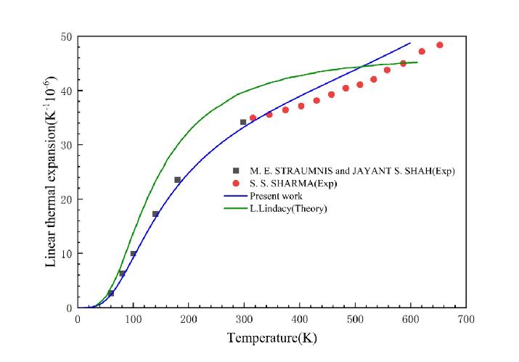
Figure5 The scientific simulation of the thermal expansion coefficient of LiF, the blue line is the validation value
To validate the reliability of the model, Density Functional Theory (DFT) calculation was performed on LiF—a typical compound in battery. As shown in Fig 5, the model predicts a thermal expansion coefficient (TEC) of 30.8 K⁻¹ for LiF, closely aligning with the experimental value of 34 K⁻¹ (deviation: 9.4%). This minor discrepancy likely stems from the exclusion of structural parameters such as lattice symmetry and atomic coordination in our formula-driven approach. Consequently, while the model demonstrates robust accuracy for magnitude-level screening of electrode-electrolyte pairs, its precision remains constrained for atomic-level design requiring explicit structural considerations.
3.2 Prediction
Following model construction and validation, we systematically screened lithium-containing compounds from the Materials Project database with chemical formula information and without elements not present in the training data. After screening, using the trained model, the thermal expansion coefficients for all 8,271 compounds are predicted. It is found that pure metal compounds may have poor estimates because there are not many pure metal compounds in the training dataset. Candidate materials with compatible thermal properties with common anode and cathode are identified and collected followed.

- Conclusion
The basic random forest was optimized by forming a three-tiered cascading random forest with residuals. Subsequently, feature construction was performed on chemical formulas to enhance the model's determination rate. But our model can just predict the thermal expansion coefficient within a certain range because the thermal expansion coefficient is always strongly related to the structure and for the same chemical formula there may be completely different thermal expansion coefficients. So further verification is necessary.

(1) Shalaby, M. S.; Alziyadi, M. O.; Gamal, H.; Hamdy, S. Solid-state lithium-ion battery: The key components enhance the performance and efficiency of anode, cathode, and solid electrolytes. Journal of Alloys and Compounds 2023, 969. DOI: 10.1016/j.jallcom.2023.172318.
(2) Burton, M.; Narayanan, S.; Jagger, B.; Olbrich, L. F.; Dhir, S.; Shibata, M.; Lain, M. J.; Astbury, R.; Butcher, N.; Copley, M.; et al. Techno-economic assessment of thin lithium metal anodes for solid-state batteries. Nature Energy 2024, 10 (1), 135-147. DOI: 10.1038/s41560-024-01676-7.
(3) Ai, S.; Wu, X.; Wang, J.; Li, X.; Hao, X.; Meng, Y. Research Progress on Solid-State Electrolytes in Solid-State Lithium Batteries: Classification, Ionic Conductive Mechanism, Interfacial Challenges. Nanomaterials 2024, 14 (22). DOI: 10.3390/nano14221773.
(4) Hanif, M. B. Tailoring thermal expansion for next-generation energy systems: Integrating the potential of NTE materials in SOFCs and beyond. Journal of Power Sources 2025, 633. DOI: 10.1016/j.jpowsour.2025.236460.
(5) Zhang, Z.; Zhang, X.; Liu, Y.; Lan, C.; Han, X.; Pei, S.; Luo, L.; Su, P.; Zhang, Z.; Liu, J.; et al. Silicon-based all-solid-state batteries operating free from external pressure. Nature Communications 2025, 16 (1). DOI: 10.1038/s41467-025-56366-z.
(6) Laskowski, F. A. L.; McHaffie, D. B.; See, K. A. Identification of potential solid-state Li-ion conductors with semi-supervised learning. Energy & Environmental Science 2023, 16 (3), 1264-1276. DOI: 10.1039/d2ee03499a.
(7) Merchant, A.; Batzner, S.; Schoenholz, S. S.; Aykol, M.; Cheon, G.; Cubuk, E. D. Scaling deep learning for materials discovery. Nature 2023, 624 (7990), 80-85. DOI: 10.1038/s41586-023-06735-9.
(8) Kumar, S.; Jaafreh, R.; Dutta, S.; Pereznieto, S.; Hamad, K.; Ho Yoon, D. Learning techniques for designing solid-state lithium-ion batteries with high thermomechanical stability. Materials Letters 2023, 351. DOI: 10.1016/j.matlet.2023.135049.
(9) Wan, Z.; Chen, X.; Zhou, Z.; Zhong, X.; Luo, X.; Xu, D. Atom substitution of the solid-state electrolyte Li10GeP2S12 for stabilized all-solid-state lithium metal batteries. Journal of Energy Chemistry 2024, 88, 28-38. DOI: 10.1016/j.jechem.2023.09.001.
(10) McGuinness, K. P.; Oliynyk, A. O.; Lee, S.; Molero-Sanchez, B.; Addo, P. K. Machine-learning prediction of thermal expansion coefficient for perovskite oxides with experimental validation. Physical Chemistry Chemical Physics 2023, 25 (46), 32123-32131. DOI: 10.1039/d3cp04017h.
(11) Tantardini, C.; Oganov, A. R. Thermochemical electronegativities of the elements. Nature Communications 2021, 12 (1). DOI: 10.1038/s41467-021-22429-0.
(12) Huang, B. F. F.; Boutros, P. C. The parameter sensitivity of random forests. BMC Bioinformatics 2016, 17 (1). DOI: 10.1186/s12859-016-1228-x.
(13) <Li 等 - 2021 - Multi-sample estimation of centered log-ratio matr.pdf>.
(14) <Zhou 和 Feng - 2017 - Deep Forest Towards An Alternative to Deep Neural.pdf>.
(15) <Ventola 等 - 2019 - Random Sum-Product Forests with Residual Links.pdf>.

Table 2 List of cathode-electrolyte materials with thermomechanical compatibility according to ML-predicted CTE values.
Cathode | Electrolyte | Difference x10⁻⁶ (K⁻¹) | Average x10⁻⁶ (K⁻¹)
LiMn₂O₄ | LiPr(GeO₃)₄ | 0.57856 | 7.72975
C | LiIn₄(Ge₂O₇)₂ | 0.30536 | 1.15268
LiCoO₂ | LiNdTiO₄ | 0.30037 | 12.84981
LiFePo₄ | LiNdTiO₄ | 0.49963 | 12.44981

