# MySql安装

**1）检查当前系统是否安装过Mysql**

[user1@hadoop102 ~]$ rpm -qa|grep mariadb

mariadb-libs-5.5.56-2.el7.x86_64 //如果存在通过如下命令卸载

[user1 @hadoop102 ~]$ sudo rpm -e --nodeps mariadb-libs //用此命令卸载mariadb

**2）将MySQL安装包拷贝到/opt/software目录下**

[user1 @hadoop102 software]# ll

总用量 528384

-rw-r--r--. 1 root root 609556480 3月 21 15:41 mysql-5.7.28-1.el7.x86_64.rpm-bundle.tar

**3）解压MySQL安装包**

[user1 @hadoop102 software]# tar -xf mysql-5.7.28-1.el7.x86_64.rpm-bundle.tar

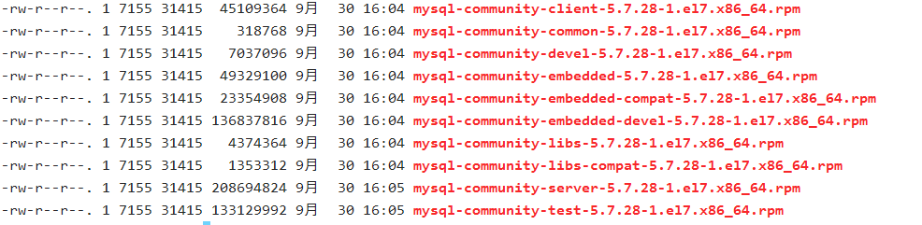

**4）在安装目录下执行rpm安装**

[user1 @hadoop102 software]$ sudo rpm -ivh mysql-community-common-5.7.28-1.el7.x86_64.rpm

[user1 @hadoop102 software]$ sudo rpm -ivh mysql-community-libs-5.7.28-1.el7.x86_64.rpm

[user1 @hadoop102 software]$ sudo rpm -ivh mysql-community-libs-compat-5.7.28-1.el7.x86_64.rpm

[user1 @hadoop102 software]$ sudo rpm -ivh mysql-community-client-5.7.28-1.el7.x86_64.rpm

[user1 @hadoop102 software]$ sudo rpm -ivh mysql-community-server-5.7.28-1.el7.x86_64.rpm

注意:按照顺序依次执行

如果Linux是最小化安装的，在安装mysql-community-server-5.7.28-1.el7.x86_64.rpm时可能会出 现如下错误

[user1@hadoop102 software]$ sudo rpm -ivh mysql-community-server-5.7.28-1.el7.x86_64.rpm

警告：mysql-community-server-5.7.28-1.el7.x86_64.rpm: 头V3 DSA/SHA1 Signature, 密钥 ID 5072e1f5: NOKEY

错误：依赖检测失败：

libaio.so.1()(64bit) 被 mysql-community-server-5.7.28-1.el7.x86_64 需要

libaio.so.1(LIBAIO_0.1)(64bit) 被 mysql-community-server-5.7.28-1.el7.x86_64 需要

libaio.so.1(LIBAIO_0.4)(64bit) 被 mysql-community-server-5.7.28-1.el7.x86_64 需要

通过yum安装缺少的依赖,然后重新安装mysql-community-server-5.7.28-1.el7.x86_64 即可

[user1@hadoop102 software] yum install -y libaio

**5）删除/etc/my.cnf文件中datadir指向的目录下的所有内容,如果有内容的情况下:**

查看datadir的值：

[mysqld]

datadir=/var/lib/mysql

删除/var/lib/mysql目录下的所有内容:

[user1 @hadoop102 mysql]# cd /var/lib/mysql

[user1 @hadoop102 mysql]# sudo rm -rf ./* //注意执行命令的位置

**6）初始化数据库**

[user1 @hadoop102 opt]$ sudo mysqld --initialize --user=mysql

**7）查看临时生成的root用户的密码**

[user1 @hadoop102 opt]$ sudo cat /var/log/mysqld.log

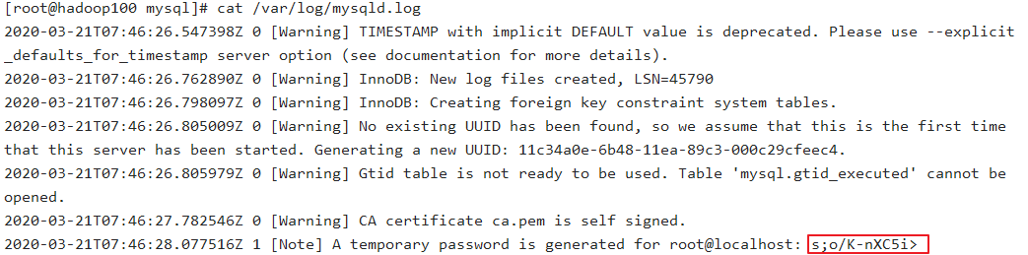

**8）启动MySQL服务**

[user1 @hadoop102 opt]$ sudo systemctl start mysqld

**9）登录MySQL数据库**

[user1 @hadoop102 opt]$ mysql -uroot -p

Enter password: 输入临时生成的密码

登录成功.

**10）必须先修改root用户的密码,否则执行其他的操作会报错**

mysql> set password = password("123456");

**11）修改mysql库下的user表中的root用户允许任意ip连接**

mysql> update mysql.user set host='%' where user='root';

mysql> flush privileges;