微信小程序手指滑动 (选项卡)

HTML:

<!--pages/bb/bb.wxml-->
<view >
<scroll-view scroll-x="true" class="tab-h" scroll-left="{{scrollLeft}}">
<view class="tab-item {{currentTab==0?'active':''}}" data-current="0" bindtap="swichNav">健康</view>
<view class="tab-item {{currentTab==1?'active':''}}" data-current="1" bindtap="swichNav">情感</view>
<view class="tab-item {{currentTab==2?'active':''}}" data-current="2" bindtap="swichNav">职场</view>
<view class="tab-item {{currentTab==3?'active':''}}" data-current="3" bindtap="swichNav">育儿</view>
<view class="tab-item {{currentTab==4?'active':''}}" data-current="4" bindtap="swichNav">纠纷</view>
</scroll-view>
<swiper class="tab-content" current="{{currentTab}}" duration="300" bindchange="switchTab"
style="height:{{winHeight}}rpx">
<swiper-item wx:for="{{[0,1,2,3,4]}}">
<scroll-view scroll-y="true" class="scoll-h" >
<block wx:for="{{[1,2,3,4]}}" wx:key="*this">
<view class="item-ans">
<view class="avatar">
<image class="img" src="http://ookzqad11.bkt.clouddn.com/avatar.png"></image>
</view>
<view class="expertInfo">
<view class="name">欢颜</view>
<view class="tag">知名情感博主</view>
<view class="answerHistory">134个回答，2234人听过 </view>
</view>
<navigator url="/pages/askExpert/expertDetail" class="askBtn">问TA</navigator>
</view>
</block>
</scroll-view>
</swiper-item>
</swiper>
</view>

CSS:

.tab-h{
height: 80rpx;width: 100%; box-sizing: border-box;overflow: hidden;line-height: 80rpx;background: #F7F7F7; font-size: 16px; white-space: nowrap;position: fixed;top: 0; left: 0; z-index: 99;}
.tab-item{margin:0 36rpx;display: inline-block;}
.tab-item.active{color: #4675F9;position: relative;}
.tab-item.active:after{ content: "";display: block;height: 8rpx;width: 52rpx;background: #4675F9;position: absolute; bottom: 0;left: 5rpx;border-radius: 16rpx;}
.item-ans{ width: 100%;display: flex; flex-grow: row no-wrap;justify-content: space-between; padding: 30rpx;box-sizing: border-box; height: 180rpx;align-items: center;border-bottom: 1px solid #F2F2F2;}
.avatar{width: 100rpx;height: 100rpx;position: relative;padding-right: 30rpx;}
.avatar .img{width: 100%;height: 100%;}
.avatar .doyen{width: 40rpx;height: 40rpx;position: absolute;bottom: -2px;right: 20rpx;}
.expertInfo{font-size: 12px;flex-grow: 2;color: #B0B0B0;line-height: 1.5em;}
.expertInfo .name{font-size: 16px;color:#000;margin-bottom: 6px;}
.askBtn{ width: 120rpx;height: 60rpx;line-height: 60rpx;text-align: center;font-size: 14px; border-radius: 60rpx;border: 1px solid #4675F9; color:#4675F9;}
.tab-content{margin-top: 80rpx;}
.scoll-h{height: 100%;}

JS：

var app = getApp();
Page({
data: {
winHeight: "",//窗口高度
currentTab: 0, //预设当前项的值
scrollLeft: 0, //tab标题的滚动条位置
expertList: [{ //假数据
img: "avatar.png",
name: "欢顔",
tag: "知名情感博主",
answer: 134,
listen: 2234
}]
},
// 滚动切换标签样式
switchTab: function (e) {
this.setData({
currentTab: e.detail.current
});
this.checkCor();
},
// 点击标题切换当前页时改变样式
swichNav: function (e) {
var cur = e.target.dataset.current;
if (this.data.currentTaB == cur) { return false; }
else {
this.setData({
currentTab: cur
})
}
},
//判断当前滚动超过一屏时，设置tab标题滚动条。
checkCor: function () {
if (this.data.currentTab > 4) {
this.setData({
scrollLeft: 300
})
} else {
this.setData({
scrollLeft: 0
})
}
},
onLoad: function () {
var that = this;
// 高度自适应
wx.getSystemInfo({
success: function (res) {
var clientHeight = res.windowHeight,
clientWidth = res.windowWidth,
rpxR = 750 / clientWidth;
var calc = clientHeight * rpxR - 180;
console.log(calc)
that.setData({
winHeight: calc
});
}
});
},
footerTap: app.footerTap
})

效果图:

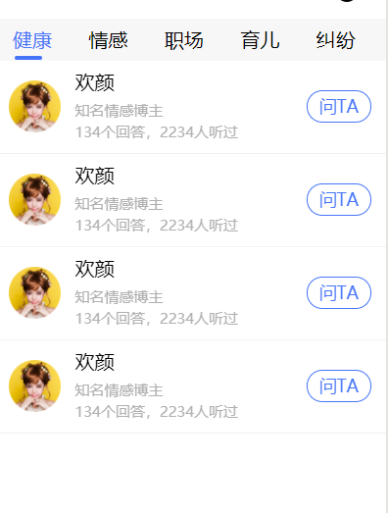

微信小程序渐变轮播图(可手指滑动)

HTML:

<!--carousel/index.wxml-->
<swiper class="imageContainer" bindchange="handleChange" previous-margin="50rpx" next-margin="50rpx" circular autoplay>
<block wx:for="{{imgUrls}}" wx:key="{{index}}">
<swiper-item class="item">
<image class="itemImg {{currentIndex == index ? 'active': ''}}" src="{{item}}"></image>
</swiper-item>
</block>
</swiper>

CSS:
/* carousel/index.wxss */
page{
background: #f7f7f7f7;
}
.imageContainer{
width: 100%;
height: 300rpx;
background: #fff;
}
.item{
height: 200rpx;
}
.itemImg{
position: absolute;
width: 100%;
height: 220rpx;
border-radius: 15rpx;
z-index: 5;
opacity: 0.7;
top: 13%;
}
.active{
opacity: 1;
z-index: 10;
height: 260rpx;
top: 7%;
transition:all .3s ease-in 0s;
}

JS:

// carousel/index.js
Page({

data: {
currentIndex: 0,
imgUrls: [
'../images/1.png',
'../images/2.png',
'../images/3.png',
],
},

onLoad: function (options) {

},
/* 这里实现控制中间凸显图片的样式 */
handleChange: function (e) {
this.setData({
currentIndex: e.detail.current
})
},
})

效果图:

