Name: Vũ Hùng Phi
StudentID: 524K0008
Report-Lab09
I. Introduction 1
II. Exercise 1
1. Exercise 1 1
2. Exercise 2 2
3. Exercise 3 2
4. Exercise 4 3
III. Screenshots 3
1. Exercise 1 3
2. Exercise 2 5
3. Exercise 3 7
4. Exercise 4 9
IV. Conclusion 12

I. Introduction
This lab focuses on unit testing and automation testing using C# .NET Core in Visual Studio. The main purpose is to understand how to create and execute unit tests using different testing frameworks such as MSTest, xUnit, and NUnit. Additionally, the lab introduces automation testing with Selenium WebDriver and data-driven testing using CSV files.
Through these exercises, students learn how to ensure software correctness, improve test coverage, and automate repetitive testing tasks efficiently.

II. Exercise

1. Exercise 1

Description
In this exercise, a console application named BasicMath was created. A class called BasicMaths was implemented with four basic operations: Add, Subtract, Multiply, and Divide. A unit test project was then created to verify these methods using MSTest and xUnit.

Steps
- Created a Console App project named BasicMath.
- Added a class BasicMaths with mathematical methods.
- Created a Unit Test Project named BasicMathTests.
- Added a reference from the test project to the main project.
- Implemented unit tests using [DataTestMethod] and [DataRow].
- Executed tests using Test Explorer.

What I learned
- How to create unit tests in Visual Studio
- How to use MSTest and xUnit frameworks
- How to apply Equivalence Partitioning (EP) and Boundary Value Analysis (BVA)
- How to validate expected and actual results

2. Exercise 2

Description
This exercise focuses on data-driven testing using CSV files. Test data was stored externally and loaded into test methods using CsvHelper.

Steps
- Created CSV files for each operation (add, subtract, multiply, divide).
- Installed CsvHelper library.
- Implemented a method to read CSV data.
- Used [MemberData] to pass data into test methods.
- Executed tests with multiple datasets.

What I learned
- How to perform data-driven testing
- How to read external data using CSV files
- How to separate test logic from test data
- How to improve scalability of test cases

3. Exercise 3

Description
A BankAccount system was implemented with operations such as Debit, Credit, and Withdraw. Unit tests were created to validate both normal and exceptional cases.

Steps
- Created a console project BankAccountApp.
- Implemented BankAccount class with required methods.
- Created a test project BankAccountTests.
- Wrote unit tests using [Theory] and [InlineData].
- Implemented exception handling for insufficient funds.
- Extended testing using CSV data.

What I learned
- How to test real-world scenarios
- How to handle exceptions in unit testing
- How to design test cases using EP and BVA
- How to validate both valid and invalid inputs

4. Exercise 4

Description
This exercise introduces automation testing using Selenium WebDriver. A login page was created and automated tests were written to simulate user login using data from CSV files.

Steps
- Created a simple HTML login page.
- Created a CSV file containing login credentials.
- Created a Class Library project LoginAutomation.
- Installed Selenium WebDriver and CsvHelper.
- Implemented automated test script using Selenium.
- Executed tests through Visual Studio Test Explorer.

What I learned
- How to automate browser actions using Selenium
- How to interact with web elements (input, button)
- How to perform data-driven automation testing
- How to simulate real user behavior

III. Screenshots

1. Exercise 1
Step 1
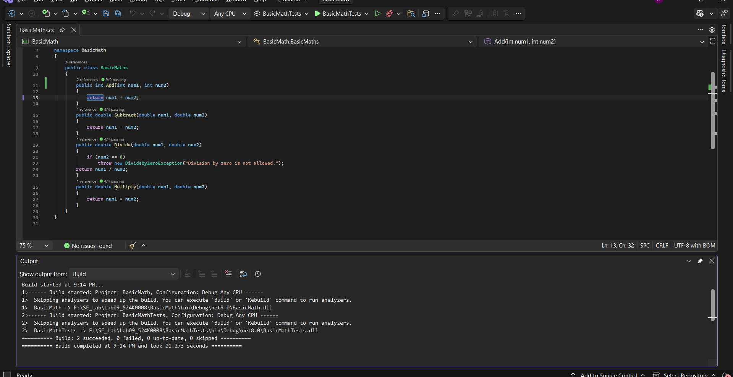
Step 2
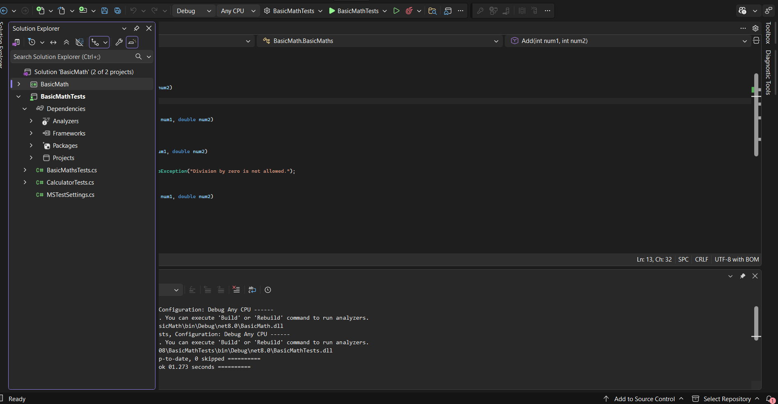
Step 3
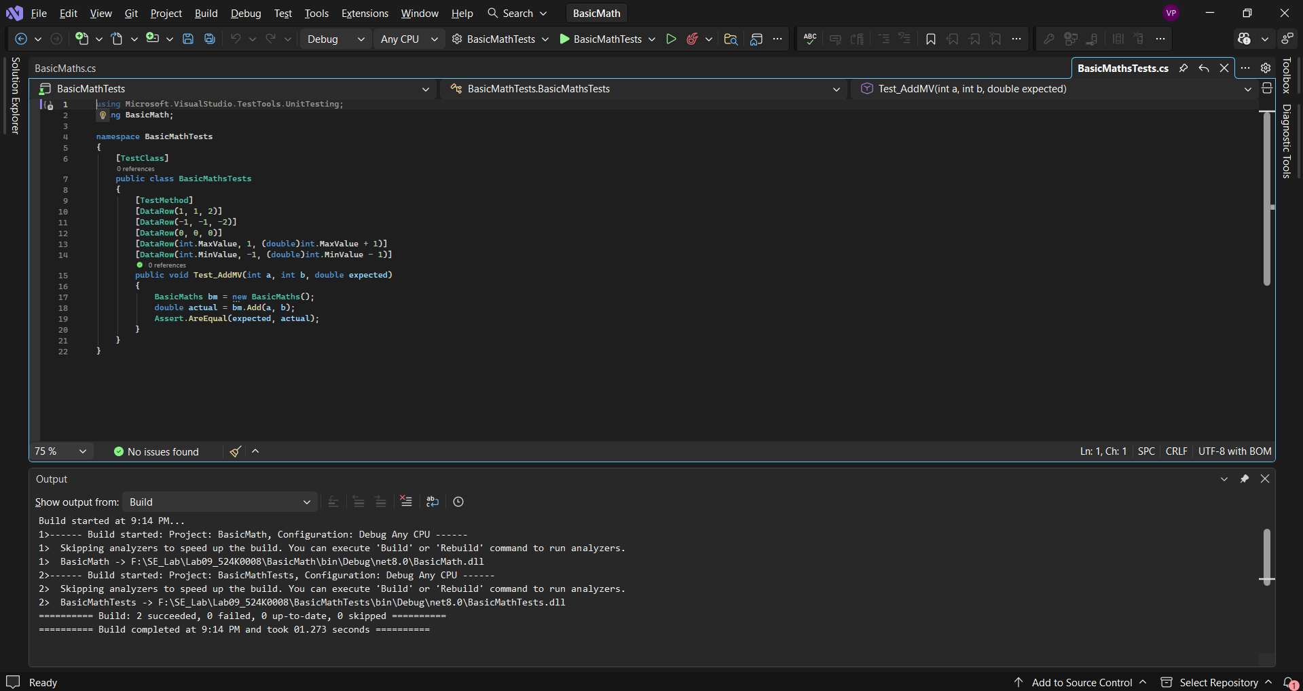
Test
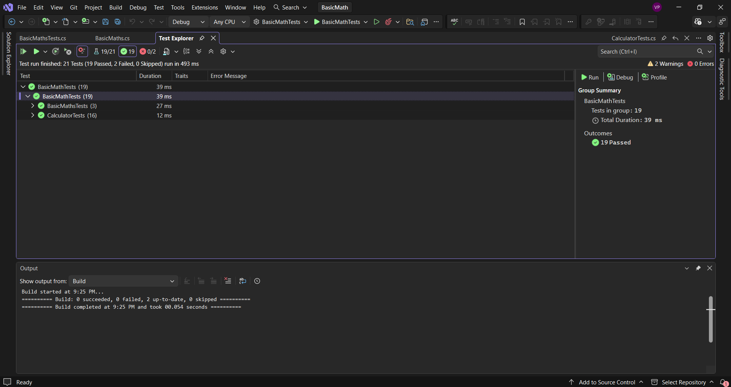

2. Exercise 2
Step 1
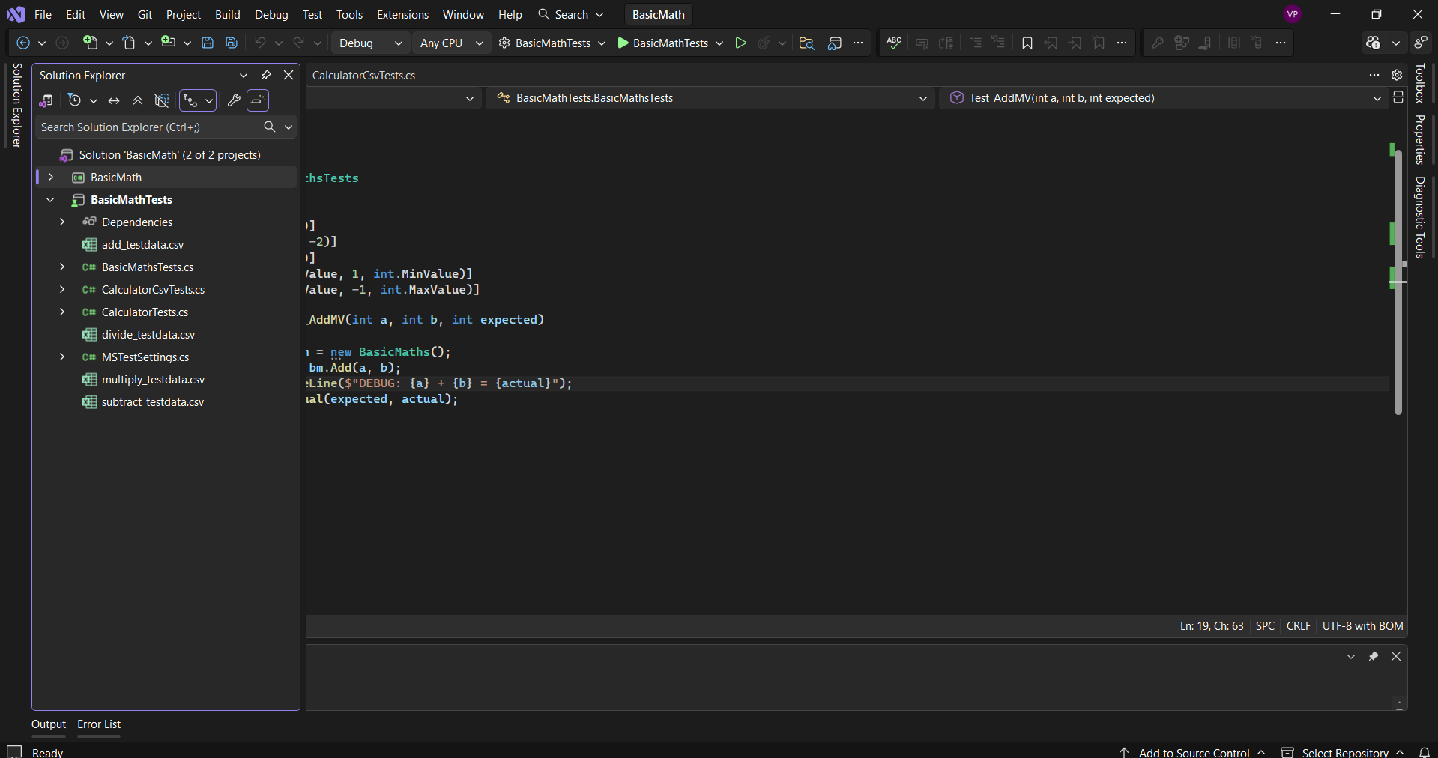
Step 2
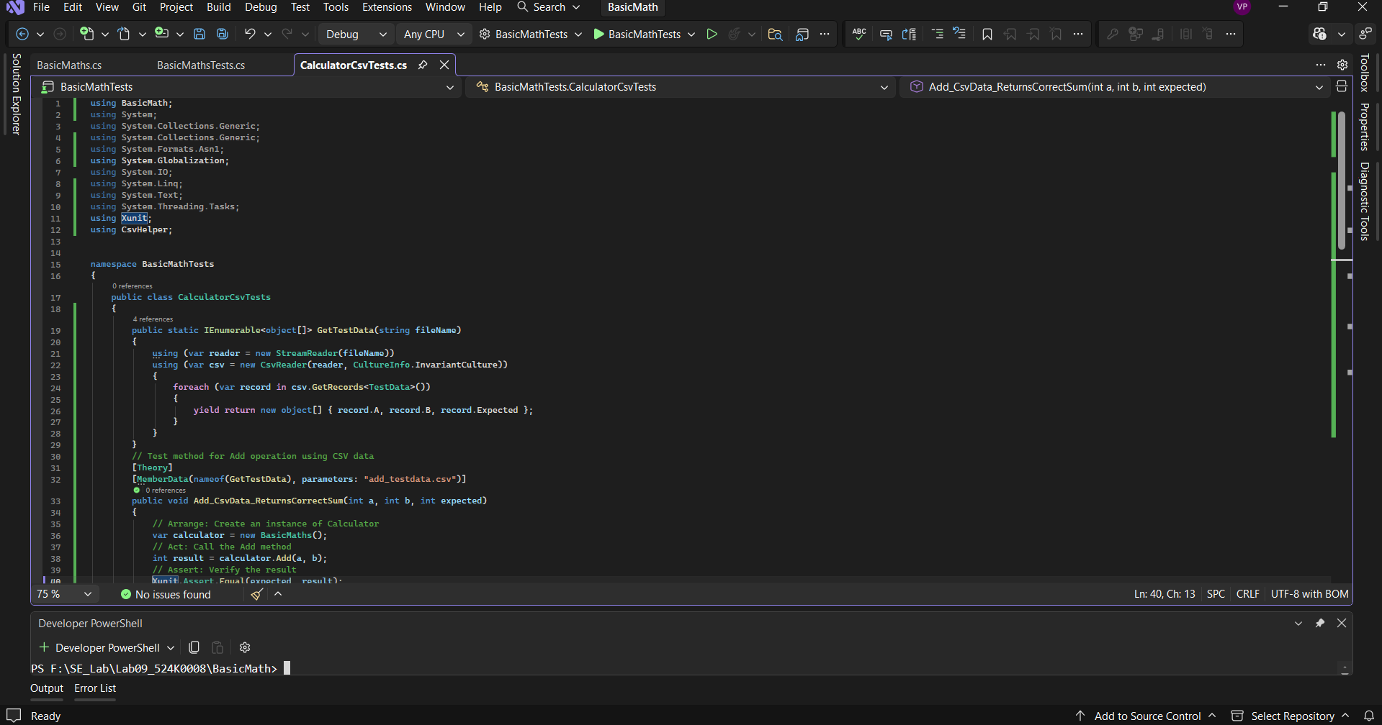
Step 3
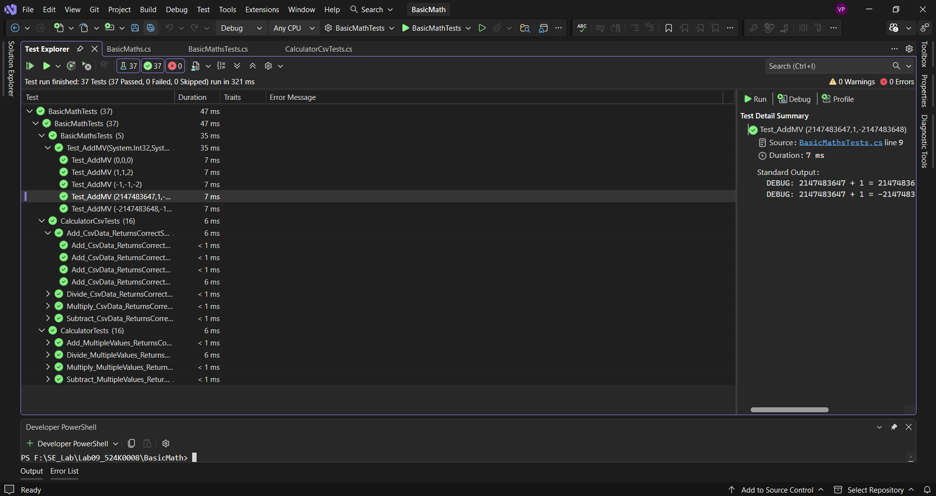

3. Exercise 3
Step 1
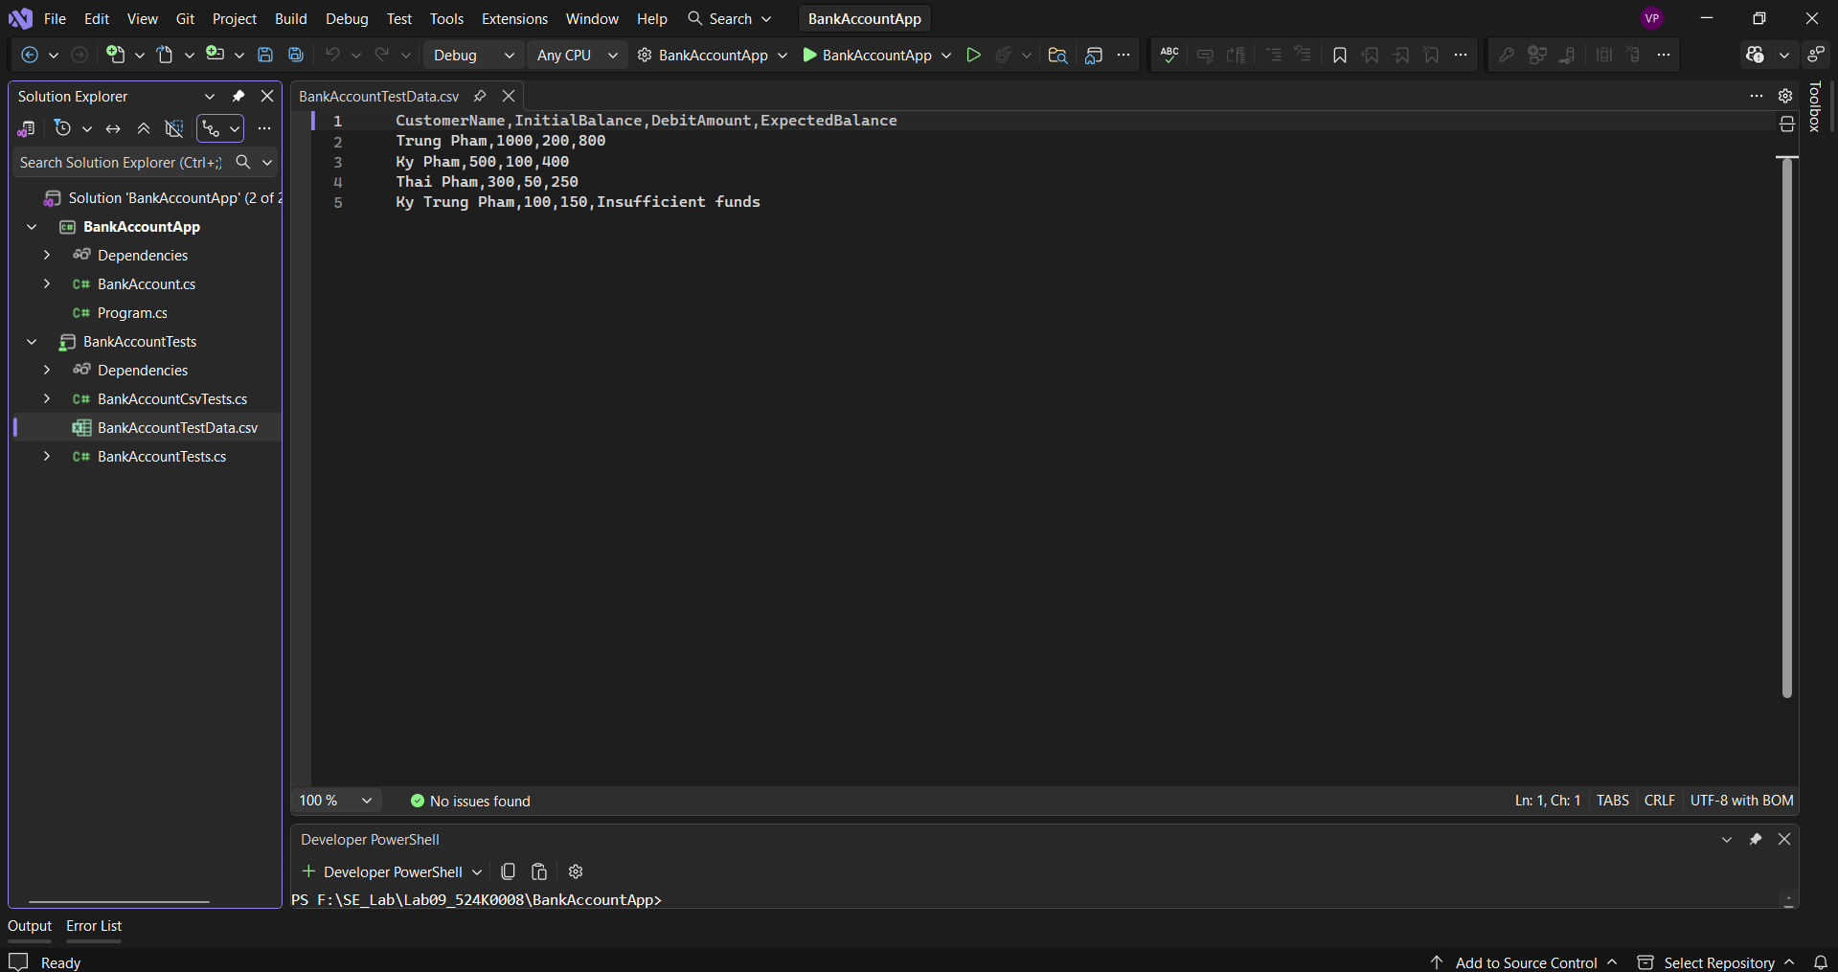
Step 2
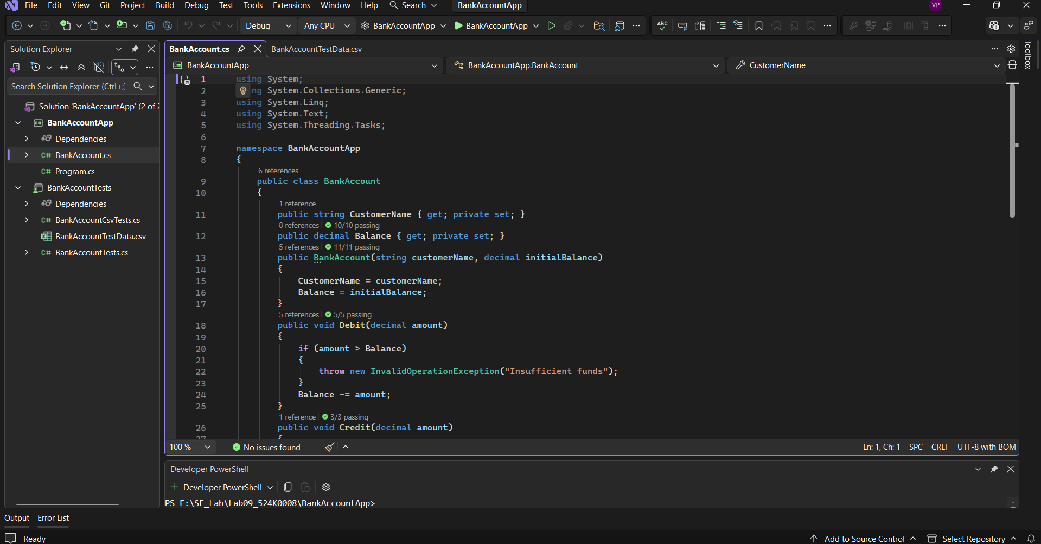
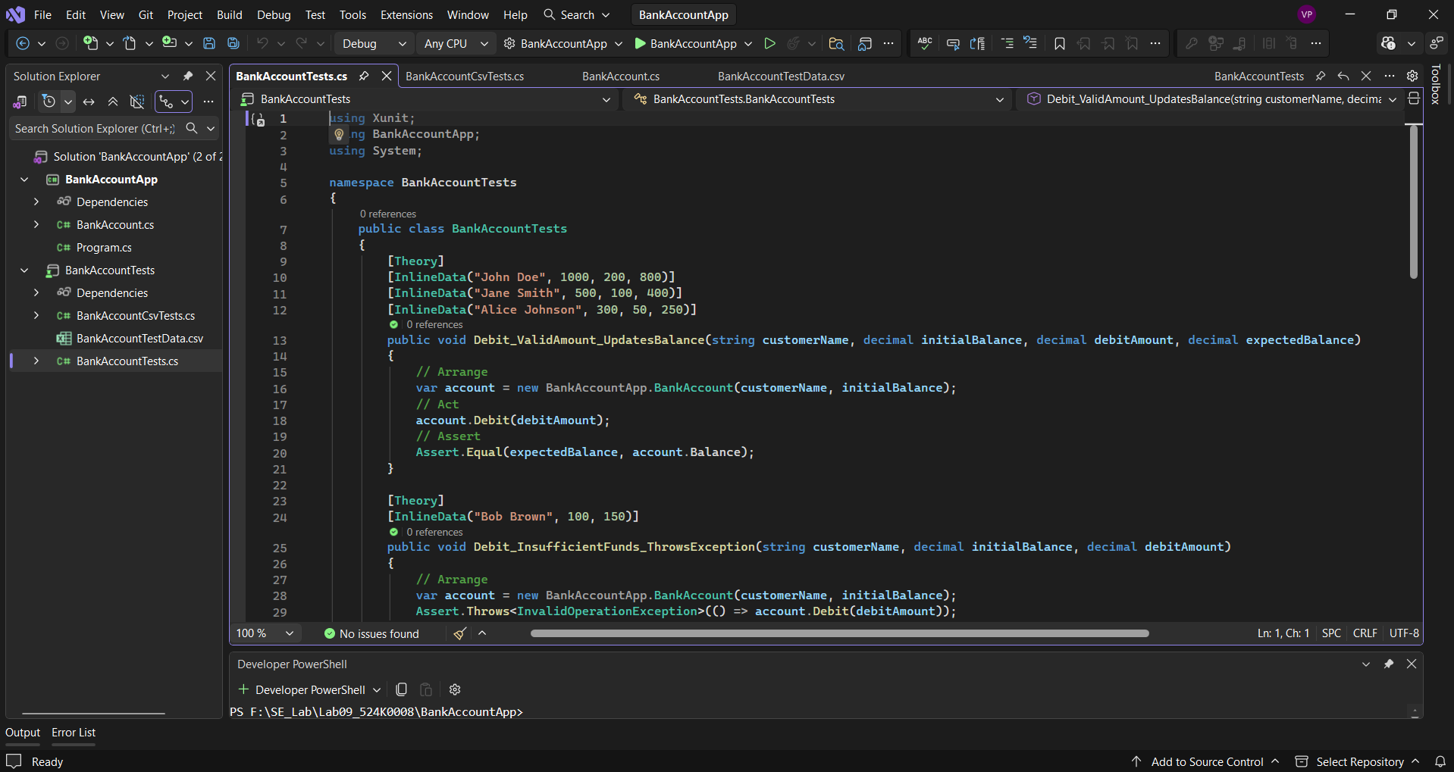
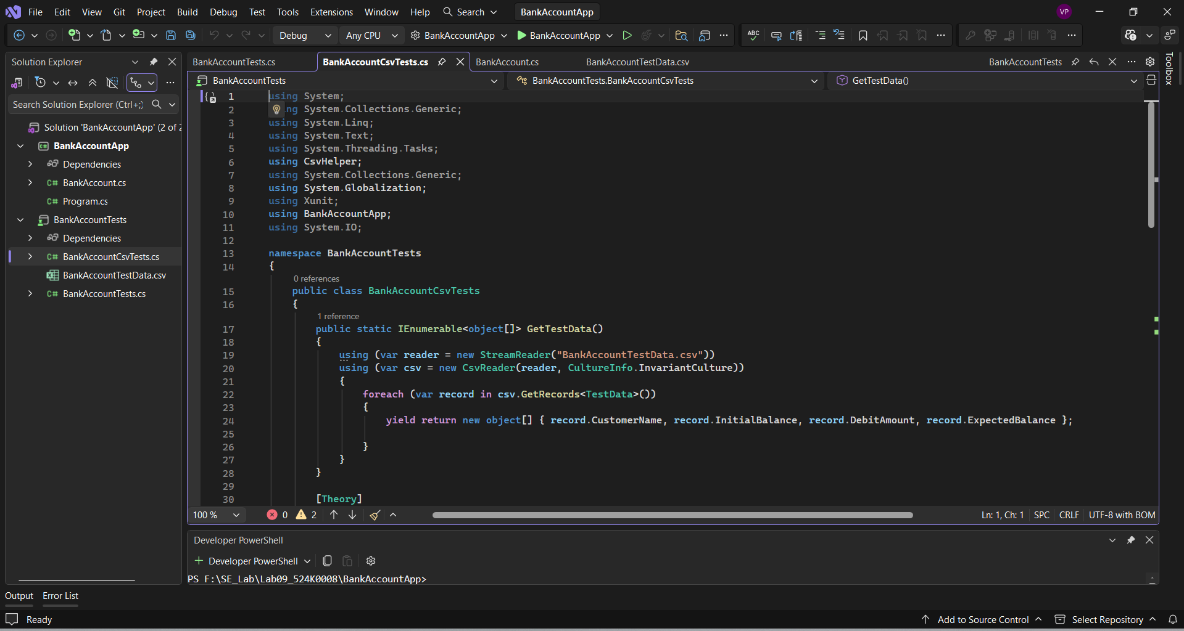
Step 3
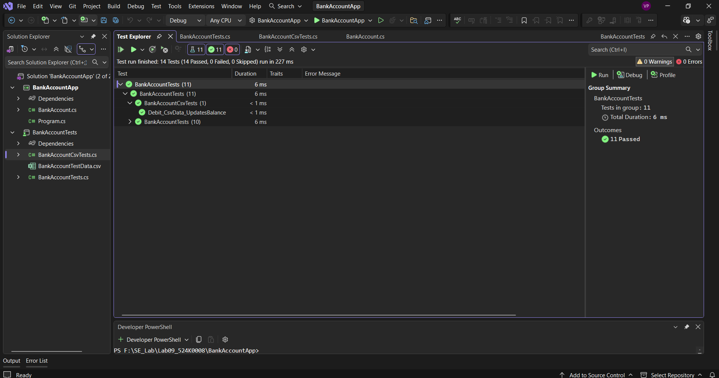

4. Exercise 4
Step 1
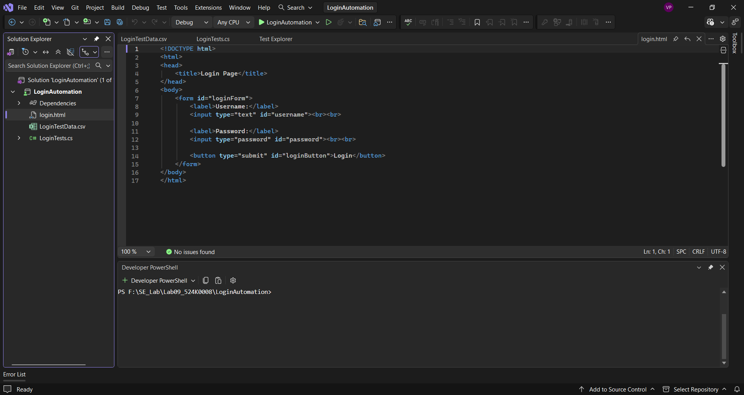
Step 2
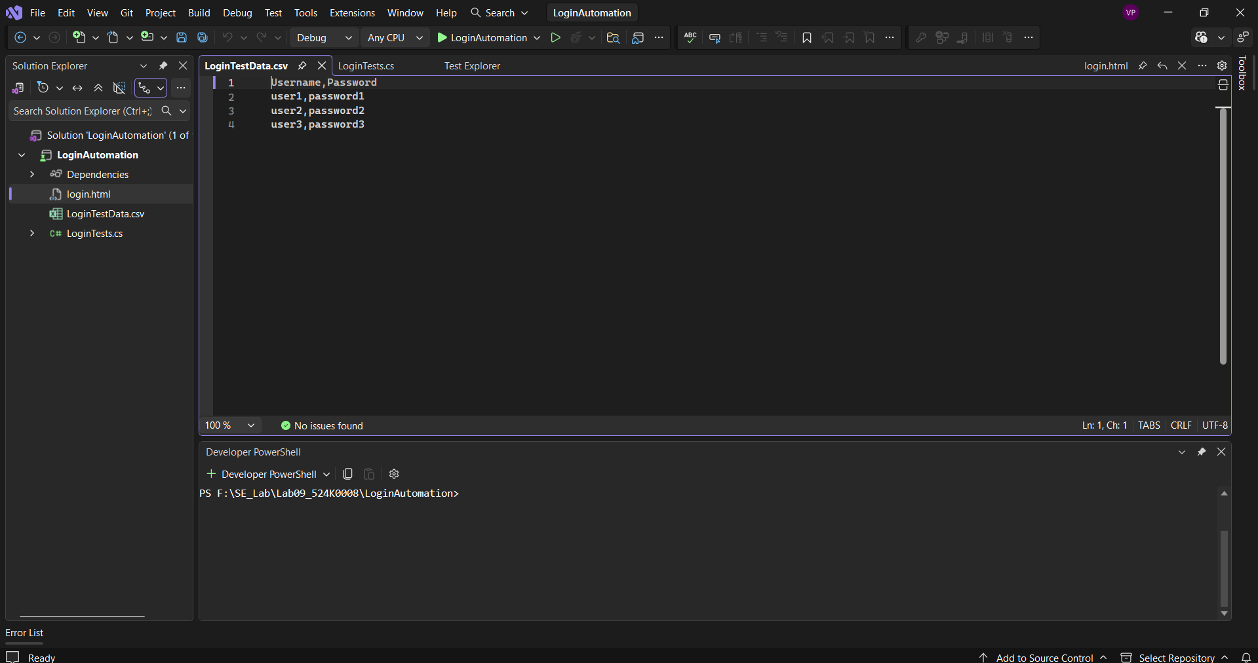
Step 3
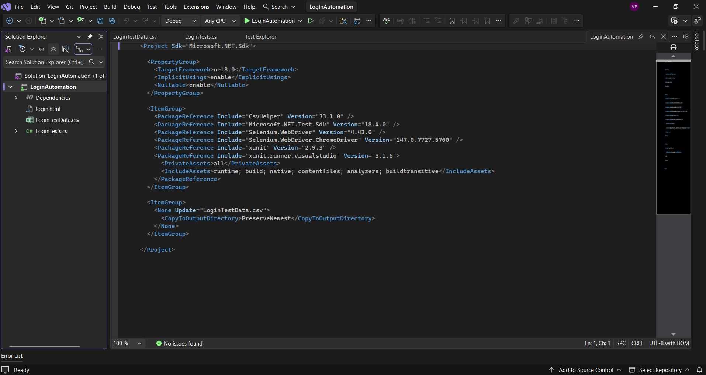
Step 4
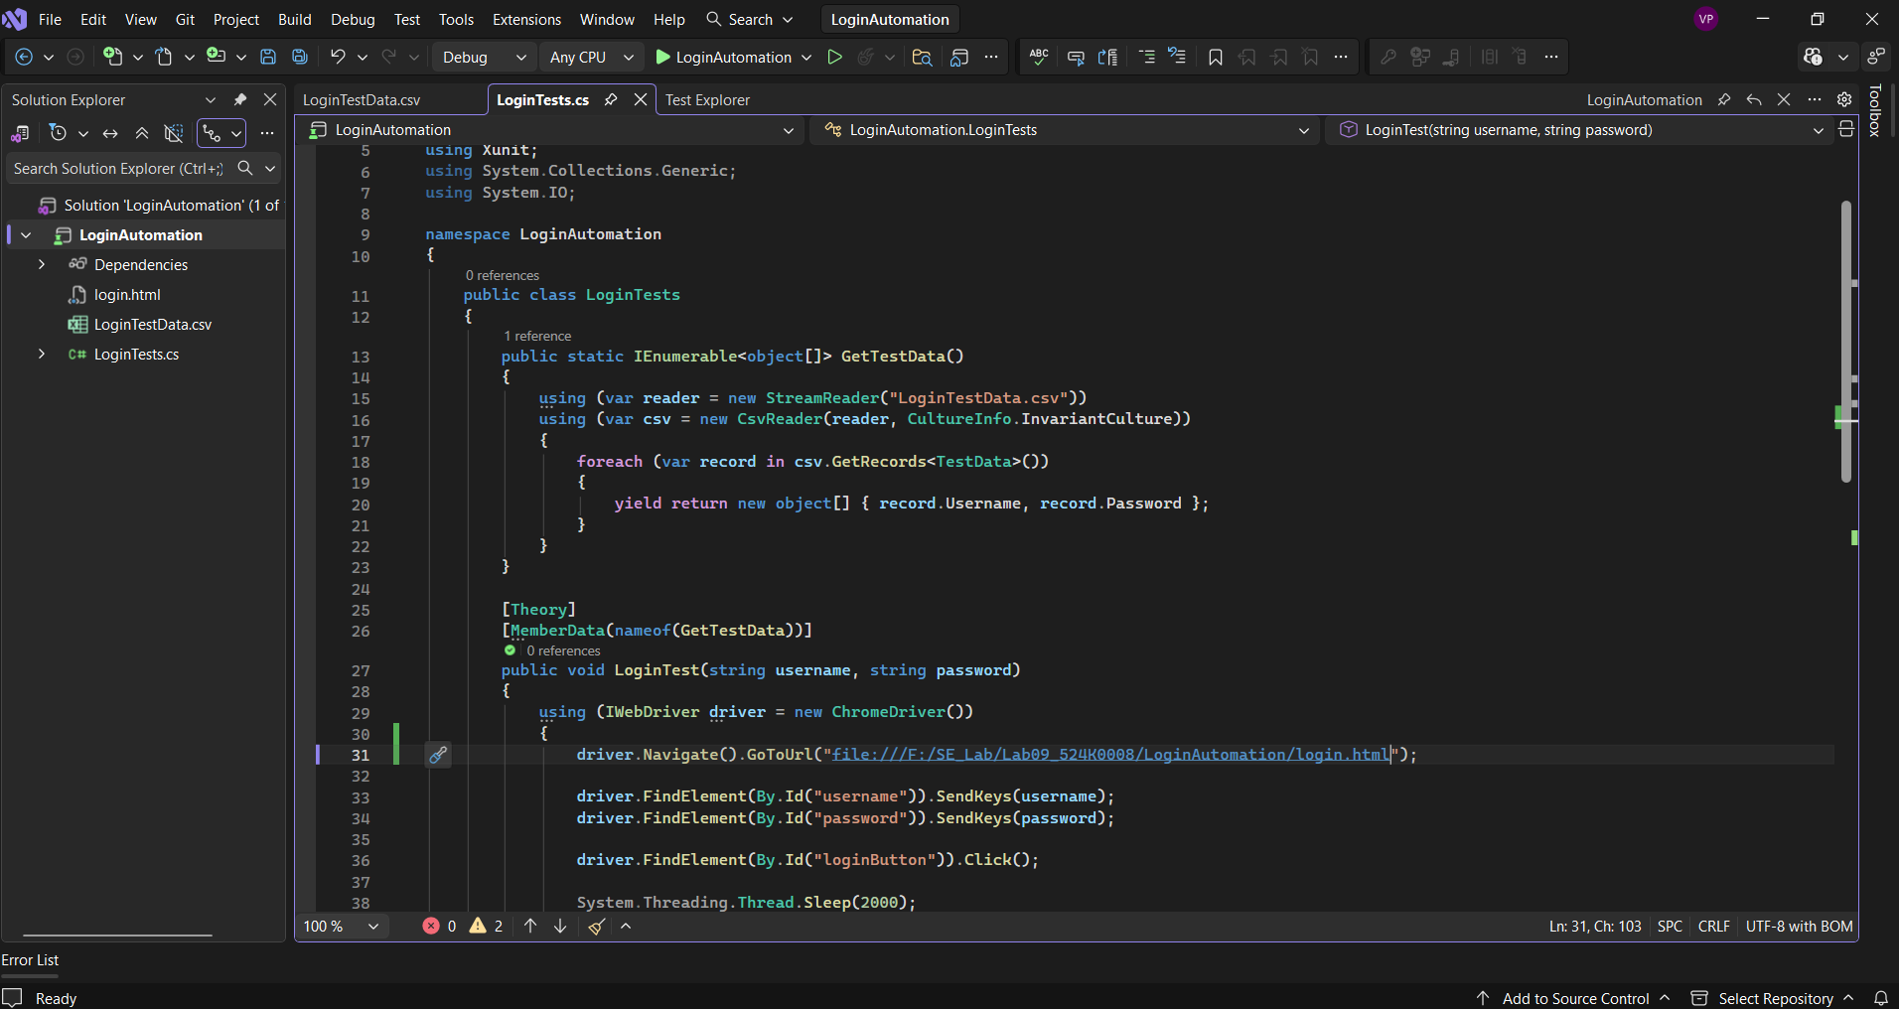
Step 5
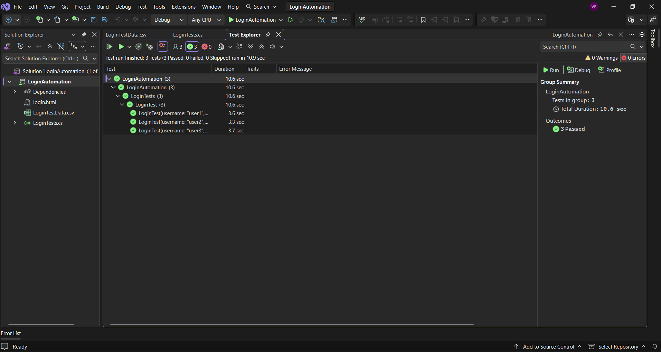

IV. Conclusion
In this lab, I gained practical experience in both unit testing and automation testing using C# .NET Core. I learned how to create and execute test cases using multiple frameworks such as MSTest, xUnit, and NUnit. Additionally, I understood how to perform data-driven testing using CSV files and how to automate web testing using Selenium.
One of the main challenges I faced was configuring test frameworks and resolving errors related to dependencies and file paths, especially when working with CSV files and Allure reporting. However, through debugging and troubleshooting, I was able to resolve these issues and successfully complete all exercises.
Overall, this lab helped me improve my understanding of software testing techniques and tools, which are essential for ensuring software quality in real-world applications.

