**Formula 1+1**

Formula 1 is a motorsport where 20 drivers and 10 manufacturers compete for the podium in over 20 races each year. One of the main issues with Formula 1, is the initial difficulty for new viewers to understand the sport. Unlike basketball, or football, viewers can’t take part in racing F1 cars themselves, which makes them less likely to spend time to understand why the sport is entertaining. I want to create a website for new Formula 1 fans where they can learn about the sport and why it’s exciting for the millions of viewers.

I will design a website containing statistics of current F1 driver scores and standings of the ongoing season, and information about the engineering, strategies, and skill that goes into these races. In order to show current scores, I plan to update the website after each race to include the new scores and standings. I’ll be using my own understanding, as well as various sources, like websites and videos, to create pages containing information about the sport.

The main users of the website will be people who are new fans of Formula 1 racing that want to increase their understanding of the sport. My friends, Jayanand Mijagiri, and John Zabul are a good example of potential users that I will be talking to. They’re big fans of racing games, which is why I easily convinced them to start watching Formula 1, but ultimately, they don’t know much about the sport, aside from cars trying to pass each other. I plan on showing them a bunch of F1 topics that might seem interesting and let them decide which topics beginner fans, such as themselves would like to see.

In order to improve the interactivity of the site, I want to use JavaScript to slideshow that automatically switch pictures. For example, if I wanted to make a page explaining the multiple tire compounds an F1 car can choose from, I would want to have a slide show of different tires, and maybe a cross section of one so the viewer can have a better understanding. I also want pictures that redirect to a different webpage, which I can use as a way of improving the browsing experience for the user. For example, on the scoreboard page, I can include pictures of the top drivers, and the clicking on their picture would take the user to a different page about that driver.

An example of the slide show I want to implement:

<https://assettocorsa.club/content-manager.html>

An example of the interactive image I want to implement:

<https://www.spa-francorchamps.be/en/circuit/news?page=1>

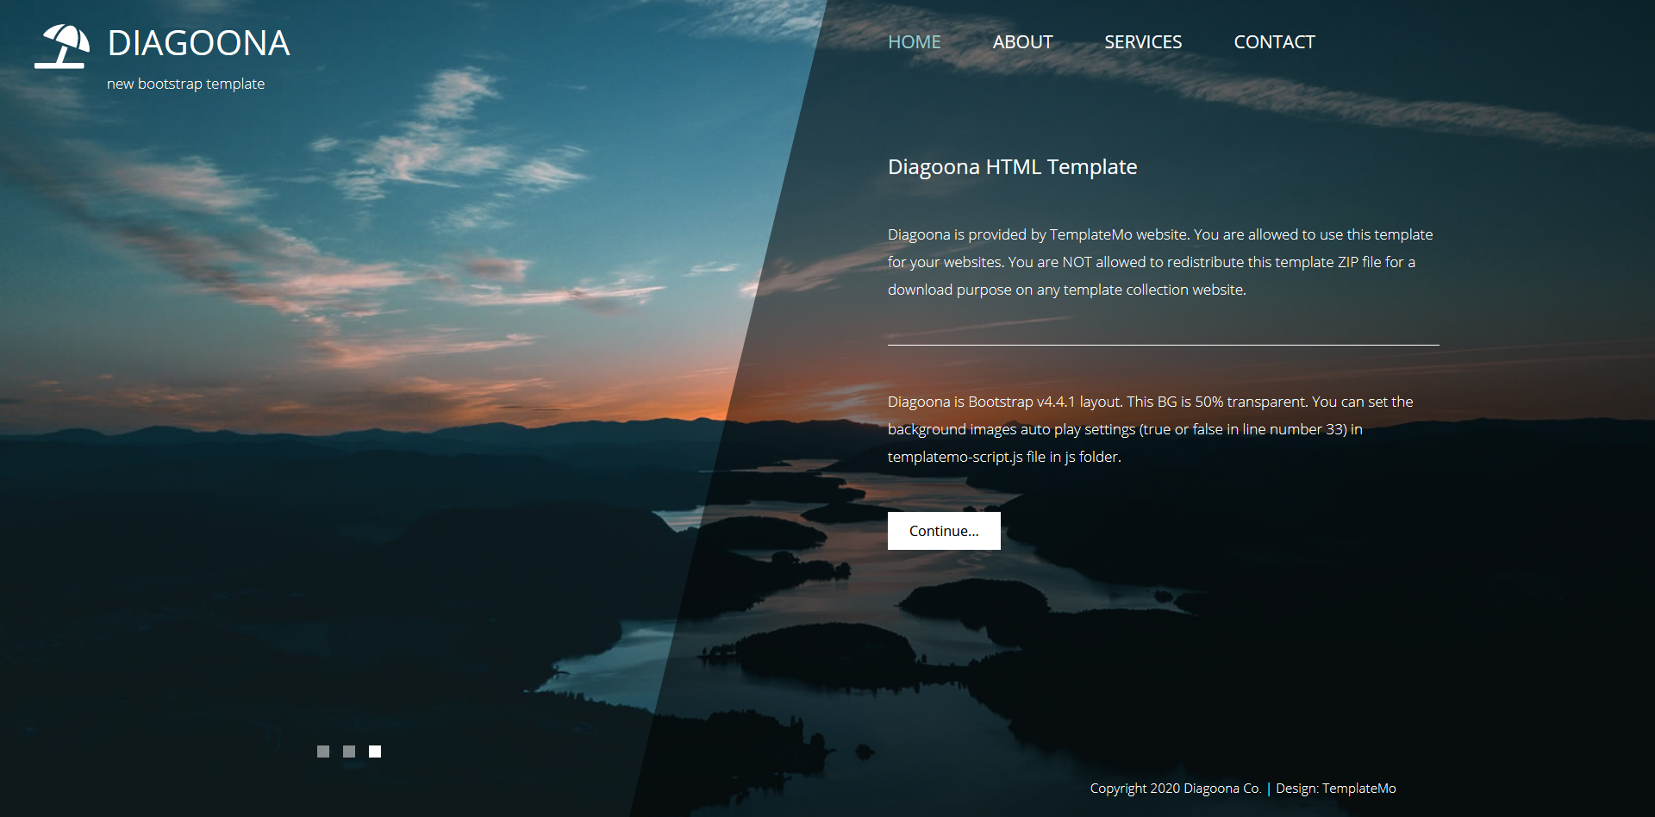

I chose this template mainly because of how much focus is put onto the images. Its best feature is having the background constantly changing to a different high-resolution photo. The color scheme is very neutral, since the text are light gray, which means a big variety of colors can be used as the background. I intend to take advantage the color scheme since each F1 car is painted with a different color palette.

Link to template: <https://webpages.uncc.edu/xzhang41/Template/diagoona/index.html>