SELECT * FROM 表格数据库名称；SELECT ..., ..., ... FROM 表格数据库名称
LIMIT 字段数
OFFSET 字段数;
WHERE ... =<>>= <= '....' and ... < ...;
ORDER BY ... DESC ;WHERE ... LIKE '...%_' ;
WHERE ... BETWEEN 小数字 AND 大数字；
WHERE ... BETWEEN 小数字 AND 大数字 AND ...= '...';
WHERE ... BETWEEN 小数字 AND 大数字 AND (...= '...' OR '...' = '...');
注意：and优先级比or高，因此需优先处理and，如需解决优先级问题，加{}即可
WHERE ... BETWEEN 小数字 AND 大数字 AND (... IN ('...' , '...' = '...'));
SELECT AVG(...), SUM(...), MAX(...), MIN(...), COUNT(...)
FROM ...;
SELECT AVG(...) AS ..., SUM(...) AS ..., MAX(...) AS ..., MIN(...) AS ..., COUNT(...) AS ...
FROM ...;
SELECT ROUND (AVG(...) , 1) AS ...
FROM ...;保留平均值小数位数为1位
SELECT ROUND (AVG(...) ) AS ...
FROM ...;四舍五入平均值为整数位
SELECT ROUND (AVG(...) ) AS ...
FROM ...
GROUP BY ...;
SELECT ROUND (AVG(...) ) AS ...
FROM ...
GROUP BY ...
ORDER BY ... DESC OR ASC;
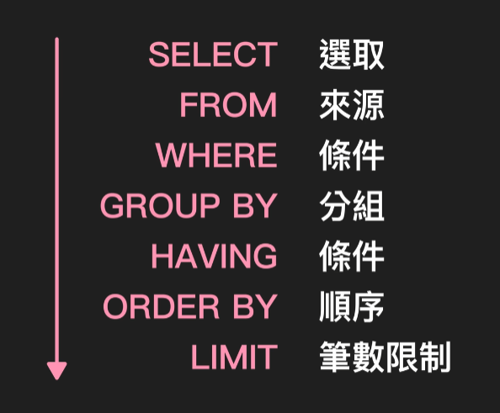

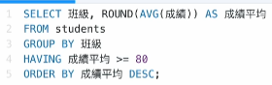
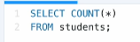
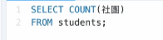
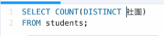
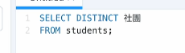
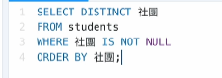
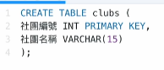
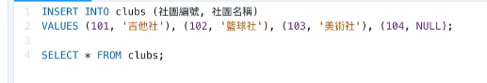
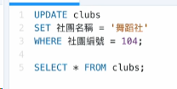
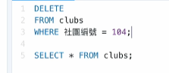


JOIN =INNER JOIN

