**­**

**Turkish Discourse Bank 1.0**

**User Agreement Form**

Please email this form to: corpora@metu.edu.tr

I hereby agree that I will not use Turkish Discourse Bank (TDB 1.0) for any purpose other than academic research, reproduce or distribute it in any way and that I will share the results of the research I conduct using the corpus.

Note: If you use Turkish Discourse Bank 1.0 in your research, please cite the following papers:

Demirşahin, I., & Zeyrek, D. (2017). Pair annotation as a novel annotation procedure: The case of Turkish Discourse Bank. In *Handbook of Linguistic Annotation* (pp. 1219-1240). Springer, Dordrecht.

Zeyrek, D., Demirşahin, I., Sevdik-Çallı, A. B., & Çakıcı, R. (2013). Turkish Discourse Bank: Porting a discourse annotation style to a morphologically rich language. D&D, 4(2), 174-184.

**User’s**

Name : Philippe

Surname : Muller

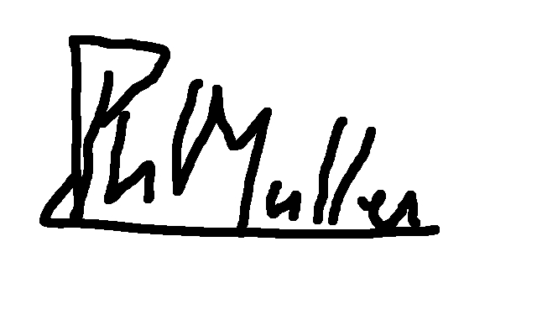Signature :

Organization : University of Toulouse

Address : 118 Route de Narbonne

31062 Toulouse Cedex

France

Phone/Fax : +33 561558298

E-mail : philippe.muller@irit.fr

Please, indicate for which purpose the corpus will be used: disrpt workshop shared task on discourse segmantation for 2019