Analyzing wellbeing through profile images on social media

Long Xiong1,2[1] and Ming Ye1[2]

1 EasyChair

2 University of Manchester, Manchester, U.K.

andrei@voronkov.com, hoderk@cs.man.ac.uk

Abstract

Profile images, as a stable content, are posted by users on their social media, which driven by users' gender, age, personality and other characteristics. In this paper, we investigated individual differences in profile picture choice between wellbeing traits. We concluded that each wellbeing trait has a specific style of profile images. For example, users high in positive relationship prefer to use pictures with bokeh and depth of filed style as their profile image. Users high in engagement do not like to use pictures with surface texture, object details and quality of material as their profile image.

1. Introduction

In recent years, researchers have tried to make use of profile images to study users’ online behaviors and offline psychological states. On the one hand, researchers try to figure out factors driving users to choose their profile images. On the other hand, they attempted to obtain the characteristics of users from their profile images. Several studies have examined the differences of users' profile images are related to age, gender and personality (Zheng, et al. 2016). For example, users high in openness prefer more aesthetic photos, which tend to have higher contrast, sharpness, saturation and less blur. What attracts researchers is that users can choose profile images to enhance their physical attractiveness without being judged deceptive, this means profile images can reflect users' actual psychological states.

With the rise of social media, the way people express their feelings and opinions gradually shifts from offline to online. Online platform allow users to create their own profiles with text, images, videos, etc. Moreover, the opinions and feelings expressed by users in social media can be spread and communicated quickly. There profiles may be different from the user's actual profile, but it can reflect personal psychological characteristics (Zheng, et al. 2016). Users' feeling and opinions is beneficial to the development of personalized search engines, recommendation systems and online markets. For the government, effective control of the focus of public opinion and emotional orientation is good to improve the decision-making mechanism and timely response to emergencies. Users with different personalities have differences in color, content and other characteristics when selecting profile image on personal social media (Liu, et al. 2016), which also prompts us to shift our research goals to wellbeing and image style. Importantly, Liu did not consider the abstract content contained in images, such as atmosphere, they focused on colors, facial expressions, image composition and other certain content. Texture information is also important for human perception of image style (Sun,et al.2017). Convolution neural network was used to extract style features and content information to identify image style, this method makes better use of the poor explanatory and abstract characteristics of CNNs to obtain abstract style of image. In this paper, we used the CNNs model proposed by (Sun,et al.2017) to extract image style(Detailed, Pastel, Melancholy, etc.), then we uncover their relationships with wellbeing traits from the PERMA. We also compared and studied the relationship between wellbeing, image color and facial features.

Wellbeing is not just about simply positive emotions or mood. Psychologists, organizations, and governments measuring wellbeing are now using multi-dimensional measures that include a range of factors. PERMA (Seligman 2012) decomposes the wellbeing construct into five domains: Positive emotion, Engagement, Relationships, Meaning, and Accomplishment (PERMA). With these five elements of PERMA, people can have their own happiness and enjoy a vigorous life. In our study, we found high correlation between wellbeing traits and users’ profile image style.

1. Related Works

Many researchers now realize that income is not the only measure of individual wellbeing, and governments around the world are starting to rethink the way they measure citizens' wellbeing. In 2011, the psychologist Martin Seligman proposed PERMA, which is a five-dimensional model of wellbeing. Seligman’s new theory therefore posits that wellbeing consists of the nurturing of one or more of the five following elements: Positive emotion, Engagement, Relationships, Meaning, and Accomplishment (abbreviated as the PERMA). These five elements are the best approximation of human self-interest, which is why they have a place in wellbeing theory. PERMA also includes social and cognitive components that may show more differences in different languages and cultures.

There is a certain relationship between the style of users' profile image style and users' personality (Liu, et al. 2016). For example, users with high openness prefer to use images with higher contrast, clarity and saturation. (Chen et al. 2017) proposed a unified approach to construct a profile of subjective wellbeing based on social media language in Facebook status updates. They apply sentiment analysis to generate users’ affect scores, and train a random forest model to predict wellbeing using affect scores and other language features of the status updates. In a recent work, (Schwartz et al. 2016) developed an English PERMA model using Facebook data. They perform an additional evaluation at the user-level, finding that a multi-level cascaded model, using both message-level predictions and user-level features, performs best and outperforms popular lexicon-based happiness models.

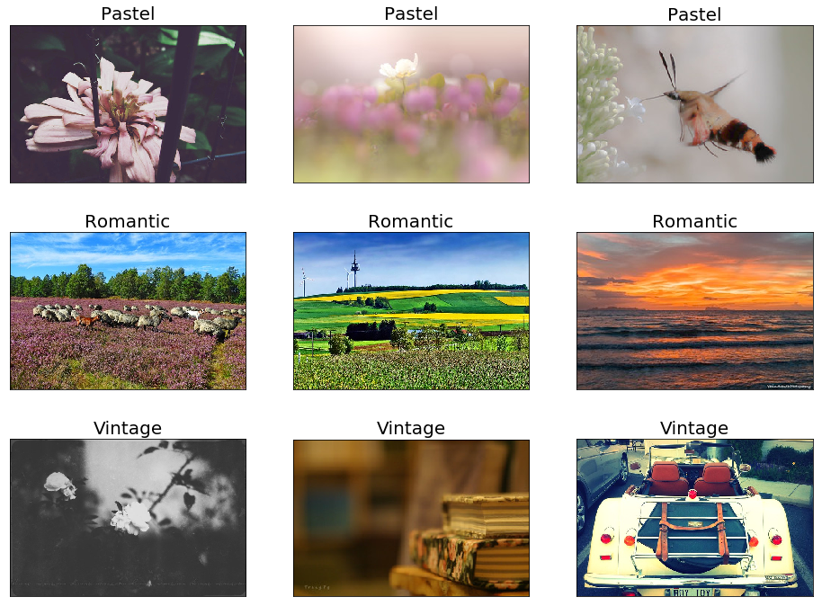

Figure 1: Three types of pictures with different styles

Different image styles bring different feelings to people. For different image styles, people can feel subtle differences, but it is quite difficult to describe them. One reason is that the style information of an image may be encoded in any component of the image including local and global, shape and color features. Another reason is that the definition of a style is often subjective, especially for photography works, which may vary from person to person. (Karayev et al. 2013) uses low-level statistics, color choices, composition, and content to construct the style prediction model, which has a good explanation of what is the image style. In addition, through comparative experiments, they found that the performance of their classifier was quite accurate compared with that of trained artificial markers. (Sun et al. 2017) propose a CNN-based model that integrates both content (or object) information and texture information for image style recognition. Moreover, their work using the CNN-based model improves over the state-of-the-art results.

1. Data

In this paper, we use the dataset established by (Volkova et al. 2013), they focus on learning gender differences in the use of subjective language in English, Spanish and Russian Twitter data, and explore cross-cultural differences in emoticon and hashtag use for male and female users. We used Scrapy to crawl the tweets of 1,721 english-language twitter users rom Jan. 1, 2010, to Dec. 31, 2018. Users with more than 100 tweets were retained, screened out to 1,523 and downloaded their profile images. DLATK (Schwartz et al. 2017) is used to process data, including filtering out English tweets, removing URLs and @-mentions, and removing tweets which contains the same first 6 tokens as another message within the same group, which improves the language classification.

1. Image Features Extraction

The recognition of image style is a research hotspot developed in recent years. Although is it very recognizable to human observers, visual style is a difficult concept to rigorously define. (Karayev et al. 2013) define several different types of image style, and gather a new, large-scale dataset of photographs annotated with style labels. Importantly, they find that deep convolutional neural network (CNN) features perform best for the task. (Sun et al. 2017) propose a CNN architecture with two pathways extracting object features and texture features, respectively. The object pathway represents the standard CNN architecture and the texture pathway intermixes the object pathway by outputting the gram matrices of intermediate features in the object pathway. the two pathway architecture performs much better than individual pathways, which indicates that the two pathways contain complementary information of an image’s style. In our work, we use the deep learning model with two pathways for image style recognition. 除此之外，我们还是用另外两个API提取图像的人脸特征和色彩特征。

* 1. Image Style

In this work, we used Flickr dataset to train the style recognition model. The Flickr Style was also introduced by (Karayev et al. 2013). It contains 80,000 images with 20 style labels. The labels are grouped into several categories and each category contains two to five labels. For example, the Atmosphere category has two labels, Hazy and Sunny. We calculated the p value corresponding to the Pearson correlation between each feature and the target trait.

* 1. Facial Presentation

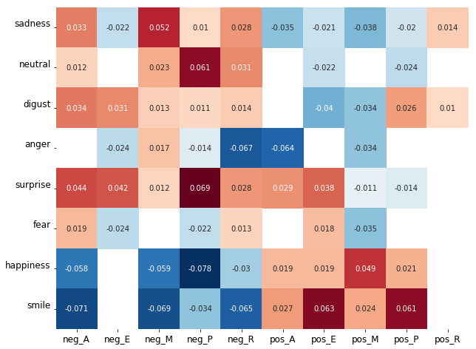

* 1. Image Color

1. Analysis

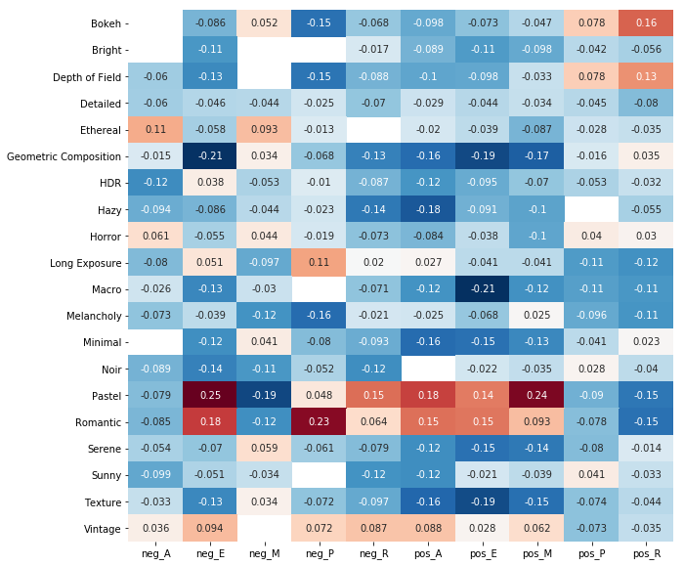

Figure 1: Pearson correlations between proﬁle image and and wellbing

As can be seen from the figure above, Positive Engagement, Positive Accomplishment and Positive Meaning show a similar correlation with image style. On the one hand, there is a strong correlation between style Romantic with style Pastel (p=0.6), and between Pastel with Vintage (p=0.54). On the other hand, there is a strong positive correlation between Positive Engagement, Positive Accomplishment and Positive Meaning. These three styles of images are easier for ordinary people to distinguish as the names of the styles often come from the feeling the photos convey.

Positive Emotion Is one of the most studied aspects of wellbeing, positive emotion (Sun et al. 2017 )includes positive emotions such as joy, contentment, and excitement.

Most importantly, users high in Positive Emotion are correlated with Bokeh and Depth of filed. What these two styles have in common is different hierarchies of objects in the image, such as distance, clarity and blur.

Engagement is a multidimensional structure that includes behavioral, cognitive, and affinity components. It can mean participation and participation in a group or activity, enthusiasm and interest in the activity, commitment and dedication to the job, and focus on the task at hand [15]。Users of Engagement do not like to use pictures with textures and surface details as profile pictures (Macro, Texture and Geometric regularity are negatively correlated, and all of them show that the content of photos often contains details of objects.). On the contrary, users who lack Engagement are much more likely to use Pastel and Romantic style images than users with high positive Engagement scores. The same thing is that both groups rejected the Composition categories.

Relationship includes trusting others, perceiving others as being there if needed, receiving social support, and giving to others[16]. Plenty of evidence indicates the importance of positive Relationship to health, longevity, and other important qualities of life. Users who lack relationship prefer images in styles like Pastel. Typically, such users' profile images are not Hazy in style. For users with high Relationship scores, they prefer images involving optical techniques as profile images. Compared with those users who lack Relationship, they do not prefer rich profile image.

Meaning explains the purpose and importance of life, as well as the understanding of life [18]。Users with higher Meaning scores prefer the pastel style. This type of user does not like to use images in the Composition category, and does not like to use images in the Atmosphere category as profile images. For users with negative Meaning, their profile images are more likely to use detailed, transparent or translucent Ethereal style. And rare Romantic and Pastel styles with rich color content.

* 1. Submitting the Article for Reviewing
  2. Submitting the Final Version for the Proceedings

References

[1]Zheng, W. , Yuan, C. H. , Chang, W. H. , & Wu, Y. C. J. . (2016). Profile pictures on social media: gender and regional differences. Computers in Human Behavior, 63, 891-898.

[2]Liu, L., Preotiuc-Pietro, D., Samani, Z. R., Moghaddam, M. E., & Ungar, L. (2016, March). Analyzing personality through social media profile picture choice. In Tenth international AAAI conference on web and social media.

[3]Sun, T., Wang, Y., Yang, J., & Hu, X. (2017). Convolution neural networks with two pathways for image style recognition. IEEE Transactions on Image Processing A Publication of the IEEE Signal Processing Society,26(9), 1-1.

[4]Sap, M., Park, G., Eichstaedt, J., Kern, M., Stillwell, D., Kosinski, M., ... & Schwartz, H. A. (2014, October). Developing age and gender predictive lexica over social media. In Proceedings of the 2014 Conference on Empirical Methods in Natural Language Processing (EMNLP) (pp. 1146-1151).

[5]Kosinski, M., Stillwell, D., & Graepel, T. (2013). Private traits and attributes are predictable from digital records of human behavior. Proceedings of the National Academy of Sciences, 110(15), 5802-5805.

[6]face++

[7]Chen, L., Gong, T., Kosinski, M., Stillwell, D., & Davidson, R. L. (2017). Building a profile of subjective wellbeing for social media users. PloS one, 12(11), e0187278.

[8]Schwartz, H. A., Sap, M., Kern, M. L., Eichstaedt, J. C., Kapelner, A., Agrawal, M., ... & Kosinski, M. (2016). Predicting individual wellbeing through the language of social media. In Biocomputing 2016: Proceedings of the Pacific Symposium(pp. 516-527).

[9]Seligman, M. E. (2012). Flourish: A visionary new understanding of happiness and wellbeing. Simon and Schuster.

[10]Seligman, M. E. (2012). Flourish: A visionary new understanding of happiness and wellbeing. Simon and Schuster.

[11]Volkova, S., Wilson, T., & Yarowsky, D. (2013, October). Exploring demographic language variations to improve multilingual sentiment analysis in social media. In Proceedings of the 2013 Conference on Empirical Methods in Natural Language Processing (pp. 1815-1827).

[12]Karayev, S., Trentacoste, M., Han, H., Agarwala, A., Darrell, T., Hertzmann, A., & Winnemoeller, H. (2013). Recognizing image style. arXiv preprint arXiv:1311.3715.

[13]Sun, T., Wang, Y., Yang, J., & Hu, X. (2017). Convolution neural networks with two pathways for image style recognition. IEEE Transactions on Image Processing, 26(9), 4102-4113.

[14]Forgeard, M. J., Jayawickreme, E., Kern, M. L., & Seligman, M. E. (2011). Doing the right thing: Measuring wellbeing for public policy. International journal of wellbeing, 1(1).

[15]Csikszentmihalyi, M. (1997). Flow and the psychology of discovery and invention. HarperPerennial, New York, 39.

[16]Friedman, H. S. (Ed.). (2011). The Oxford handbook of health psychology. Oxford University Press.

[17]Applied Psychology: Health and Wellbeing

[18]Frankl, V. E. (2011). Man's search for ultimate meaning. Random House.

[19]Zheng, W., Yuan, C. H., Chang, W. H., & Wu, Y. C. J. (2016). Profile pictures on social media: Gender and regional differences. Computers in Human Behavior, 63, 891-898.

[20]Whitty, M. T., Doodson, J., Creese, S., & Hodges, D. (2018). A picture tells a thousand words: What Facebook and Twitter images convey about our personality. Personality and Individual Differences, 133, 109-114.

[21]Schwartz, H. A., Giorgi, S., Sap, M., Crutchley, P., Ungar, L., & Eichstaedt, J. (2017, September). Dlatk: Differential language analysis toolkit. In Proceedings of the 2017 Conference on Empirical Methods in Natural Language Processing: System Demonstrations (pp. 55-60).

[22]Diener, E., & Seligman, M. E. (2002). Very happy people. Psychological science, 13(1), 81-84.

[23]Zhou, E., Fan, H., Cao, Z., Jiang, Y., & Yin, Q. (2013). Extensive facial landmark localization with coarse-to-fine convolutional network cascade. In Proceedings of the IEEE International Conference on Computer Vision Workshops (pp. 386-391).

1. Masterminded EasyChair and created the first stable version of this document
2. Created the first draft of this document